STM32 Cortex-M0 作業 Ex2
學號：06 姓名：鄭立強
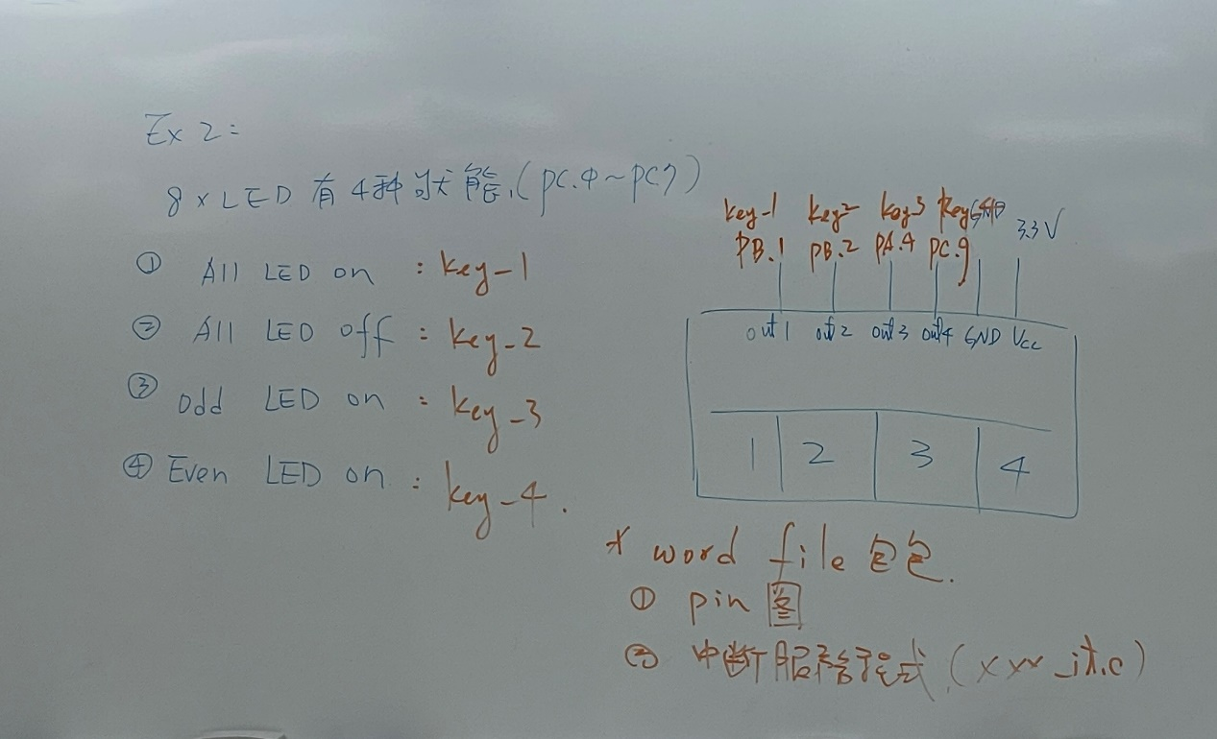

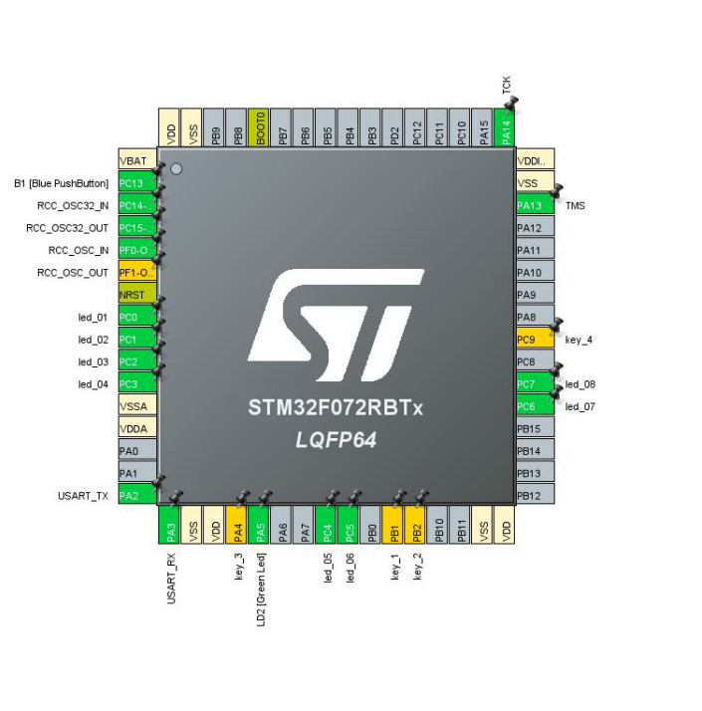

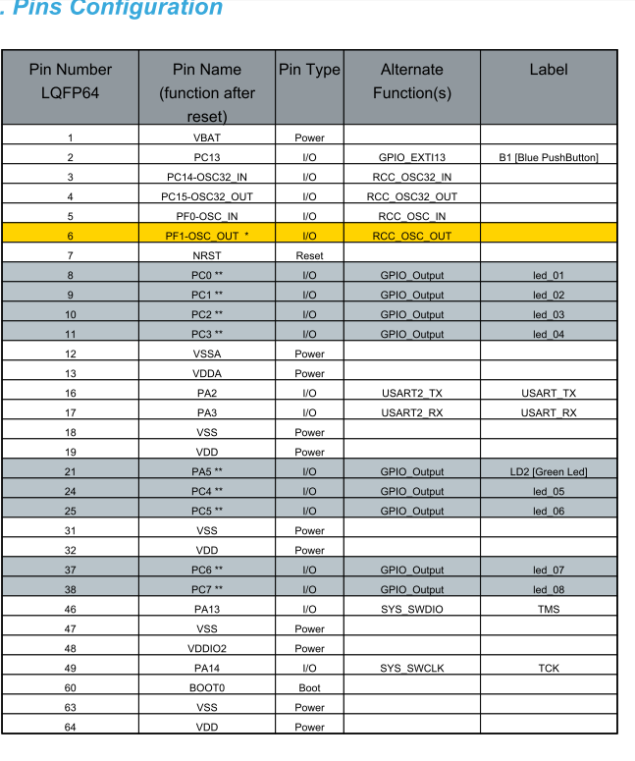

作業內容：利用 4 個 Active LOW 觸控按鍵（PB1、PB2、PA4、PC9）透過 EXTI 下降緣中斷，控制 8 顆 LED（PC0～PC7）。

功能對照
觸控按鍵／腳位 | 功能
KEY1 / PB1 | 8 顆 LED 全亮
KEY2 / PB2 | 8 顆 LED 全滅
KEY3 / PA4 | 奇數 LED 亮（1、3、5、7）
KEY4 / PC9 | 偶數 LED 亮（2、4、6、8）
接線備註：LED 使用 GPIO 高電位點亮的接法，每顆 LED 須串聯限流電阻；觸控模組 VCC 接 +3V3，GND 與開發板共地。
作業錄影：06_鄭立強_M0作業_Ex2.mp4（另附檔，未嵌入 Word）。

Stm32f0xx_it.c:
/* USER CODE BEGIN Header */
/**
******************************************************************************
* @file stm32f0xx_it.c
* @brief Interrupt Service Routines.
******************************************************************************
* @attention
*
* Copyright (c) 2026 STMicroelectronics.
* All rights reserved.
*
* This software is licensed under terms that can be found in the LICENSE file
* in the root directory of this software component.
* If no LICENSE file comes with this software, it is provided AS-IS.
*
******************************************************************************
*/
/* USER CODE END Header */

/* Includes ------------------------------------------------------------------*/
#include "main.h"
#include "stm32f0xx_it.h"
/* Private includes ----------------------------------------------------------*/
/* USER CODE BEGIN Includes */
/* USER CODE END Includes */

/* Private typedef -----------------------------------------------------------*/
/* USER CODE BEGIN TD */

/* USER CODE END TD */

/* Private define ------------------------------------------------------------*/
/* USER CODE BEGIN PD */

/* USER CODE END PD */

/* Private macro -------------------------------------------------------------*/
/* USER CODE BEGIN PM */

/* USER CODE END PM */

/* Private variables ---------------------------------------------------------*/
/* USER CODE BEGIN PV */

/* USER CODE END PV */

/* Private function prototypes -----------------------------------------------*/
/* USER CODE BEGIN PFP */

/* USER CODE END PFP */

/* Private user code ---------------------------------------------------------*/
/* USER CODE BEGIN 0 */

/* USER CODE END 0 */

/* External variables --------------------------------------------------------*/

/* USER CODE BEGIN EV */

/* USER CODE END EV */

/******************************************************************************/
/* Cortex-M0 Processor Interruption and Exception Handlers */
/******************************************************************************/
/**
* @brief This function handles Non maskable interrupt.
*/
void NMI_Handler(void)
{
/* USER CODE BEGIN NonMaskableInt_IRQn 0 */

/* USER CODE END NonMaskableInt_IRQn 0 */
/* USER CODE BEGIN NonMaskableInt_IRQn 1 */
while (1)
{
}
/* USER CODE END NonMaskableInt_IRQn 1 */
}

/**
* @brief This function handles Hard fault interrupt.
*/
void HardFault_Handler(void)
{
/* USER CODE BEGIN HardFault_IRQn 0 */

/* USER CODE END HardFault_IRQn 0 */
while (1)
{
/* USER CODE BEGIN W1_HardFault_IRQn 0 */
/* USER CODE END W1_HardFault_IRQn 0 */
}
}

/**
* @brief This function handles System service call via SWI instruction.
*/
void SVC_Handler(void)
{
/* USER CODE BEGIN SVC_IRQn 0 */

/* USER CODE END SVC_IRQn 0 */
/* USER CODE BEGIN SVC_IRQn 1 */

/* USER CODE END SVC_IRQn 1 */
}

/**
* @brief This function handles Pendable request for system service.
*/
void PendSV_Handler(void)
{
/* USER CODE BEGIN PendSV_IRQn 0 */

/* USER CODE END PendSV_IRQn 0 */
/* USER CODE BEGIN PendSV_IRQn 1 */

/* USER CODE END PendSV_IRQn 1 */
}

/**
* @brief This function handles System tick timer.
*/
void SysTick_Handler(void)
{
/* USER CODE BEGIN SysTick_IRQn 0 */

/* USER CODE END SysTick_IRQn 0 */
HAL_IncTick();
/* USER CODE BEGIN SysTick_IRQn 1 */

/* USER CODE END SysTick_IRQn 1 */
}

/******************************************************************************/
/* STM32F0xx Peripheral Interrupt Handlers */
/* Add here the Interrupt Handlers for the used peripherals. */
/* For the available peripheral interrupt handler names, */
/* please refer to the startup file (startup_stm32f0xx.s). */
/******************************************************************************/

/** @brief External interrupt lines 0..1 (KEY1 on PB1). */
void EXTI0_1_IRQHandler(void)
{
HAL_GPIO_EXTI_IRQHandler(key_1_Pin);
}

/** @brief External interrupt lines 2..3 (KEY2 on PB2). */
void EXTI2_3_IRQHandler(void)
{
HAL_GPIO_EXTI_IRQHandler(key_2_Pin);
}

/**
* @brief This function handles EXTI line 4 to 15 interrupts.
*/
void EXTI4_15_IRQHandler(void)
{
/* USER CODE BEGIN EXTI4_15_IRQn 0 */
/* Handle PA4 KEY3, PC9 KEY4 and the existing board button PC13. */
HAL_GPIO_EXTI_IRQHandler(key_3_Pin);
HAL_GPIO_EXTI_IRQHandler(key_4_Pin);
HAL_GPIO_EXTI_IRQHandler(B1_Pin);
/* USER CODE END EXTI4_15_IRQn 0 */
/* USER CODE BEGIN EXTI4_15_IRQn 1 */

/* USER CODE END EXTI4_15_IRQn 1 */
}

/* USER CODE BEGIN 1 */

/* USER CODE END 1 */

