Django第二次作業
- 建立homework2專案，建立myapp
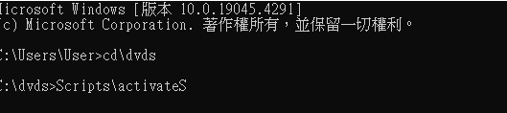
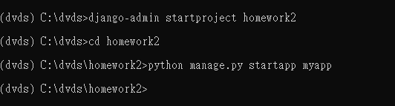

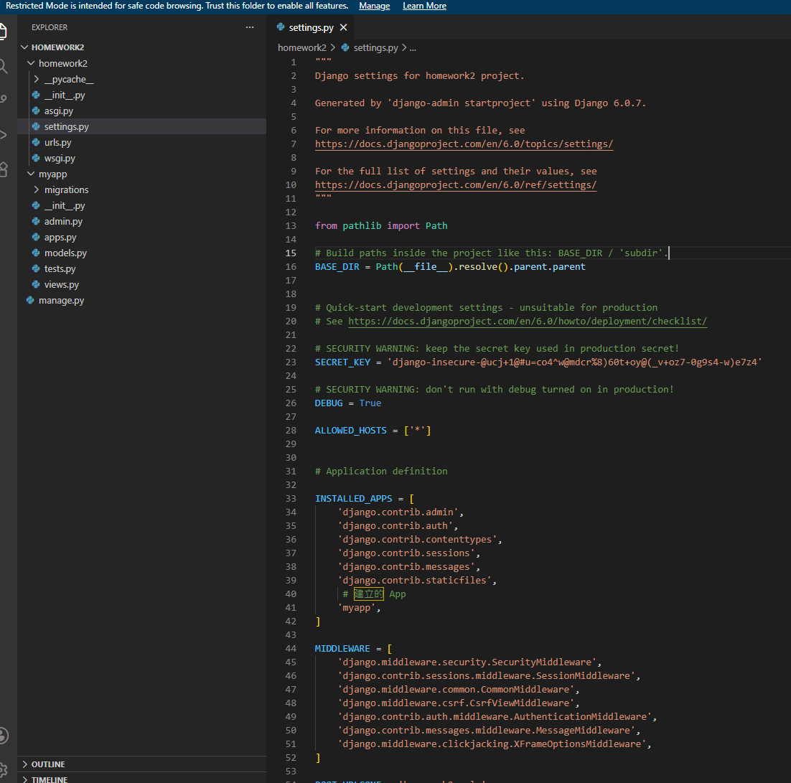
Code:
"""
Django settings for homework2 project.

Generated by 'django-admin startproject' using Django 6.0.7.

For more information on this file, see
https://docs.djangoproject.com/en/6.0/topics/settings/

For the full list of settings and their values, see
https://docs.djangoproject.com/en/6.0/ref/settings/
"""

from pathlib import Path

# Build paths inside the project like this: BASE_DIR / 'subdir'.
BASE_DIR = Path(__file__).resolve().parent.parent

# Quick-start development settings - unsuitable for production
# See https://docs.djangoproject.com/en/6.0/howto/deployment/checklist/

# SECURITY WARNING: keep the secret key used in production secret!
SECRET_KEY = 'django-insecure-@ucj+1@#u=co4^w@mdcr%8)60t+oy@(_v+oz7-0g9s4-w)e7z4'

# SECURITY WARNING: don't run with debug turned on in production!
DEBUG = True

ALLOWED_HOSTS = ['*']

# Application definition

INSTALLED_APPS = [
'django.contrib.admin',
'django.contrib.auth',
'django.contrib.contenttypes',
'django.contrib.sessions',
'django.contrib.messages',
'django.contrib.staticfiles',
# 建立的 App
'myapp',
]

MIDDLEWARE = [
'django.middleware.security.SecurityMiddleware',
'django.contrib.sessions.middleware.SessionMiddleware',
'django.middleware.common.CommonMiddleware',
'django.middleware.csrf.CsrfViewMiddleware',
'django.contrib.auth.middleware.AuthenticationMiddleware',
'django.contrib.messages.middleware.MessageMiddleware',
'django.middleware.clickjacking.XFrameOptionsMiddleware',
]

ROOT_URLCONF = 'homework2.urls'

TEMPLATES = [
{
'BACKEND': 'django.template.backends.django.DjangoTemplates',
'DIRS': [BASE_DIR / 'templates'],
'APP_DIRS': True,
'OPTIONS': {
'context_processors': [
'django.template.context_processors.request',
'django.contrib.auth.context_processors.auth',
'django.contrib.messages.context_processors.messages',
],
},
},
]

WSGI_APPLICATION = 'homework2.wsgi.application'

# Database
# https://docs.djangoproject.com/en/6.0/ref/settings/#databases

DATABASES = {
'default': {
'ENGINE': 'django.db.backends.sqlite3',
'NAME': BASE_DIR / 'db.sqlite3',
}
}

# Password validation
# https://docs.djangoproject.com/en/6.0/ref/settings/#auth-password-validators

AUTH_PASSWORD_VALIDATORS = [
{
'NAME': 'django.contrib.auth.password_validation.UserAttributeSimilarityValidator',
},
{
'NAME': 'django.contrib.auth.password_validation.MinimumLengthValidator',
},
{
'NAME': 'django.contrib.auth.password_validation.CommonPasswordValidator',
},
{
'NAME': 'django.contrib.auth.password_validation.NumericPasswordValidator',
},
]

# Internationalization
# https://docs.djangoproject.com/en/6.0/topics/i18n/

LANGUAGE_CODE = 'zh-Hant'
TIME_ZONE = 'Asia/Taipei'

USE_I18N = True

USE_TZ = True

# Static files (CSS, JavaScript, Images)
# https://docs.djangoproject.com/en/6.0/howto/static-files/

STATIC_URL = 'static/'
STATICFILES_DIRS = [
BASE_DIR / 'static',
]
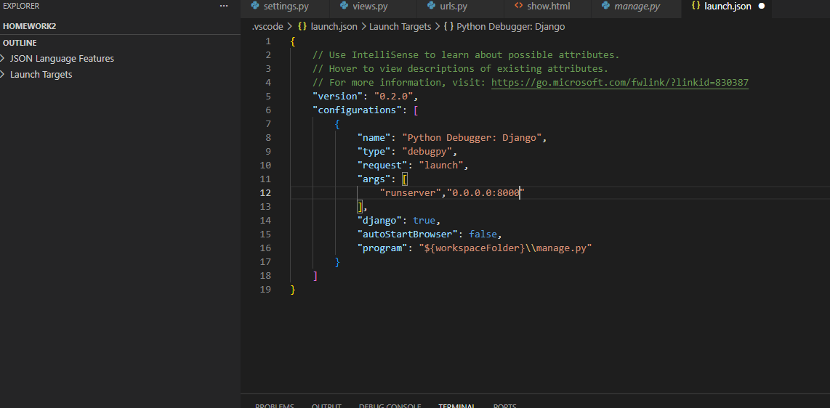
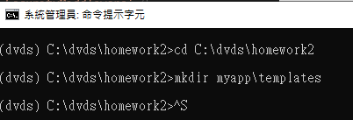
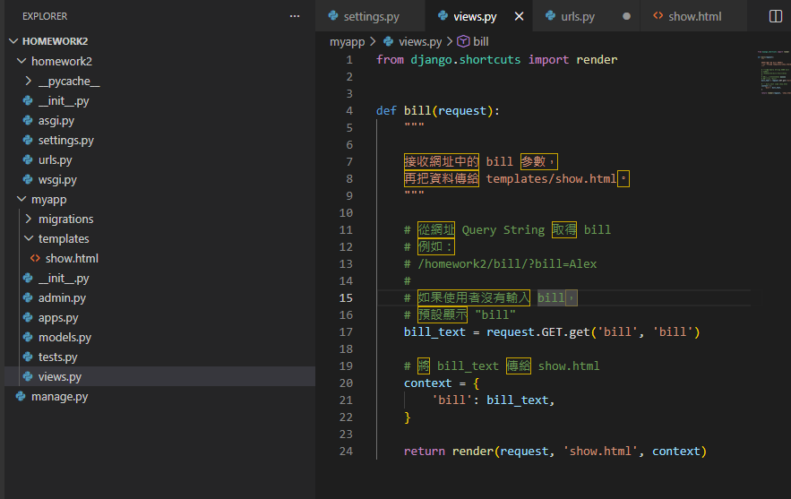

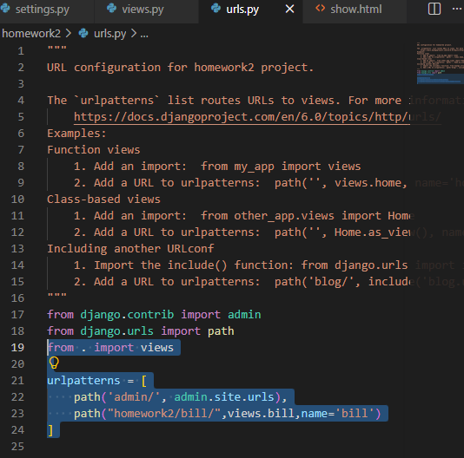

- 同上題，製作url: 192.168.x.x/homework2/bill/
a. 其中bill可以讓使用者輸入字串，並建立templates「show.html」
b. 執行結果如下
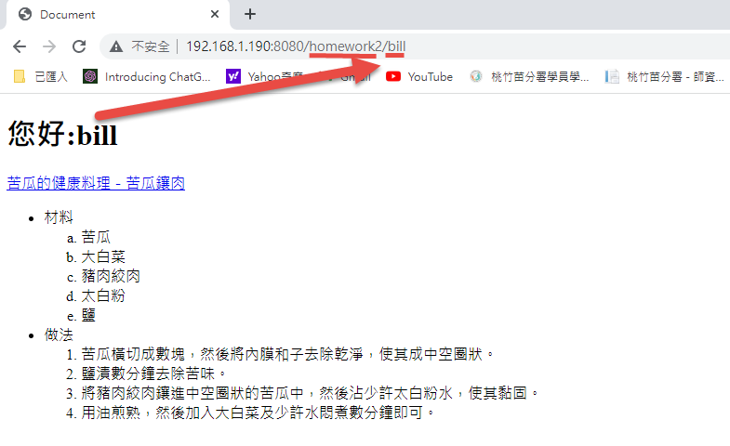
其中，「苦瓜的健康料理－苦瓜鑲肉」，超連結至google
ANS:
<!DOCTYPE html>
<html lang="zh-Hant">

<head>
<meta charset="UTF-8">
<title>苦瓜的健康料理－苦瓜鑲肉</title>
</head>

<body>

<!--

顯示使用者從網址輸入的 bill 字串
-->
<h1>您好:{{ bill }}</h1>

<!--
題目指定：
「苦瓜的健康料理－苦瓜鑲肉」
要超連結到 Google
-->
<p>
<a href="https://www.google.com/"
target="_blank">
苦瓜的健康料理－苦瓜鑲肉
</a>
</p>

<!-- 第二題文字內容 -->
<p>
苦瓜又稱為錦荔枝，因其「實大如鴿子，有皺紋，似荔枝」而得名。
</p>

<h2>材料</h2>

<ul>
<li>苦瓜</li>
<li>大白菜</li>
<li>豬肉絞肉</li>
<li>太白粉</li>
<li>鹽</li>
<li>植物油</li>
</ul>

<h2>做法</h2>

<ol>
<li>
苦瓜橫切成數塊，然後將內膜和子去除乾淨，
使其成中空圈狀。
</li>

<li>
鹽漬數分鐘去除苦味。
</li>

<li>
將豬肉絞肉鑲進中空圈狀的苦瓜中，
然後沾少許太白粉水，使其黏固。
</li>

<li>
用油煎熟，然後加入大白菜及少許水悶煮數分鐘即可。
</li>
</ol>

</body>

</html>

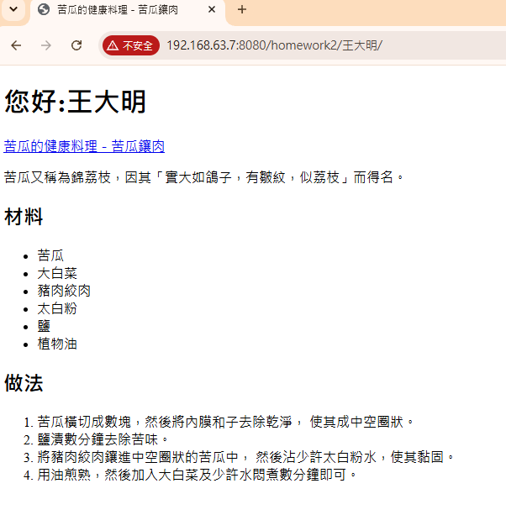
3、樂透號碼顯示(1~5，1組)
a.url:127.0.0.1:8000/lotto1/
b. templates: lotto1.html
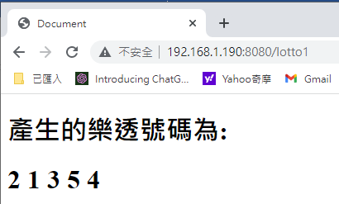
ANS:
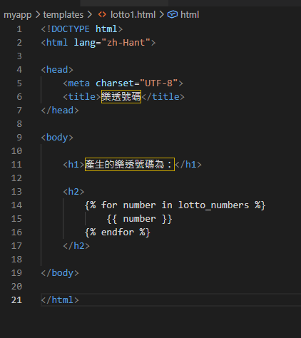
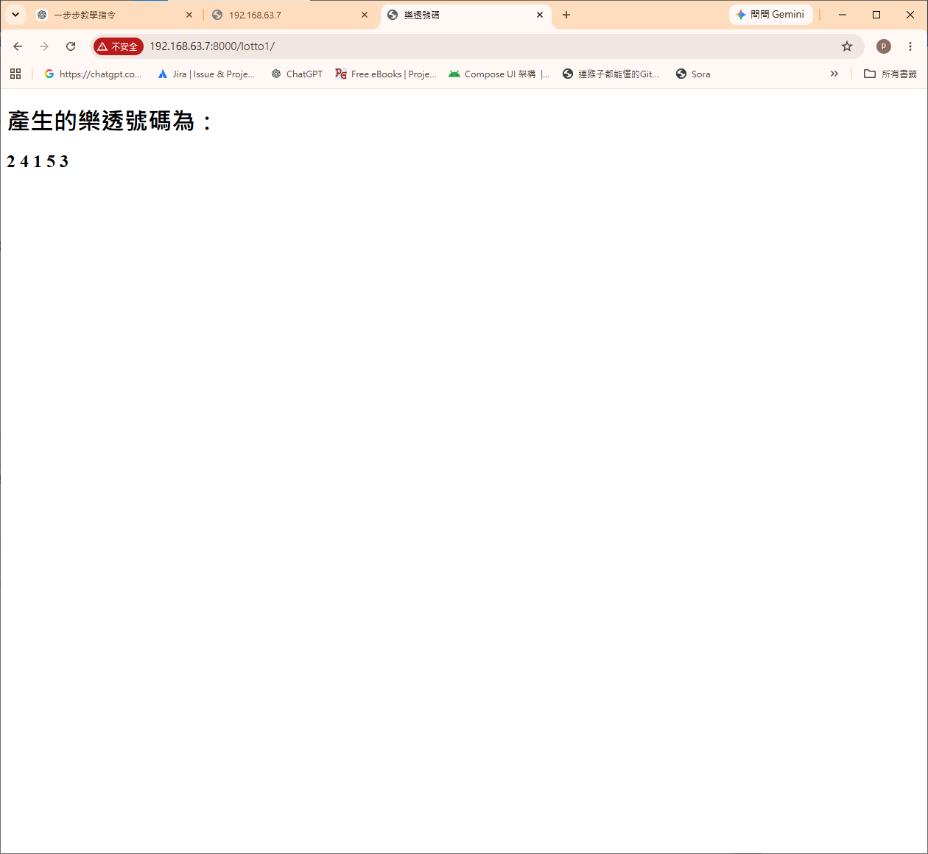

產生亂數提示:
https://blog.csdn.net/weixin_43283397/article/details/99207607
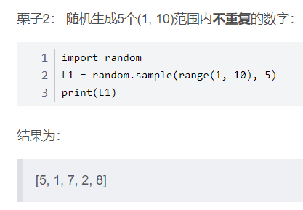

4、樂透號碼顯示(1~42，6組)
a.http://192.168.x.x:8080/lotto2/
b. templates: lotto2.html
ANS:
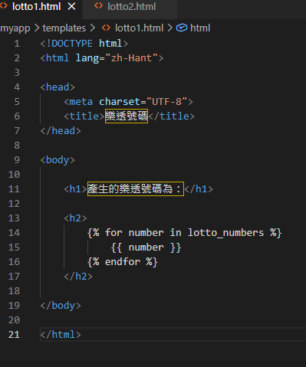
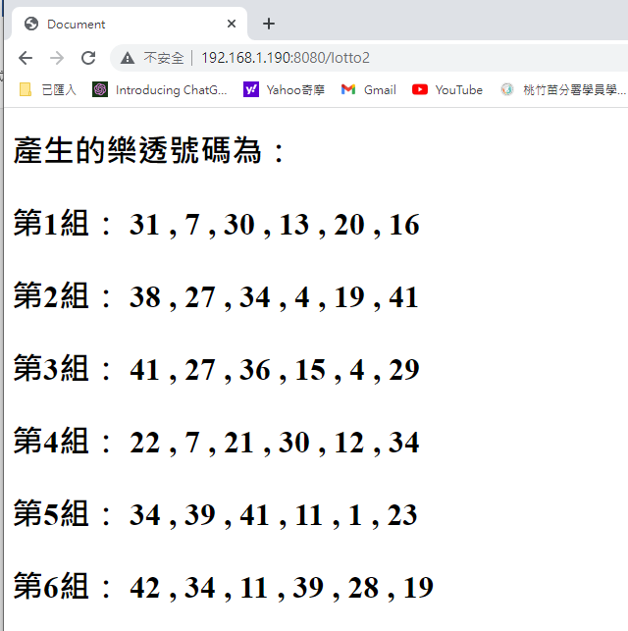
ANS:
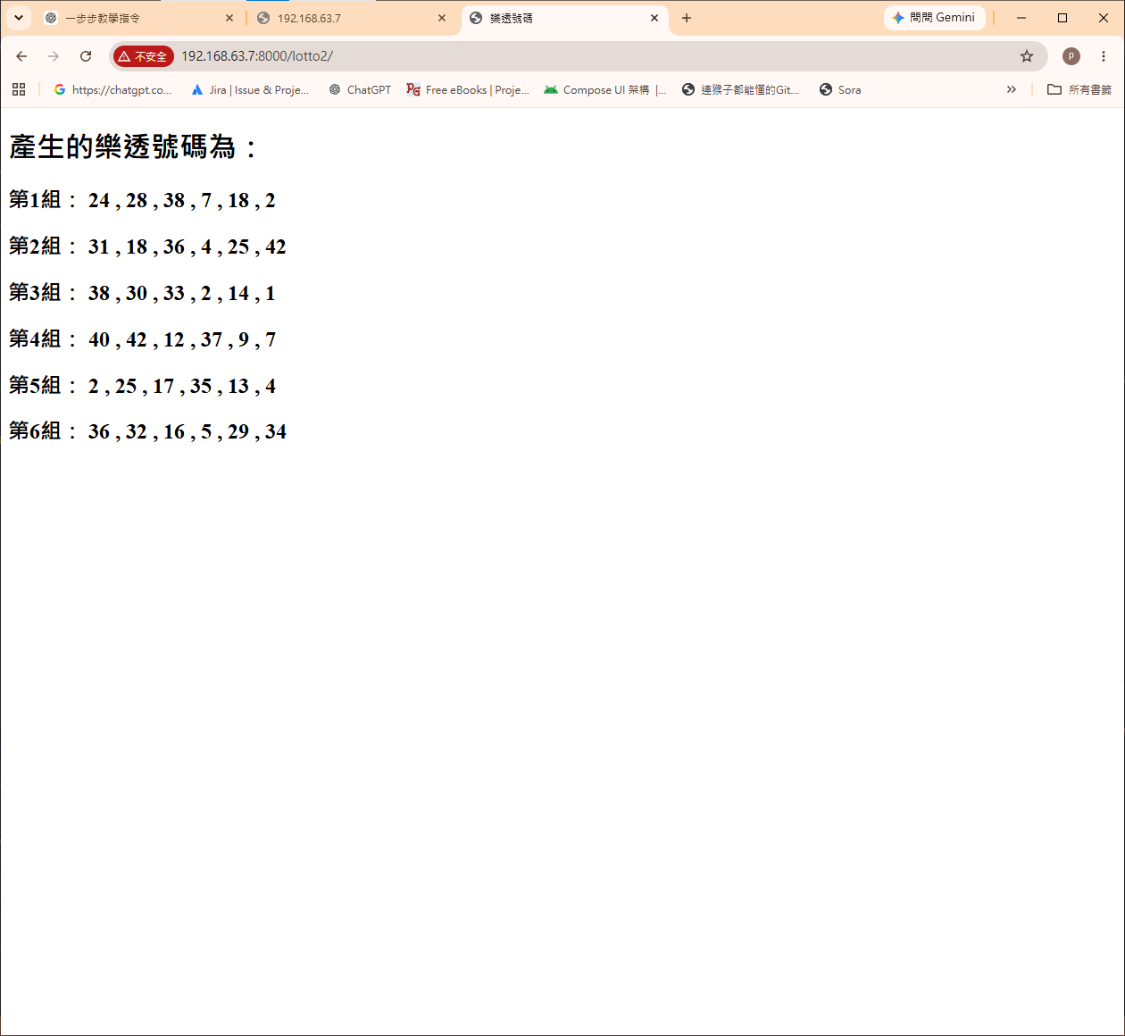
產生亂數提示:
https://blog.csdn.net/weixin_43283397/article/details/99207607

