Software Design Specifications

ReserveIt

# 

# Supervisor

Ubaib Ahmed Chawla

# 

# Fall 2019

# 

# Document History

|  |  |  |  |
| --- | --- | --- | --- |
| **Version** | **Name of Person** | **Date** | **Description of change** |
| 1.0 | Muhammad Fakhar | 26/12/19 | Document Created |
|  |  |  |  |
|  |  |  |  |
|  |  |  |  |
|  |  |  |  |
|  |  |  |  |
|  |  |  |  |

# Distribution List

|  |  |
| --- | --- |
| **Name** | **Role** |
| Ubaib Aftab Chawla | Supervisor |
|  |  |
|  |  |

# Document Sign-Off

|  |  |  |  |  |
| --- | --- | --- | --- | --- |
| **Version** | **Sign-off Authority** | **Project Role** | **Signature** | **Sign-off Date** |
| 1.0 | Ubaib Aftab Chwala | Supervisor |  |  |
|  |  |  |  |  |
|  |  |  |  |  |
|  |  |  |  |  |
|  |  |  |  |  |
|  |  |  |  |  |
|  |  |  |  |  |

# Document Information

|  |  |
| --- | --- |
| **Category** | **Information** |
| Customer | Public |
| Project | ReserveIT |
| Document | Software Design Specification |
| Document Version | 1.0 |
| Status | Draft |
| Author(s) | Muhammad Fakhar, Rajnesh, Haris, Samad |
| Approver(s) | Ubaib Aftab Chawla |
| Issue Date | 26/12/19 |
| Document Location | Karachi |
| Distribution | Arshey Sehar |

# Definition of Terms, Acronyms and Abbreviations

[

|  |  |
| --- | --- |
| **Term** | **Description** |
|  | NA |
|  |  |
|  |  |
|  |  |
|  |  |
|  |  |
|  |  |
|  |  |

# 1. Introduction

## **1.1. Purpose of Document**

This document specifies the general factor like the external interfaces, growth path of the system, user characteristics, functional requirements, dependencies and the risk associate with the tweet creditability meter.

## **1.2. Intended Audience**

The purpose of this project is to Reserve a seat in a restaurant that would provide a convenient way to reserve a seat, this would target the customers who are fond of outing and the restaurant owners.

## **1.3. Document Convention**

* Arial
* 12

## **1.4. Project Overview**

## The people were unable to order a reserve a seat in their desire restaurant and people had to call to the restaurant and ask for reservation. To cover this issue we have created this application.

## **1.5. Scope**

**In scope**

We will develop an android application that would reserve a seat in a restaurant and owner can also register their restaurant.

**Not In Scope**

We will not include IOS application and Desktop application or web application for this project.

# 2. Design Considerations

## **2.1. Assumptions and Dependencies**

We assume that our design will be user friendly in terms of reserve a seat in the restaurant and we assume that all the restaurant had filled their restaurant in the application.

## **2.2. Risks and Volatile Areas**

In case the firebase crashes or google end the support of firebase, this application will become useless.

# 3. System Architecture

## **3.1. System Level Architecture**

First It will check all the selected restaurant and then it will tell the user which time slot they want to reserve a seat and at what seats and a restaurant can fill his maximum of 30 seats only in each time slots.

## **3.2. Software Architecture**

We are using Firebase as a database. The system will fetch and retrieve the information in the firebase database and the detailed description of architecture are shown below.

# 

# 4. Design Strategy

The system will use firebase as a database and it would have different screens and using intend function will call all the function and the detailed diagram are described in next heading.

# 5. Detailed System Design

**Class Diagram**

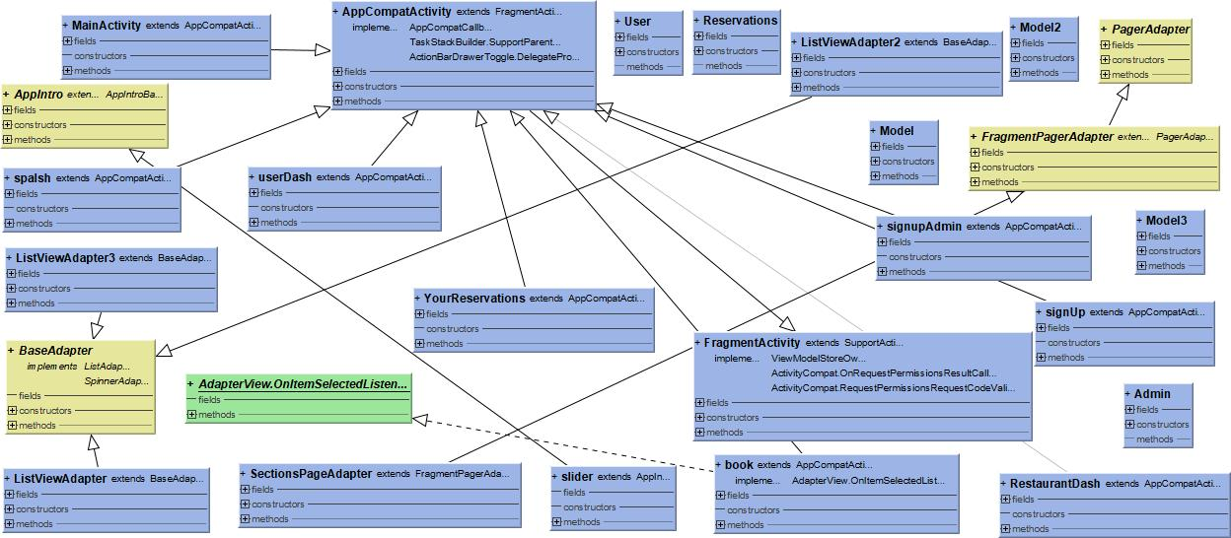

**ER Diagram**

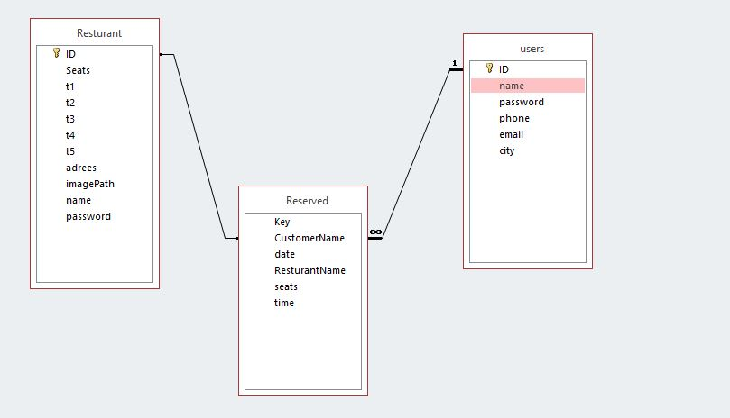

**Use Case Diagram**

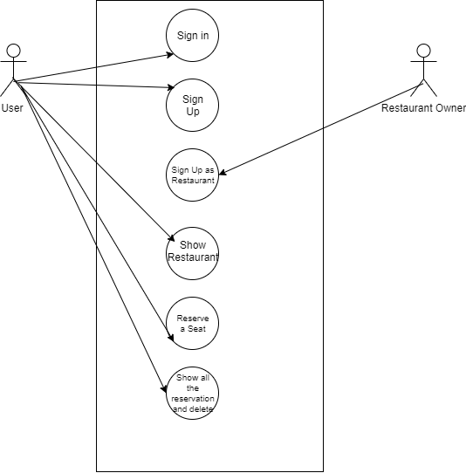

# 6. References

NA

# 7. Appendices

Not applicable