**PROJECT 6 REPORT**

**Introduction**

Project 6 is a Java application designed to facilitate the management of individual person records.

It employs exception handling and file input/output operations for data validation, verification, and storage.

**Functionalities**

**User Input Validation and Verification**

The system ensures that user-provided data, such as first name, last name, street, city, state, zip code, and phone number, is validated and verified before it is stored.

**Random Data Generation**

The project includes functionality to generate random person data, which is useful for testing and demonstration purposes.

**Data Persistence**

The program allows for the storage and retrieval of person data from files, ensuring that the data is retained across program executions.

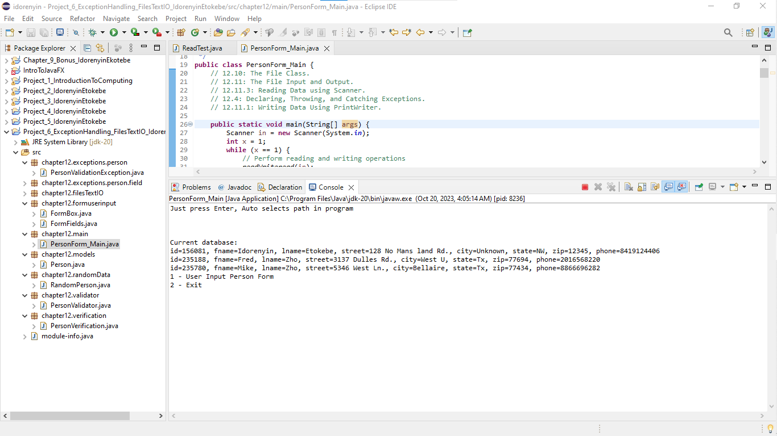

**Exception Handling**

The system incorporates various types of exceptions (e.g., FirstNameValidationException, LastNameValidationException) to handle potential errors during data input and processing.

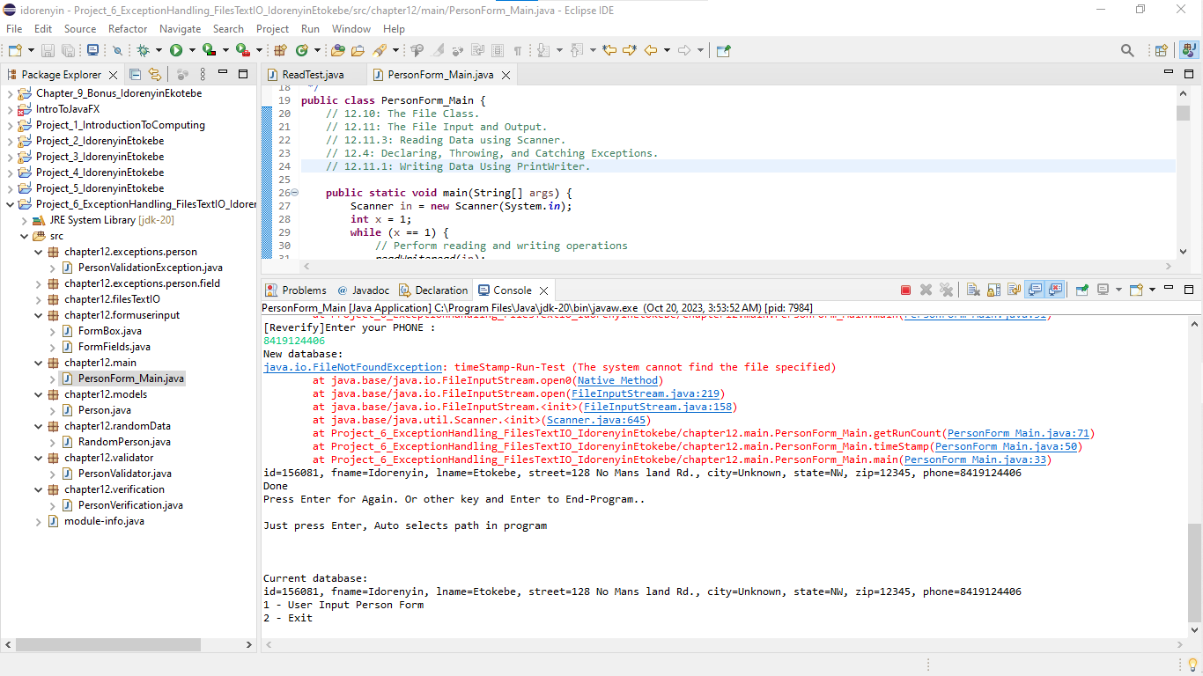

**Purpose**

The purpose of Project 6 is to create a robust java application that manages individual person data effectively.

It enables users to input and store person information while ensuring the data's integrity through validation and verification processes. Additionally, it ensures data is stored persistently.

**Topics**

**Exception Handling:**

The project extensively applies exception handling techniques to deal with potential errors during data input and processing.

This includes throwing and catching custom exceptions for various validation scenarios.

**Files Input and Output:**

The program utilizes the File class, as well as PrintWriter and Scanner, for reading and writing data to and from files.

This allows for data persistence between program runs.

**Interests**

Among the various components of the project, the validation and verification process in the PersonValidator.java and PersonVerification.java classes are particularly intriguing.

The part of the project that interests me the most is the validation process. It demonstrates a robust approach to ensure that the data entered by the user adheres to specified criteria.

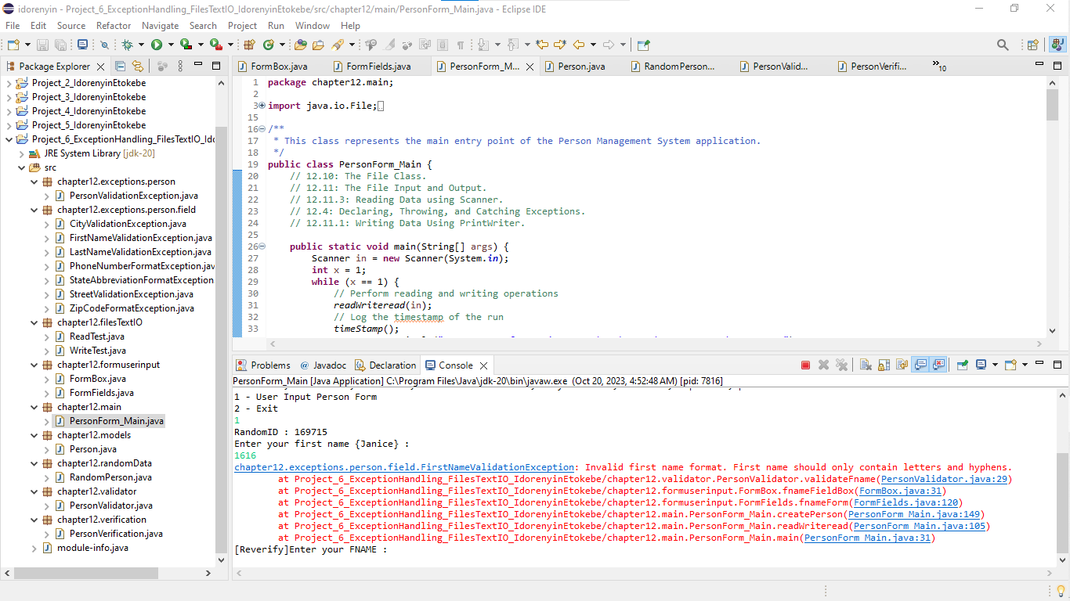

This not only provides a seamless user experience but also ensures the integrity of the stored information.

These classes play a crucial role in ensuring the integrity of the data entered by the user.

**Conclusion**

Project 6 demonstrates the effective implementation of exception handling, file input/output operations, and user data validation and verification in Java Programming. This provides a practical solution for managing individual data while ensuring data integrity through input validation and verification.

The project's functionalities, purpose, and utilization of Chapter 12 topics collectively contribute to its robustness and practicality.