915MHz Antenna Specification
( Model: BY-915-05 )
Serial Number
915MHz Antenna
Jiaxing Beyondoor Electronics Co., Ltd
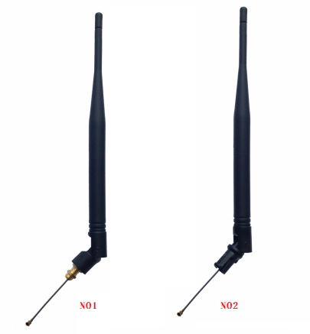
( I ) Product Overview
Frequency（MHz）：915
Bandwidth（MHz）：902,000 to 928,000 MHz (USA ISM band)
VSWR ≤ 2
Gain（dBi）：3
Max Input power（W）：50
Input Impedance（Ω）：50
Polarization：Vertical
Antenna Length（mm）：195
Connector：SMA male/MCX/IPEX/U.FL etc.
Cable length customed
Cable type: customed
( II ) Characteristic curve
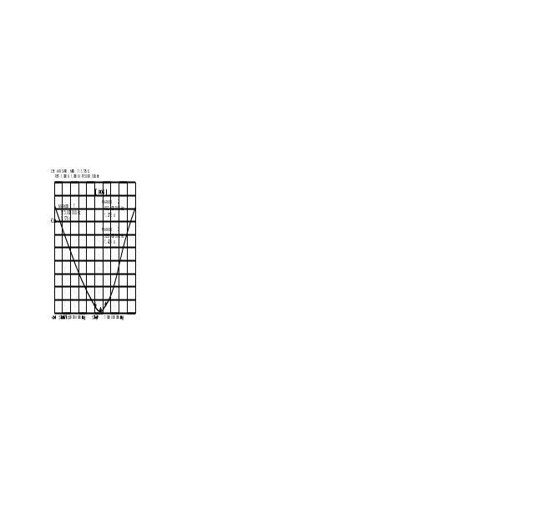
( III ) Mechanical
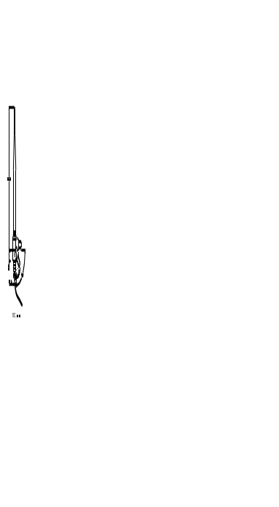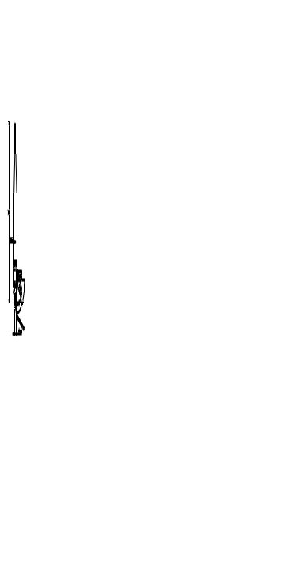 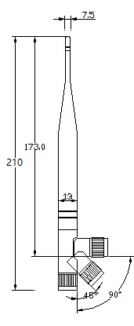 UNIT:mm
( IV )Environmental
Working Temp：-40℃~+85℃
Storage Temp：-45℃~+100℃
Vibration：Sine sweep 1g(0-p)10~50~10Hz each axis
Humidity：Humidity95%~100%RH

