GPS/Glonass Antenna Specification
( Model: BY-GPS-Glonass-10 )
Serial Number
GPS/Glonass Antenna
Jiaxing Beyondoor Electronics Co., Ltd
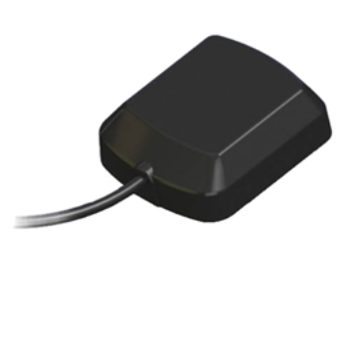
( I ) Product Overview
Dielectric Antenna
Center Frequency（MHz）：1575/1602
VSWR：1.5:1
Bandwidth（MHz）：±5
Impedance（Ω）：50
Peak Gain ＞3dBi Based on 7cm×7cm ground plane
Gain Coverage ＞-4dBi at –90°＜0 ＜+90°(over 75% Volume)
Polarization：RHCP
（ii）LNA/Filter
LNA Gain (Without cable) ：28 dBi Typical
Noise Figure（dB）：2.0
Filter Out Band Attenuation (f0=1575.42 MHz) :40dB Min 1592+/-130MHz ;
VSWR ＜2.0
DC Voltage（V）：2.7 to 5.5v
DC Current（mA）：15Max
（iii）Mechanical
Weight（gram ）＜110
Size（mm）：42×36×13.5
Cable Length（m）：2,3 etc.
Connector：SMA/SMB/SMC/BNC/FME/TNC/MCX/MMCX/FAKRA etc.
Mounting：Magnetic/adhesive
Housing：Black
（iv）Environmental
Working Temp：-40℃~+85℃
Storage Temp：-45℃~+100℃
Vibration：Sine sweep 1g(0-p)10~50~10Hz each axis
Humidity：Humidity95%~100%RH
Weatherproof：100%Waterproof

( II ) Mechanical
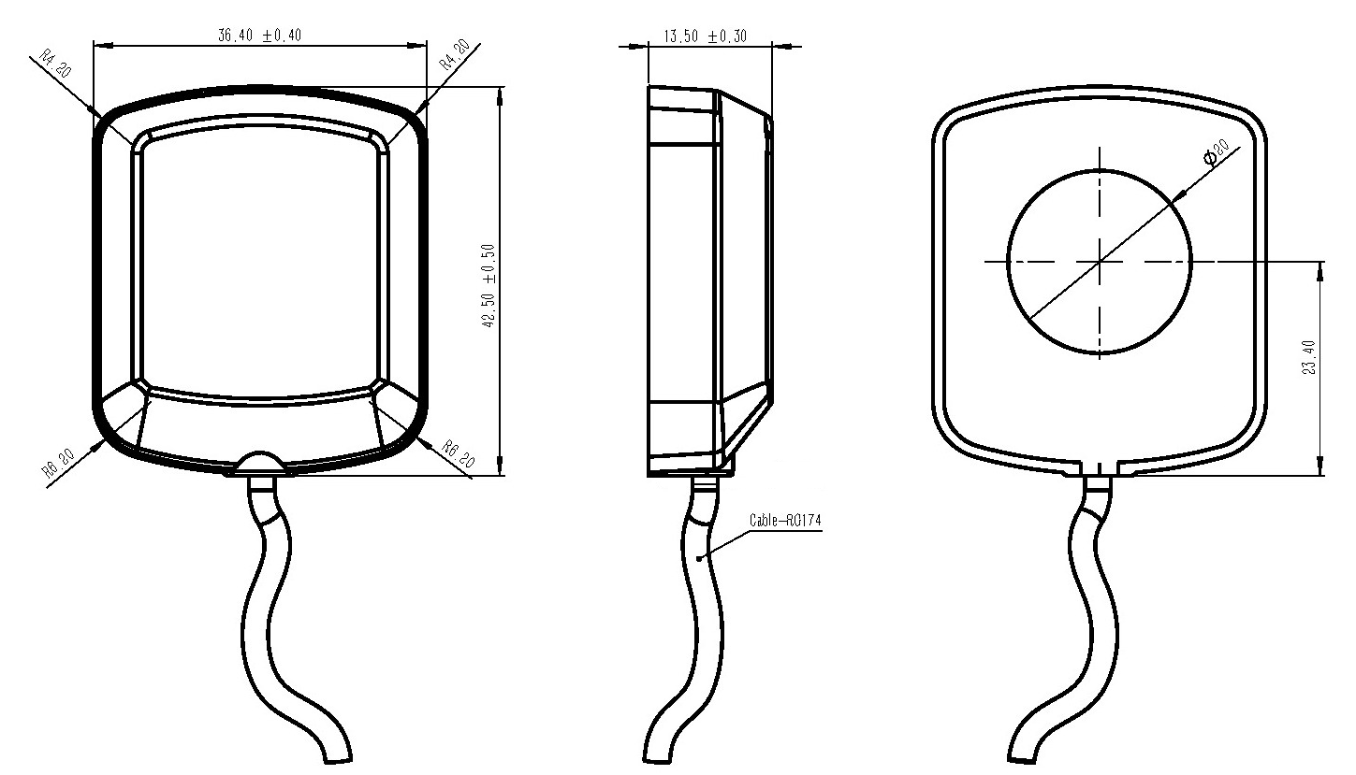

( III ) Characteristic curve

