868MHz Antenna Specification
( Model: BY-868-915-05)
Serial Number
868MHz Antenna
Jiaxing Beyondoor Electronics Co., Ltd
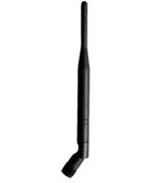
( I ) Product Overview
Frequency（MHz ）：868
VSWR ≤1.5
Gain（dBi）：2.5
Polarization：Vertical
Radiation：Omni
Power（W）：50
Input Impedance（Ω）：50
Antenna Length（mm）：210
Connector：SMA Series
Radome Material：Polyurethane
Radome Color：Black

( II ) Characteristic curve
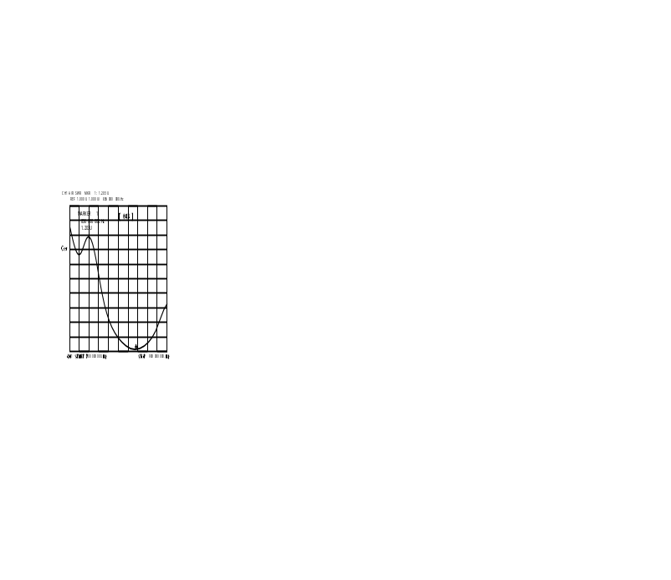
( III ) Mechanical
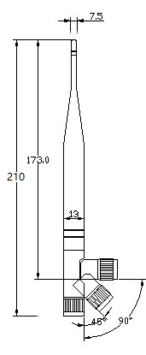 UNIT:mm
( IV )Environmental
Working Temp：-40℃~+85℃
Storage Temp：-45℃~+100℃
Vibration：Sine sweep 1g(0-p)10~50~10Hz each axis
Humidity：Humidity95%~100%RH

