

**Smart Fleet Monitoring System**

**Functional Document**

**Date: August 13, 2020**

Contents

1. Trip Dashboard 3

2. Fleet Dashboard 5

3. Driver Dashboard 7

4. Add Trip 9

5. Add Fleet 11

6. Add Driver 13

## Trip Dashboard

This screen will show KPI’s related to on-going trip with its ID. It will show Current Trip, Vehicle Monitoring, Driver Details, Weather KPIs, and also Alerts related to each trip.

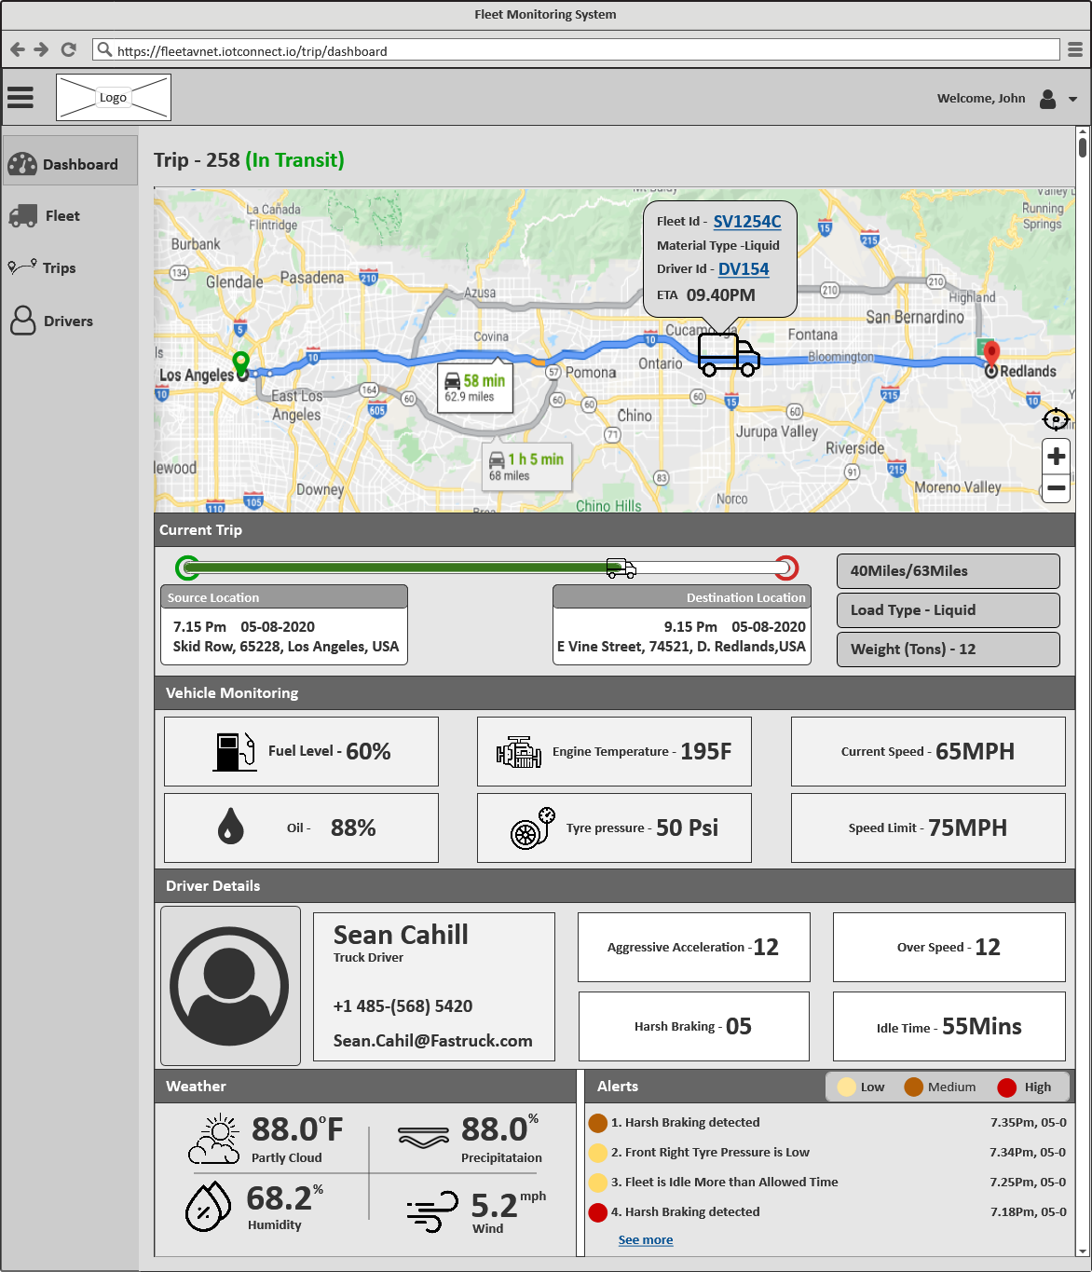

*[Screen 1: Trip Dashboard]*

**Map:** The user will able to view the current trip on the map and able to locate where the fleet is currently with Source and Destination. Clicking on Fleet, the user will able to view the fleet information

**Current Trip:** This KPI will show the statistics related to Current on-going Trip like Trip Progress statistics, Source Location Details (Trip Started Date-Time & Address), Destination Location Details (Trip Ending Date-Time & Address), Fleet Travelled Distance (miles), Load Type, Weight (Tons). All these KPIs will be measured from the GPS tracker.

**Vehicle Monitoring:** This KPI will show the monitored statistics of the fleet like Remaining Fuel Level (%), Remaining Oil (%), Engine Temperature (F), Tire Pressure (Psi), Current Speed (mph), Speed Limit (mph). All these KPIs will be measured from the associated sensors. Sensors will be connected through a gateway and it will send collected data to the system.

**Driver Details:** This KPI will show the driver details like Driver Photo, Driver Name, Driver Type, Phone Number, Email ID, and Driver behavioral details for the current trip like Aggressive Acceleration Count, Harsh Breaking Count, Over Speed Count, and Idle Minute Count. All these KPIs will be measured from the accelerator meter.

**Weather:** This KPI will show the weather details such as Humidity, Humidity, and Precipitation at the fleet's current location. All these KPIs will be measured from GPS.

**Alerts**: This KPI will show the alert details related to the trip with severity (Yellow: Low, Mustard: Medium, Red: High). Clicking on "See More" the user will able to view the list of alerts.

## Fleet Dashboard

This screen will show KPI’s related to the on-going fleet with its ID. It will show Total Trips, Total Fuel Consumption, Maintenance statistics, and Fleet wise KPIs. Also, alerts are related to the fleet.

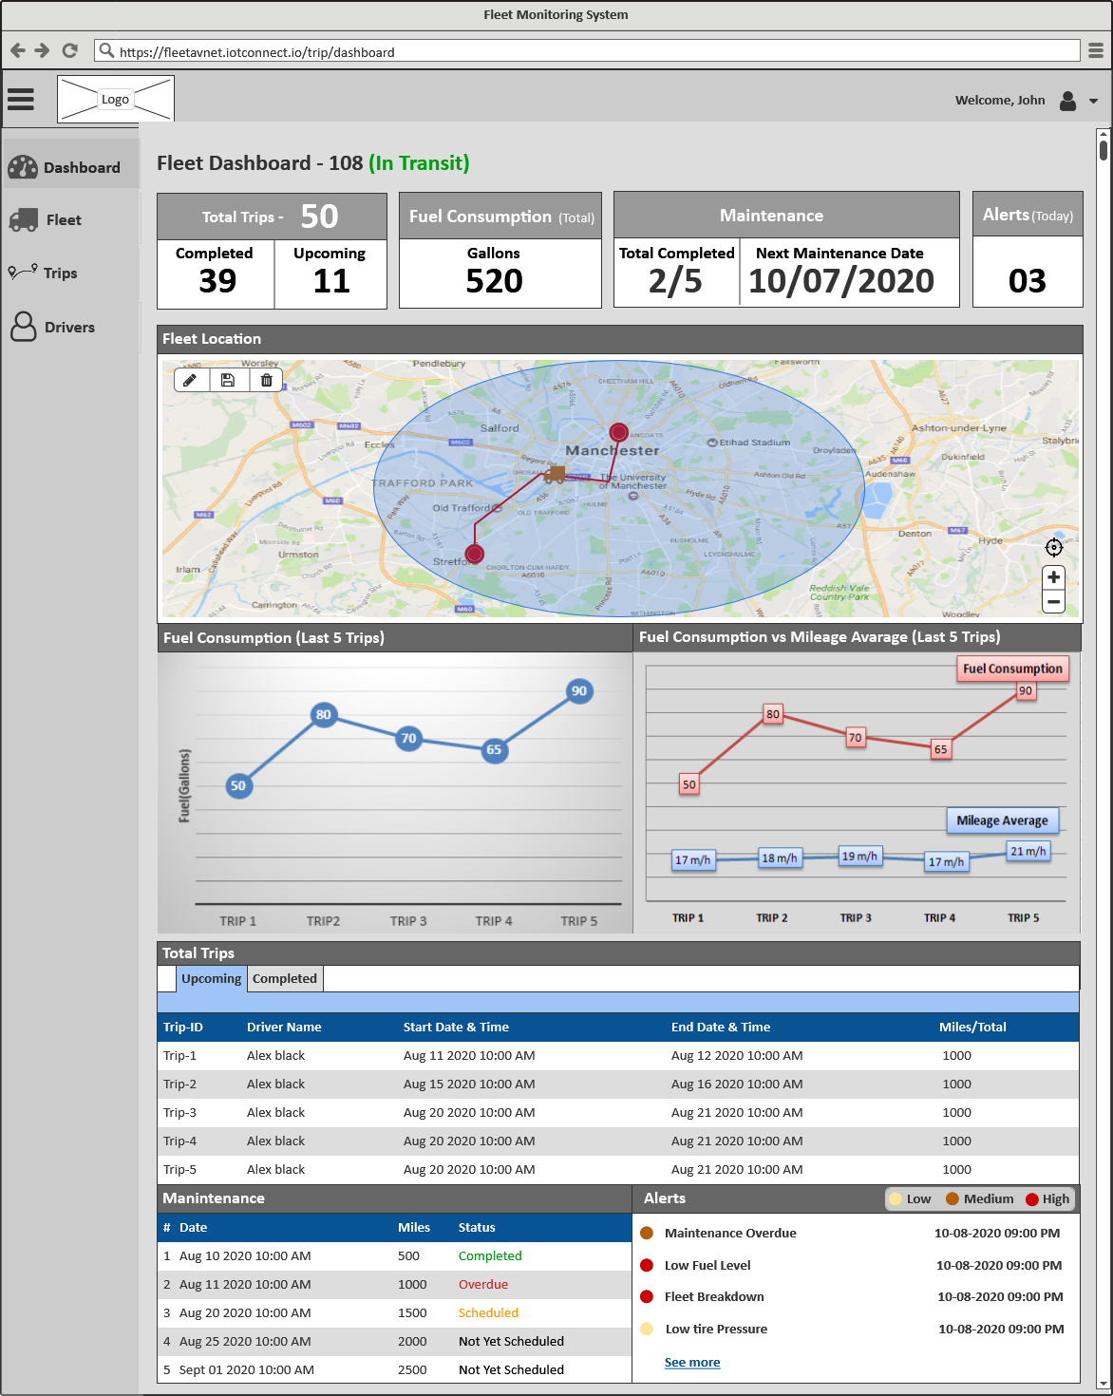

*[Screen 2: Fleet Dashboard]*

**Total Trips:** This KPI will show the total no. of trips conducted by the fleet with Completed and Upcoming Trip Count. Based on the trip status and created trips, the count will display.

**Fuel Consumption:** This KPI will show the statistics related to the total fuel consumption of that fleet. Associated sensors will be connected through a gateway and it will send collected data to the system.

**Maintenance:** This KPI will show the statistics related to the total completed maintenance count and the next maintenance date. Based on the predefined traveled KMs for the fleet, maintenance data will be displayed.

**Alerts**: This KPI will show the total count of today's generated alerts

**Fleet Location:** This KPI will show the current location of the fleet on the map and also able to define the geofence on the map for that fleet. The current location of feet will capture using GPS tracker.

**Last 5 Trips Fuel Consumption:** This KPI will show the fuel consumption for the last 5 trips on the chart. Associated sensors will provide the fuel consumption data w.r.t each trip. Sensors will send Pre and Post fuel consumption data.

**Fuel Consumption vs Mileage Average:** This KPI will show the fuel consumption vs Fleet's average mileage for the last 5 trips on the chart. Mileage will be calculated from the speed maintained by driver and sensors will provide the fuel consumption data based on each trip.

**Total Trips:** This KPI will show the list of upcoming and completed trips by the fleet

**Maintenance:** This KPI will show the list of maintenance overdue, completed and scheduled for the fleet as per completed miles of the fleet

**Alerts**: This KPI will show the alert details related to the fleet (Yellow: Low, Mustard: Medium, Red: High). Clicking on "See More" the user will able to view the list of alerts.

## Driver Dashboard

This screen will show KPI’s related to the driver with ID. It will show Total Trips, incidents, status, and alerts related to the driver.

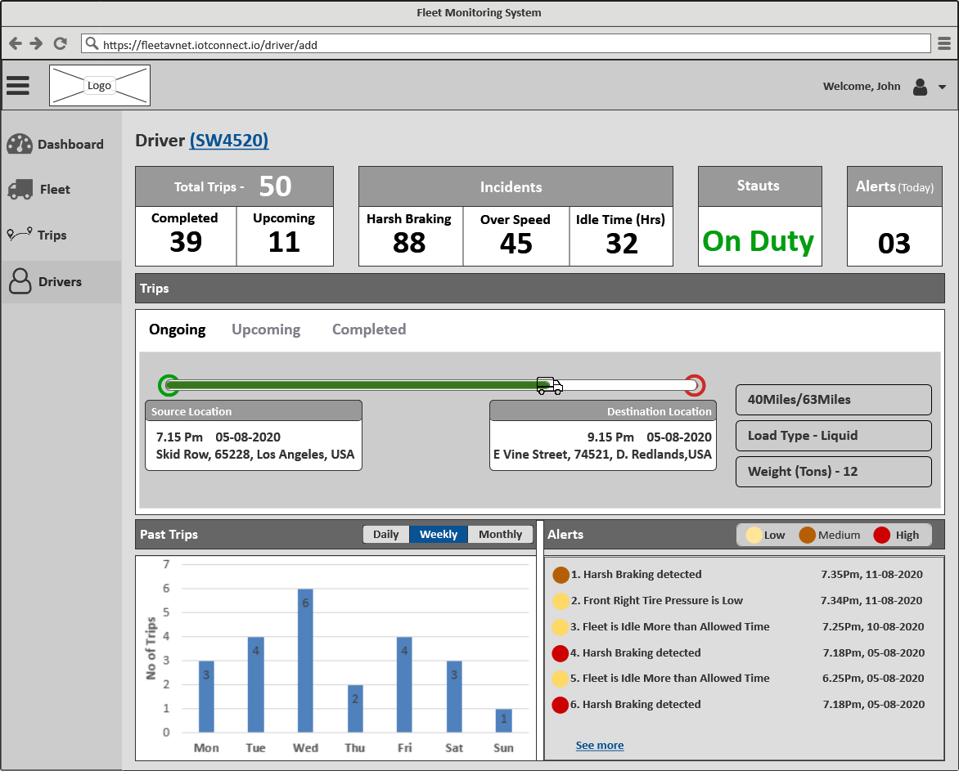

*[Screen 3: Driver Dashboard]*

**Total Trips:** This KPI will show the total no. of trips assigned to the driver with Completed and Upcoming Trip Count. Based on the trip status and created trips, the count will display.

**Incidents:** This KPI will show the statistics related to the incidents like Harsh Braking, Over Speed, and Idle Time (Hrs). All these KPIs will be measured from the accelerator meter.

**Status:** This KPI will show the status of the driver like Off Duty and On Duty. Based on the trip status, driver status will be displayed.

**Alerts**: This KPI will show the total count of today's generated alerts

**Trips:** This KPI will show On-going, upcoming, and Completed trips statistics.

**Past Trips:** This KPI will show the statistics related to Daily, Weekly, and Monthly no. of trips taken by the driver

**Alerts**: This KPI will show the alert details related to the driver (Yellow: Low, Mustard: Medium, Red: High). Clicking on "See More" the user will able to view the list of alerts.

## Add Trip

This screen will allow users to add new trip information.

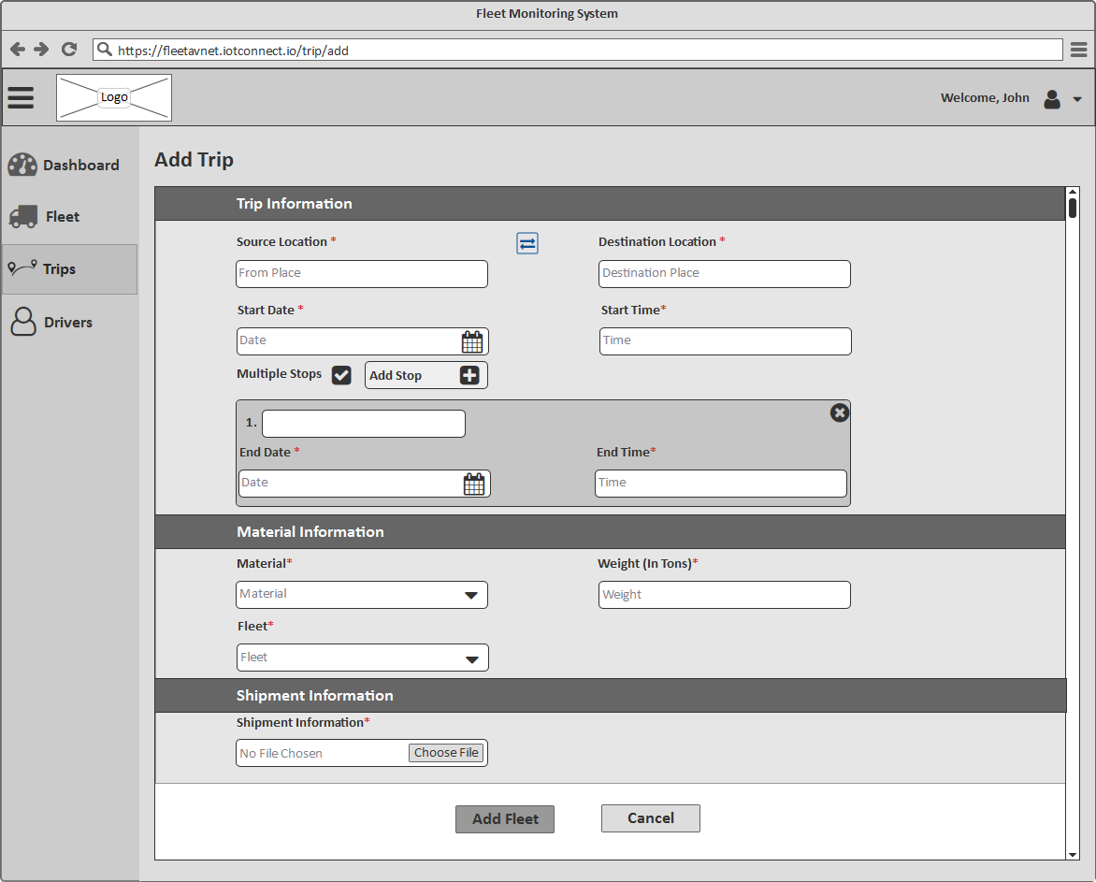

*[Screen 4: Add Trip]*

Trip Information will be divided into 3 sections:

***Trip Information***

**Source Location:** The user will able to enter the source location of the trip

**Destination Location**: The user will able to enter the destination location of the trip

*Note:* Clicking on a reversed icon will reverse the source and destination locations vice versa

**Start Date**: The user will able to select and/or enter the start date of the trip

**Start Time**: The user will able to enter the start time of the trip

**Multiple Stops:** The user will able to mark the checkbox if he/she wants to add multiple stops between Source and Destination location

**Add Stop:** Clicking on it, stop information section will display.

**Stop Location**: The user will able to enter the stop location address

**End Date**: The user will able to select and/or enter the end date of the trip's stop

**End Time**: The user will able to enter the end time of the trip's stop

**Remove:** Clicking on it, the stop section will remove.

***Material Information***

**Material**: The user will able to select the material loaded in the fleet from the dropdown.

**Weight (In Tons)**: The user will able to enter the weight of the material in Tons.

**Fleet**: The user will able to select the fleet used in the trip from the dropdown.

***Shipment Information***

**Shipment Information - Choose File**: The user will able to upload shipment related files like permission, driver license, etc. Uploaded files will display beneath and the user will also able to delete the uploaded file by clicking on the "Cross" icon.

**Add Trip**: Clicking on this button, the application will validate the information added by the user. If the validation is unsuccessful then the appropriate validation message will display else success message will display.

**Cancel**: Clicking on this button will close the page and navigate the user back to Trips listing page

## Add Fleet

This screen will allow users to add new fleet information.

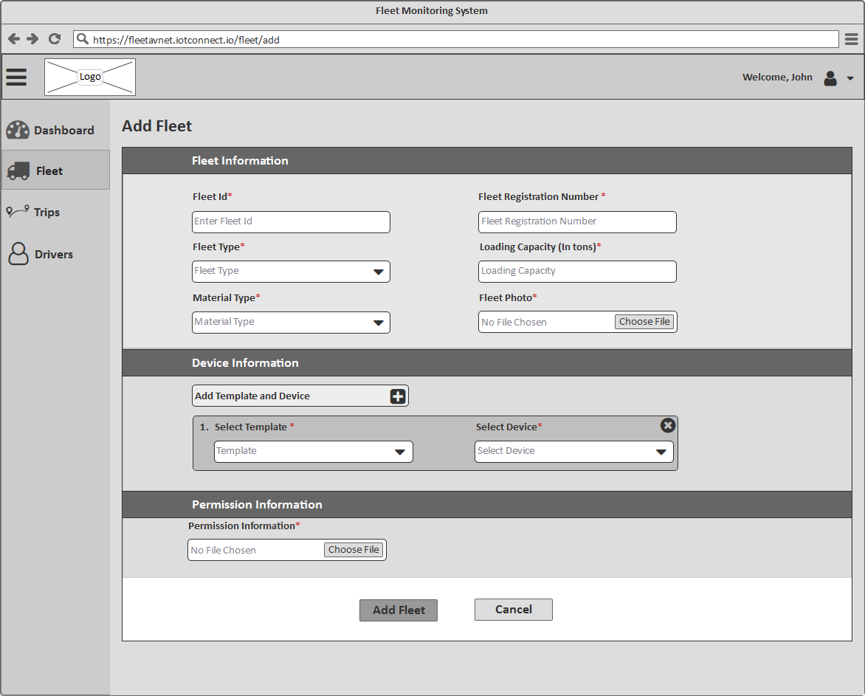

*[Screen 5: Add Fleet]*

Fleet Information will be divided into 3 sections:

***Fleet Information***

**Fleet ID:** The user will able to enter the fleet ID.

**Fleet Registration Number**: The user will able to enter the fleet registration number

**Fleet Type**: The user will able to select the fleet type from the dropdown

**Loading Capacity (In Tons)**: The user will able to enter the loading capacity of the fleet in Tons.

**Material**: The user will able to select the material loaded in the fleet from the dropdown.

**Fleet Photo - Choose File**: The user will able to upload a fleet photo. Uploaded photo will display beneath and the user will also able to delete the uploaded photo by clicking on the "cross" icon.

***Device Information***

**Add Template & Device:** Clicking on it, add device template & device section will open and will able to add multiple devices and templates.

**Select Template**: The user will able to select the template from the dropdown.

**Select Device**: The user will able to select the device from the dropdown.

**Remove**: Clicking on it, add template & device section will remove.

***Permission Information***

**Permission Information - Choose File**: The user will able to upload permission related files of the fleet. Uploaded files will display beneath and the user will also able to delete the uploaded file by clicking on the "cross" icon.

**Add Fleet**: Clicking on this button, the application will validate the information added by the user. If the validation is unsuccessful then the appropriate validation message will display else success message will display.

**Cancel**: Clicking on this button will close the page and navigate the user back to a fleet listing page

## Add Driver

This screen will allow users to add new driver information.

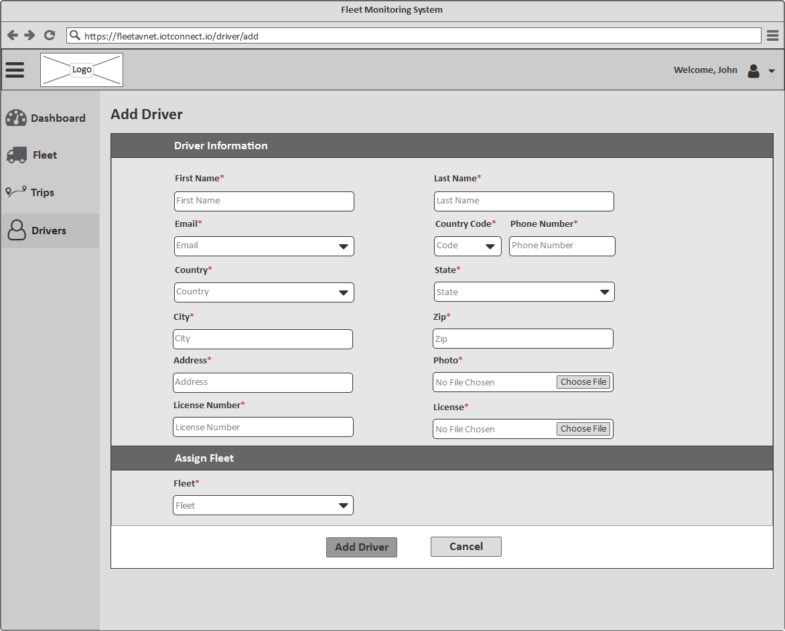

*[Screen 6: Add Driver]*

Driver Information will be divided into 2 sections:

***Driver Information***

**First Name**: The user will able to enter the first name of the driver.

**Last Name**: The user will able to enter the last name of the driver.

**Country Code**: The user will able to select the country code from the dropdown

**Phone Number**: The user will able to enter the phone number of the driver.

**Country**: The user will able to select the country from the dropdown

**State**: The user will able to select the state from the dropdown

**City**: The user will able to enter the city.

**Zip**: The user will able to enter the zip code

**Photo - Choose File**: The user will able to upload photos. Uploaded photo will display beneath and the user will also able to delete the uploaded photo by clicking on the "cross" icon.

**License Number**: The user will able to enter the license number of the driver

**License - Choose File**: The user will able to upload a license photo. Uploaded photo will display beneath and the user will also able to delete the uploaded photo by clicking on the "cross" icon.

***Assign Fleet***

**Fleet**: The user will able to select and assign the fleet to the driver.

**Add Driver**: Clicking on this button, the application will validate the information added by the user. If the validation is unsuccessful then the appropriate validation message will display else success message will display.

**Cancel**: Clicking on this button will close the page and navigate the user back to drivers listing page