**Internet Of Things Network and Virtualization**

Amirhosein Ataei - amirhosein.ataei@mail.polimi.it

**Keywords:**

iot, network, routing, communications, segmentation, server

**Introduction:**

In the new telecom world we will have a lot of devices that want to connect to internet to communicate together trough the net which called iot or ioe.

The iot network consist of vast variety of devices like wearable or outdoor sensor that connect to internet indirect or direct

In these days the statistic of devices that need internet connectivity grow up rocketly than the past such as smart watches, garbage sensors, parking actuators and so on.

To continue we see how this connectivity work

**Network architecture:**

To simulating a simple iot network we need some knowledge about routing such as knowing how routers work and what is a routing table also some knowledge about the routing algorithm and protocols

First of all I want to wire a simple iot network that demonstrate as well in the below picture

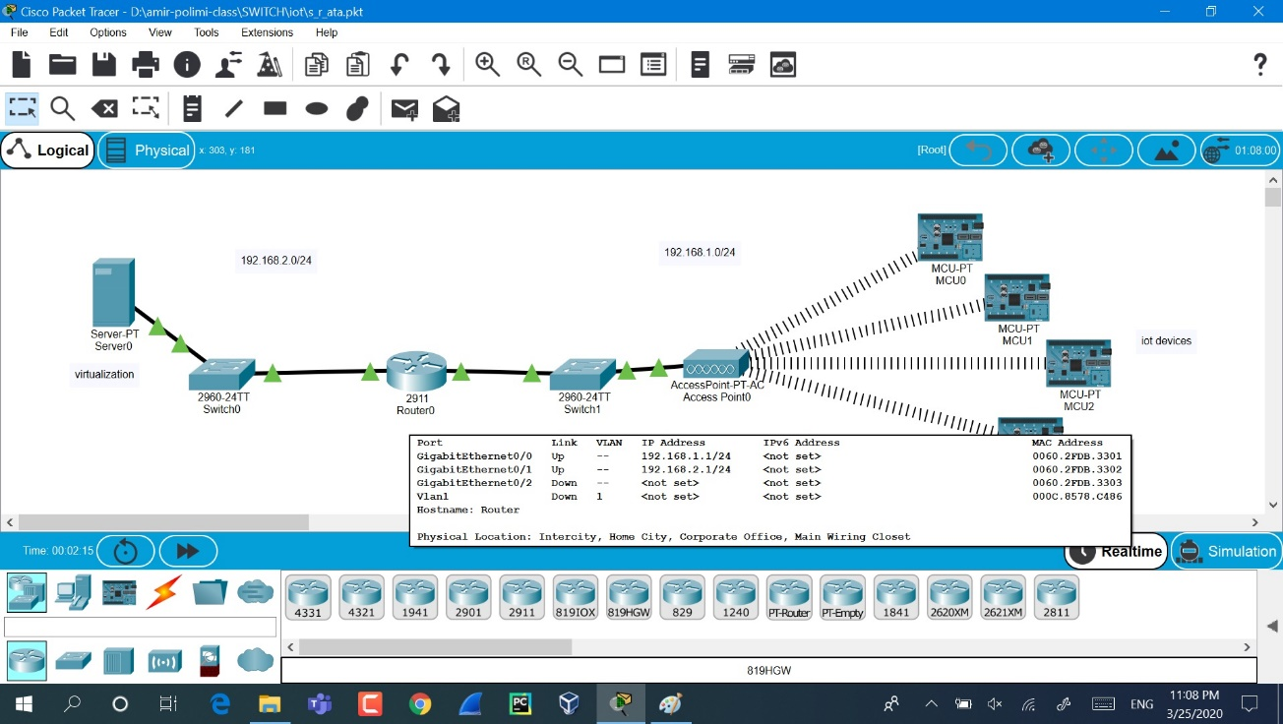

This is a simple simulate in cisco packet tracer software that show us four iot devices such as simple *(Arduino uno wifi)* that connect to an access point with wireless connectivity in range of network 192.168.1.0/24

The address of 192.168.1.0/24 show to us that this is a network address of iot devices and /24 at the end of this ip address say to us that using the first 24 bits of 32 bits for network and we can use 8 bits for the number of devices that in this case equal to 255 devices.

**Routing:**

Routers in the world of networks play an important rule to connect networks together also has a lot of duty such as routing the packets from source to destination

We have some algorithm for routing and nowadays one of the important things for router is the speed of them to finding a best way for routing

In this case we need a router between a two network because we have different address of network in each side

We have two network on of them is the network of devices that demonstrate the right side of the above picture with the address of network 192.168.1.0/24 and one of them is the network of the server side that demonstrate the left of the above picture with address of network 192.168.2.0/24

For configuring the router we should know the commands of router also knowledge about the console terminal

I describe the commands sequently below:

For the side of iot devices network with network address of 192.168.1.0/24, we connect the transit switch cable to the gigether0/0

- Type **en** that is short of **enable** command to get to privileged mode (this gives you more options in configuring the router)  
- Type **config terminal**(or **config t** for short) to access the configuration menu.  
- Type **int** or **interface fastethernet0/0** to access Ethernet0/0 or for gig port type **int** **gigethernet0/0**  
- Type**ip address 192.168.1.0  255.255.255.0**to assign an IP address and [subnet mask](http://learn-networking.com/network-design/how-to-subnet-a-network) to the interface.  
- Type **no shutdown**to open the interface up for business.

For the side of server network with network address of 192.168.2.0/24, we connect the transit switch cable to the gigether0/1

- Type **int** or **interface fastethernet0/0** to access Ethernet0/0 or for gig port type **int** **gigethernet0/0**  
- Type**ip address 192.168.2.0  255.255.255.0**to assign an IP address and [subnet mask](http://learn-networking.com/network-design/how-to-subnet-a-network) to the interface.  
- Type **no shutdown**to open the interface up for business.

for more detail subnet mast give us a mask that say which section is related to net and which one is related to host

finally we can **ping** two network and can see the reply of this command on cmd

**Segmentation:**

To be more specific when we have number of devices connect together in a specific network and we want to connect all of these to another network we need a component like a router or switch to receive all the data from different node and send with one transit link to other networks

This is the general aspect of the networks communication

In this case the access point plays a rule of router in the network side of iot devices and all the devices connect to it wirelessly

Sometimes, we have a lot of devices in the side of users like iot devices

When we have a lot of devices like iot net in the network we should divide the devices geographically and each segment connect to own router separately *(like a cellular connectivity in mobile)*

In this artichecture we have some devices and after that a router also a switch to connect all the router together this time that you see in the above picture

**Hardware:**

Each iot devices consist of connectivity section and processing section also sensor part

Iot devices has a lot of sensors such as luminate sens, proximity, gyroscope, barometer, heart rate and so on to gathering a data from a local environment for processing a specific function

In this case we measure a light with a simple LDR sensor and after that we measure and translate it also prepare a packet with payload of the light level data

The simulation of Arduino uno wifi run in proteus software that for simulating logically the controllers that you can see the measured data in terminal of simulation below

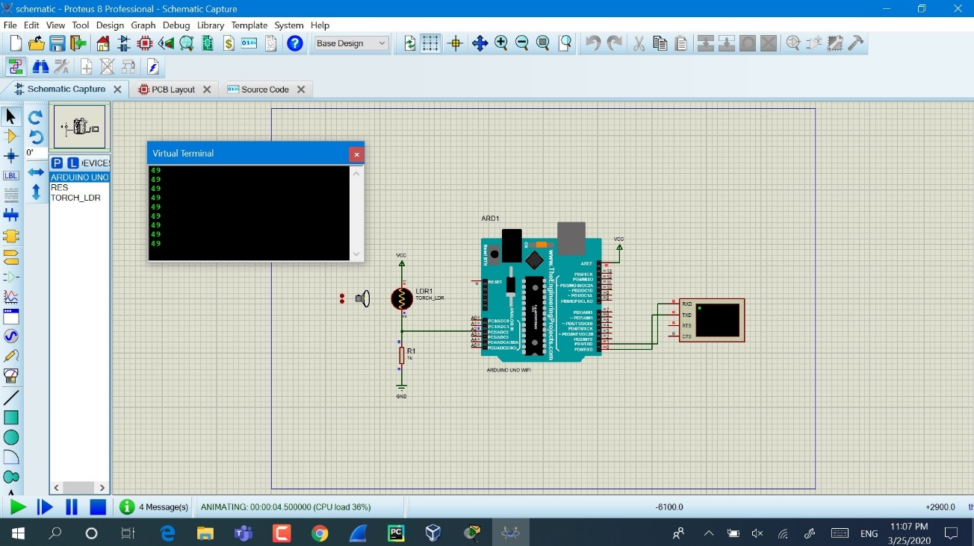

First of all we receive the analog signal from the sensor and send to the ADC section of processor to quantize and translate to digital value, after that we send the data with an tcp package with post method through the internet using onboard wireless component of Arduino to the destination

**Operation system(iot devices):**

there is a lot of important factor for an iot operating system that I described below:

- light weight -> low space need and had a lot of library also low power consumption

- fast response -> high speed algorithm for translating the sensors language for preparing the network packet with compress data for sending with good managing

- flexible -> support protocols and high-level program language also OTP

For example, **tinyos** can be suitable that has all the above parameters

**Server:**

In the server side we have one standard hardware with specific storage and processor also NIC

In this side of network, we want to receive the data from the iot motes and process the data in the server and finally get a solution in a specific function

We can use containerization technic in our server to run each application as a container on a server separately to improve the efficiency and use the hardware resources as wll as possible

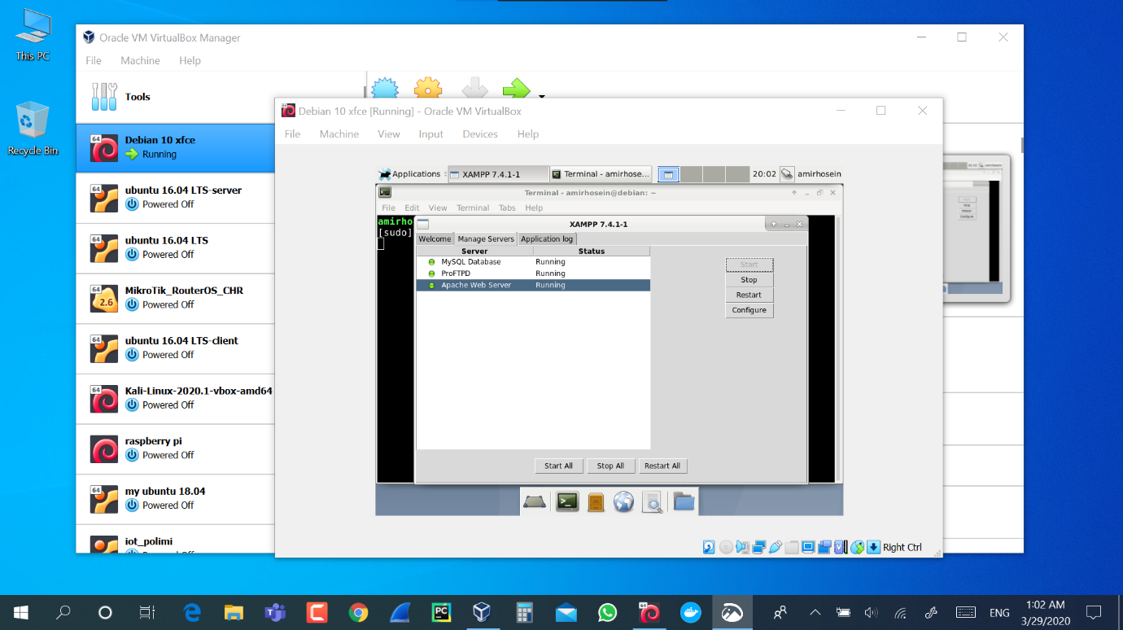

Also the control of the server side be so easier that can remotely modify it

**Software(programming):**

The program of this case written on arduino based on C language that can see below

We can program the new version of the code directly with (Over The air Programming) method with the internet connectivity

We have a serial port for debugging the data that send on the network

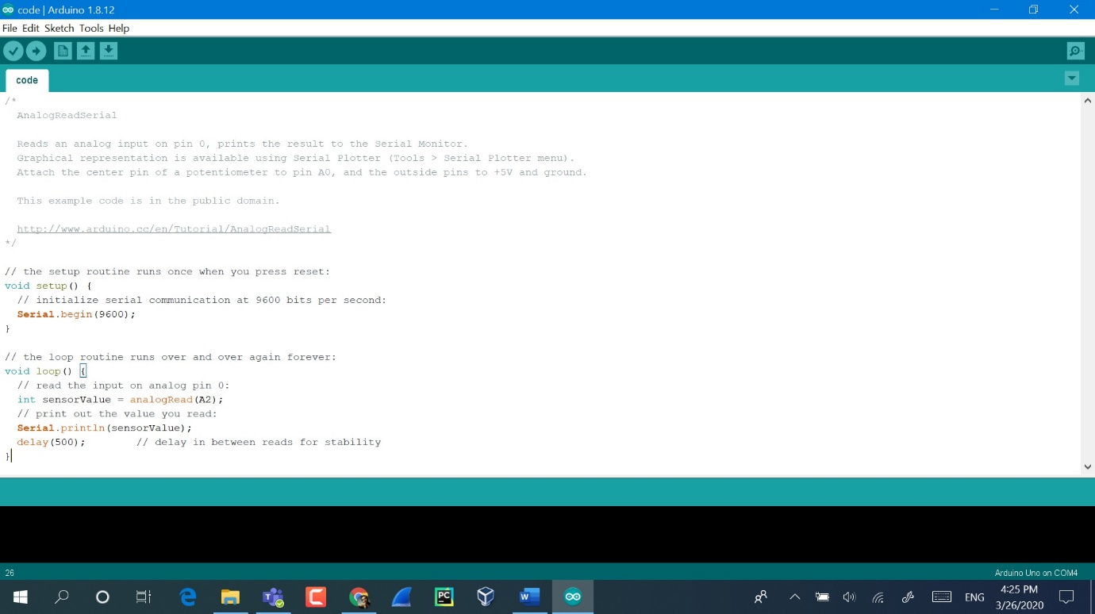

**Conclusion:**

With this note that evaluate it above briefly, we saw the iot system consist of what equipment and how a simple data gather from sensor and finally process it in the server for a specific solution

Finally, we figure out the aspect of virtualization and how much this method can be important for our server and the efficiency.