**I2C**

40 + 41 I2C

unpopulated 0ohms to VPWR

**Thermistor (B57164K103J)**

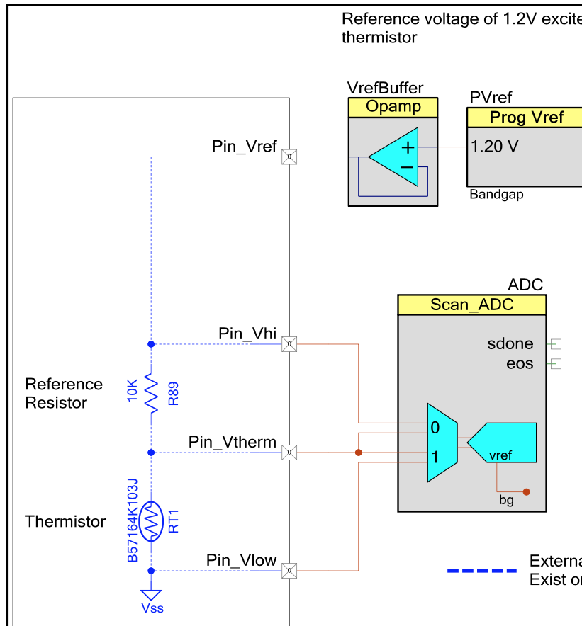

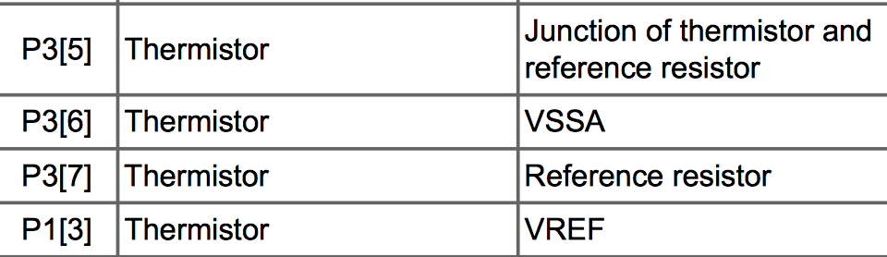

**Humidity HPP801A031**

**P1[5]**

**P1[7]**

**P5[2] CMOD**

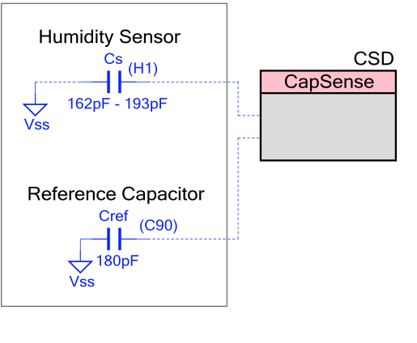

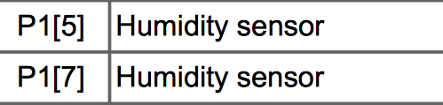

**ALS (Vishay TEMD6200FX01)**

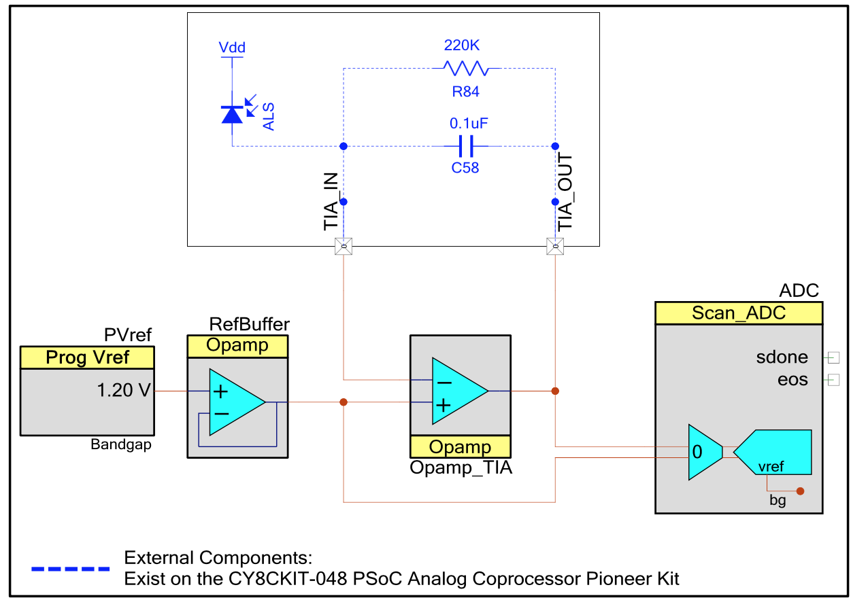

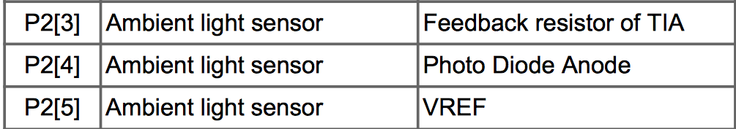

**Capsense buttons**

**Mechanical buttons**

**LEDs**

**5-pin programming header**

P0[0] & P0[1]

**OLED Display**

**Power Supply**

0-ohm power with unpopulated 3 position header

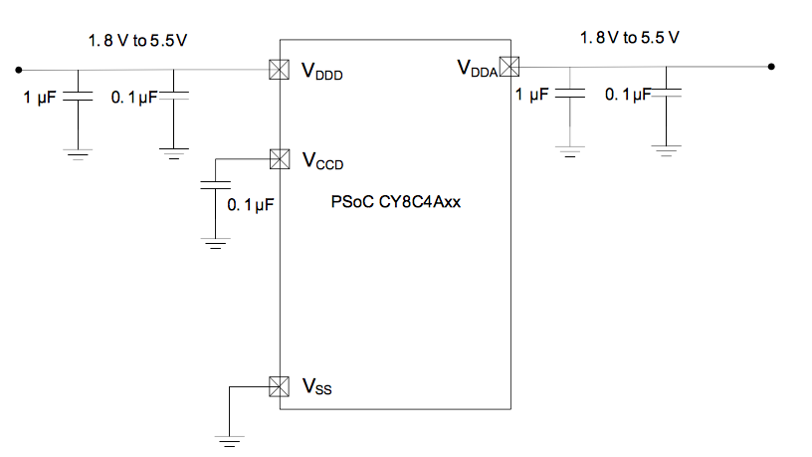

**GPIO 🡪 Digital**