Chapter 4A: The Essential BLE Peripheral Example
After completing chapter 4A you will have all the required knowledge to create the most basic WICED Bluetooth Low Energy Peripheral.
4A.1 WICED BLE System Lifecycle 2
4A.1.1 Turning on the WICED Bluetooth Stack 4
4A.1.2 Start Advertising 5
4A.1.3 Make a Connection 6
4A.1.4 Exchange Data 7
4A.2 Advertising Packets 8
4A.3 Attributes, the Generic Attribute Profile & GATT Database 10
4A.3.1 Attributes 10
4A.3.2 Profiles – Services - Characteristics 11
4A.3.3 Service Declaration in the GATT DB 11
4A.3.4 Characteristic Declaration in the GATT DB 12
4A.4 Bluetooth Configurator 14
4A.4.1 Running the Tool 14
4A.4.2 Generated Code 19
4A.4.3 Editing the Firmware 20
4A.4.4 Testing the Project 22
4A.5 WICED Bluetooth Stack Events 25
4A.5.1 Essential Bluetooth Management Events 25
4A.5.2 Essential GATT Events 25
4A.5.3 Essential GATT Sub-Events 26
4A.6 WICED Bluetooth Firmware Architecture 27
4A.6.1 Turning on the Stack 27
4A.6.2 Start Advertising 28
4A.6.3 Processing Connection Events from the Stack 28
4A.6.4 Processing Client Read Events from the Stack 29
4A.6.5 Processing Client Write Events from the Stack 30
4A.7 WICED GATT Database Implementation 31
4A.7.1 gatt_database[] 31
4A.7.2 gatt_db_ext_attr_tbl 33
4A.7.3 uint8_t Arrays for the Values 34
4A.7.4 The Application Programming Interface 34
4A.8 CySmart 36
4A.8.1 CySmart PC Application 36
4A.8.2 CySmart Mobile Application 39
4A.9 Exercises 40
Exercise - 4A.1 Create a BLE Project with a ModusLED Service 40
Exercise - 4A.2 Add a connection status LED 40
Exercise - 4A.3 Create a BLE Advertiser 42
Exercise - 4A.4 Connect using BLE 44

WICED BLE System Lifecycle
Basically, every book that I have ever read on Bluetooth or WiFi starts with the radio stack and works its way back (or up depending on your point of view) to the Application. You know the drill, 2.4 GHz Digital Spread Spectrum, Adaptive Frequency Hopping, blah blah blah. This approach surfaces a bewildering number of technical issues which have almost nothing to do with building your first system. That approach is cool and everything, and it has stuff which eventually you will need to know, but that is not what we are going to do here. In this chapter I am going to give you the absolute minimum that you need to know to write your first WICED BLE application that a cellphone App can connect with. Before you launch into this chapter please install CySmart (for Android or Apple iOS) from the appropriate App store and also install the PC version of CySmart on your laptop.
All these wireless systems work the same basic way. You write Application (A) Firmware which calls Bluetooth APIs in the Stack (S). The Stack then talks to the Radio (R) hardware which in turn, sends and receives data. When something happens in the Radio, the Stack will also initiate actions in your Application firmware by creating Events (e.g. when it receives a message from the other side.) Your Application is responsible for processing these events and doing the right thing. This basic architecture is also true of Apps running on a cellphone (in iOS or Android) but we will not explore that in more detail in this course other than to run existing Apps on those devices.
There are 4 steps your application firmware needs to handle:
- Turn on the WICED Bluetooth Stack (from now on referred to as "the Stack")
- Start Advertising as connectable
- Process connection events from the stack
- Process read/write events from the stack
Here is the overall picture which I will describe in pieces as we go:
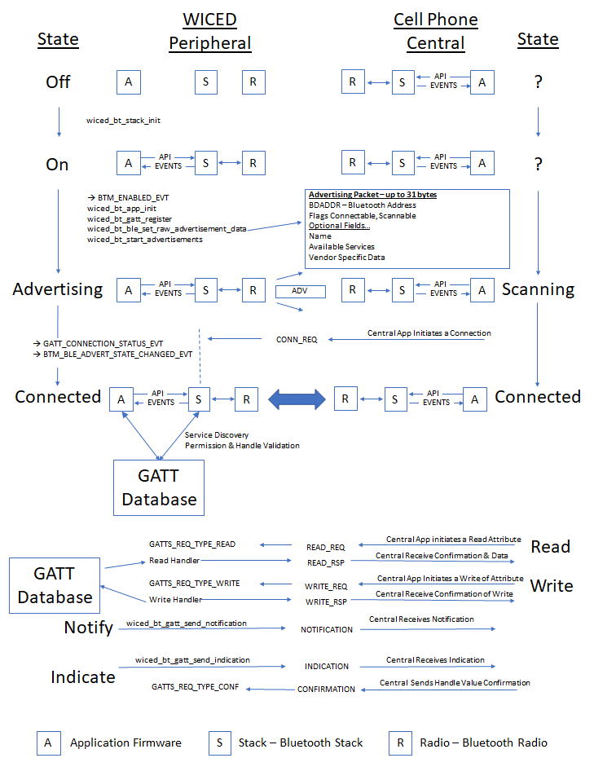

Turning on the WICED Bluetooth Stack
In the beginning, you have a Bluetooth SoC device and a Cell Phone, and they are not connected, the Bluetooth stack state is Off, so that's where we will start.
Like all great partnerships, every BLE connection has two sides, one side called the Peripheral and one side called the Central. In the picture below, you can see that the Peripheral starts Off, there is no connection from the Peripheral to the Central (which is in an unknown state). In fact, at this point the Central doesn't know anything about the Peripheral and vice versa.
From a practical standpoint, the Peripheral should be the device that requires the lowest power – often it will be a small battery powered device like a beacon, a watch, etc. The reason is that the Central needs to Scan for devices (which is power consuming) while the Peripheral only needs to Advertise for short periods of time. Note that the GATT database is often associated with the Peripheral, but that is not required and sometimes it is the other way around.
The first thing you do in your firmware is to turn on BLE. That means that you initialize the Stack and provide it with a function that will be called when the Stack has events for you to process (this is often called the "callback" function for obvious reasons).
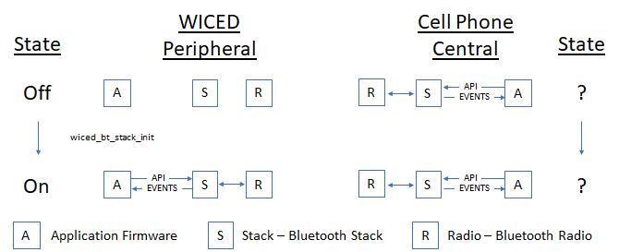

Start Advertising
For a Central to know of your existence you need to send out Advertising packets. The Advertising Packet will contain your Bluetooth Address (BDADDR), some flags that include information about your connection availability status, and one or more optional fields for other information, like your device name or what Services you provide (e.g. Heart Rate, Temperature, etc.).
There are four primary types of Bluetooth Advertising Packets:
- BTM_BLE_EVT_CONNECTABLE_ADVERTISEMENT
- BTM_BLE_EVT_CONNECTABLE_DIRECTED_ADVERTISEMENT
- BTM_BLE_EVT_SCANNABLE_ADVERTISEMENT
- BTM_BLE_EVT_NON_CONNECTABLE_ADVERTISEMENT
When a Scannable Advertising Packet is scanned, the peripheral sends a Scan Response Packet (BTM_BLE_EVT_SCAN_RSP), which contains another 31 bytes of information.
The Stack is responsible for broadcasting your advertising packets at a configurable interval into the open air. That means that all BLE Centrals that are scanning and in range may hear your advertising packet and process it. Obviously, this is not a secure way of exchanging information, so be careful what you put in the advertising packet. I will discuss ways of improving security later.
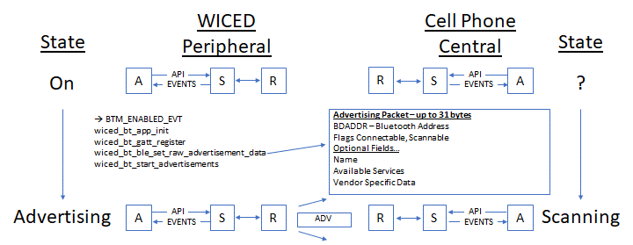
The first item in the advertising packet is called Flags. It tells the remote device how to make a connection by identifying the type of Bluetooth supported (BLE, Classic, BR/EDR) and the way connections are allowed. The packet can also carry extra information, such as the device name, address, role and so on, but it has a maximum size of 31 bytes.
The format of the packet is quite simple. Each item you wish to advertise starts with a length byte, followed by the type (e.g. Flags or Name) and then the data, the size of which is determined by that length byte. The items are simple concatenated together, up to 31 bytes.

Make a Connection
Once a Central device processes your advertising packet it can choose what to do next such as initiating a connection. When the Central App initiates a connection, it will call an API which will trigger its Stack to generate a Bluetooth Packet called a "conn_req" which will then go out the Central's radio and through the air to your radio.
The radio will feed the packet to the Stack and it will automatically stop advertising. You do not have to write code to respond to the connection request, but the Stack will generate two callbacks to your firmware (more on that later).
You are now connected and can start exchanging messages with the central.
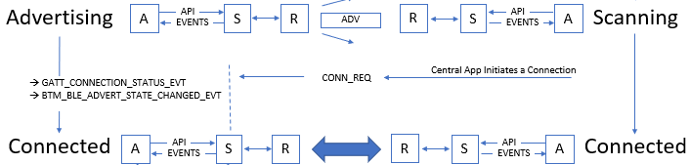

Exchange Data
Now that you are connected you need to be able to exchange data. In the world of BLE this happens via the Attribute Protocol (ATT). The basic ATT protocol has 4 types of transactions: Read & Write which are initiated by the Client and Notify & Indicate which are initiated by the Server.
ATT Protocol transactions are all keyed to a very simple database called the GATT database which typically (but not always) resides on the Peripheral. The side that maintains the GATT Database is commonly known as the GATT Server or just Server. Likewise, the side that makes requests of the database is commonly known as the GATT Client or just Client. The client is typically (but not always) the Central. This leads to the obvious confusion that the Peripheral is the Server and the Central is the Client, so be careful.
You can think of the GATT Database as a simple table. The columns in the table are:
- Handle - 16-bit numeric primary key for the row
- Type - A Bluetooth SIG specified number (called a UUID) that describes the Data
- Data - An array of 1-x bytes
- Permission Flags
I'll talk in more detail about the GATT database in section 4A.7 . With all of that, here is the final section of the big picture.
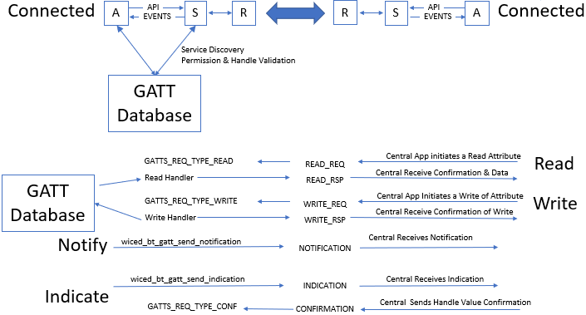

Advertising Packets
The Advertising Packet is a string of 3-31 bytes that is broadcast at a configurable interval. The interval chosen has a big influence on power consumption and connection establishment time. The packet is broken up into variable length fields. Each field has the form:
- Length in bytes (not including the Length byte)
- Type
- Optional Data
The minimum packet requires the <<Flags>> field which is a set of flags that defines how the device behaves (e.g. is it connectable?).
Here is a list of the other field Types that you can add:
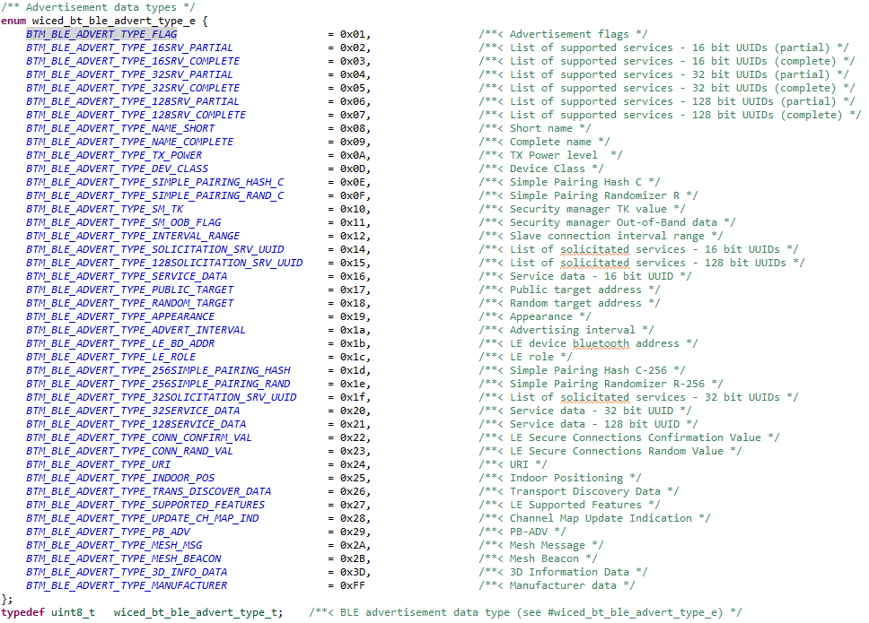
For example, if you had a device named "Kentucky" you could add the name to the Advertising packet by adding the following bytes to your Advertising packet:
- 9 (the length is 1 for the field type plus 8 for the data)
- BTM_BLE_ADVERT_TYPE_NAME_COMPLETE
- 'K', 'e', 'n', 't', 'u', 'c', 'k', 'y'
The WICED Bluetooth API wiced_bt_ble_set_raw_advertisement_data() will allow you to configure the data in the packet. You pass it an array of structures of type wiced_bt_ble_advert_elem_t and the number of elements in the array.
The wiced_bt_ble_advert_elem_t structure is defined as:
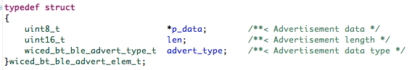
To implement the earlier example of adding "Kentucky" to the Advertising Packet as the Device name I could do this:
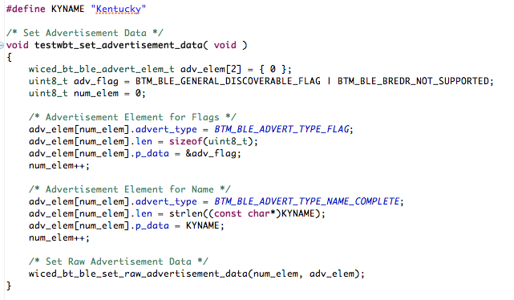
The Advertising packet enables several interesting use cases which we will talk about in more detail in the next chapter.

Attributes, the Generic Attribute Profile & GATT Database

Attributes
As mentioned earlier, the GATT Database is a just a table with up to 65535 rows. Each row in the table represents one Attribute and contains a Handle, a Type, a Value and Permissions.
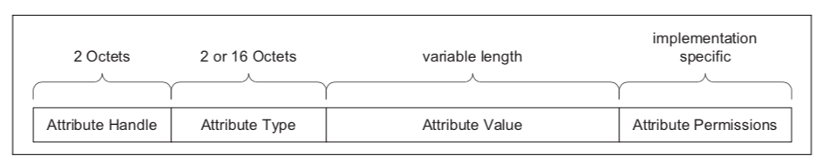
(This figure is taken from the Bluetooth Specification)
The Handle is a 16-bit unique number to represent that row in the database. These numbers are assigned by you, the firmware developer, and have no meaning outside of your application. You can think of the Handle as the database primary key.
The Type of each row in the database is identified with a Universally Unique IDentifier (UUID). The UUID scheme has two interesting features:
- Attribute UUIDs are 2 bytes or 16 bytes long. You can purchase a 2-byte UUID from the SIG for around $5K
- Some UUIDs are defined by the Bluetooth SIG and have specific meanings and some can be defined by your application firmware to have a custom meaning
In the Bluetooth spec they frequently refer to UUIDs by a name surrounded by « ». To figure out the actual hex value for that name you need to look at the assigned numbers table on the Bluetooth SIG website. Also, most of the common UUIDs are inserted for you into the right place by the WICED tools (more on this later).
The Permissions for Attributes tell the Stack what it can and cannot do in response to requests from the Central/Client. The Permissions are just a bit field specifying Read, Write, Encryption, Authentication, and Authorization. The Central/Client can't read the permission directly, meaning if there is a permission problem the Peripheral/Server just responds with a rejection message. WICED helps you get the permission set correctly when you make the database, and the Stack takes care of enforcing the Permissions.

Profiles – Services - Characteristics
The GATT Database is "flat" – it's just a bunch rows with one Attribute per row. This creates a problem because a totally flat organization is painful to use, so the Bluetooth SIG created a semantic hierarchy. The hierarchy has two levels: Services and Characteristics. Note that Services and Characteristics are just different types of Attributes.
In addition to Services and Characteristics, there are also Profiles which are a previously agreed to, or Bluetooth SIG spec'd related, set of data and functions that a device can perform. If two devices implement the same Profile, they are guaranteed to interoperate. A Profile contains one or more Services.
A Service is just a group of logically related Characteristics, and a Characteristic is just a value (represented as an Attribute) with zero, one or more additional Attributes to hold meta data (e.g. units). These meta-data Attributes are typically called Characteristic Descriptors.
For instance, a Battery Service could have one Characteristic - the battery level (0-100 %) - or you might make a more complicated Service, for instance a CapSense Service with a bunch of CapSense widgets represented as Characteristics.
There are two Services that are required for every BLE device. These are the Generic Attribute Service and the Generic Access Service. Other Services will also be included depending on what the device does.
Each of the different Attribute Types (i.e. Service, Characteristic, etc.) uses the Attribute Value field to mean different things.

Service Declaration in the GATT DB
To declare a Service, you need put one Attribute in the GATT Database. That row just has a Handle, A Type of 0x2800 (which means this GATT Attribute is a declaration of a Service), the Attribute Value which in this case is just the UUID of the Service and the Attribute Permission.
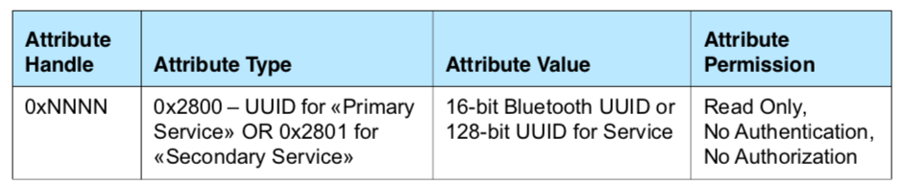
GATT Row for a Service (This figure is taken from the Bluetooth Specification)
For the Bluetooth defined Services, you are obligated to implement the required Characteristics that go with that Service. You are also allowed implement custom Services that can contain whatever Characteristics you want. The Characteristics that belong to a Service must be in the GATT database after the declaration for the Service that they belong to and before the next Service declaration.
You can also include all the Characteristics from another Service by declaring an Include Service.
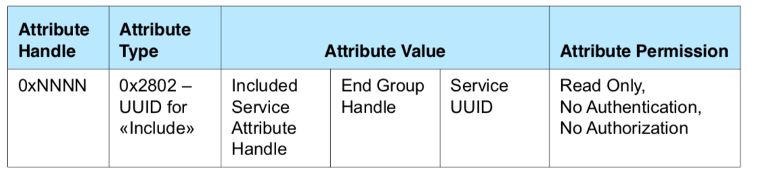
GATT Row for an Included Service (This figure is taken from the Bluetooth Specification)

Characteristic Declaration in the GATT DB
To declare a Characteristic, you are required to create a minimum two Attributes: the Characteristic Declaration (0x2803) and the Characteristic Value. The Characteristic Declaration creates the property in the GATT database, sets up the UUID and configures the Properties for the Characteristic (which controls permissions for the characteristic as you will see in a minute). This Attribute does not contain the actual value of the characteristic, just the handle of the Attribute (called the Characteristic Value Attribute) that holds the value.
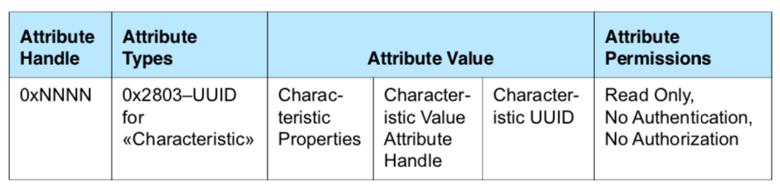
GATT Row for a Characteristic Declaration (This figure is taken from the Bluetooth Specification)
Each Characteristic has a set of Properties that define what the Central/Client can do with the Characteristic. These Characteristic Properties are used by the Stack to enforce access to Characteristic by the Client (e.g. Read/Write) and they can be read by the Client to know what they can do. The Properties include:
- Broadcast – The Characteristic may be in an Advertising broadcast
- Read – The Client/Central can read the Characteristic
- Write Without Response – The Client/Central can write to the Characteristic (and that transaction does not require a response by the Server/Peripheral)
- Write – The Client/Central can write to the Characteristic and it requires a response from the Peripheral/Server
- Notify – The Client can request Notifications from the Server of Characteristic values changes with no response required by the Client/Central. The stack sends notifications from the GATT server when a database characteristic changes.
- Indicate – The Client can ask for Indications from the Server of Characteristic value changes and requires a response by the Client/Central. The stack sends indications from the GATT server when a database characteristic changes and waits for the client to send the response.
- Authenticated Signed Writes – The client can perform digitally signed writes
- Extended Properties – Indicates the existence of more Properties (mostly unused)
When you configure the Characteristic Properties, you must ensure that they are consistent with the Attribute Permissions of the characteristic value.
The Characteristic Value Attribute holds the value of the Characteristic in addition to the UUID. It is typically the next row in the database after the Characteristic Declaration Attribute.
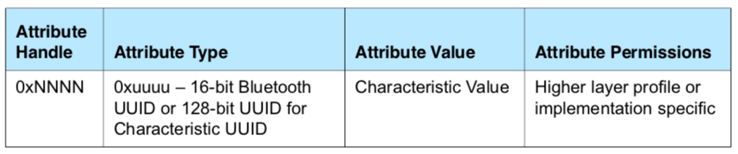
GATT Row for a Characteristic Value (This figure is taken from the Bluetooth Specification)
There are several other interesting Characteristic Attribute Types which will be discussed in the next chapter.

Bluetooth Configurator
Bluetooth Configurator is a tool that will build a semi-customized GATT database and device configuration for Bluetooth Low Energy applications. The generates two files – cycfg_gatt_db.c and cycfg_gatt_db.h.
For this example, I am going to build a BLE project that has one custom service called the “ModusLED” Service with one writable characteristic called "LED". When the Client writes a 0 or 1 (strictly any non-zero value) into that Characteristic, my application firmware will just write that value into the GPIO driving the LED.

Running the Tool
To run the tool, click on Configure Device in the Quick Panel. This opens the Device Configurator, which we used to set up LEDs and PWMs in chapter 2, but it also supports the Bluetooth peripheral. 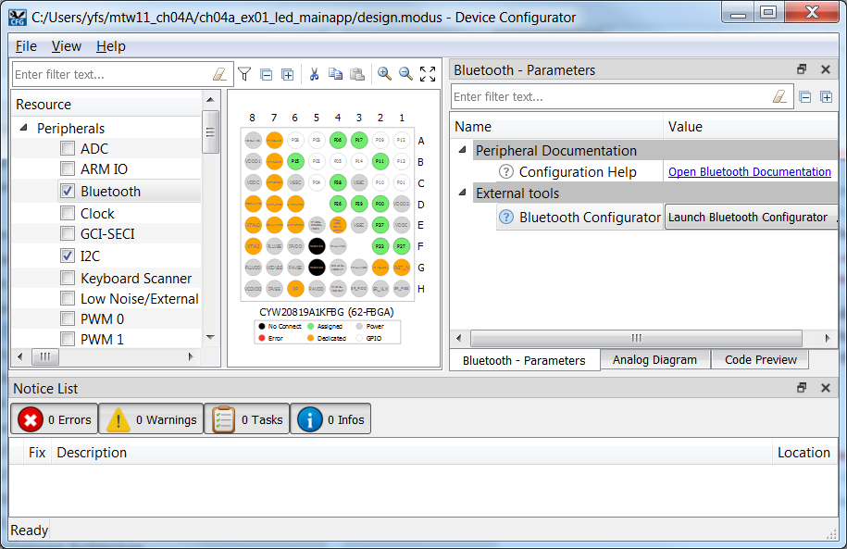
When the Bluetooth checkbox is enabled (it should be already enabled by the BSP) you can click on Launch Bluetooth Configurator… to start the new tool. To avoid situations where edits in one configurator conflict with the other, the Device Configurator becomes disabled while the Bluetooth Configurator is open. Because you launched the tool from the Device Configurator, the device family “20xxx” is pre-selected and displayed in the bottom-right corner.
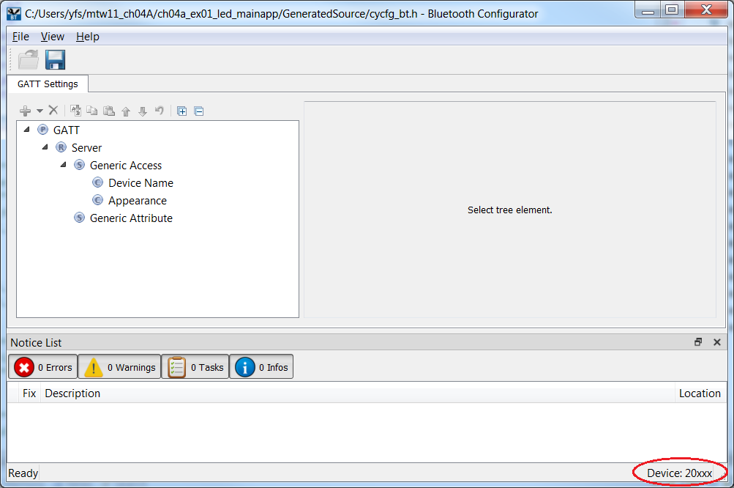
You need to give your device a name and this is done by clicking on the Device Name field and typing into the Value text box. The name is just a string (format “utf8s” per the BLE spec) and, once it is entered you can press “Enter” or click outside of the text box and the tool calculates the string length for you.
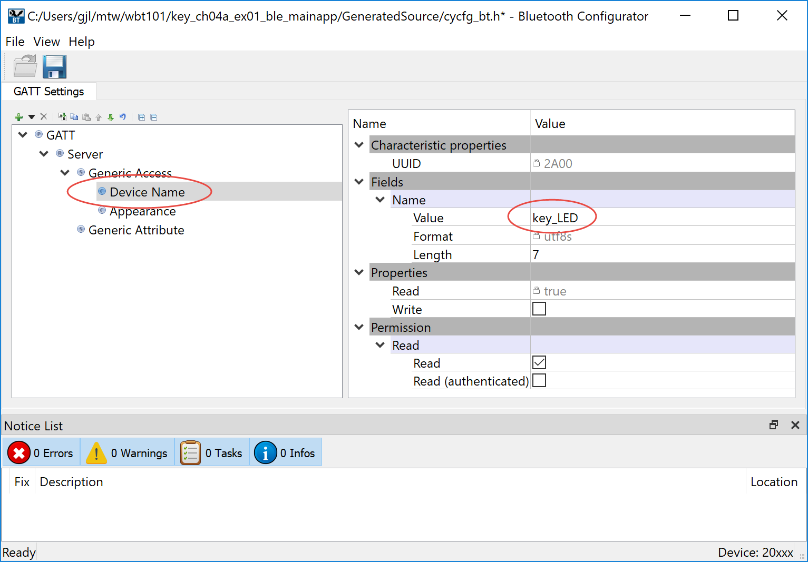
It is important that the name you choose is unique or you will not be able to identify your device when making connections from your cell phone. In this case, I've called the device key_LED. When you do this yourself, use a unique device name such as <inits>_LED where <inits> is your initials.

The next step is to set up a Service. To do this:
- Select Server in the GATT database.
- Right-click and choose Add Service, then select Custom Service (it is near the bottom of the list). A Custom Service entry appears in the GATT database.
- Right-click on the custom service and select Rename. Call the service “ModusLED”.
- The tool will choose a random UUID for this Service, but you could specify your own UUID if desired. For this exercise, just keep the random UUID.
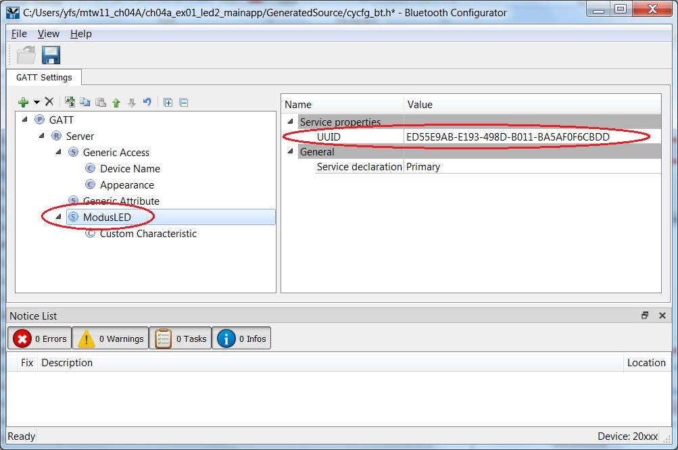

The Service includes a Characteristic, which we are going to use to control the LED. To do this you:
- Right-click on Custom Characteristic under the ModusLED Service and Rename to “LED”.
- Under Fields, optionally provide a name. This name is not used and can be left as-is.
- Change the format from utf8s (which requires a length) to uint8 (which has a length of 1 by definition).
- Change the value of the LED characteristic to 0, which we will take to mean “OFF”. This will be the initial value.
- We want the client to be able to Read and Write this Characteristic, so under Properties, enable Read and Write. Note that the tool makes the corresponding changes to the Permissions section for you, so you don't need to set them unless you need an unusual combination of Properties and Permissions.
- Again, keep the randomly assigned UUID for the Characteristic just like you did for the Service UUID.
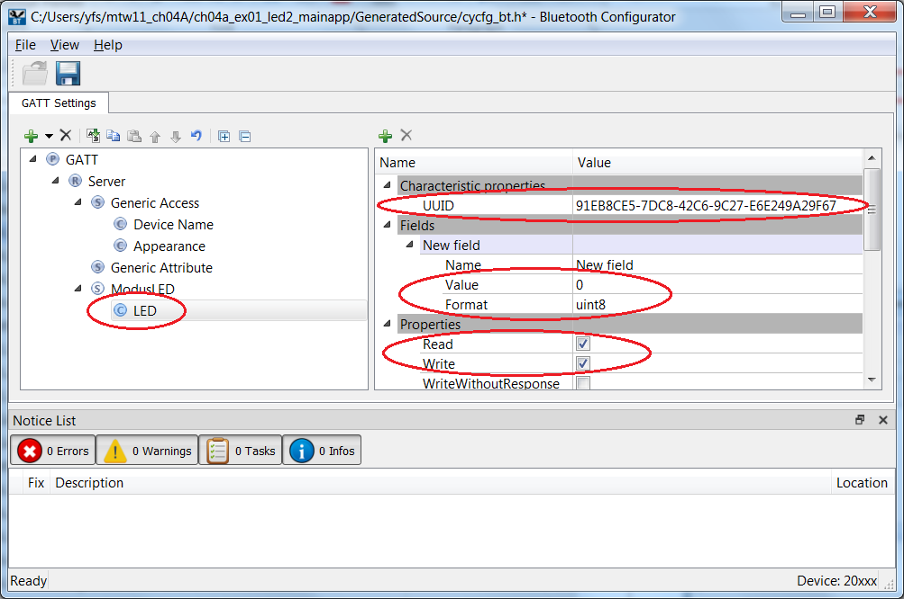
- Click the Save button to generate GATT database code. Note that it is safe to close the configurator and return to it later. The tool generates source code that you should not need to hand-edit and so you can make changes to the setup without breaking your application.
- Close the Bluetooth Configurator and then close the Device Configurator.

Generated Code
The configurator creates two files - cycfg_gatt_db.c and cycfg_gatt_db.h in the GeneratedSource folder of your application. The header file includes the following defines for our ModusLED service and its LED characteristic (app_modusled_led[]).
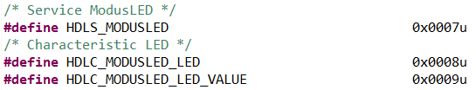
The C source contains the GATT database structure and some global variables like the device name and characteristic value (initialized to 0), which you will use later. Note that the device name is null-terminated because you added 1 to the length in the configurator.
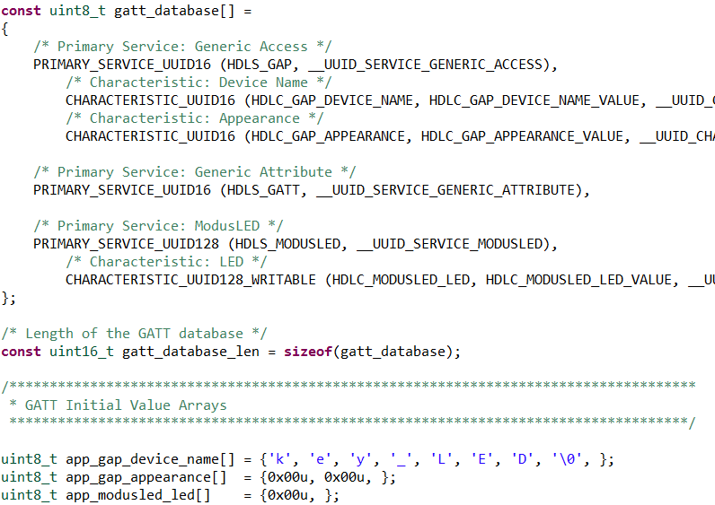

Editing the Firmware
The template for the exercises in this chapter includes a little bit of setup code for the BTM_ENABLED_EVT and some very helpful functions, as follows.
- app_bt_management_callback() is the callback function that you edited in chapter 2. The BTM_ENABLED_EVT code now sets up the Bluetooth Device Address (BDA), the GATT database, and starts advertising for a connection.
- app_gatt_callback() handles GATT events such as connect/disconnect and attribute read/write requests.
- app_set_advertisement_data() creates the advertising packet that includes the device name you will see in the CySmart app.
- app_generate_random_bda() uses the random number generator to create a unique address for the device.
- app_gatt_get_value() searches the GATT database for the requested characteristic and extracts the value. We use this function to read the state of the LED.
- app_gatt_set_value() searches the GATT database for the requested characteristic and updates the value. We use this function to write the state of the LED into the database and, later, notify the central device.
Follow these instructions to control the device behavior. Note that the template sets up the PUART for debugging traces so you can use WICED_BT_TRACE() to better understand how the stack is behaving.
- Start by opening app.c and adding the include for the generated database, as follows:
#include "GeneratedSource/cycfg_gatt_db.h"
- Template code for the BTM_ENABLED_EVT case in app_bt_management_callback() sets up the Bluetooth Device Address when the stack gets enabled. Note that this must be unique to avoid collisions with other devices. The BDA is 6 bytes and is set up by the app_generate_random_bda() function. Make sure you understand how that code works.

- In the BTM_ENABLED_EVT case, add the following lines to set up the GATT database according to your selections in the Configurator:
/* Configure the GATT database and advertise for connections */
wiced_bt_gatt_register( app_gatt_callback );
wiced_bt_gatt_db_init( gatt_database, gatt_database_len );
- Next, I don't want to allow pairing to the device just yet so change the pairable mode from WICED_TRUE to WICED_FALSE:
wiced_bt_set_pairable_mode( WICED_FALSE, WICED_FALSE );
The above will allow you to connect to your device and open the GATT database.
The following edits enable the device to respond to GATT read and write requests.
- Add the following case statement in app_gatt_get_value() to print the state of the LED to the UART. This event will occur whenever the Central reads the LED characteristic. Note that the code uses the GATT database value, not the state of the pin itself, and so non-zero implies “on” and zero means “off”.
// TODO: Add code for any action required when this attribute is read
switch ( attr_handle )
{
case HDLC_MODUSLED_LED_VALUE:
WICED_BT_TRACE( "LED is %s\r\n", app_modusled_led[0] ? "ON" : "OFF" );
break;
}
- In app_gatt_set_value(), notice how the template function automatically updates the GATT database with a call to memcpy(). There is no need to write to the app_modusled_led array.
// Value fits within the supplied buffer; copy over the value
app_gatt_db_ext_attr_tbl[i].cur_len = len;
memcpy(app_gatt_db_ext_attr_tbl[i].p_data, p_val, len);
res = WICED_BT_GATT_SUCCESS;

- Add the following case statement in app_gatt_set_value() to update the LED and printout the result. This event will occur whenever the Central writes the LED characteristic. We are going to use LED_2 for this example. Note that the LEDs on the kit are active low so the pin is set to the NOT of the value.
// TODO: Add code for any action required when this attribute is written
// For example, you may need to write the value into NVRAM if it needs to be persistent
switch ( attr_handle )
{
case HDLC_MODUSLED_LED_VALUE:
wiced_hal_gpio_set_pin_output( WICED_GPIO_PIN_LED_2, app_modusled_led[0] == 0 );
WICED_BT_TRACE( "Turn the LED %s\r\n", app_modusled_led[0] ? "ON" : "OFF" );
break;
}

Testing the Project
Start up a UART terminal, then build and program target. When the application firmware starts up you see some messages.
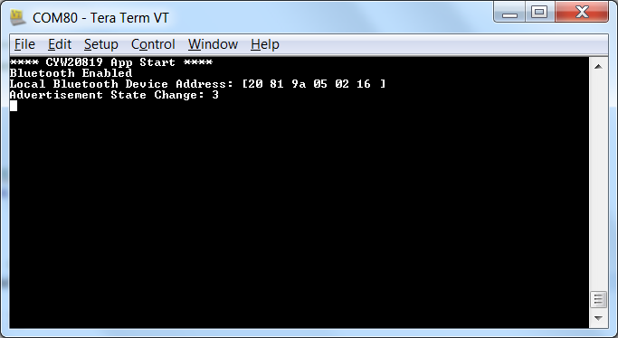

Run CySmart on your phone (more details on CySmart later on). When you see the "<inits>_LED" device, tap on it. CySmart will connect to the device and will show the GATT browser widget.
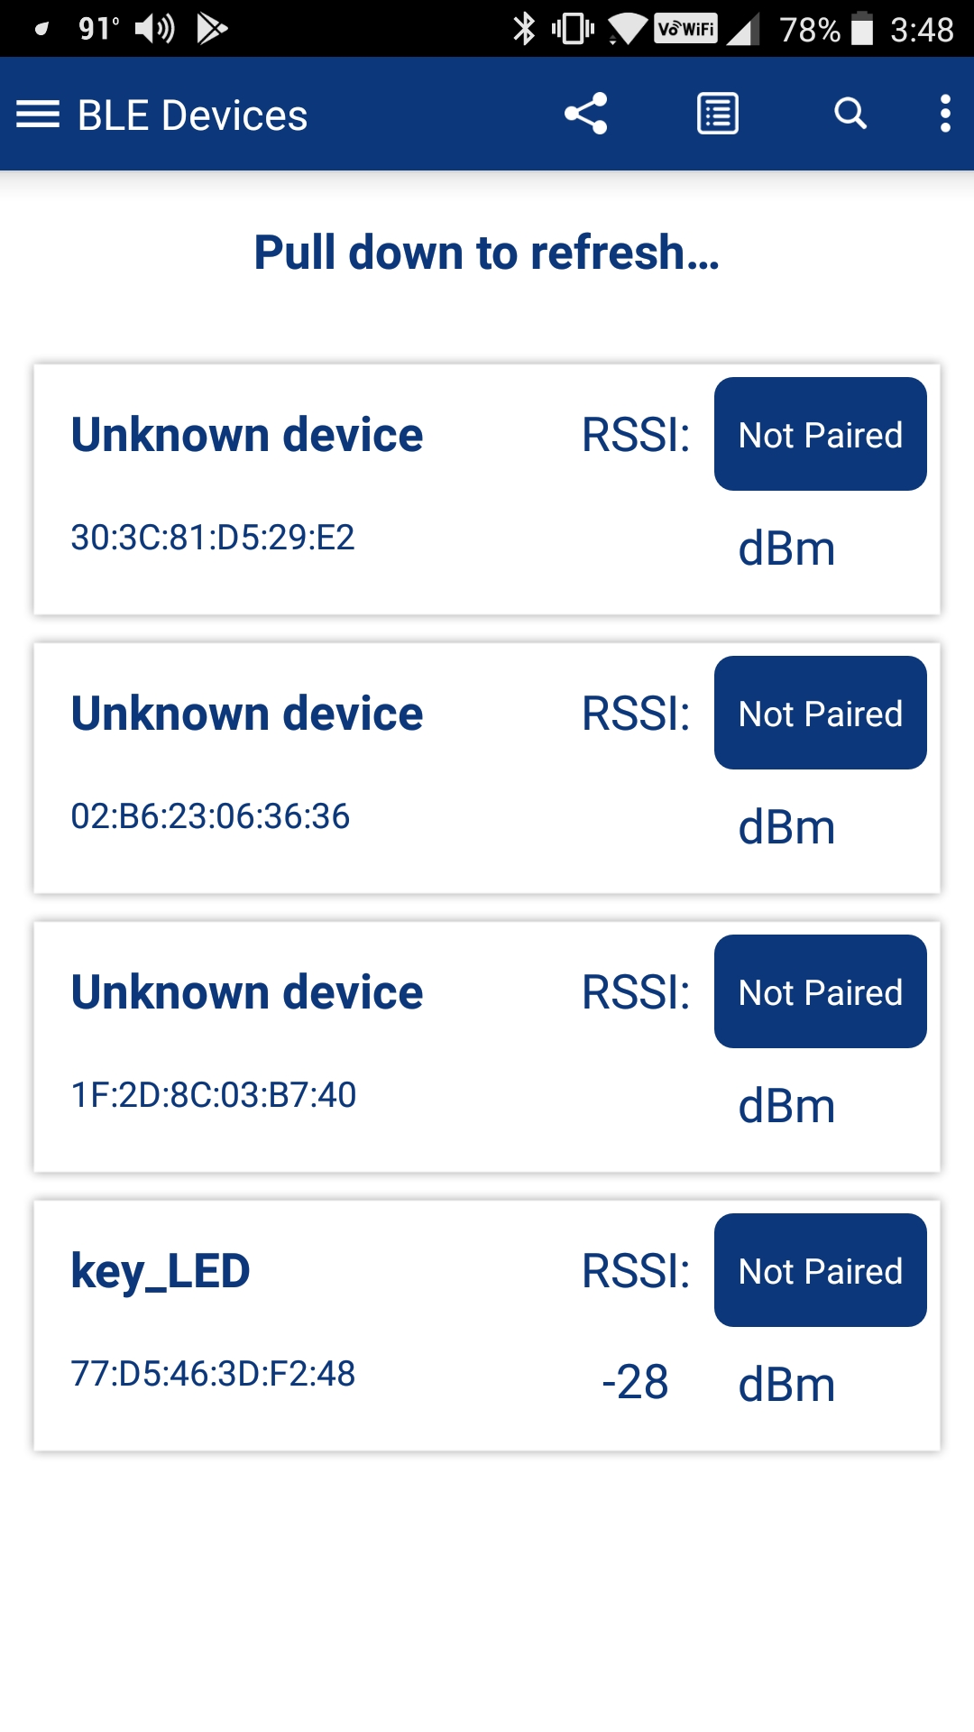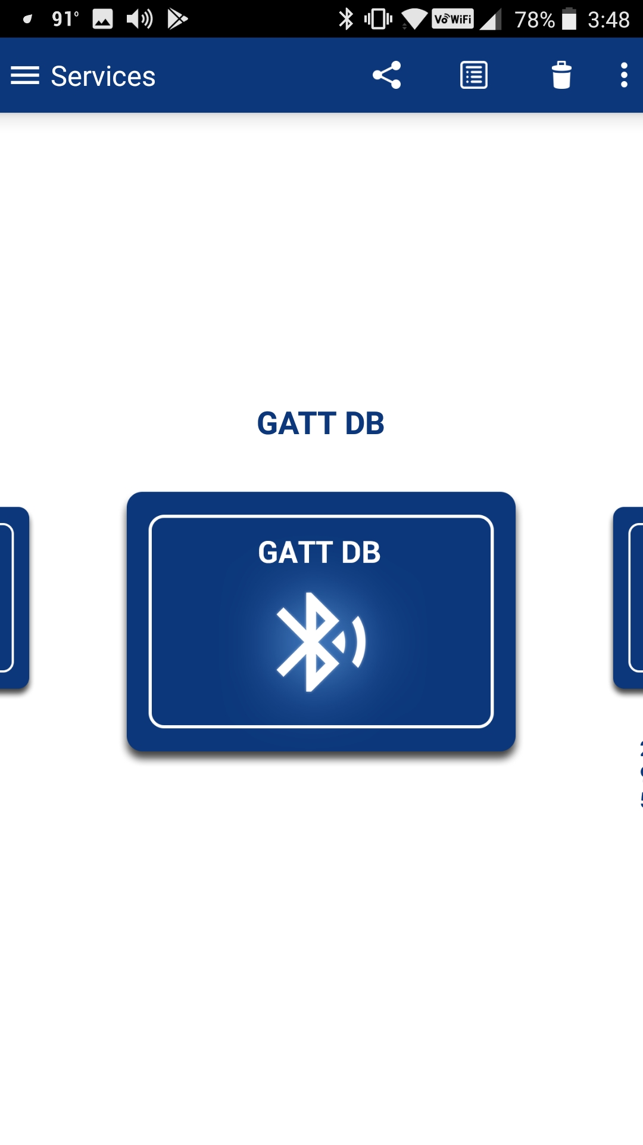
On the terminal window, you will see that there has been a connection and the advertising has stopped.
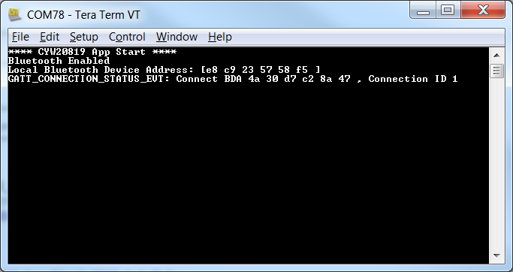
Back in CySmart, tap on the GATT DB widget to open the browser. You will see an Unknown Service (which I know is ModusLED). Tap on the Service and CySmart will tell you that there is a Characteristic with the UUID shown (which I know is LED).
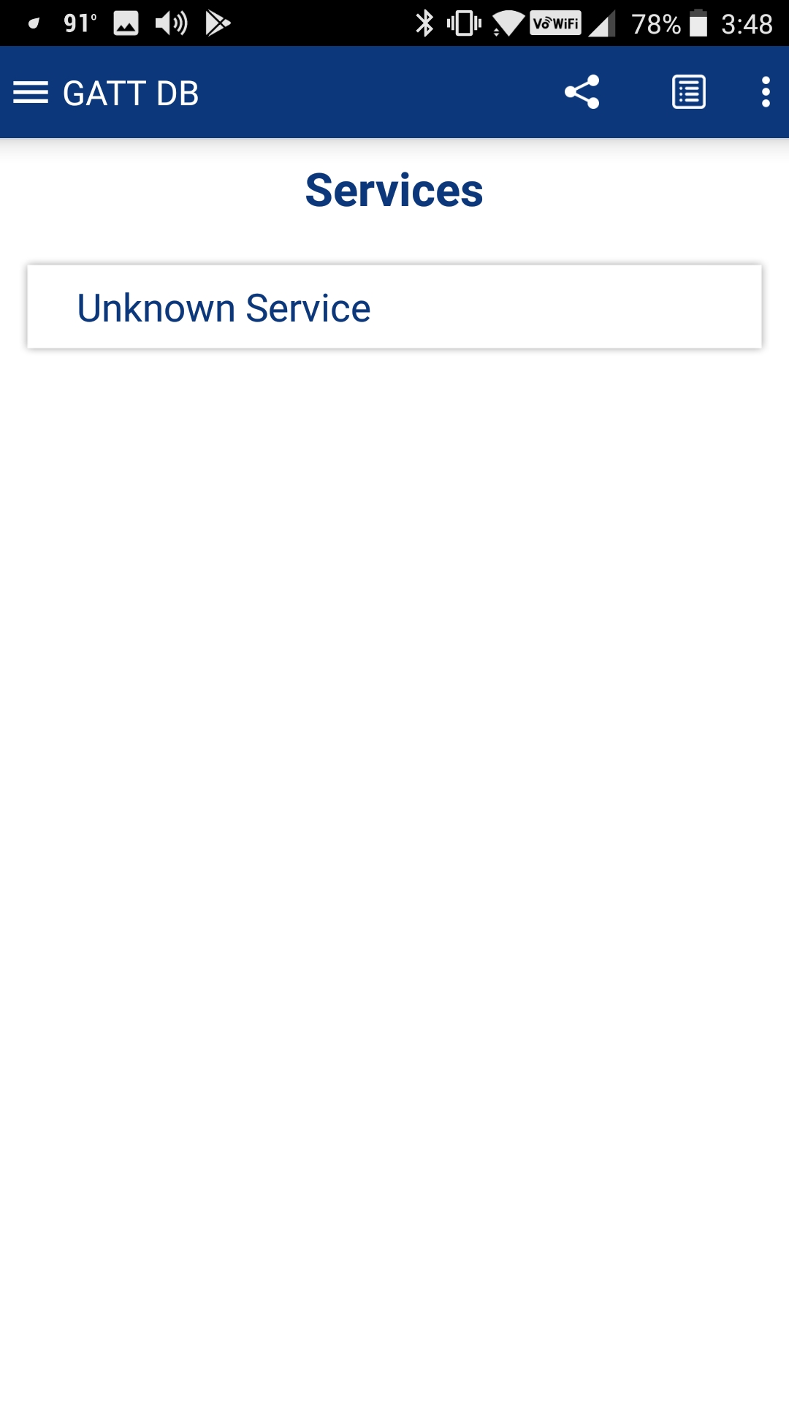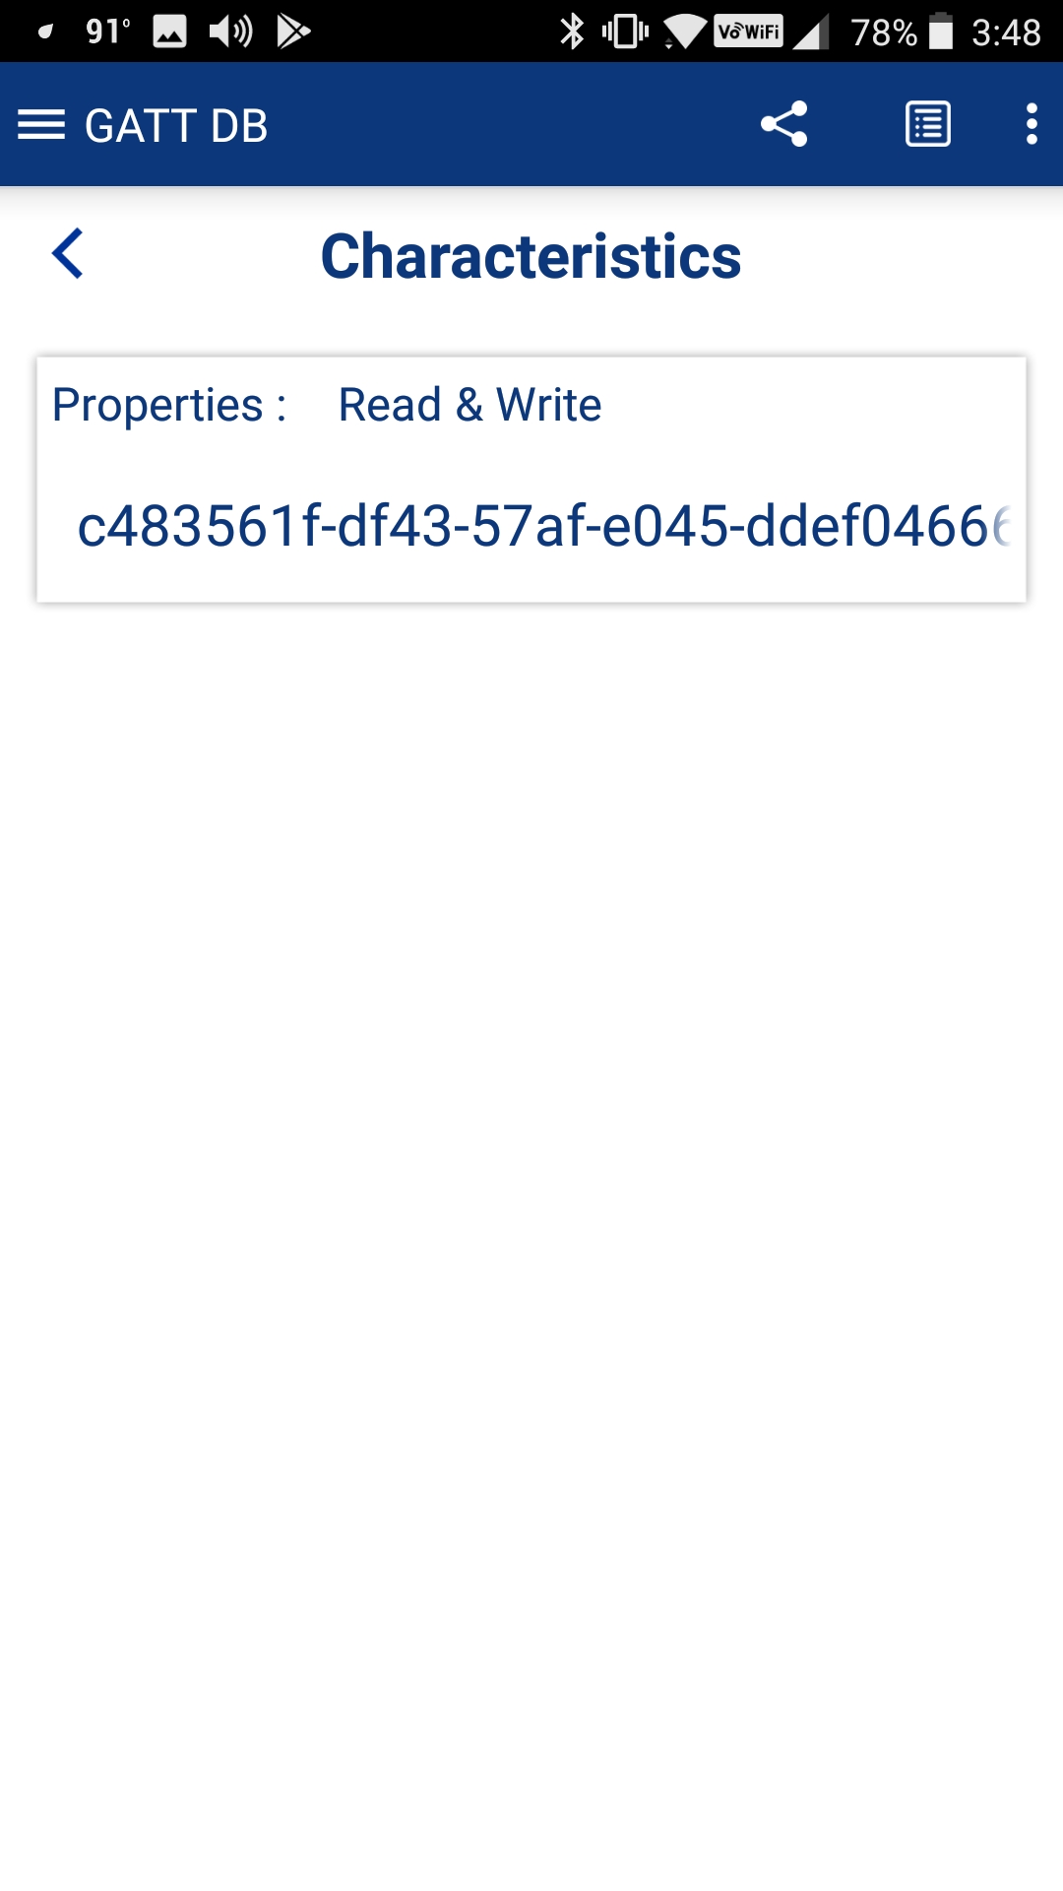
Tap on the Service to see details about it. First, tap the Read button and you will see that the current value is 0. Now you can Write 1s or 0's into the Characteristic and you will find that the LED turns on and off accordingly.
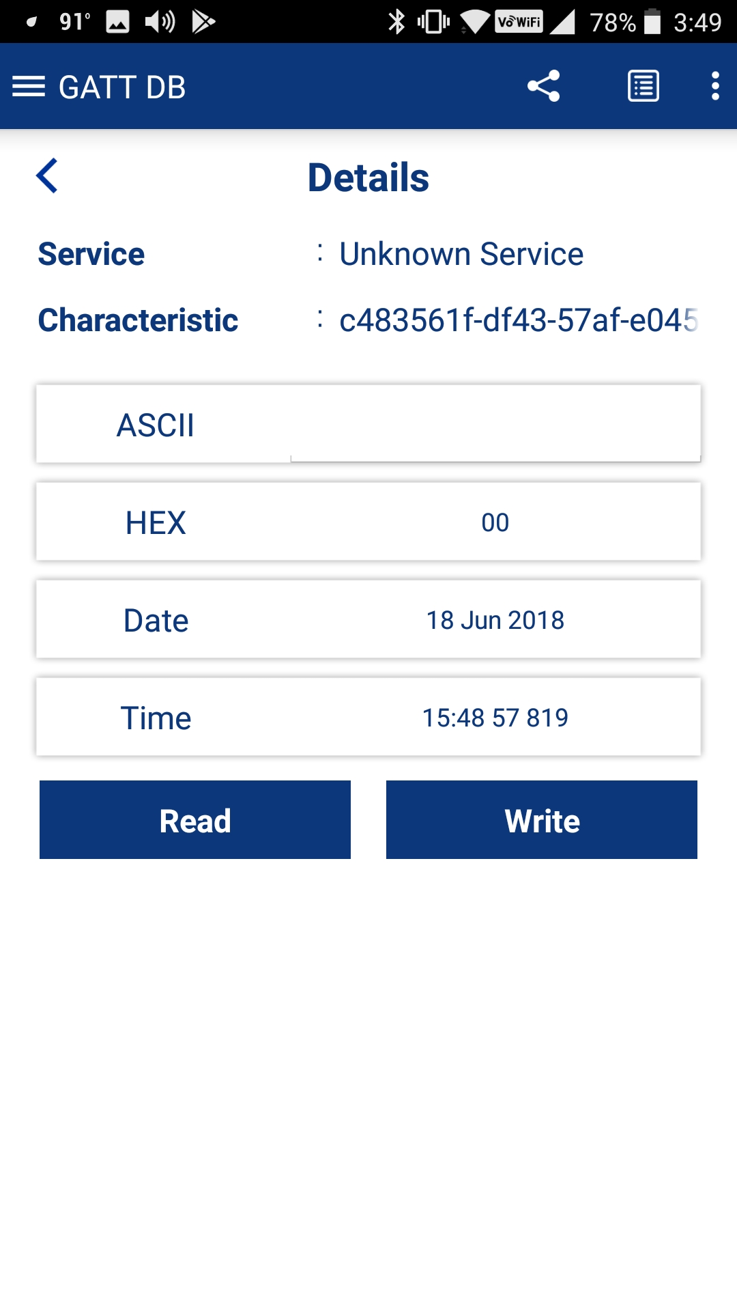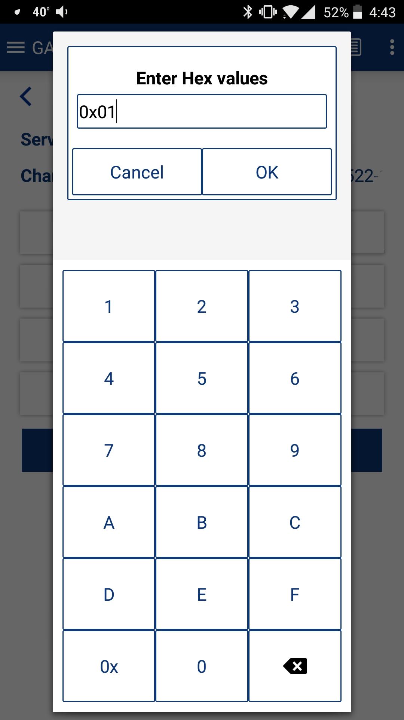
Finally press back until CySmart disconnects. When that happens, you will see the disconnect message in the terminal window.
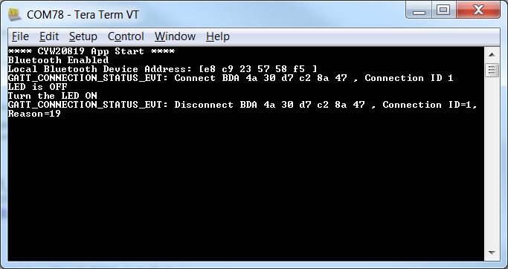
In the next several sections we will walk you through the code.

WICED Bluetooth Stack Events
The Stack generates Events based on what is happening in the Bluetooth world. After an event is created, the Stack will call the callback function which you registered when you turned on the Stack. Your callback firmware must look at the event code and the event parameter and take the appropriate action.
There are two classes of events: Management, and GATT. Each of these has its own callback function. The stack will generate more events than are needed for the first simple example, and I will deal with them in the next chapter.
For the purposes of the simple example, you need to understand these events:

Essential Bluetooth Management Events
Event | Description
BTM_ENABLED_EVT | When the Stack has everything going. The event data will tell if you it happened with WICED_SUCCESS or !WICED_SUCCESS.
BTM_BLE_ADVERT_STATE_CHANGED_EVT | When Advertising is either stopped or started by the Stack. The event parameter will tell you BTM_BLE_ADVERT_OFF or one of the many different levels of active advertising.

The ModusToolbox starter template code (app.c) for this class provides and registers a function called app_bt_management_callback (or similar) to handle Management events.

Essential GATT Events
Event | Description
GATT_CONNECTION_STATUS_EVT | When a connection is made or broken. The event parameter tells you WICED_TRUE if connected.
GATT_ATTRIBUTE_REQUEST_EVT | When a GATT Read or Write occurs. The event parameter tells you GATTS_REQ_TYPE_READ or GATTS_REQ_TYPE_WRITE.

The ModusToolbox starter template code (app.c) for this class provides and registers a function called app_gatt_callback (or similar) to handle GATT events.

Essential GATT Sub-Events
In addition to the GATT events described above, there are sub-events associated with each of the main events which are handled in the template .

GATT_CONNECTION_STATUS_EVT
For this example, there are two sub-events for a Connection Status Event that we care about. Namely:
Event | Description
connected == WICED_TRUE | A GATT connection has been established.
connected != WICED_TRUE | A GATT connection has been broken.

The app_gatt_callback function contains some basic code to handle connect/disconnect events and you can add you own functionality as needed.

GATT_ATTRIBUTE_REQUEST_EVT
For this example, there are two sub-events for an Attribute Request Event that we care about. Namely:
Event | Description
GATTS_REQ_TYPE_READ | A GATT Attribute Read has occurred. The event parameter tells you the request handle and where to save the data.
GATTS_REQ_TYPE_WRITE | A GATT Attribute Write has occurred. The event parameter tells you the handle, a pointer to the data and the length of the data.

The app_gatt_callback function contains some basic code to handle attribute read/write events and you can add you own functionality as needed. In our application the app_gatt_callback function calls app_gatt_set_value for GATTS_REQ_TYPE_WRITE events and that function contains the code we wrote to change the state of the LED (it does predictably similar things for READ events).

WICED Bluetooth Firmware Architecture
At the very beginning of this chapter I told you that there are four steps to make a basic WICED BLE Peripheral:
- Turn on the Stack
- Start Advertising
- Process Connection Events from the Stack
- Process Read/Write Events from the Stack
The Bluetooth template provided for this class mimics this flow.

Turning on the Stack
When a WICED device turns on, the chip boots, starts the RTOS and then jumps to a function called application_start which is where your Application firmware starts. At that point in the proceedings, your Application firmware is responsible for turning on the Stack and making a connection to the WICED radio. This is done with the API call wiced_bt_stack_init. One of the key arguments to wiced_bt_stack_init is a function pointer to the management callback. The template uses the name app_bt_management_callback for the Bluetooth management callback.
In app_bt_management_callback it is your job to fill in what the firmware does to processes various events. This is implemented as a switch statement in the callback function where the cases are the Stack events. Some of the necessary actions are provided automatically and others will need to be written by you.
When you start the Stack, it generates the BTM_ENABLED_EVT event and calls the app_bt_management_callback function which then processes that event.
The app_bt_management_callback case for BTM_ENABLED_EVT event calls the functions wiced_bt_gatt_register and wiced_bt_gatt_db_init, which initializes the GATT database and registers a callback function for GATT database events.
The BTM_ENABLED_EVT ends by calling the wiced_bt_start_advertising function.

Start Advertising
The Stack is triggered to start advertising by the last step of the Off On process with the call to wiced_bt_start_advertising.
The function wiced_bt_start_advertising takes 3 arguments. The first is the advertisement type and has 9 possible values:
BTM_BLE_ADVERT_OFF, /**< Stop advertising */
BTM_BLE_ADVERT_DIRECTED_HIGH, /**< Directed advertisement (high duty cycle) */
BTM_BLE_ADVERT_DIRECTED_LOW, /**< Directed advertisement (low duty cycle) */
BTM_BLE_ADVERT_UNDIRECTED_HIGH, /**< Undirected advertisement (high duty cycle) */
BTM_BLE_ADVERT_UNDIRECTED_LOW, /**< Undirected advertisement (low duty cycle) */
BTM_BLE_ADVERT_NONCONN_HIGH, /**< Non-connectable advertisement (high duty cycle) */
BTM_BLE_ADVERT_NONCONN_LOW, /**< Non-connectable advertisement (low duty cycle) */
BTM_BLE_ADVERT_DISCOVERABLE_HIGH, /**< discoverable advertisement (high duty cycle) */
BTM_BLE_ADVERT_DISCOVERABLE_LOW /**< discoverable advertisement (low duty cycle) */
For non-directed advertising (which is what we will use in our examples) the 2nd and 3rd arguments can be set to 0 and NULL respectively.
The Stack then generates the BTM_BLE_ADVERT_STATE_CHANGED_EVT management event and calls the app_bt_management_callback .
The app_bt_management_callback case for BTM_BLE_ADVERT_STATE_CHANGED_EVT looks at the event parameter to determine if it is a start or end of advertising. In the template code it does not do anything when advertising is started, but you could, for instance, turn on an LED to indicate the advertising state.

Processing Connection Events from the Stack
The getting connected process starts when a Central that is actively Scanning hears your advertising packet and decides to connect. It then sends you a connection request.
The Stack responds to the Central with a connection accepted message.
The Stack then generates a GATT event called GATT_CONNECTION_STATUS_EVT which is processed by the app_gatt_callback function.
The code for the GATT_CONNECTION_STATUS_EVT event uses the event parameter to determine if it is a connection or a disconnection. It then prints a message.
On a connection, the Stack then stops the advertising and calls app_bt_mangement_callback with a management event BTM_BLE_ADVERT_STATE_CHANGED_EVT.
The app_bt_management_callback determines that it is a stop of advertising and just prints out a message. You could add your own code here to, for instance, turn off an LED or restart advertisements.

Processing Client Read Events from the Stack
When the Client wants to read the value of a Characteristic, it sends a read request with the Handle of the Attribute that holds the value of the Characteristic. We will talk about how handles are exchanged between the devices later.
The Stack generates a GATT_ATTRIBUTE_REQUEST_EVT and calls app_gatt_callback, which determines the event is GATT_ATTRIBUTE_REQUEST_EVT. The code for this event looks at the event parameter and determines that it is a GATTS_REQ_TYPE_READ, then calls the function app_gatt_get_value to find the current value of the Characteristic.
That function looks through that GATT Database to find the Attribute that matches the Handle requested. It then copies the value's bytes out of the GATT Database into the location requested by the Stack.
Finally, the get value function returns a code to indicate what happened - either WICED_BT_GATT_SUCESS, or if something bad has happened (like the requested Handle doesn't exist) it returns the appropriate error code such as WICED_BT_GATT_INVALID_HANDLE. The list of the return codes is taken from the wiced_bt_gatt_status_e enumeration. This enumeration includes (partial list):
enum wiced_bt_gatt_status_e
{
WICED_BT_GATT_SUCCESS = 0x00, /**< Success */
WICED_BT_GATT_INVALID_HANDLE = 0x01, /**< Invalid Handle */
WICED_BT_GATT_READ_NOT_PERMIT = 0x02, /**< Read Not Permitted */
WICED_BT_GATT_WRITE_NOT_PERMIT = 0x03, /**< Write Not permitted */
WICED_BT_GATT_INVALID_PDU = 0x04, /**< Invalid PDU */
WICED_BT_GATT_INSUF_AUTHENTICATION = 0x05, /**< Insufficient Authentication */
WICED_BT_GATT_REQ_NOT_SUPPORTED = 0x06, /**< Request Not Supported */
WICED_BT_GATT_INVALID_OFFSET = 0x07, /**< Invalid Offset */
WICED_BT_GATT_INSUF_AUTHORIZATION = 0x08, /**< Insufficient Authorization */
WICED_BT_GATT_PREPARE_Q_FULL = 0x09, /**< Prepare Queue Full */
WICED_BT_GATT_NOT_FOUND = 0x0a, /**< Not Found */
WICED_BT_GATT_NOT_LONG = 0x0b, /**< Not Long Size */
WICED_BT_GATT_INSUF_KEY_SIZE = 0x0c, /**< Insufficient Key Size */
WICED_BT_GATT_INVALID_ATTR_LEN = 0x0d, /**< Invalid Attribute Length */
WICED_BT_GATT_ERR_UNLIKELY = 0x0e, /**< Error Unlikely */
WICED_BT_GATT_INSUF_ENCRYPTION = 0x0f, /**< Insufficient Encryption */
WICED_BT_GATT_UNSUPPORT_GRP_TYPE = 0x10, /**< Unsupported Group Type */
WICED_BT_GATT_INSUF_RESOURCE = 0x11, /**< Insufficient Resource */
When I looked at this table for the first time I thought to myself that Victor must have a sense of humor after all, given error code WICED_BT_GATT_ERR_UNLIKELY.
The status code generated by the get value function is returned up through the function call hierarchy and eventually back to the Stack, which in turn sends it to the Client.
To summarize, the course of events for a read is:
- Stack calls app_gatt_callback with GATT_ATTRIBUTE_REQUEST_EVT
- app_gatt_callback detects the GATTS_REQ_TYPE_READ request type
- app_gatt_callback calls app_gatt_get_value

Processing Client Write Events from the Stack
When the Client wants to write a value to a Characteristic, it sends a write request with the Handle of the Attribute of the Characteristic along with the data.
The Stack generates the GATT event GATT_ATTRIBUTE_REQUEST_EVT and calls the function app_gatt_callback, which determines the event is GATT_ATTRIBUTE_REQUEST_EVT. The code for this event looks at the event parameter and determines that it is a GATTS_REQ_TYPE_WRITE, then calls the function app_gatt_set_value to update the current value of the Characteristic.
The app_gatt_set_value function looks through that GATT Database to find the Attribute that matches the Handle requested. It then copies the value bytes from the Stack generated request into the GATT Database. Finally, the set value function returns a code to indicate what happened just like the Read - either WICED_BT_GATT_SUCESS, or the appropriate error code. The list of the return codes is again taken from the wiced_bt_gatt_status_e enumeration.
The status code generated by the set value function is returned up through the function call hierarchy and eventually back to the Stack. One difference here is that if your callback function returns WICED_BT_GATT_SUCCESS, the Stack sends a Write response of 0x1E. If your callback returns something other than WICED_BT_GATT_SUCCESS, the stack sends an error response with the error code that you chose.
To summarize, function call hierarchy for a write is:
- Stack calls app_gatt_callback with GATT_ATTRIBUTE_REQUEST_EVT
- app_gatt_callback detects the GATTS_REQ_TYPE_WRITE request type
- app_gatt_callback calls app_gatt_set_value

WICED GATT Database Implementation
The Bluetooth Configurator automatically creates a GATT Database implementation to serve as a starting point. The database is split between cycfg_gatt_db.c and cycfg_gatt_db.h.
Even though the Bluetooth Configurator will create all of this for you, some understanding of how it is constructed is worthwhile knowing. The implementation is generic and will work for most situations, however you can make changes to handle custom situations.
When you start the Stack by calling wiced_bt_stack_init one of the parameters is a pointer to the GATT DB, meaning that the Stack will directly access your GATT DB for some purposes.
The GATT DB is used by both the Stack and by your application firmware. The Stack will directly access the Handles, UUIDs and Permissions of the Attributes to process some of the Bluetooth Events. Mainly the Stack will verify that a Handle exists and that the Client has Permission to access it before it gives your application a callback.
Your application firmware will use the GATT DB to read and write data in response to WICED BT Events.
The WICED Implementation of the GATT Database is simple generic "C" (obviously) and is composed logically of four parts. The first three are in cycfg_gatt_db.c while the last is implemented in the application code (in app.c in the template).
- An Array, named gatt_database, of uint8_t bytes that holds the Handles, Types and Permissions.
- An Array of Structs, named app_gatt_db_ext_attr_tbl, which holds Handles, a Maximum and Current Length and a Pointer to the actual Value.
- The Values as arrays of uint8_t bytes.
- Functions that serve as the API

gatt_database[]
The gatt_database is just an array of bytes with special meaning.
To create the bytes representing an Attribute there is a set of C-preprocessor macros that "do the right thing". To create Services, use the macros:
- PRIMARY_SERVICE_UUID16(handle, service)
- PRIMARY_SERVICE_UUID128(handle, service)
- SECONDARY_SERVICE_UUID16(handle, service)
- SECONDARY_SERVICE_UUID128(handle, service)
- INCLUDE_SERVICE_UUID16(handle, service_handle, end_group_handle, service)
- INCLUDE_SERVICE_UUID128(handle, service_handle, end_group_handle)
The handle parameter is just the Service Handle, which is a 16-bit number. The Bluetooth Configurator will automatically create Handles for you that will end up in the cycfg_gatt_db.h file. For example:
/* Service Generic Access */
#define HDLS_GAP 0x0001u
/* Service Generic Attribute */
#define HDLS_GATT 0x0006u

/* Service ModusLED */
#define HDLS_MODUSLED 0x0007u
The Service parameter is the UUID of the service, just an array of bytes. The Bluetooth Configurator will create them for you in cycfg_gatt_db.h. For example:
#define __UUID_SERVICE_MODUSLED 0xD5u, 0x8Eu, 0x79u, 0x8Bu, 0x2Cu, 0xDEu, 0x11u, 0x89u, 0x45u, 0x47u, 0x5Au, 0x31u, 0x6Au, 0xA3u, 0xFAu, 0x34u
In addition, there are a bunch of predefined UUIDs in wiced_bt_uuid.h.
To create Characteristics, use the following C-preprocessor macros which are defined in wiced_bt_gatt.h:
- CHARACTERISTIC_UUID16(handle, handle_value, uuid, properties, permission)
- CHARACTERISTIC_UUID128(handle, handle_value, uuid, properties, permission)
- CHARACTERISTIC_UUID16_WRITABLE(handle, handle_value, uuid, properties, permission)
- CHARACTERISTIC_UUID128_WRITABLE(handle, handle_value, uuid, properties, permission)
As before, the handle parameter is just the 16-bit number that the Bluetooth Configurator creates for the Characteristics which will be in the form of #define HDLC_ for example:
/* Characteristic LED */
#define HDLC_MODUSLED_LED 0x0008u
#define HDLC_MODUSLED_LED_VALUE 0x0009u
The _VALUE parameter is the Handle of the Attribute that will hold the Characteristic's Value.
The UUIDs are 16-bits or 128-bits in an array of bytes. The Bluetooth Configurator will create #defines for the UUIDs in the file cycfg_gatt_db.h.
Properties is a bit mask which sets the properties (i.e. Read, Write etc.) The bit mask is defined in wiced_bt_gatt.h:
/* GATT Characteristic Properties */
#define LEGATTDB_CHAR_PROP_BROADCAST (0x1 << 0)
#define LEGATTDB_CHAR_PROP_READ (0x1 << 1)
#define LEGATTDB_CHAR_PROP_WRITE_NO_RESPONSE (0x1 << 2)
#define LEGATTDB_CHAR_PROP_WRITE (0x1 << 3)
#define LEGATTDB_CHAR_PROP_NOTIFY (0x1 << 4)
#define LEGATTDB_CHAR_PROP_INDICATE (0x1 << 5)
#define LEGATTDB_CHAR_PROP_AUTHD_WRITES (0x1 << 6)
#define LEGATTDB_CHAR_PROP_EXTENDED (0x1 << 7)
The Permission field is just a bit mask that sets the Permission of an Attribute (remember Permissions are on a per Attribute basis and Properties are on a per Characteristic basis). They are also defined in wiced_bt_gatt.h.
/* The permission bits (see Vol 3, Part F, 3.3.1.1) */
#define LEGATTDB_PERM_NONE (0x00)
#define LEGATTDB_PERM_VARIABLE_LENGTH (0x1 << 0)
#define LEGATTDB_PERM_READABLE (0x1 << 1)
#define LEGATTDB_PERM_WRITE_CMD (0x1 << 2)
#define LEGATTDB_PERM_WRITE_REQ (0x1 << 3)
#define LEGATTDB_PERM_AUTH_READABLE (0x1 << 4)
#define LEGATTDB_PERM_RELIABLE_WRITE (0x1 << 5)
#define LEGATTDB_PERM_AUTH_WRITABLE (0x1 << 6)

#define LEGATTDB_PERM_WRITABLE (LEGATTDB_PERM_WRITE_CMD | LEGATTDB_PERM_WRITE_REQ| LEGATTDB_PERM_AUTH_WRITABLE)
#define LEGATTDB_PERM_MASK (0x7f) /* All the permission bits. */
#define LEGATTDB_PERM_SERVICE_UUID_128 (0x1 << 7)

gatt_db_ext_attr_tbl
The gatt_database array does not contain the actual values of Attributes. To find the values there is an array of structures of type gatt_db_lookup_table. Each structure contains a handle, a max length, actual length and a pointer to the array where the value is stored.
// External Lookup Table Entry
typedef struct
{
uint16_t handle;
uint16_t max_len;
uint16_t cur_len;
uint8_t *p_data;
} gatt_db_lookup_table;
Bluetooth Configurator will create this array for you automatically in cycfg_gatt_db.c:
/************************************************************************************
* GATT Lookup Table
************************************************************************************/

gatt_db_lookup_table_t app_gatt_db_ext_attr_tbl[] =
{
/* { attribute handle, maxlen, curlen, attribute data } */
{ HDLC_GAP_DEVICE_NAME_VALUE, 8, 8, app_gap_device_name },
{ HDLC_GAP_APPEARANCE_VALUE, 2, 2, app_gap_appearance },
{ HDLC_MODUSLED_LED_VALUE, 1, 1, app_modusled_led },
};
The functions app_gett_get_value and app_gatt_set_value help you search through this array to find the pointer to the value.

uint8_t Arrays for the Values
Bluetooth Configurator will generate arrays of uint8_t to hold the values of writable/readable Attributes. You will find these values in a section of the code in cycfg_gatt_db.c marked with a comment "GATT Initial Value Arrays". In the example below, you can see there is a Characteristic with the name of the device, a Characteristic with the GAP appearance, and the LED Characteristic.
/*****************************************************************************
* GATT Initial Value Arrays
****************************************************************************/

uint8_t app_gap_device_name[] = {'k', 'e', 'y', '_', 'L', 'E', 'D', '\0', };
uint8_t app_gap_appearance[] = {0x00u, 0x00u, };
uint8_t app_modusled_led[] = {0x00u, };

One thing that you should be aware of is the endianness. Bluetooth uses little endian, which is the same as ARM processors.

The Application Programming Interface
There are two functions which make up the interface to the GATT Database, app_gatt_get_value and app_gatt_set_value. Here are the function prototypes from the template code:
wiced_bt_gatt_status_t app_gatt_get_value( uint16_t attr_handle,
uint16_t conn_id, uint8_t *p_val, uint16_t max_len, uint16_t *p_len );
wiced_bt_gatt_status_t app_gatt_set_value( uint16_t attr_handle,
uint16_t conn_id, uint8_t *p_val, uint16_t len );

These functions have the following input parameters:
- uint16_t attr_handle – Recall that all transactions in BLE are based on the handle. The Client writes data based on the handle and you respond to reads based on the handle.
- uint16_t conn_id – In the case of multiple connections, this parameter is used to determine which connection is requesting data. The template only supports a single connection at a time, so it ignores this parameter.
- uint8_t *p_val – A pointer to the data. For a write, this is a pointer to the data that is copied into the database, for a read this is a pointer to a location where data that will be sent to the Client is copied from the database.
- (read) uint16_t max_len – When you get a read, you should not return more than max_len bytes. The template code automatically does both the read and write correctly.
- (read) uint8_t *p_len – When a read occurs you need to tell the calling function how many bytes you are returning. For example, *p_len = 23; // returning 23 bytes.
- (write) uint16_t len – For a write, you will be told how many bytes got written to you.
Both functions loop through the GATT Database and look for an attribute handle that matches the input parameter. Then they memcpy the data into the right place, either saving it in the database, or writing into the buffer for the Stack to send back to the Client.
Both functions have a switch where you might put in custom code to do something based on the handle. This place is marked with //TODO: in the two functions.
You are supposed to return a wiced_bt_gatt_status_t which will tell the Stack what to do next. Assuming things works this function will return WICED_BT_GATT_SUCCESS. In the case of a Write this will tell the Stack to send a WRITE Response indicating success to the Client.

CySmart
Cypress provides a PC and mobile device application (Android and iOS) called CySmart which can be used to scan, connect, and interact with services, characteristics, and attributes of BLE devices.
There are other utilities available for iOS and Android (such as Lightblue Explorer) which will also work. Feel free to use one of those if you are more comfortable with it.

CySmart PC Application
To use the CySmart PC Application, a CY5670 CySmart USB Dongle is required. When CySmart is started, it will search for supported targets and will display the results. Select the dongle that you want to use and click on "Connect".
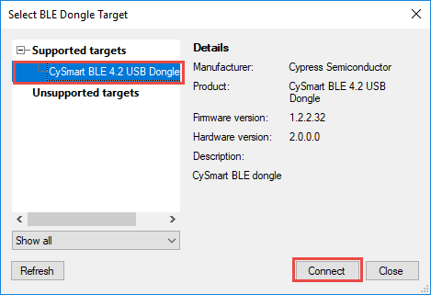
Once a dongle is selected, the main window will open as shown below. Click on "Start Scan" to search for advertising BLE devices.
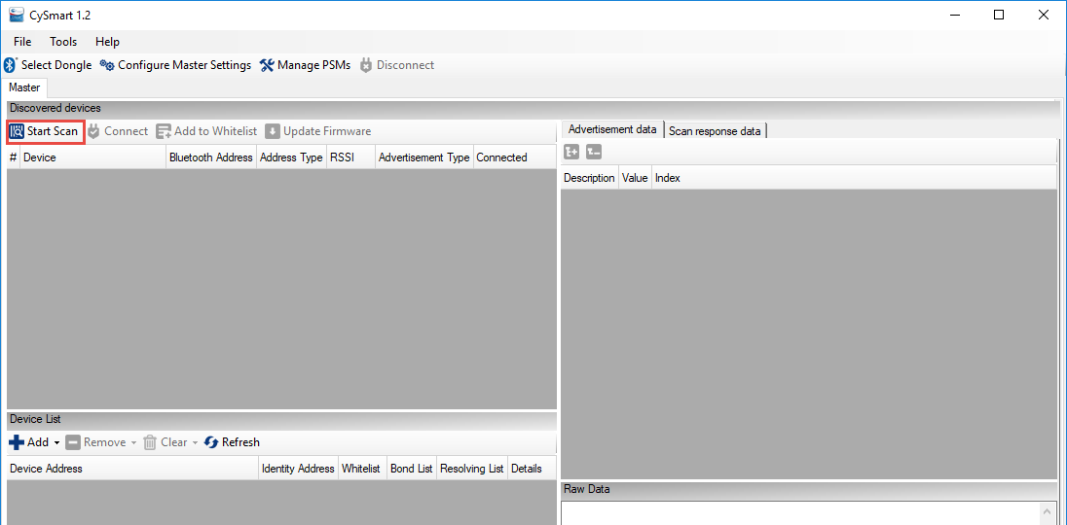
Once the device that you want to connect to appears, click on "Stop Scan" and then click on the device you are interested in. You can then see its Advertisement data and Scan response data in the right-hand window. Click "Connect" to connect to the device.
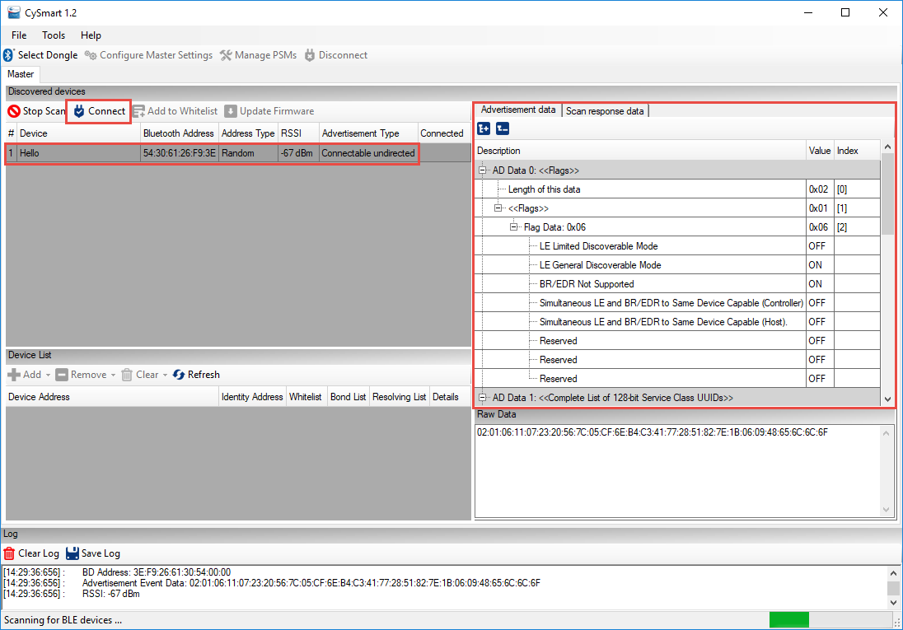
When the device is connected, click on "Pair" and then "Discover All Attributes". Once that is complete, you will see a representation of all Services, Characteristics, and Attributes from the GATT database. You can read and write values by clicking on an attribute and using the buttons in the right-hand window. Click "Enable All Notifications" if you want to see real-time value updates in the left-hand window for characteristics that have notification capability.
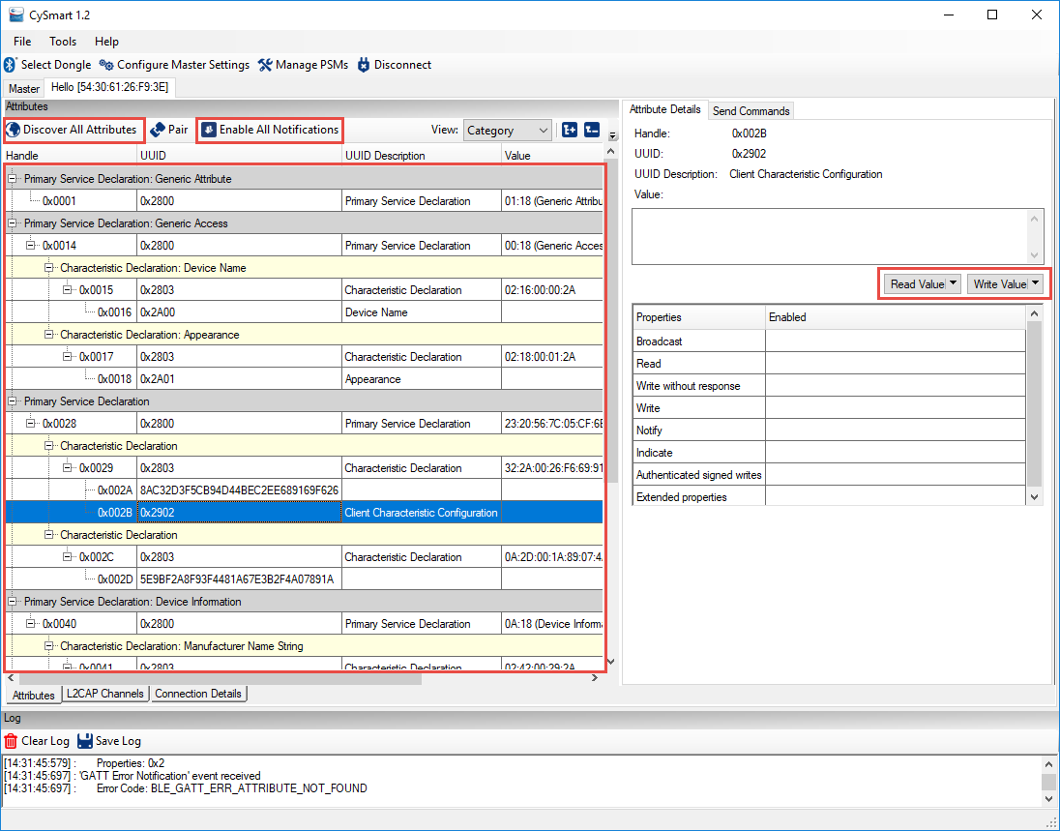
The complete User Guide for the CySmart PC application can be opened in the tool under Help -> Help Topics. It can also be found on the CySmart website at:
http://www.cypress.com/documentation/software-and-drivers/cysmart-bluetooth-le-test-and-debug-tool
Scroll down to the Related Files section of the page to find the User Guide.

CySmart Mobile Application
The CySmart mobile application is available on the Google Play store and the Apple App store. The app can connect and interact with any connectable BLE device. It supports specialized screens for many of the BLE adopted services and a few Cypress custom services such as CapSense and RGB LED control. In addition, there is a GATT database browser that can be used to read and write attributes for all services even if they are not supported with specialized screens.
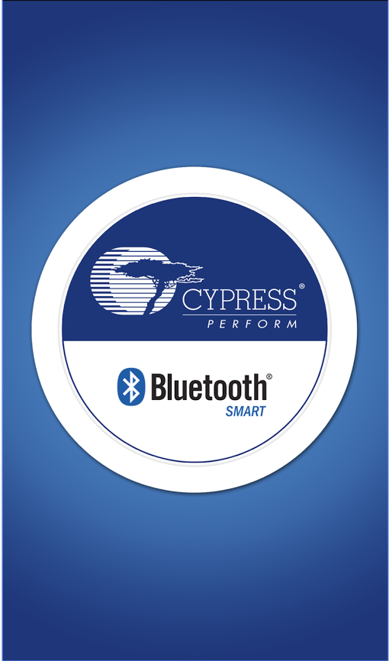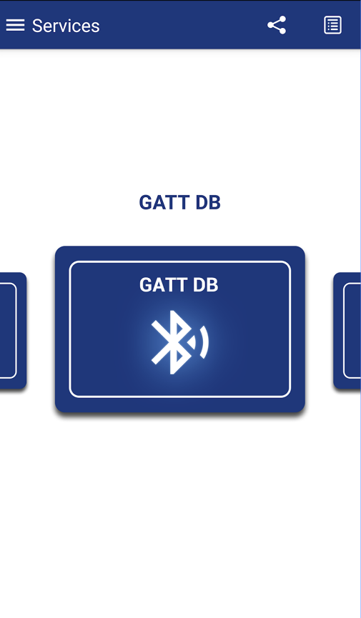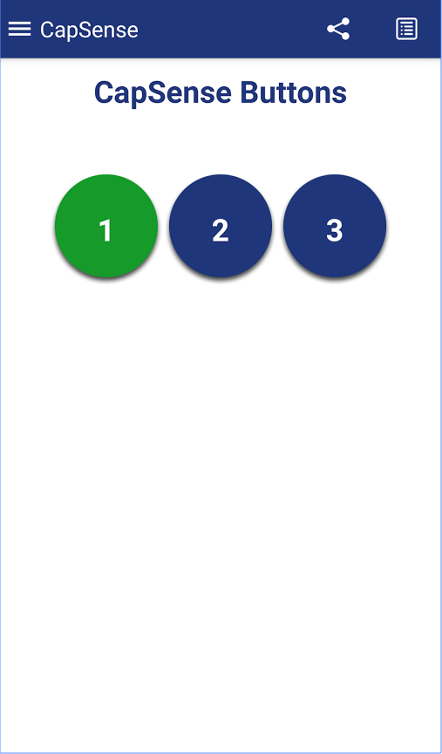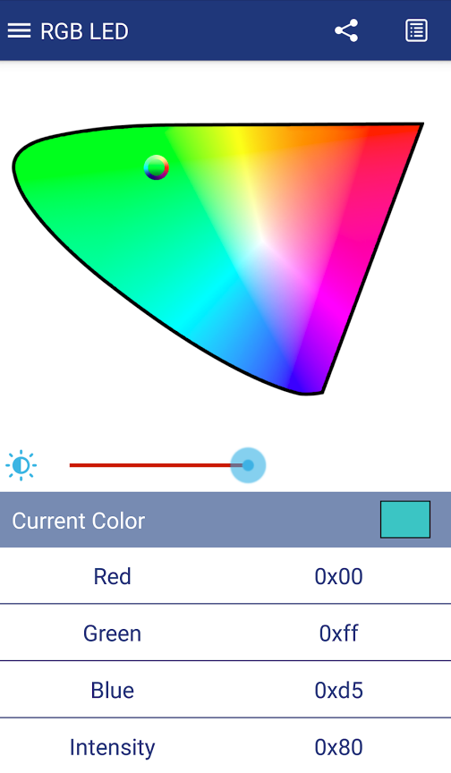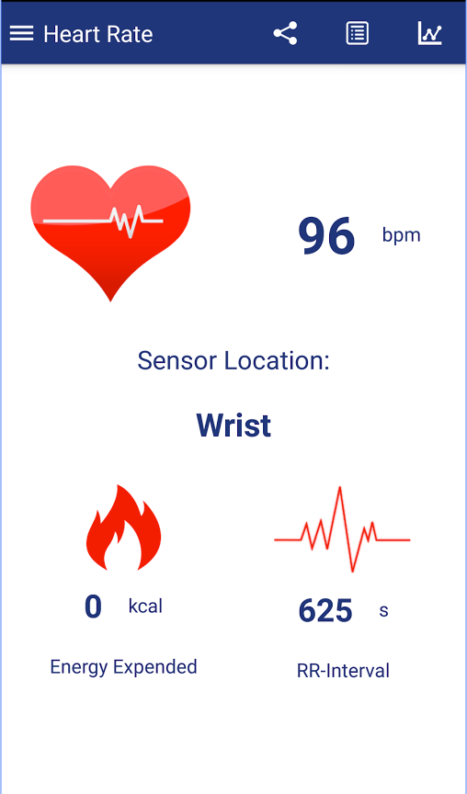
Complete documentation and source code can be found on the CySmart Mobile App website at:
http://www.cypress.com/documentation/software-and-drivers/cysmart-mobile-app
Documentation of the Cypress custom profiles supported by the tool can be found at:
http://www.cypress.com/documentation/software-and-drivers/cypresss-custom-ble-profiles-and-services

Exercises
- Create a BLE Project with a ModusLED Service
Use the template in folder “templates/CYW920819EVB/ch04a” to create a project called ch04a_ex01_ble.
Follow the instructions in section 4A.4 to use the Bluetooth Configurator to set up a Service called ModusLED with a Characteristic called LED that allows an LED on the kit to be controlled from your phone using CySmart.

- Add a connection status LED

Introduction
In this exercise, you will implement a connection status LED that is:
- Off – when the device is not advertising
- Blinking – when the device is advertising
- On – when there is a connection
Hint: You will have to use LED_1 for the connection status since LED_2 is already used for the LED Characteristic. Remember that LED_1 is not configured as an LED by default

Project Creation
- Use the template to create a project called ch04a_ex02_status.
- Launch the Device Configurator.
  - Enable PWM0.
  - Connect PWM0 output to LED_1.
  - Change the type of LED_1 from “LED” to “Peripheral”.
  - Save your edits.
- Launch Bluetooth Configurator.
  - Set the device name to <inits>_status
  - Save your changes and close the configurators. We are only using the GATT database to handle connections in this exercise and so there is no need to add a service.
- Open app.c and #include "GeneratedSource/cycfg_gatt_db.h"
  - Hint: If you don't see cycfg_gatt_db.h in the GeneratedSource folder, right click on the folder and select "Refresh".
- Include wiced_hal_pwm.h.
- Include wiced_hal_aclk.h.
- In the BTM_ENABLED_EVT case, start the ACLK and PWM but set the compare value to match the maximum value so that the LED is always off.
/* Start the PWM in the LED always off state */
wiced_hal_aclk_enable( PWM_FREQUENCY, ACLK1, ACLK_FREQ_24_MHZ );
wiced_hal_pwm_start( PWM0, PMU_CLK, PWM_ALWAYS_OFF, PWM_INIT, 0 );
  - Hint: Use the pre-defined macros for PWM_ALWAYS_ON, PWM_ALWAYS_OFF, and PWM_TOGGLE from the template to make the PWM code easier to write.
- In the BTM_ENABLED_EVT case, enable the GATT database and disallow pairing.
/* Configure the GATT database and advertise for connections */
wiced_bt_gatt_register( app_gatt_callback );
wiced_bt_gatt_db_init( gatt_database, gatt_database_len );
wiced_bt_set_pairable_mode( WICED_FALSE, WICED_FALSE );
- Declare a global uint16_t variable to keep track of the connection ID and initialize to 0.
  - Hint: This will be needed so that when advertisements stop, you will know if the LED should be turned ON (connected) or OFF (not connected).
- Set/clear the connection ID variable at the appropriate places.
  - Hint: Look in the GATT connect callback function.
    - For a connection: connection_id = conn->conn_id;
    - For a disconnection: connection_id = 0;
- Turn the LED ON or OFF when advertising stops based on the connection ID.
  - Hint: In the BTM_BLE_ADVERT_STATE_CHANGED_EVT case, create a switch statement for p_event_data->ble_advert_state_changed that handles the following cases; BTM_BLE_ADVERT_OFF (sets the LED on or off based on connection_id), BTM_BLE_ADVERT_UNDIRECTED_HIGH and BTM_BLE_ADVERT_UNDIRECTED_LOW (both set the PWM to toggle).
- Note: If you are impatient, like us, you can speed up your testing by changing the values of high_duty_duration and low_duty_duration to 15 in app_bt_cfg.c, which will make the stack change advertising state much faster.

Testing
- Program the application to your kit.
- Use the PC version of CySmart to connect to the kit. Observe the state of LED_1 when not advertising, when advertising and when a connection is active.
  - Hint: You will have to wait for the advertising timeout while not connected to see the first case.

- Create a BLE Advertiser

Introduction
In this exercise, you will create a project that will send out advertisement packets but will not allow any connections. This is common for devices like beacons or locator tags. The advertisement packet will include the flags, complete name, appearance and three bytes of manufacturer specific data. Each time a button is pressed on the kit, the value of the manufacturer data will be incremented, and advertisements will be re-started.
Below is a table showing the events that occur during this exercise. Arrows indicate the cause/effect of the stack events.
External Event | BLE Stack Event | Action
Board reset | BTM_LOCAL_IDENTITY_KEYS_REQUEST_EVT | Not used yet
Board reset | BTM_ENABLED_EVT | Initialize application, start the button interrupt
 | BTM_BLE_ADVERT_STATE_CHANGED_EVT (BTM_BLE_ADVERT_NONCONN_HIGH) | Start advertising
Scan for devices in CySmart PC application. Look at advertising data.
Press MB1. | BTM_BLE_ADVERT_STATE_CHANGED_EVT (BTM_BLE_ADVERT_NONCONN_HIGH) | Update information in the advertising packet and restart advertising
Re-start scan in CySmart. Look at new advertising data.
Wait for timeout. | BTM_BLE_ADVERT_STATE_CHANGED_EVT  (BTM_BLE_ADVERT_NONCONN_LOW) | Stack switches to lower advertising rate to save power

Project Creation
- Use the template to create a project called ch04a_ex03_adv.
- Launch the Device Configurator and open Bluetooth Configurator.
  - Set the device name to <inits>_adv
  - In the “Appearance” characteristic, choose the “Generic Tag” type.
  - Save your changes and close the configurators.
- Open app.c and #include "GeneratedSource/cycfg_gatt_db.h"
- Locate the line in the main C file that starts advertisements. Change the advertisement type to BTM_BLE_ADVERT_NONCONN_HIGH because we don't want the device to be connectable.
  - Hint: Right click on the existing advertisement type and select Open Declaration to see all the available choices.
- Locate the function that sets up the advertisement data and add a new element to send Cypress’ unique manufacturer ID and a count value.
  - Hint: Create a global uint8_t array of size three. Set the first two values equal to 0x31 and 0x01. The third value will hold the count value.
    - The Cypress manufacturer ID assigned by the Bluetooth SIG is 0x0131. The value is little endian in the advertising packet which is why the first two bytes are 0x31 and 0x01.
  - Hint: The advertisement type for this element should be BTM_BLE_ADVERT_TYPE_MANUFACTURER.
  - Hint: don't forget to increase the number of elements in the advertising data array.
- Configure Button1 for a falling edge interrupt in the BTM_ENABLED_EVT. Add a button interrupt callback that does the following:
  - Clear the pin interrupt
  - Increment the third byte of the array holding the manufacturer's data (i.e. the count value).
  - Update the advertisement packet data array
    - Hint: you can just call the function that sets up the advertising packet again.

Testing
- Program the project to the board and use the PC version of CySmart to examine the advertisement packets. Start scanning and the stop once you see your device listed. Then click on your device to see its advertisement data. Press the button, re-start/stop the scan, and look at your device's scan response to see that the value has incremented.
  - Hint: you must have a CY5677 CySmart BLE USB dongle connected to your PC to run CySmart.

Questions
- How many bytes is the advertisement packet?

- Connect using BLE

Introduction
In this exercise, you will create a project that will have a custom Service called "Modus101" containing two Characteristics:
- A Button characteristic with the state of the button on the kit
- An LED Characteristic to control an LED.
You will monitor the button on the kit board and update its state in a GATT Characteristic so that a client can read the value. The LED Characteristic will behave like the LED in exercise 01 – you will be able to Read and Write the LED state from a client to control the LED on the board.
Below is a table showing the events that occur during this exercise. Arrows indicate the cause/effect of the stack events. New events introduced in this exercise are highlighted.
External Event | BLE Stack Event | Action
Board reset | BTM_LOCAL_IDENTITY_KEYS_REQUEST_EVT | Not used yet
Board reset | BTM_ENABLED_EVT | Initialize application
 | BTM_BLE_ADVERT_STATE_CHANGED_EVT (BTM_BLE_ADVERT_ UNDIRECTED _HIGH) | Start advertising
CySmart will now see advertising packets
Connect to device from CySmart | GATT_CONNECTION_STATUS_EVT | Set the connection ID and enable pairing
Connect to device from CySmart | BTM_BLE_ADVERT_STATE_CHANGED_EVT (BTM_BLE_ADVERT_OFF)
Read Button characteristic while touching buttons | GATT_ATTRIBUTE_REQUEST_EVT, GATTS_REQ_TYPE_READ | Returns button state
Disconnect | GATT_CONNECTION_STATUS_EVT | Clear the connection ID and re-start advertising
Disconnect | BTM_BLE_ADVERT_STATE_CHANGED_EVT (BTM_BLE_ADVERT_UNDIRECTED_HIGH)
Wait for timeout. | BTM_BLE_ADVERT_STATE_CHANGED_EVT  (BTM_BLE_ADVERT_ UNDIRECTED _LOW) | Stack switches to lower advertising rate to save power
Wait for timeout. | BTM_BLE_ADVERT_STATE_CHANGED_EVT  (BTM_BLE_ADVERT_OFF) | Stack stops advertising.

Project Creation
- Use the template to create a project called ch04a_ex04_con.
- Launch the Device Configurator
  - Enable PWM0 and connect it to LED1.
  - Set LED1 type to Peripheral.
  - Save your changes.
- From the Device Configurator, open the Bluetooth Configurator.
  - Set the device name to <inits>_con.
  - Add a new custom service to the GATT server and rename it “Modus101”.
    - Note: Right click on the service and choose "rename" to rename it.
  - Rename the custom characteristic to “LED”
  - Configure LED to be a uint8 that is initially 0 and enable both read and write.
  - Add a new custom characteristic alongside LED.
  - Rename it to “Button”.
  - Configure Button to be a uint8_t that is initially 0 but only enable it for read.
- Save your changes and close both the configurators.
- Open app.c and #include "GeneratedSource/cycfg_gatt_db.h"
- Include wiced_hal_pwm.h
- Include wiced_hal_aclk.h
- You are going to re-create the advertising status LED (on LED1) behavior from ex02_status
  - Create a global uint16_t for the connection ID.
  - Add code to set and clear the variable GATT_CONNECTION_STATUS_EVT event in the GATT callback handler.
  - Turn on the PWM when the BLE stack comes up (ALWAYS_OFF)
  - Add code to change the blink behavior in the BTM_BLE_ADVERT_STATE_CHANGED_EVT event in the management callback function.
- Enable GATT connections and disallow pairing.
/* TODO: Configure the GATT database and advertise for connections */
wiced_bt_gatt_register( app_gatt_callback );
wiced_bt_gatt_db_init( gatt_database, gatt_database_len );

/* TODO: Enable/disable pairing */
wiced_bt_set_pairable_mode( WICED_FALSE, WICED_FALSE );
- Add the code to the app_gatt_set_value function from exercise 01 to set the state of LED_2 based on the LED Characteristic value.
  - Hint: The name of the array will be different because the project name and service names are different. The name can be found in the GATT Initial Value Arrays section of the code.
- You may want to build/program/test at this point to make sure everything works up until this point. You should be able to connect and see one service with two Characteristics. The Read/Write Characteristic should still control LED_2.
- Configure the button for an interrupt on both edges. In the interrupt callback, save the current state of the button to the appropriate GATT array.
  - Hint: On the CYW920819EVB-02 kit, invert the value before storing it in the array since the button is active low and we want the button Characteristic value to be high when the button is pressed. This is not necessary on the CYBT-213043-MESH kit because the button is active high.

Testing
- Program the project to the board.
- Open the mobile CySmart app.
- Connect to the device.
- Open the GATT browser widget and then open the Modus101 Service followed by the Button Characteristic.
- Read the value while both pressing and not pressing the button to see the values.
- Switch to the LED characteristic and verify that it still works to turn the LED ON/OFF.
- Disconnect from the mobile CySmart app and start the PC CySmart app.
- Start scanning and then connect to your device.
- Click on "Discover all Attributes".
- Read the button value in CySmart by clicking on the Characteristic and then clicking the "Read Value" button. Continue reading as you press and release the button and verify that the value is correct.
- Click "Disconnect".

Questions
- What function is called when there is a Stack event? Where is it registered?

- What function is called when there is a GATT database event? Where is it registered?

- Which GATT events are implemented? What other GATT events exist? (Hint: right click and select Open Declaration on one of the implemented events)

- In the GATT "GATT_ATTRIBUTE_REQUEST_EVT", what request types are implemented? What other request types exist?

