Chapter 7B: Bluetooth Mesh Protocol

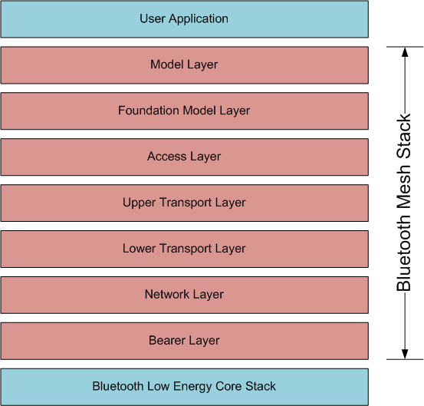
MESH Stack Architecture

Bearer Layer
- Advertising or GATT (via proxy)

Network Layer
- Defines message address types and message format
- Can have multiple interfaces including local to determine message routing between elements in the same node
- Input filter and output filters are used to determine if messages should be delivered up/down
- Relay and Proxy are implemented in the network layer
- It only decrypts using the NetKey, not the AppKey so it doesn't read the application data

Lower Transport Layer
- Segmenting and reassembling

Upper Transport Layer
- Encryption, decryption, and authentication of application data using the AppKey
- Deals with control messages (friendship and heartbeat messages)

Access Layer
- Defines how higher-level applications can use the UTL. Format of app data, encryption and decryption used in the UTL, etc.

Foundation Model Layer
- Device configuration and node health models

Model Layer
- All other models besides the foundation models – generic, sensor, lighting, etc.
- This is the layer the user application interacts with

