Title: CY8CKIT-032 PSoC Analog Front End (AFE) Shield IROS
1. Purpose/Scope: 3
1.1 Purpose 3
1.2 Scope 3
1.3 IROS Document Format 3
1.4 Definitions, Acronyms, and Abbreviations 3
2. Responsibilities: 3
3. Referenced Documents: 4
3.1 Required References 4
3.2 Project References 4
3.3 Platform References 4
3.4 Firmware IP BROS References 4
3.5 Hardware IP BROS References 4
3.6 Software IP (Runtime) BROS References 4
3.7 Software IP (Configuration time) BROS/IROS References 4
3.8 Other references 5
4. Materials: N/A 5
5. Equipment: N/A 5
6. Safety: N/a 5
7. Critical Requirements Summary 5
7.1 System Description 5
7.2 Project Objectives 5
7.3 System Technology Requirements 6
7.4 System Architecture 7
7.5 Traceability Matrix 12
7.6 Developer-Related Requirements 13
7.7 Engineering Assumptions and Risks 14
8. Design Details 14
8.1 Hardware Design 14
8.2 Firmware Design 24
8.3 Software Design 33
8.4 Mechanical 33
8.5 Manufacturing 34
9. Quality Requirements: 34
9.1 System Hardware Design for Test 34
9.2 System Firmware Design for Test 34
9.3 System Software Design for Test 34
9.4 System Test Framework Design 34
10. ComplIance requirements 35
10.1 System Hardware Design for USB certification requirements 35
10.2 System Hardware Design for EMI/EMC compliance 35
10.3 System Hardware Design for other compliance requirements 35
11. Records: 35
12. Preventive Maintenance: N/A 35
13. Posting Sheets/Forms/Appendix 35
13.1 Appendix 1 - Requirements Traceability Matrix 35

Purpose/Scope:

Purpose
The purpose of this System Product IROS is to define and describe the detailed system design requirements of the CY8CKIT-032 PSoC Analog Front End (AFE) Shield so the engineering team can design the system product that is defined in the System Product EROS (External Requirement Objectives Specification). The IROS includes the System Architecture, Design Details and Design for Test implementation.

Scope
This document describes all features, modes, and performance specifications that will be implemented in the product design for this project. All aspects of the design are covered, including System Hardware, Firmware and Software.
The IROS is continually updated throughout the project. It begins as a design requirements document at PR1 and evolves into a design implementation document by PR3.

IROS Document Format
The general layout of this document follows the Cypress document standard specified in 00-00021 CY Spec Format.
Sections 7, 8 and 9 are formatted as follows:
- Section 7: Overview of high-level product requirements, system architecture and project requirements.
- Section 8: Hardware, firmware and software design details.
- Section 9: System test implementation.

Definitions, Acronyms, and Abbreviations
- AFE – Analog Front End
- PSoC – Programmable System-on-Chip
- I2C – Inter Integrated Circuit Interface

Responsibilities:
The Tactical Marketing and PSD Kit Development Team are responsible for:

- Creating and maintaining this document for projects.
- Mapping the corresponding external requirements found in the project EROS in to this document.
- Submitting this document as a specification prior to the PR1 milestone.
- Keeping this document current as the project progresses.

Referenced Documents:

Required References
00-00064 Cypress Record Retention Policy
001-55229 System New Product Development Methodology
001-56153 System Hardware Development Methodology
001-80844 PSOC CREATOR COMPONENTS AND PDL DRIVERS DEVELOPMENT PROCESS

Project References
002-21685 NPP FOR CY8CKIT-032
002-21218 SNPD SYSTEM EROS - CY8CKIT-032 PSOC ANALOG FRONT END (AFE) SHIELD

Platform References
N/A

Firmware IP BROS References
N/A

Hardware IP BROS References
N/A

Software IP (Runtime) BROS References
N/A

Software IP (Configuration time) BROS/IROS References
N/A

Other references
00-00021 Cypress Specification Requirements
001-07907 CapSense Performance Specifications

Materials: N/A

Equipment: N/A

Safety: N/a

Critical Requirements Summary

System Description
This kit is an Arduino form factor shield that will serve four basic purposes:
- Companion shield to baseboard kits used for IoT classes such as Cypress Academy WICED WiFi101 (WW101) and Cypress Academy WICED Bluetooth 101 (WBT101). This shield adds features to the baseboard such as: analog IoT-type sensors (temperature, humidity, ambient light); OLED graphics display; and CapSense buttons/proximity detection.
- Companion shield for video versions of the classes listed above.
- Companion shield for university classes based on the classes listed above or for general university classes.
- Cross-selling tool for PSoC as an AFE and user interface such as CapSense.
This kit will be given away to students in the Cypress Academy classes and may also be handed out at trade-shows so the cost must be kept as low as possible.
Refer to the CY8CKIT-032 PSoC Analog Front End (AFE) Shield EROS, Spec # 002-21218 for additional information on the market requirements for this product.

Project Objectives
The CY8CKIT-032 is an Arduino form-factor shield that adds features to the baseboard that it connects to. The various features supported are:
- A PSoC 4 that acts as an AFE and a user interface providing:
- Temperature measurement
- Humidity measurement
- Ambient light measurement
- Potentiometer
- 2 mechanical buttons
- 7 LEDs
- 4 CapSense buttons and 1 CapSense proximity detector
- The values for the temperature, humidity, ambient light, and potentiometer can be read from the PSoC via I2C.
- The analog values for ambient light, potentiometer and a programmable DAC value from the PSoC are available on Arduino analog pins.
- The button/proximity states (mechanical and CapSense) can be read from the PSoC via I2C. The mechanical button values can also be read from Arduino digital pins. Note: the mechanical buttons route through the PSoC but appear to the base board to be directly connected.
- 2 LEDs are controlled from Arduino digital pins. The other 5 LEDs are logically connected with CapSense buttons/proximity. Note: all LEDs route through the PSoC but the 2 LEDs that connect to Arduino digital pins appear to the base board to be directly connected.
- An I2C based graphics OLED display

System Technology Requirements
The shield is intended to be used in a classroom (room temperature) environment and with nominal voltages supplied by the baseboard. It should be able to work from 3V – 3.6V and from 4.5V – 5.5V. For temperature, it should be able to work from 10C – 35C.
The shield needs to show good CapSense and analog performance to act as a sales tool for PSoC 4 as an AFE. Specific requirements are:
Temperature measurement: within 0.5C at room temperature
Humidity measurement: within 10% of actual humidity
Ambient Light measurement: must report LUX < 10 when sensor is covered and LUX > 1000 when a flashlight is shined on the sensor.
Potentiometer voltage: Within 0.01V.
Temperature is measured using a thermistor. Humidity is measured using a capacitive based humidity sensor. Ambient light is measured using a photodiode. Each of these solutions is based on the CY8CKIT-048.

Cypress Devices Required
CY8C4A45AZI-483 48-TQFP -> PSoC 4 Analog Co-processor

System Architecture

Top-level System Block Diagram(s)
The following shows how the shield will interface with an Arduino compatible baseboard.
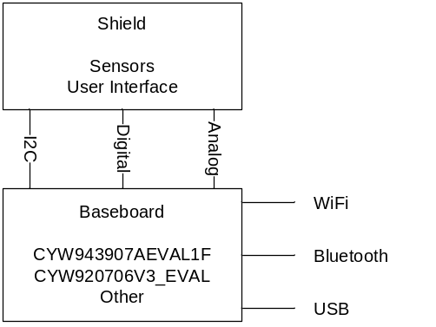

Hardware Platform
The following is a block diagram of the shield hardware.
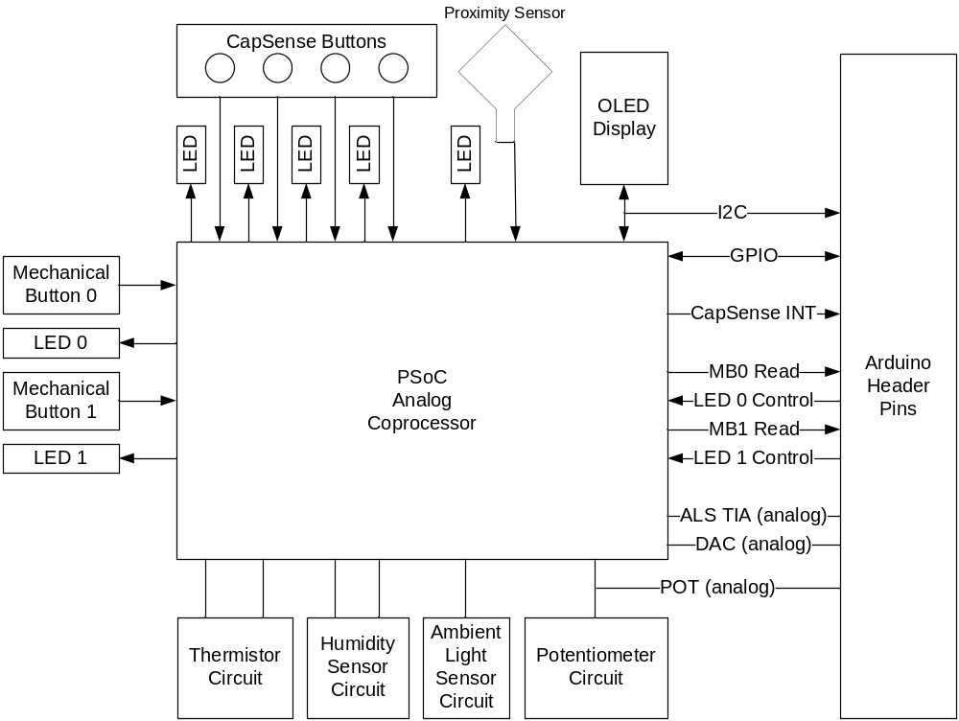

Non-Cypress Devices used
No Non-Cypress ICs are used on this shield.

Programming options for Development kits
N/A

Design and Validation using PSVP Platform
The silicon used for this shield is already available in samples. Therefore, no PSVP will be done.

Firmware Functional Flow
The figure below shows a high-level flow diagram of the firmware.
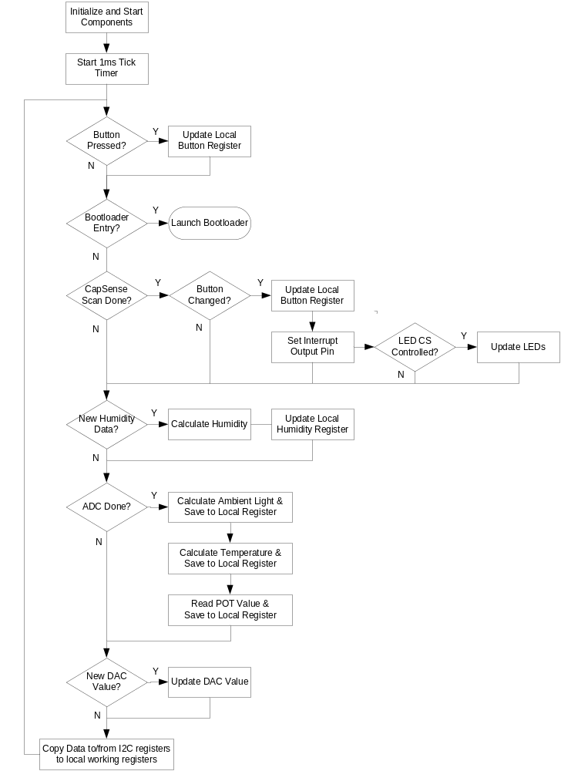

FLASH Budgets and Actuals
The project (including bootloader) must fit into the flash available on the CY8C4A45AZI-483 device, which is 32kB. The firmware uses 25.3kB of flash (79%).

SRAM Budgets and Actuals
The project (including bootloader) must fit into the SRAM available on the CY8C4A45AZI-483 device, which is 4kB. The firmware uses 1.9kB of flash (48%).

Performance Budgets and actuals
There is no CPU time budget for this kit.

Software Functional Flow
N/A – There is no software for this kit.

System-Level Block Descriptions

Hardware Blocks

PSoC 4B-S0
The PSoC will operate in two modes – normal mode and bootloader mode. The device will power up in normal mode.
In normal mode the PSoC: interfaces to the analog sensors; supplies a DAC output voltage; supplies CapSense buttons, proximity, and humidity sensor measurements; monitors mechanical buttons; drives LEDs; and provides an EZ-I2C slave interface to the base board.
In bootloader mode, new firmware can be loaded using the I2C interface.

OLED Display
The OLED display is a 128x64 pixel dot matrix display with an I2C interface. The OLED display module contains an SSD1306 controller.

Arduino Interface
The board has a standard footprint Arduino interface with female pins that stick out from the bottom of the board (i.e. it is an Arduino shield).

User Interface (Buttons, LEDs, CapSense)
There are 4 CapSense buttons and 1 Proximity sensor. Each of these has an associated LED that is turned on when the given element is active. There are 2 mechanical buttons and an LED next to each button. The mechanical buttons and LEDs connect to the PSoC but to the end user they appear to connect to the Arduino pins. This is accomplished in the PSoC using the SmartIO component to route the connections in hardware. The LED polarity is inverted in the SmartIO so that they appear active high to the base board even though they are actually active low on the shield board.

Analog Sensors
There are 4 analog sensors on the board:
- Thermistor
- Ambient Light Sensor
- Humidity (this is measured using CapSense)
- Potentiometer
Each of these sensors connects to the PSoC. The ambient light sensor and Potentiometer also connect to Arduino analog headers.
There is also a DAC whose output voltage is programmable by the PSoC from 0 – 2.4V. This analog voltage connects to an Arduino analog header.

Power Supply
Power is supplied directly from the Arduino header. The default configuration uses the 3.3V power input. There is a 0-ohm resistor selection that can be changed to use the 5V power input instead. There is also a 3-pin header (unpopulated) that can be added to the board and used if the 0-ohm resistor is removed. That jumper allows 3.3V/5V selection without changing the resistor placement.

Firmware Blocks

CapSense
The CapSense firmware block scans and reads each of the CapSense elements one at a time in a round robin fashion. There are 6 sensors:
- Buttons 0 – 3
- Proximity Loop
- Humidity

There is a shield layer beneath the proximity loop which can be driven actively or can be driven to ground.

Buttons and LEDs
During normal operation, the mechanical buttons and associated LEDs are controlled in hardware using the SmartIO component. The mechanical buttons are monitored in hardware so that their state can be captured in an I2C register and so that they can be used to enter bootloader mode.
In bootloader mode, the LEDs are driven by a PWM to blink in an alternating fashion.

ADC
The Scanning SAR ADC is used to measure the thermistor, ambient light sensor, and potentiometer. A conversion is started by firmware every 100ms. An interrupt is used to capture the results when each conversion is complete. Processing of the data is handled in the main loop whenever new data is ready.

DAC
The DAC output voltage is set from 0V – 2.4V using an I2C register. Once the value is set, hardware handles buffering and sending the value to the connected Arduino pin.

I2C
The I2C interface is an EZ-I2C slave with an address of 0x42. It must operate at a minimum of 100kHz and should work up to 400kHz. It provides an interface for the baseboard to:
- Read values of CapSense buttons, proximity, and mechanical buttons
- Control the LEDs next to the CapSense buttons independently
- Set the DAC output voltage
- Read the values of the analog sensors (temperature, humidity, ambient light, and potentiometer)

Bootloader
An I2C bootloader is provided to update the PSoC firmware without a programmer connection. To enter the bootloader, the firmware monitors the two mechanical buttons and potentiometer. If the potentiometer is turned through a change of at least 1V while both buttons are held down the device enters bootloader mode.

Software Blocks
N/A – There is no software for this kit.

Traceability Matrix
The Product Traceability Matrix correlates the system requirements defined in the EROS to the design requirements in the IROS. All EROS requirements must have an associated IROS requirement.
The matrix is reviewed at all design reviews to ensure that all product specifications have been defined as an engineering requirement. The matrix spreadsheet is in Appendix 1.

Apportioning of Requirements
No EROS requirements are delayed or postponed.

Developer-Related Requirements
Engineering samples of the CY8C4A5AZI-483 48-TQFP are required for prototype builds. Production units are required for production builds of the kit.
The silicon for the CY8C4A5AZI-483 48-TQFP is the PSoC 4B-S0 which is PM system ID 94495. Currently it is forecasted to achieve PR4 on WW201802.

System Hardware Engineering Requirements

Dependencies
A reliable and affordable supply of OLED displays must be found to keep the cost of the shield down.

Firmware Functionality
No firmware is required for hardware development.

Software Functionality
N/A – There is no software for this kit.

System Firmware Engineering Requirements

Dependencies
None.

Hardware Functionality
Firmware can be completed without requiring any hardware. However, the firmware requires the shield hardware before it can be validated.

Software Functionality
N/A – There is no software for this kit.

System Software Engineering Requirements
N/A – There is no software for this kit.

Engineering Assumptions and Risks
Availability of PSoC 4B-S0 silicon – see section 7.6
Availability of OLED display – see section 7.6.1.1

Design Details

Hardware Design
The schematic and board layout for this design are done using the Eagle set of board development tools. This is done so that ARH can blog about creating the board using tools that are freely available. In addition, the design will be provided along with the class material on GitHub and it is desired to use a toolset that is commonly used by hobbyists.

PSoC 4B-S0

Detailed Circuit Description
The PSoC 4B-S0 is the analog front end and user interface to the baseboard. It includes a 5-pin programming header which can be used to re-program the PSoC if necessary, but most programming is done using the I2C bootloader.
The schematic for the PSoC is shown here:
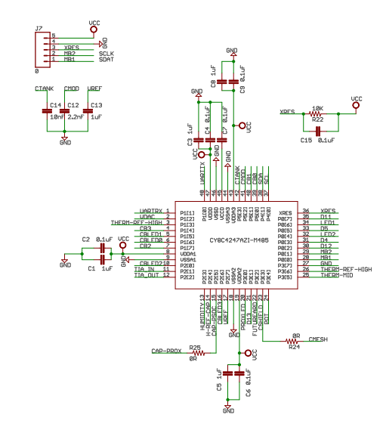

Function Requirements
The PSoC will operate in two modes – normal mode and bootloader mode. The device will power up in normal mode. To enter bootloader mode, the user must hold down the two mechanical buttons and turn the potentiometer across a voltage change of at least 1V. Once in bootloader mode, the 2 LEDs next to the buttons will flash in an alternating pattern. The device will stay in bootloader mode until new firmware is loaded, or until the device is reset (XRES or power cycle).
In normal mode the PSoC: interfaces to the analog sensors; supplies a DAC output voltage; supplies CapSense buttons, proximity, and humidity sensor measurements; monitors mechanical buttons; drives LEDs; and provides an EZ-I2C slave interface to the base board.

Signal/Data Bus Inputs and Outputs to/from the Block
Pin | Net Name | Function
P00 | MB1 | Mechanical Button 1 / SDAT
P01 | MB2 | Mechanical Button 2 / SCLK
P02 | D12 | Arduino D12 / User Access to Mechanical Button 2
P03 | D4 | Arduino D4 / User Access to Mechanical Button 1
P04 | LED1 | LED1
P05 | D5 | Arduino D5 / User Access to LED2
P06 | LED2 | LED2
P07 | D11 | Arduino D11 / User Access to LED1
P10 | UARTTX | UART Tx from baseboard, UART Rx to PSoC
P11 | UARTRX | UART Rx to baseboard, UART Tx from PSoC
P12 | VDAC | Arduino A0 / VDAC Output
P13 | THERM-REF-HIGH | High input to Thermistor / Driven by Ref and Opamp
P14 | CB3 | CapSense Button 3
P15 | CBLED1 | LED for CapSense Button 1
P16 | CBLED0 | LED for CapSense Button 0
P17 | CB2 | CapSense Button 2
P20 | CBLED2 | LED for CapSense Button 2
P21 | TIA_IN | Ambient Light Sensor input to TIA
P22 | TIA_OUT | Arduino A0 / Ambient Light Sensor output from TIA
P23 | HUMIDITY | Humidity Sensor (CapSense)
P24 | H-REF-CAP | Humidity Sensor Reference Capacitor
P25 | CAP-PROX | CapSense Proximity Sensor
P26 | CBLED3 | LED for CapSense Button 3
P27 | VREF | Reference Bypass Capacitor
P30 | PROXLED | LED for CapSense Proximity
P31 | D13 | Arduino D13 / CapSense Interrupt
P32 | FUTUREARD | Arduino D2 / Unused Header Connection to PSoC
P33 | CSHIELD | CapSense shield under proximity sensor
P34 | POT | Arduino A2 / Potentiometer voltage input to ADC
P35 | THERM-MID | Thermistor resistor divider / Input to ADC
P36 | THERM-REF-HIGH | High input to Thermistor / Input to ADC
P37 | GND | Ground input to ADC for thermistor
P40 | SCL | Arduino SCL / I2C Clock
P41 | SDA | Arduino SDA / I2C Data
P50 | CB0 | CapSense Button 0
P51 | CB1 | CapSense Button 1
P52 | CMOD | CMOD for CapSense
P53 | CTANK | CTANK for CapSense

Clock and Block Timing Requirements
All clocks are internal to the PSoC. It has a 24MHz IMO and 40kHz ILO.

Power Requirements
There is no specific power budget for the PSoC. Power input filtering is done per the PSoC datasheet recommendations.

Design Trade-Offs
A PSoC was chosen for this device to provide cross-selling of PSoC as an AFE and CapSense user interface.

Hardware-Specific
N/A

OLED Display

Detailed Circuit Description
This block is a complete I2C OLED display module. It contains an SSD1306 controller and a 128x64 pixel dot-matrix OLED.
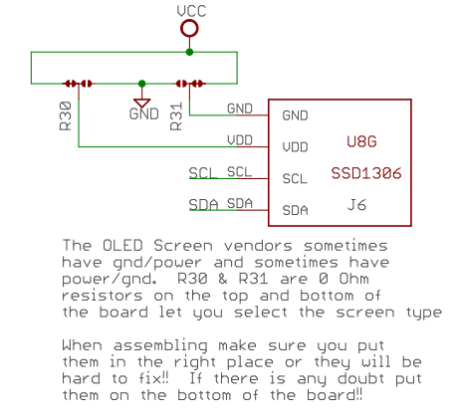

Function Requirements
The OLED must be able to be controlled using the I2C pins either from the PSoC or the baseboard. In its default configuration, the PSoC is an I2C slave and does not control the OLED.

Signal/Data Bus Inputs and Outputs to/from the Block
The OLED display uses I2C to communicate. It is an I2C slave with address 0x3C. It is connected to the standard Arduino I2C pins on the digital header.
Module pinouts vary from vendor to vendor and sometimes from the same vendor. Specifically, the order of the power and ground pins is sometimes reversed. To handle that situation, there are two 0-ohm resistors on the board that can be changed to swap the power/ground connections to the display.

Clock and Block Timing Requirements
The block requires valid I2C clock/data timing.

Power Requirements
N/A

Design Trade-Offs
N/A

Hardware-Specific
N/A

Arduino Interface

Detailed Circuit Description
A set of Arduino headers is provided for connection to a baseboard.
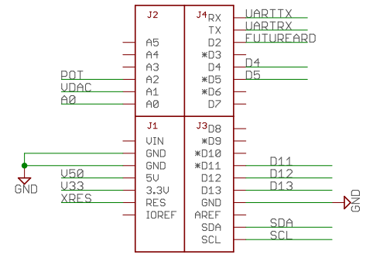

Function Requirements
The headers must match the Arduino Uno formfactor so that it will work with all Arduino Uno compatible kits.

Signal/Data Bus Inputs and Outputs to/from the Block
The Arduino pins are assigned as follows:
Arduino  Pin | Kit Function
A0 | Ambient Light Sensor (after TIA implemented in the PSoC)
A1 | DAC voltage (implemented in the PSoC)
A2 | Potentiometer
A3 | N/C
A4 | N/C
A5 | N/C
D0 | UART RX (connected to PSoC)
D1 | UART TX (connected to PSoC)
D2 | GPIO (unused pin from PSoC available for custom firmware)
D3 | N/C
D4 | Mech Button 1 (physically connected to PSoC Smart IO)
D5 | LED 1 (physically connected to PSoC Smart IO)
D6 | N/C
D7 | N/C
D8 | N/C
D9 | N/C
D10 | N/C
D11 | LED 0 (physically connected to PSoC Smart IO)
D12 | Mech Button 0 (physically connected to PSoC Smart IO)
D13 | CapSense Interrupt (connected to PSoC)
SDA | I2C SDA (connected to PSoC and OLED display)
SCL | I2C SCL (connected to PSoC and OLED display)
IOREF | N/C
AREF | N/C
RES | Reset (connected to PSoC XRES)
VIN | N/C
5V | 5V power option (selectable using resistor or jumper)
3.3V | 3.3V power option (selectable using resistor or jumper)
GND | Ground

Clock and Block Timing Requirements
N/A

Power Requirements
N/A

Design Trade-Offs
N/A

Hardware-Specific
N/A

User Interface (Buttons, LEDs, CapSense)

Detailed Circuit Description
The user interface consists of 2 mechanical buttons, 4 CapSense buttons, 1 CapSense proximity loop, and 7 LEDs (one next to each button, and one for the proximity loop).
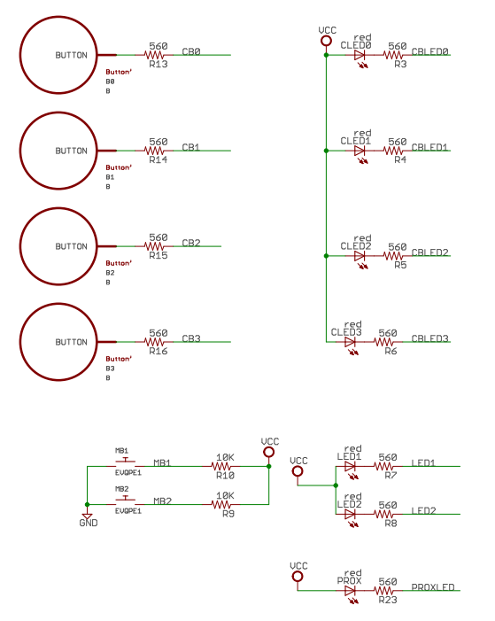

Function Requirements
Each of the user interface elements is connected to the PSoC. The mechanical buttons and their associated LEDs are connected via the SmartIO component to Arduino shield pins. This allows the PSoC to control them in hardware such that they appear to the baseboard to be directly connected to the Arduino pins, but the PSoC can take control of them when necessary without causing contention. For example, in bootloader mode, the LEDs flash in an alternating pattern even though the base board might be doing something different to the Arduino
“LED” pins.

Signal/Data Bus Inputs and Outputs to/from the Block
The mapping of the buttons and LEDs to/from the Arduino headers via the PSoC is shown below. Note that to the user who is interfacing from a baseboard, it appears as if the buttons and LEDs are connected directly to the headers – they don’t need to interact with the PSoC to control them.
Component | <- PSoC Pin | SmartIO | PSoC Pin -> | Arduino Pin
MB1 | P0.0 | Direct -> | P0.3 | D4
MB2 | P0.1 | Direct -> | P0.2 | D12
LED1 | P0.6 | <- Invert | P0.7 | D11
LED2 | P0.4 | <- Invert | P0.5 | D5

Clock and Block Timing Requirements
N/A

Power Requirements
N/A

Design Trade-Offs
N/A

Hardware-Specific
N/A

Analog Sensors and DAC Output

Detailed Circuit Description
The analog sensors on the board are:
- Thermistor
- Ambient Light
- Humidity
- Potentiometer
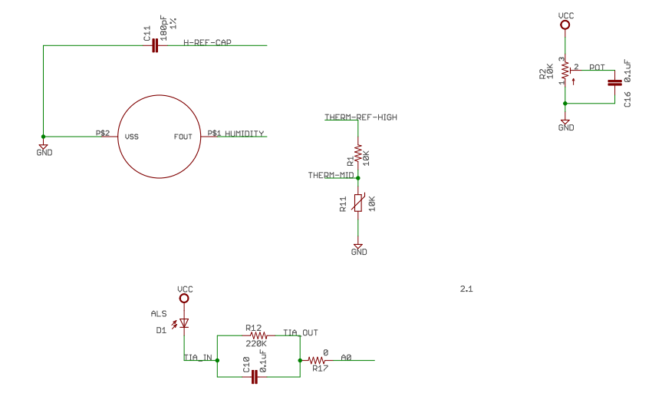

Function Requirements
The thermistor, ambient light sensor, and potentiometer are sampled by the ADC on the PSoC every 100ms. The humidity sensor is measured using the CapSense block.
The ambient light sensor and potentiometer are also routed to the Arduino Analog pins. In the case of the ambient light sensor, it is connected to the Arduino pins after the TIA on the PSoC so it is possible to still use the PSoC Opamp to provide the TIA functionality and then read the value from a baseboard connected to A0.
The PSoC outputs a DAC voltage that is programmable from 0V – 2.4V using an I2C register. This is buffered by an Opamp before being sent to the Arduino header.

Signal/Data Bus Inputs and Outputs to/from the Block
Sensor | Connection | PSoC Pin | Arduino Pin
Thermistor | Voltage Divider (Mid) | P3.5 | N/A
 | Reference | P3.6 | N/A
Ambient Light | TIA In | P2.1 | N/A
 | TIA Out | P2.2 | A0
Humidity | Sensor | P2.3 | N/A
 | Reference Cap | P2.4 | N/A
POT | POT Voltage | P3.4 | A2
DAC | DAC Voltage | P1.2 | A1

Clock and Block Timing Requirements
N/A

Power Requirements
N/A

Design Trade-Offs
The thermistor is not routed to the Arduino headers because there is only 1 available Arduino analog pin, but the thermistor requires 2 pins to get an accurate measurement (high side reference voltage and voltage divider mid-point). In addition, many baseboards being used cannot easily provide an accurate reference voltage for the high side reference.

Hardware-Specific
N/A

Power Supply

Detailed Circuit Description
The power supply comes directly from the Arduino header pins. It can be powered either from the 3.3V pin (default) or the 5V pin.
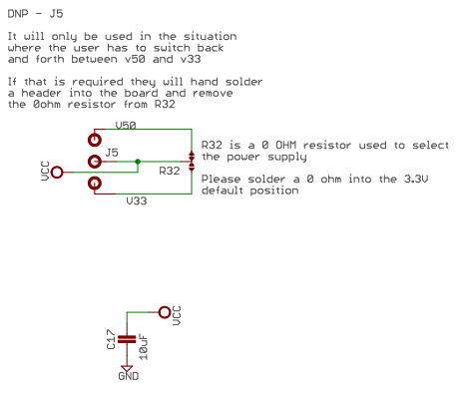

Function Requirements
By default, the power is supplied from the Arduino 3.3V pin. There is a 0-ohm resistor that makes this selection. The resistor can be moved to an alternate position to supply power from the Arduino 5V pin instead.
An additional alternative is also provided in parallel with the 0-ohm resistor selection. This alternative is a 3-pin header (100mil center pin spacing). By using this option, power can be switched from 3.3V to 5V by just moving a jumper position. In this case, the resistor would be removed.

Signal/Data Bus Inputs and Outputs to/from the Block
N/A

Clock and Block Timing Requirements
N/A

Power Requirements
N/A

Design Trade-Offs
The 3.3V – 5V power selection is done using a 0-ohm resistor while the 3-pin header is an unpopulated option. This is done to minimize complexity of the board and to reduce cost. The vast majority of users will use the 3.3V option so this is an acceptable tradeoff.

Hardware-Specific
N/A

Firmware Design

CapSense and LEDs

Application Functionality
The CapSense system reads the state of 4 CapSense buttons, 1 proximity sensor, a humidity sensor, and a humidity reference capacitor. Each of the 7 widgets is scanned and read individually in a state machine. This allows independent control over scanning settings. For example, the driven shield can be enable during proximity loop scanning but can be disabled for other scans.
Once data is available, it is saved in the appropriate I2C register and the appropriate LED is turned ON/OFF if applicable. If the CapSense button state has changed (i.e. if a button has been pressed or released) the CapSense Interrupt signal goes high for a period of 1ms – 2ms.
The LEDs associated with the CapSense buttons can be configured so that they are controllable from an I2C register instead of by the CapSense buttons. See the I2C section for details.
In the case of humidity, each time the sensor and reference capacitor have been scanned, the humidity value is calculated.

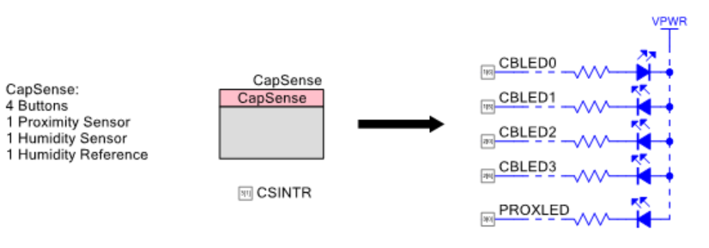
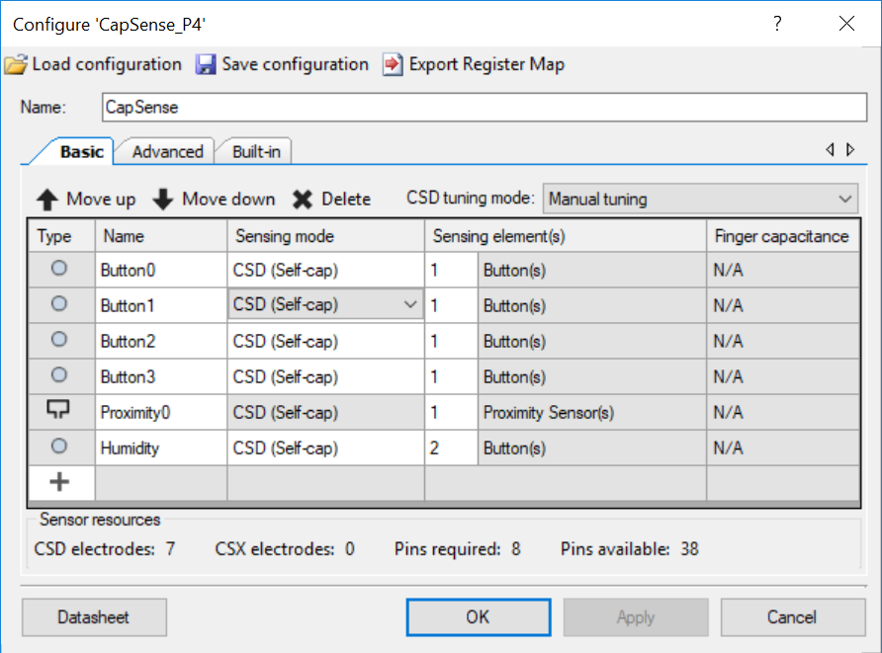

Human Interface
The 4 buttons and proximity sensor are the user interface for this module.

Data Types
Data from this block is contained in 2 I2C registers – one for button/proximity status and one for humidity. See the I2C section for details.

Control Structures
Selection of widgets in a round-robin fashion is done in the firmware using a case statement to step through each widget one at a time.

Application Development Environment
The button/proximity and humidity I2C registers are available for users in their applications. See the I2C section for details.

Firmware-Specific
N/A

Characteristics
N/A

Buttons and LEDs

Application Functionality
The two mechanical buttons and their associated LEDs appear to the user as if they were directly connected to the Arduino pins. However, they really connect to the PSoC and are routed to the Arduino pins using the SmartIO component.
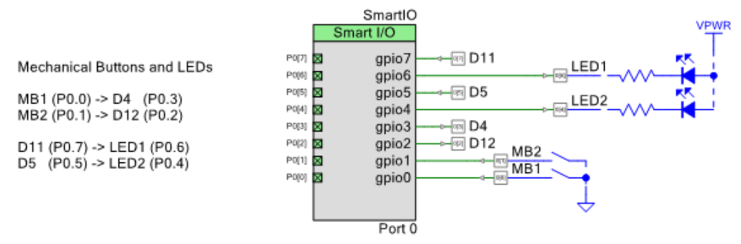
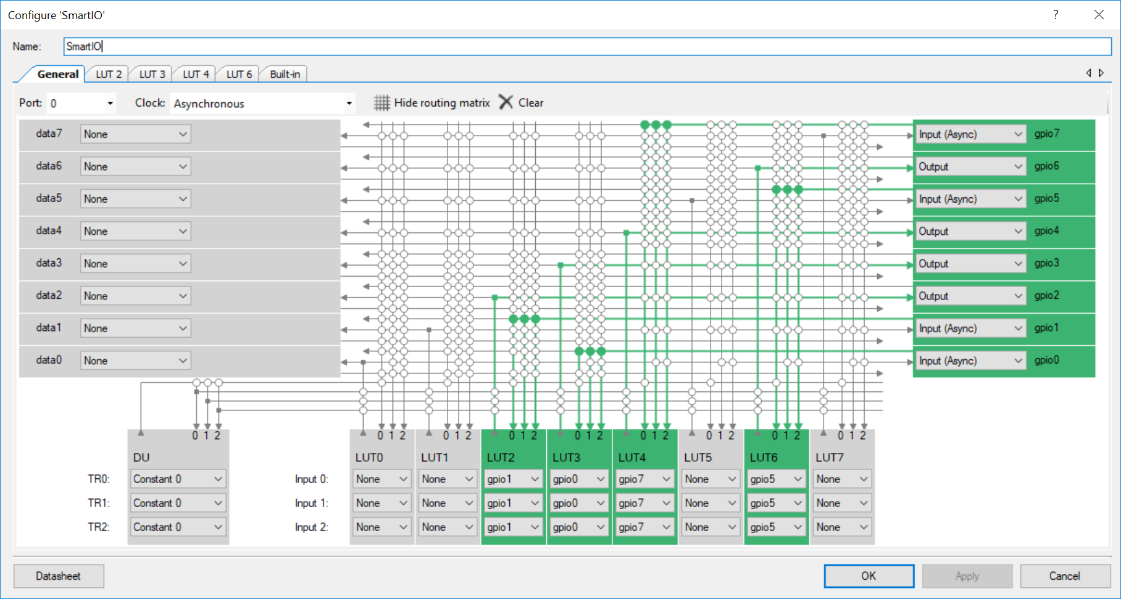
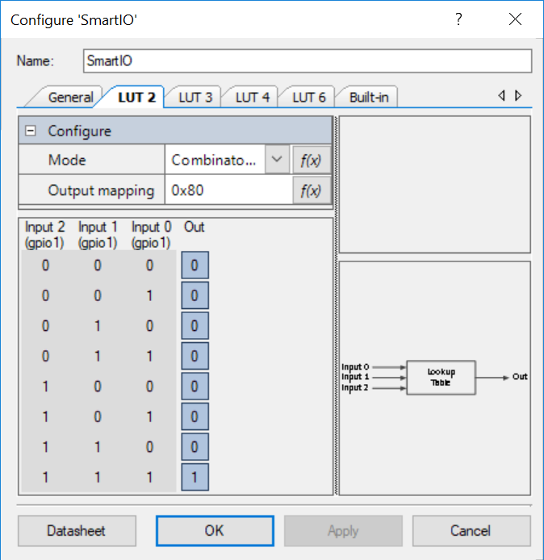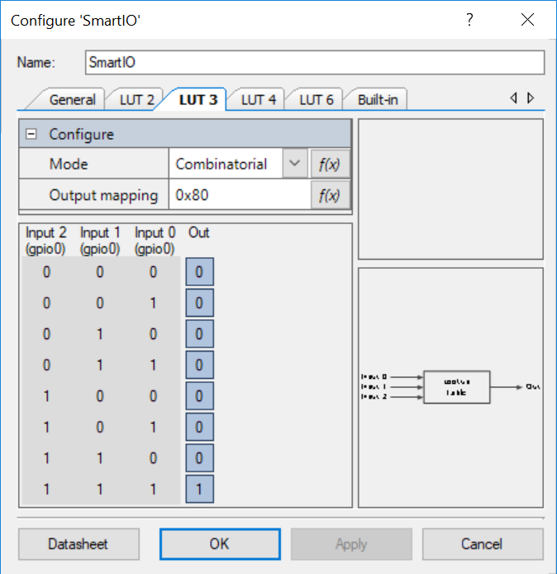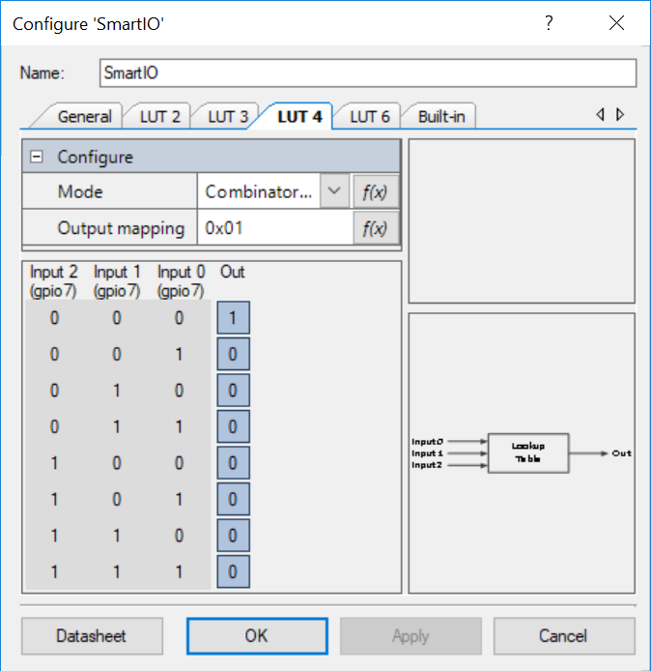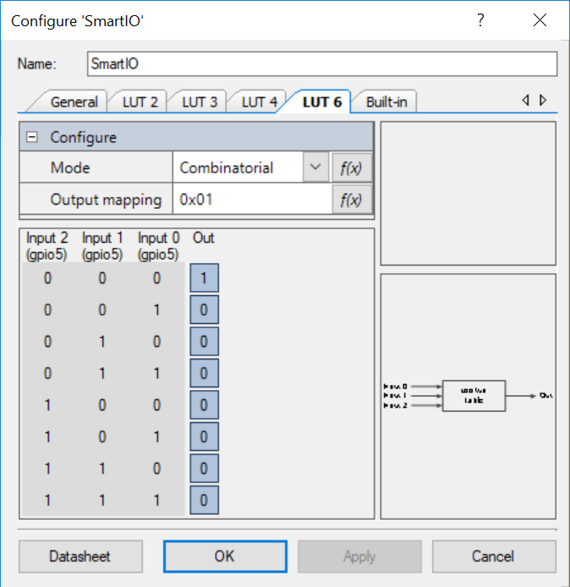

Since this is handled in hardware, the firmware does not need to handle this functionality. However, the firmware does monitor the buttons for entry into bootloader mode. Moreover, once in bootloader mode, the LEDs next to the buttons flash in an alternating pattern. This is done using a PWM in the bootloader project.

Human Interface
The buttons and LEDs are the user interface for this module.

Data Types
The state of the mechanical buttons is contained in an I2C register. See the I2C section for details.

Control Structures
N/A

Application Development Environment
The button I2C register is available for users in their applications. See the I2C section for details.

Firmware-Specific
N/A

Characteristics
N/A

ADC

Application Functionality

The ADC has 4 differential channels as shown below. conversion is started in firmware once every 100ms by a timer. The ADC sequences through all 4 channels each time a conversion is started. When a conversion cycle completes, an interrupt is triggered. The ISR just copies the ADC results to an array and the ADC state flag to PROCESS so that the data will be processed.
In the main firmware loop, when the state is PROCESS, the ambient light, temperature, and potentiometer values are calculated and then stored to the appropriate I2C register (see the I2C section for details).
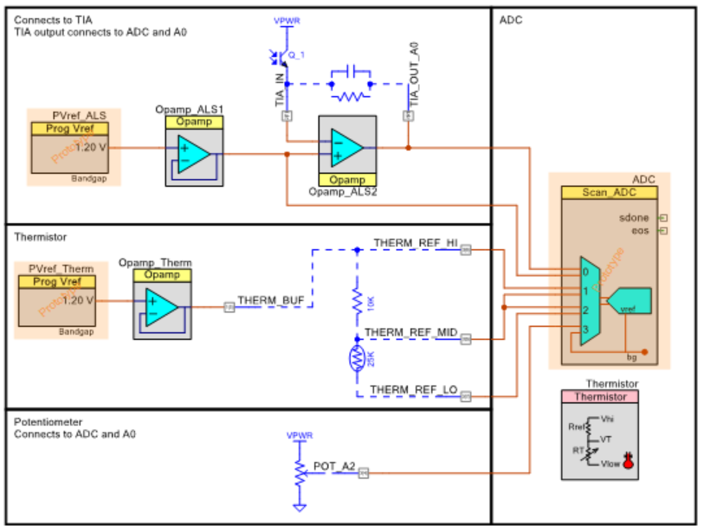

Human Interface
N/A

Data Types
The ambient light, temperature, and potentiometer values are provided as 32-bit floating point values over I2C (4 I2C registers per value).

Control Structures
The adcState variable has three states: DONE, RUNNING, and PROCESS. It begins in the DONE state. Every 100ms when the timer expires, if the state is DONE, it changes it to RUNNING and starts the ADC. When the ADC completes a conversion, the ISR copies the raw results and sets the state to PROCESS. Once the firmware processes the results, it sets the state back to DONE so that the next conversion can start.

Application Development Environment
N/A

Firmware-Specific
N/A

Characteristics

DAC

Application Functionality
There is a DAC whose value can be set from 0V – 2.4V using I2C. The selected value is buffered using an OpAmp and is then sent to the Arduino pin. The main firmware loop looks at the I2C register value, compares it to the DAC’s current value, and updates the DAC value if they are different.
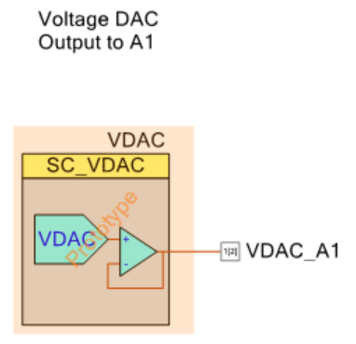

Human Interface
The DAC voltage is selected using I2C. See the I2C section for details.

Data Types
N/A

Control Structures
N/A

Application Development Environment
The DAC value is available via I2C. See the I2C section for details.

Firmware-Specific
N/A

Characteristics

I2C

Application Functionality
An I2C interface is provided for communicating the following information from/to the baseboard:
- Reading analog sensor values
- Setting DAC output voltage
- Reading button states (Mechanical, CapSense, and Proximity)
- Enabling I2C control of the 4 LEDs next to the CapSense buttons and setting their value
The I2C interface is a slave that will operate up to 400kHz. It uses the EZ-I2C protocol and has a slave address of 0x42.
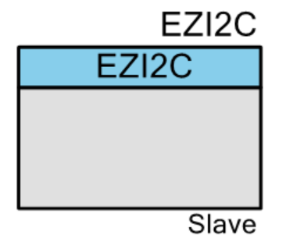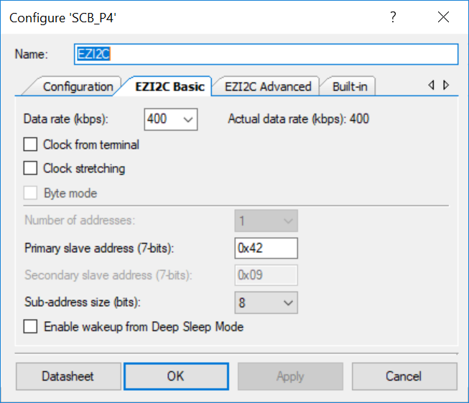

Human Interface
The human interface to this module is I2C.

Data Types
The I2C register map is shown in the table below. These are the EZ-I2C offset values used for reading from the slave.
Offset | Description | Format | Details
0x00 | DAC Voltage | 4 Byte Float | Desired DAC voltage in Volts
0x04 | LED Value | 1 Byte | CapSense LED values if LED Control bit 1 is 1.  Mapping is:  Bit 0: CSLED0  Bit 1: CSLED1  Bit2: CSLED2  Bit3: CSLED3
0x05 | LED Control | 1 Byte | Bit 0 sets how the 4 CapSense LEDs are controlled:  0 = CapSense Control  1 = Base Board Control via the LED Value Register
0x06 | Button State | 1 Byte | State of CapSense, Proximity, and  Mechanical Buttons:  Bit 0: CapSense B0  Bit 1: CapSense B1  Bit 2: CapSense B2  Bit 3: CapSense B3  Bit 4: Mechanical Button 1  Bit 5: Mechanical Button 2  Bit 6: Proximity
0x07 | Temperature | 4 Byte Float | Temperature reported in °C
0x0B | Humidity | 4 Byte Float | Humidity reported in %
0x0F | Ambient Light | 4 Byte Float | Ambient light reported in Lux
0x13 | Potentiometer | 4 Byte Float | Potentiometer reported in Volts

Control Structures
N/A

Application Development Environment
The I2C registers are available to the user via the EZ-I2C protocol.

Firmware-Specific
N/A

Characteristics

Bootloader

Application Functionality
The bootloader is a separate application that allows the application firmware to be updated over the I2C interface.
The I2C interface is a slave that can run up to 100kHz and has an I2C address of 0x42.
The only other functionality in the bootloader project is a PWM connected to 2 SmartIO pins (one connected to line and the other to line_n) which then drives 2 LEDs on the board. The PWM has a period of 1 second and a compare of 0.5 second. This results in the 2 LEDs flashing in an alternating pattern every 0.5 second.
Once bootloader mode is entered, it cannot be exited except by a chip reset (XRES or power cycle) or by loading new firmware.
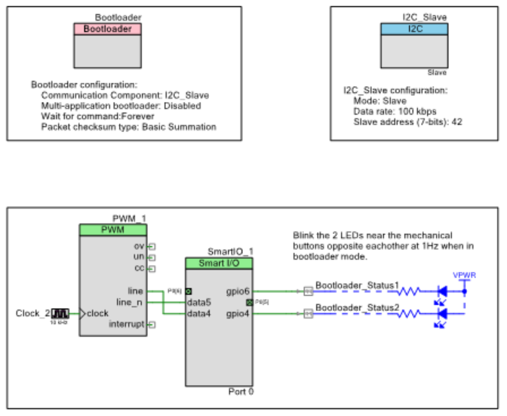

Human Interface
N/A

Data Types
N/A

Control Structures
N/A

Application Development Environment
N/A

Firmware-Specific
N/A

Characteristics

Software Design
N/A – There is no software for this kit.

Mechanical
No mechanical enclosure or overlay as part of this kit

Manufacturing
The Manufacturing test procedure will use CY8CKIT-044 as a base board and interact with PC using UART. The Code example will be modified to work as a manufacturing test software which will be integrated with Python to log the data. MiniProg3 will be used to program the shield board and on board KitProg2 will be used to program the base board.

Quality Requirements:

System Hardware Design for Test
Adequate Test Points will be provided for all critical signals (Power
domains). All the IO lines are brought to a header which can also be used for debugging purpose.

System Firmware Design for Test
Code example are to be tested in terms of performance. Apart from that, CapSense performance in terms of SNR, Cp and Raw count needs to be done.

System Software Design for Test
N/A – There is no software for this kit.

System Test Framework Design
N/A – There is no CyInstaller for the kit. Zip package will be added to website.

Test Server Infrastructure
N/A

Test Interface Application
N/A

Test Modules
N/A

ComplIance requirements

System Hardware Design for USB certification requirements
The shield will be powered from the Arduino header interface. Therefore, all power will be supplied by the baseboard. This kit will not connect to USB directly.

System Hardware Design for EMI/EMC compliance
No EMI/EMC testing will be performed on this shield.

System Hardware Design for other compliance requirements
The kit must support I2C operation at a minimum of 100kHz.

Records:
Storage location and retention period for records is specified in procedure 00-00064 Cypress Record Retention Policy.

Preventive Maintenance: N/A

Posting Sheets/Forms/Appendix

Appendix 1 - Requirements Traceability Matrix
Appendix 1

Requirements Traceability Matrix
This table maps the System Product requirements set forth in the EROS to the sections and sub-sections within the IROS that define the design requirement.
The table is to be used to develop a comprehensive list of specifications that the Engineering team must meet. It is reviewed at every Design Review to ensure that all requirements are being implemented.

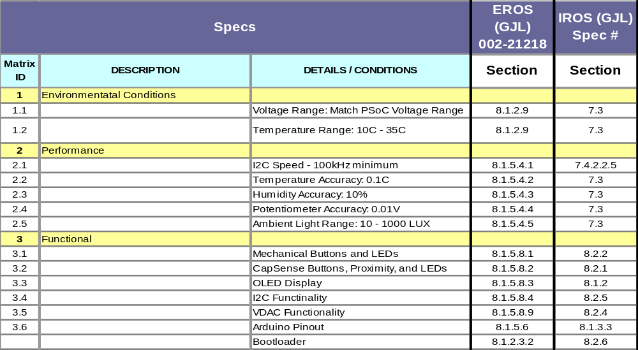
Rev. | ECN No. | Orig. of Change | Description of Change
** | 5932569 | GJL | New release.
*A | 5955717 | GJL | Minor changes to fix typos.  Added in hardware introduction that we use Eagle for this design.

