# Eletronica 2018 Demo Hardware

## Base

The base includes a custom liquid level sense shield board, an “arm” switch, and a “start/pause” switch. The base is constructed of clear acrylic. There are two standoffs for attaching the shield/pioneer kit assembly to the base.

The pioneer kit should be powered through the USB debug connection; this also provides for serial communications with the kit. The remaining external connections are on the shield or base. On the base is a small amplifier module, with two RCA jacks for speaker connections. The audio level can be adjusted by the multi-turn potentiometer R6.

The shield requires +12V for pump power. A 2.1mm center positive barrel connector is provided at J5, as shown in figure 1.

The pumps are connected to screw terminals P9 and P10, as shown in figure 1. Note the polarity difference between the left and right pumps.

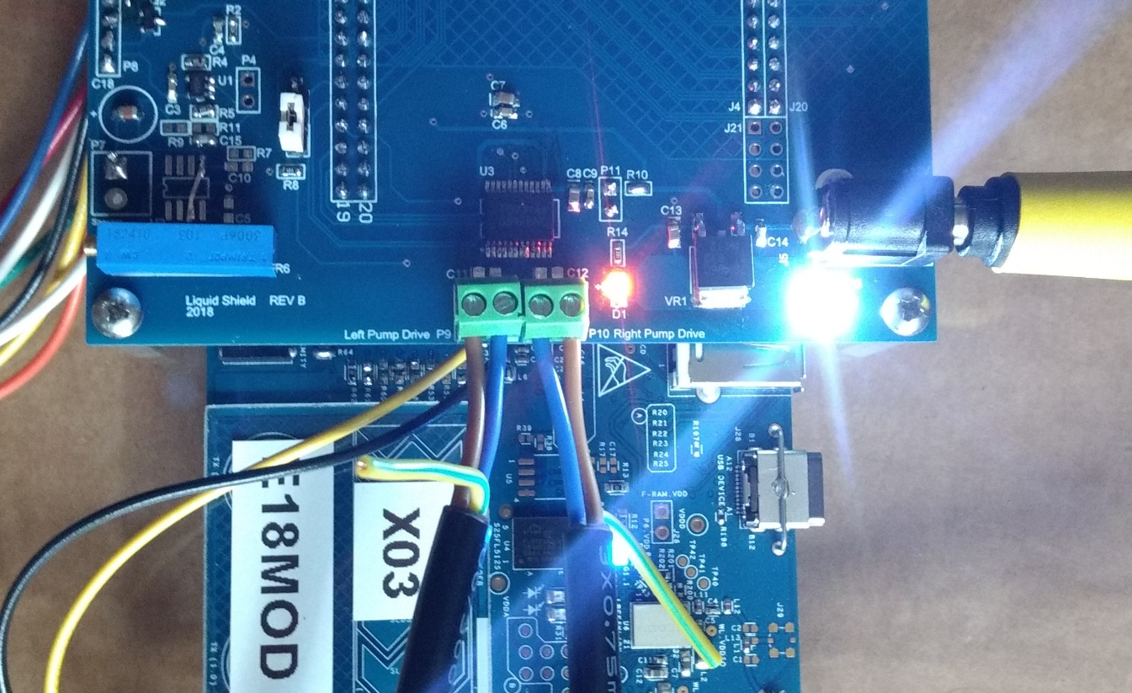

Figure 1

Liquid level sensors are connected via right angle headers P2 and P6. The shield includes a level shifter for serial communications with the strip LED drive box on P3.

## Pioneer Kit Modifications

The shield requires component changes to route the required i/o to the shield headers. Table 1 lists changes, the general location on the pioneer board, and illustration number. The option resistors are zero ohm and may be populated with a solder blob.

|  |  |  |  |
| --- | --- | --- | --- |
| **Pin** | **Change** | **Location** | **Figure** |
| P1.5 | Remove R27 | Top, upper right near RGB LED | 2 |
| P7.0 | Populate R181 | Bottom side, lower middle | 3 |
| P7.3 | Remove C29 (see note) | Top side middle | 4 |
|  | Insure R146 populated | Bottom side middle | 3 |
| P7.4 | Populate R178 | Bottom side, lower middle | 3 |
| P7.5 | Populate R179 | Bottom side, lower middle | 3 |
| P7.6 | Populate R180 | Bottom side, lower middle | 3 |
| P8.0 | Populate R64 | Top, near capsense features | 5 |
| P8.1 | Remove R61; Populate R172 | Top and bottom, near capsense features | 5, 6 |
| P8.2 | Remove R60; populate R166 | Top and bottom, near capsense features | 5, 6 |
| P8.3 | Remove R53; populate R153 | Top and bottom, near capsense features | 5, 6 |
| P8.4 | Remove R52; populate R152 | Top and bottom, near capsense features | 5, 6 |
| P8.5 | Remove R47; populate R149 | Top and bottom, near capsense features | 5, 6 |
| P8.6 | Remove R58; populate R158 | Top and bottom, near capsense features | 5, 6 |
| P8.7 | Remove R59; populate R160 | Top and bottom, near capsense features | 5, 6 |
| P9.3 | Populate R162 | Bottom side, lower middle | 3 |
| P11.0 | Remove R173; populate R175 | Bottom side, lower middle | 7 |
| P11.2 | Remove R176; populate R177 | Bottom side, lower middle | 7 |
|  |  |  |  |
| Note: Pioneer kit hardware modified in ORDC does not match description in Pioneer kit guide; the guide states C29 is not populated | | | |

*Table 1*

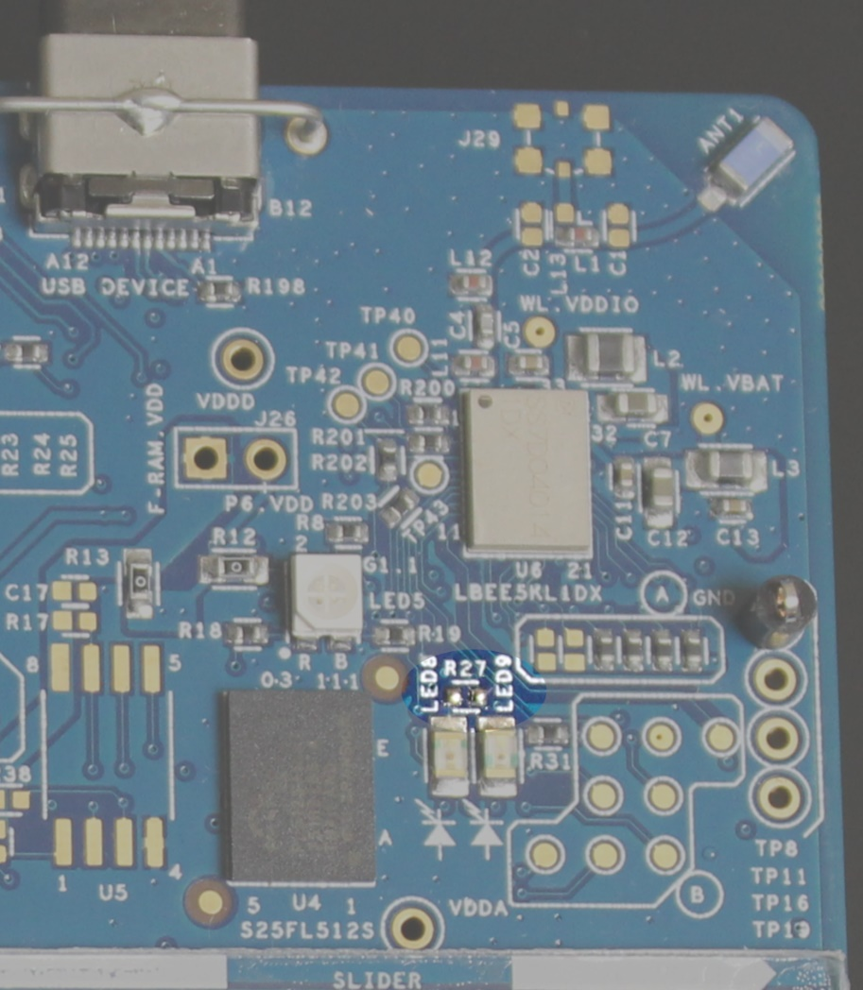

Figure 2

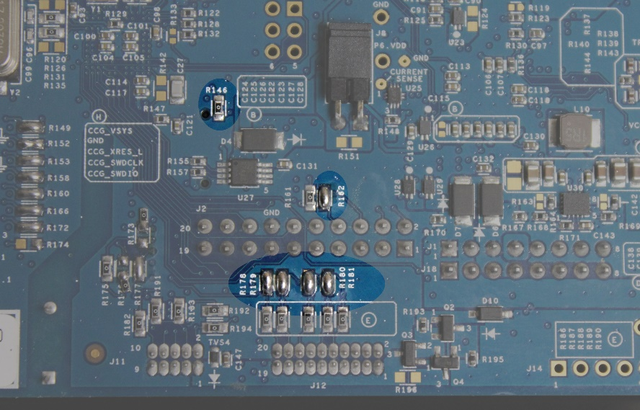

Figure 3

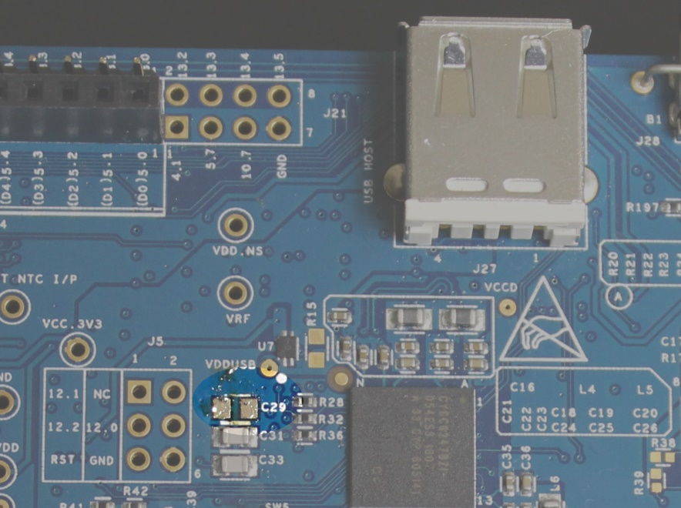

Figure 4

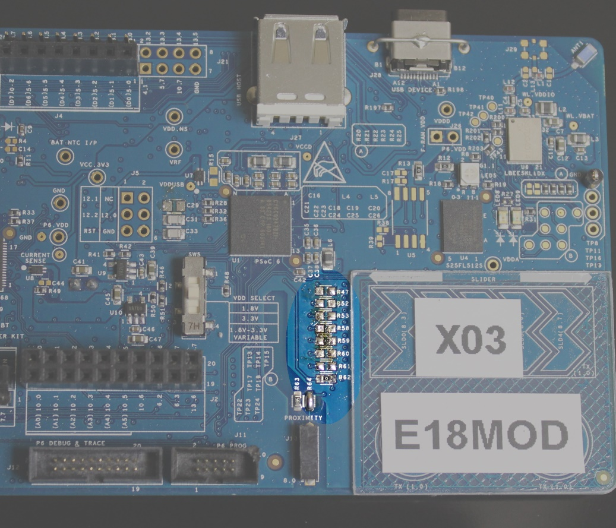

Figure 5

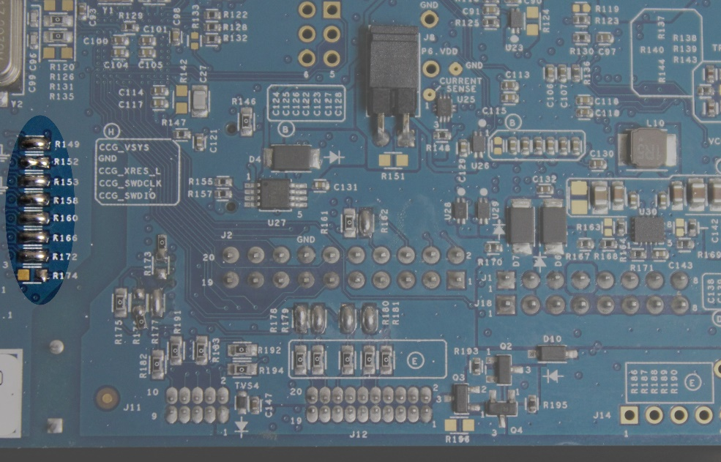

Figure 6

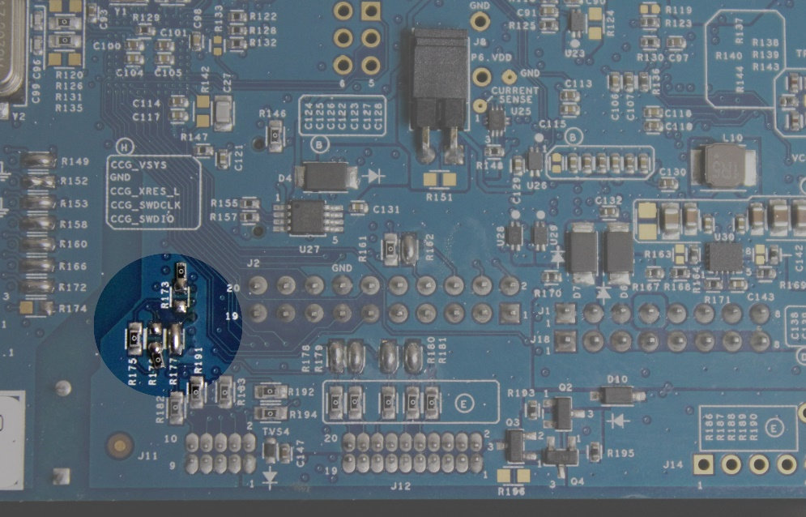

Figure 7

## Strip LEDs and Drive Box

The strip LED connections use the unique color code for WS2812 based LED strips: red +5V, white ground, green signal. The drive box is supplied with two three-pin JST connectors for the strips. Power for the drive box comes in on the left side +5V. The LED strips must be individually powered with +5V supplies.

The drive box connects to the base shield with ground (black) and signal (green) wires. These connect to wire terminal P3, ground to pin 3, signal to pin 2. See figure 8.

The drive box is based on the CY8CKIT-142 PSoC 4 BLE module. Firmware upgrades can be performed by removing box lid held in place by four screws and accessing the five-pin programming header JP19 as shown in figure 9.

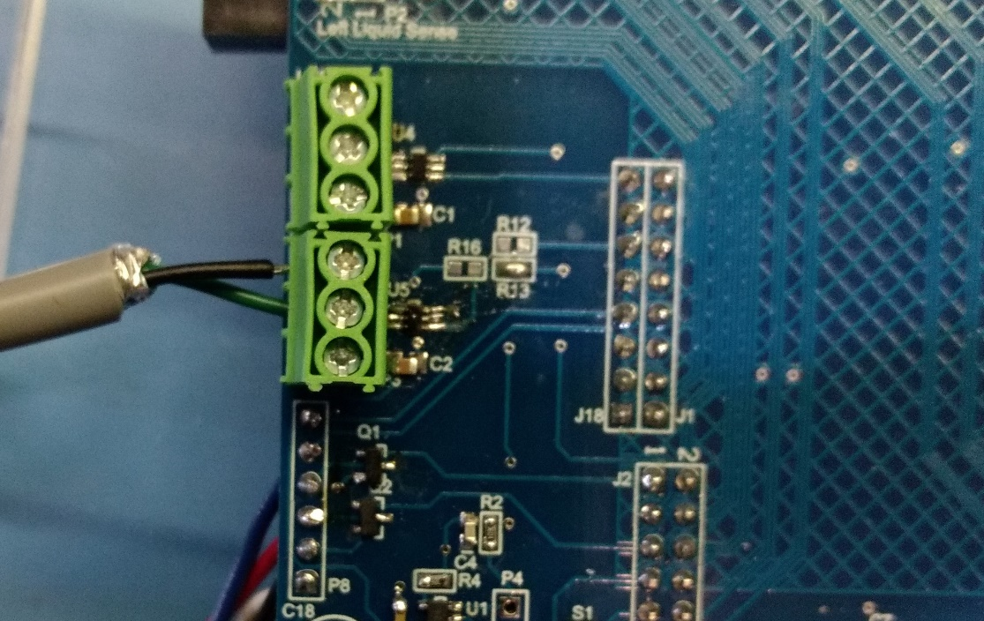

Figure 8

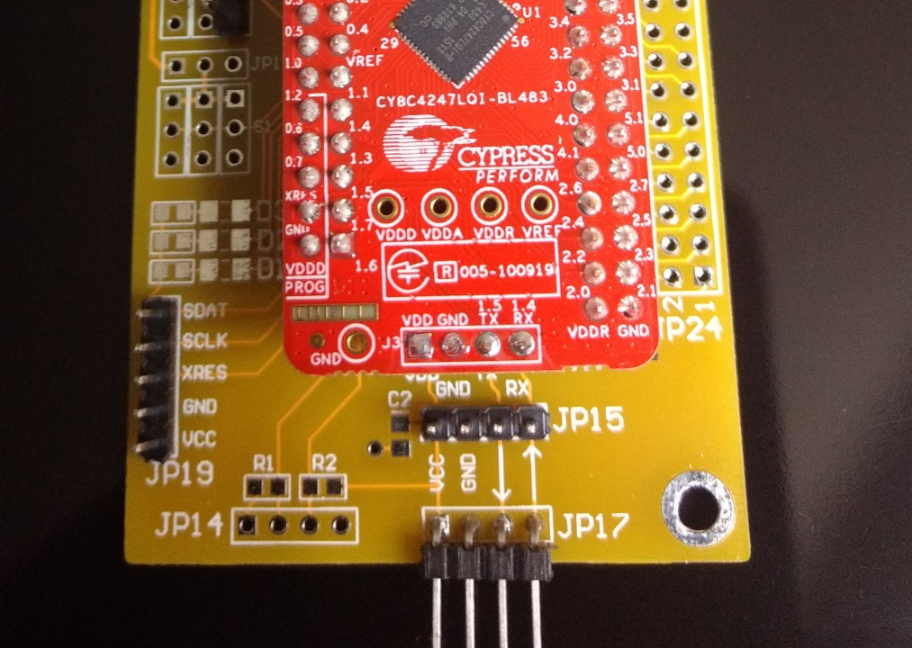

Figure 9