Step 1: Add small strip of foam mounting tape to the inside of the case. There is a rectangle in the plastic that shows where the tape should be placed.

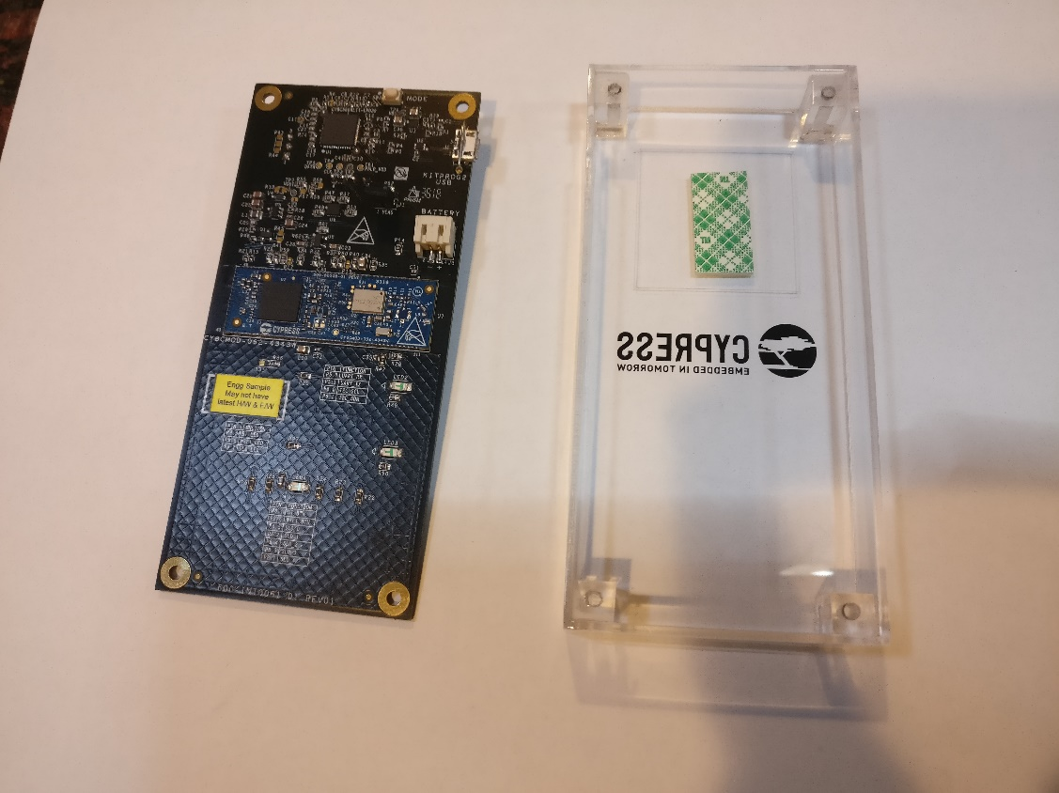

Step 2: Attach the battery to the case with the foam mounting tape. It is best if the wire is towards the bottom of the case and wraps around to the top-left as shown.

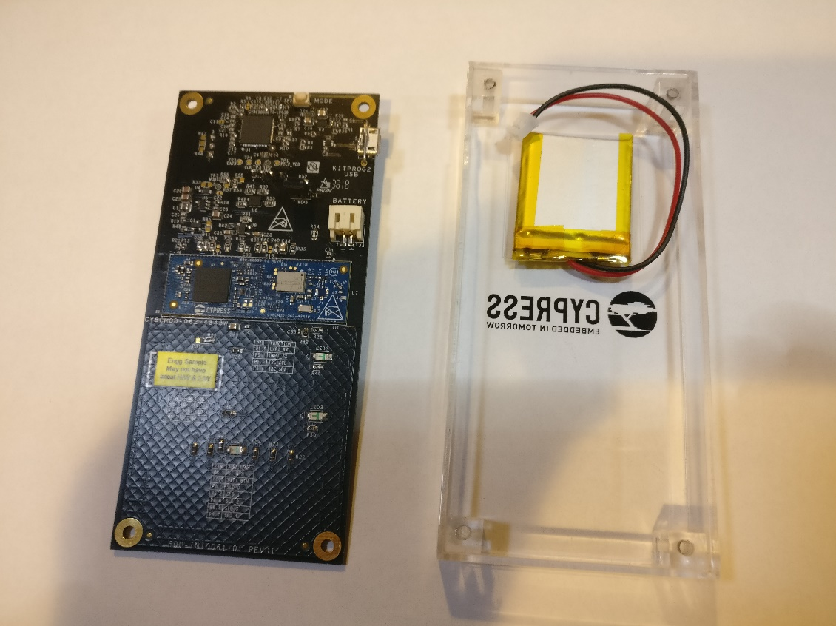

Step 3: Connect the battery to the board.

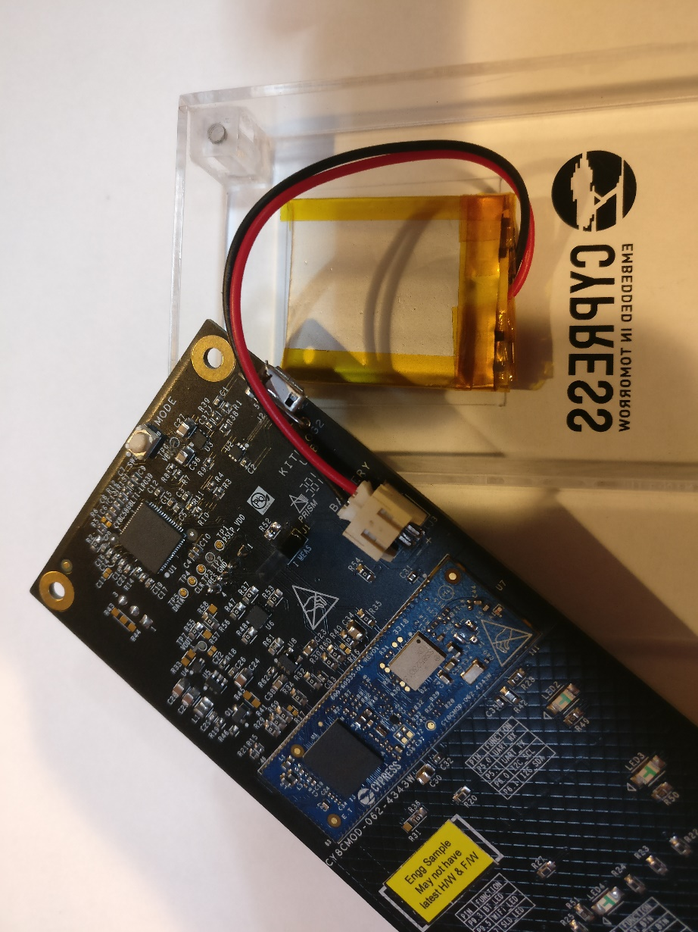

Step 4: Align the board with the case.

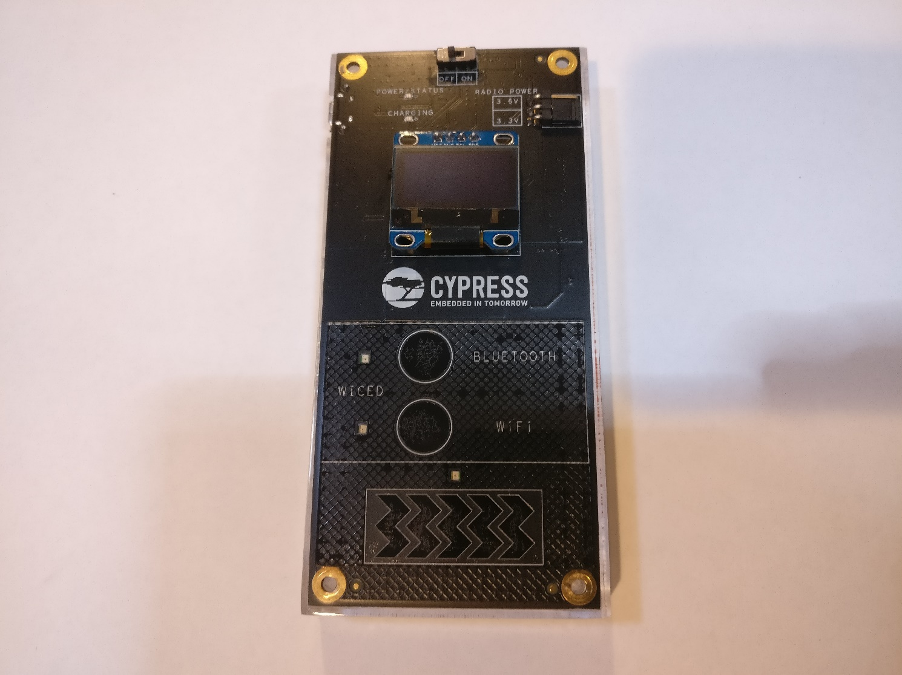

Step 5: Attach the board to the case with 4 screws.

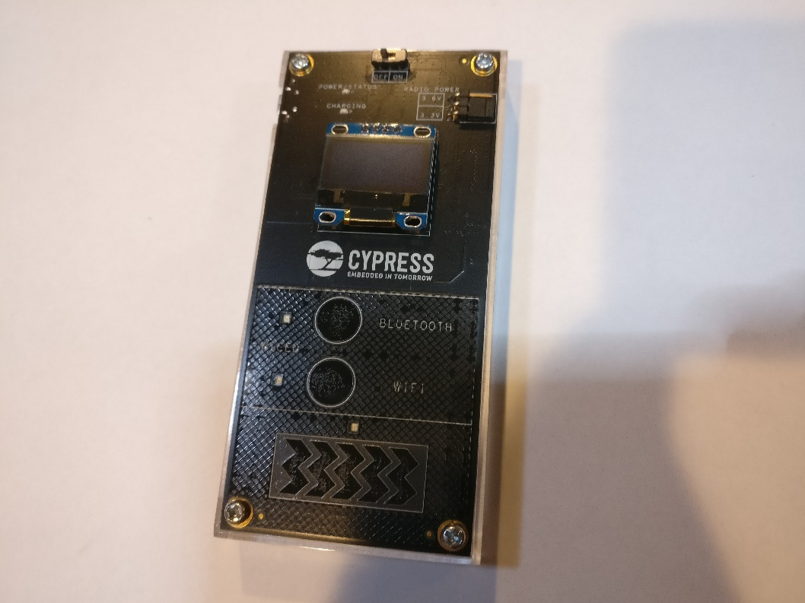

The fully assembled board should look like this from the back side:

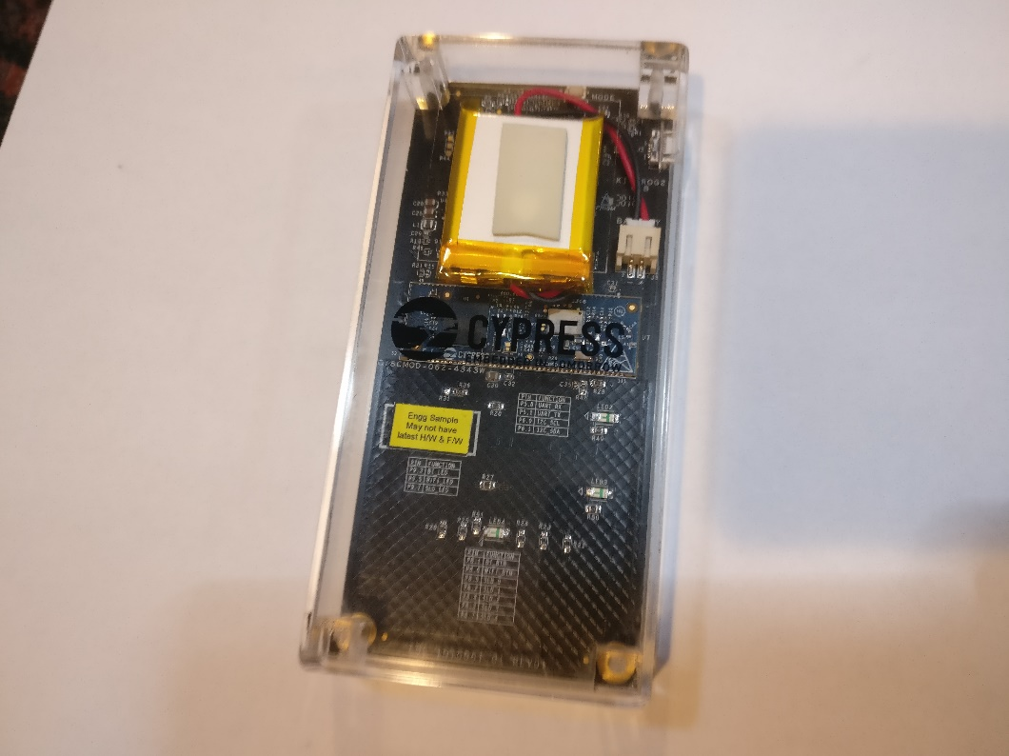

Step 6: plug the board into a USB port to charge the battery. The RED led will turn on while charging. It will turn off when the battery is fully charged.

Step 7: Program the boards with the latest firmware (this might be done during manufacturing – it depends on when we have it ready).