Spec System User Guide

**Table of Contents**

1. Purpose / Scope 3

2. Reference Documents 3

3. Overview 3

4. Login 3

5. Spec Processing 3

5.1 Create new Spec 4

5.2 Revise an existing Spec 4

5.3 Update spec in Draft state 4

5.4 Submit for Approval 5

5.5 Review 5

5.6 Approved 5

6. Screens 6

6.1 Spec (Home screen) 6

6.2 User Detail 7

# Purpose / Scope

Purpose – This document is intended to describe how to perform common user tasks related to viewing, creating, approving and revising specs.

Scope – This document is focused on features that anyone authenticated to the system can use. Out of scope are administrative functions.

# Reference Documents

N/A

# Overview

Spec System is a light-weight solution for document control. It is a controlled system for releasing, revising and obsoleting documents.

Each numbered spec is revised and released independently. It will have one or more files attached to it. It must be signed by at least one person before it is made active.

# Login

For all actions beyond some limited reading of existing documents, you must be logged into the system. Click Login  in the upper right corner to login.

# Spec Processing

Spec states:



Spec workflow:



## Create new Spec

Click on **Add Spec +** button. Select the Document Type, Department, fill in the Title and click **Save** to create a new spec. It will be given a new unique number and set to revision A.

Continue processing at 5.3 below

## Revise an existing Spec

Locate the spec to be revised. Click on the spec number/version to go to the Spec Detail page. Click on the **Create New Revision** button. Enter the Reason for Change and click Save. A new revision will be created with the next alphabetical revision (B-Z, AA-ZZ)

Each user that has elected to ‘watch’ this spec is notified via email.

Continue processing at 5.3 below

## Update spec in Draft state

Click on the spec number/version to go to the Spec Detail page.

All edits must be made while the spec is in the draft state. Once submitted for approval, all files and meta-data are locked and cannot be updated.

Click **Edit** to enter edit mode. Click **Save** to save changes. Click **Cancel** to leave edit mode without saving changes.

### Files

Each spec must have at least one file attached to be submitted for signoff.

To use the file uploader, click on the **+** to open the file chooser.

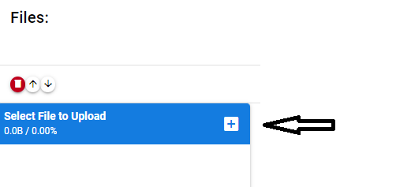

Select a file and click **open**

Click the cloud upload button to upload the file:

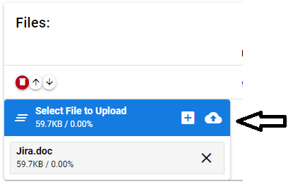

The file will now be in the list of files:

Use the up and down arrows to arrange the files in the desired order.

Check the **Add to PDF** checkbox to have the file contents included in the generated PDF that will be the default file for this spec.

### References

If this spec references other specs, click the **+** at the bottom of the References table. In the row created, enter the spec number (and optionally version).

### Signatures

The Signatures table will be pre-loaded with the minimum roles required to approve this spec based on Document Type and Department. For each row with an asterisk (*) after the role name, a signer must be specified. Enter the user name of the person who will be signing. For roles without and asterisk, the signer may be left blank.

You may add additional roles and signers by clicking the **+** at the bottom of the table to create additional rows.

### Update Jira

If there is a related Jira issue related to this spec, click on the link to see it in Jira.

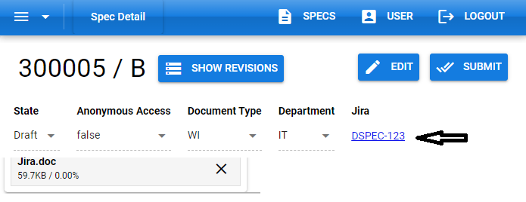

In Jira, edit the Description as appropriate for the change being made.

When done editing, Click **Save** at the bottom of the Description to save the changes.

For each task that must be completed when the spec becomes active, Click **Add a child issue** to create a SubTask. You can click on the created subtask to add a more complete description and assign an owner to the task.

The related Jira story contains the Change Impact Assessment. Each of the tasks must be reviewed. For tasks that do not apply to this spec release, enter the reason it does not apply in the task and set the task state to ‘Not Applicable’. For tasks that apply, update the description to reflect that and set the assignee of the task to the person who will perform that task.

## Submit for Approval

When everything is ready for approval, click **Submit** button.

This will change the state of the spec to Submitted. In this state no changes can be made to the meta data or the attached files.

A PDF will be generated from the documents attached and added to the spec’s file list.

Email notifications will be sent to all users that were specifically assigned to any role. Email will also to be sent to users who have elected to ‘watch’ this spec.

The Jira issue will be changed to status SignOff.

## Review

Each reviewer is responsible for reviewing the spec for accuracy and completeness. The generated PDF must be reviewed to ensure it accurately reflects the spec. The Jira story needs to be reviewed to assure the tasks reflect the correct Change Impact actions.

If there is an issue, the change can be rejected by clicking **Reject** on the Spec Detail page. Then enter a reason in the reject popup and click **Reject**. The spec and Jira issue will be returned to the Draft state.

If everything is correct, click the **Sign** button.

When someone has signed for each of the specified roles, the spec moves to the Active state. The Jira story moves to the In Process state and all people assigned to tasks under the story are notified their tasks need to be completed. Email will also to be sent to the creator of this version and users who have elected to ‘watch’ this spec.

## Approved

Once the spec has been approved, all the tasks in the Jira story must be completed. Document Control will monitor Stories for specs that are In Process to assure all deployment tasks have been completed.

# Screens

## Spec (Home screen)

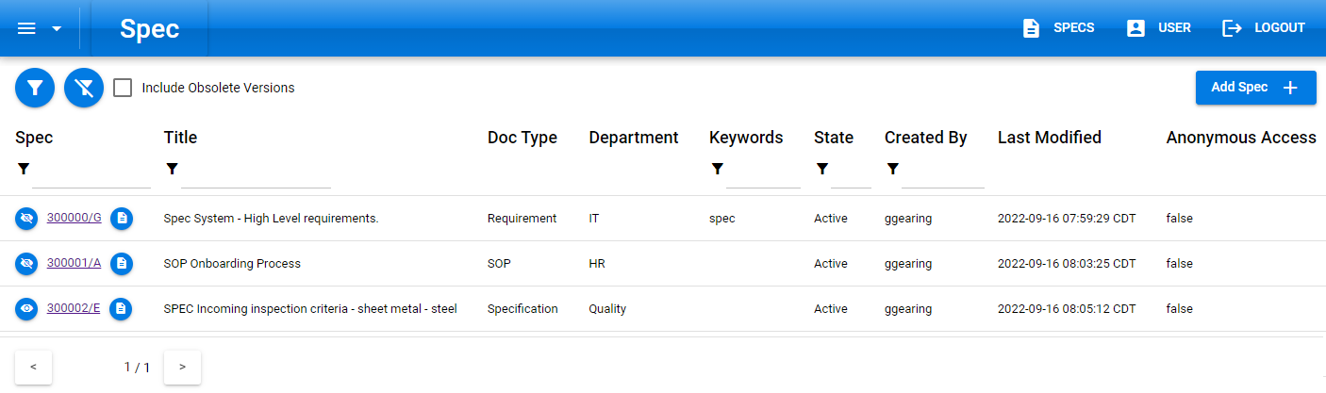

Top left: Menu to screens showing lists of values configured by administrators.

Return to home screen: 

See details for current user: 

Log in/out:  

Apply current filters: 

Clear all filters: 

 By default, unchecked. When checked, obsoleted versions of specs will be included in the list.

Filter column on value entered.

 Cycle through pages that match current filter

Columns:

* Spec – Number and revision of spec
  +  Not currently watched. Click to start watching
  + Currently watched. Click to stop watching
  + Click on hyperlink of spec number/version to go to spec detail page
  +  Link to PDF file of this spec, when not in Draft state.
* Title – Title of spec
* Doc Type – Type of document (from Doc Type list)
  + Identifies if document is confidential (readable only by role defined individuals)
  + Jira Template, if any, to be copied when a new revision is created
* Department – Department from Department list
  + Identifies Roles that have permission to read confidential documents in this department
* Keywords – used to provide search ability
* State – current state (Draft, Signoff, Active or Obsolete
* Created By – user that created this revision
* Last Modified – last time the spec was changed (updated, signed, …)
* Anonymous Access – When true, the spec can be viewed without logging into the system

## User Detail

Details of configuration for a user.

Sections:

* Assigned Pending Signatures
  + These are specs in Signoff that this user has been assigned to.
* Delegated Pending Signatures
  + These are specs in Signoff that have been assigned to a user that *this* user is a delegate for.
* Role Assigned Pending Signatures
  + These are specs in signoff that need a signature for a Role, where this user is a member of that Role.
* User Created Specs Still In-Process
  + Specs this user created that are in the Draft of Signoff state.
* Delegates
  + Comma separated list of users that can sign for this user
  + Click the Save button to the left to save a change. 
* Specs Watched
  + List of specs that you have chosen to watch
  + Click on the spec number to go to the active version of that spec.
  + Click on the watch icon to stop watching the spec. 
* Delegates For
  + List of users this user is a delegate for
  + Click on username to go to User Detail page for that user