PDF Print Test Document

This document contains various common PDF elements to test printing functionality. It includes text formatting, tables, lists, shapes, page breaks, and long text for pagination.

Formatted Text Examples: Bold, Italic, Underline, Red Text, Larger Text

Bullet List Example:
• First item
• Second item
• Third item with more text to test wrapping behavior in list items.

Numbered List Example:

1 Step one

2 Step two
3 Step three
Table Example:

ID | Name | Quantity | Price
1 | Product A | 10 | $100.00
2 | Product B | 5 | $50.00
3 Product C 20 $200.00

Chart Example (Image Embedded):

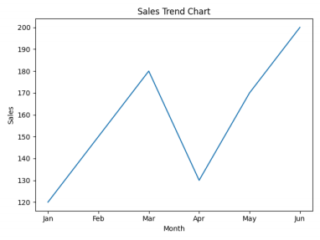

Shapes and Graphics Example:

Rectangle and Circle Shapes (Vector Graphics)

Long Text Example (Pagination Test):

This is a long paragraph used to test automatic text wrapping and page breaking. This is a long
paragraph used to test automatic text wrapping and page breaking. This is a long paragraph used to test automatic text wrapping and page breaking. This is a long paragraph used to test automatic text wrapping and page breaking. This is a long paragraph used to test automatic text wrapping and page breaking. This is a long paragraph used to test automatic text wrapping and page breaking.
This is a long paragraph used to test automatic text wrapping and page breaking. This is a long
paragraph used to test automatic text wrapping and page breaking. This is a long paragraph used to test automatic text wrapping and page breaking. This is a long paragraph used to test automatic text wrapping and page breaking. This is a long paragraph used to test automatic text wrapping and page breaking. This is a long paragraph used to test automatic text wrapping and page breaking.

