**(ICBMS-3 specification) Development of IoT-based platform technology supporting object virtualization, distributed autonomic intelligence, and data linkage/analysis**

**SI(Service Integration) oneM2M Server**

**Manual**

**Version 1.0**



**Document Approval**

**If approved by the attached document of the order, replace it with the signature of the order.**

**Event: Herit Co., Ltd.**

_______________________________________________________________________

**Sponsor: PineOne Communications Co., Ltd.**

_______________________________________________________________________

**Revised History**

|  |  |  |
| --- | --- | --- |
| Revision number | Revision page and contents | Revision date |
| 1.0 | Installation & testing manual for SI source code | 2018/01/10 |
|  |  |  |
|  |  |  |
|  |  |  |
|  |  |  |
|  |  |  |
|  |  |  |
|  |  |  |
|  |  |  |
|  |  |  |
|  |  |  |
|  |  |  |
|  |  |  |
|  |  |  |
|  |  |  |
|  |  |  |
|  |  |  |
|  |  |  |
|  |  |  |
|  |  |  |
|  |  |  |
|  |  |  |
|  |  |  |
|  |  |  |
|  |  |  |
|  |  |  |

INDEX

1. SI oneM2M Server 7

1.1. Introduction 7

1.2. SI oneM2M Server 7

1.2.1. System Structure 7

1.2.2. Connectivity Structure 8

1.2.3. Software Structure 8

1.2.4. Features 9

1.2.5. Supported Addressing Format 9

1.2.6. Supported Protocol Bindings 10

1.2.7. Supported Serialization data format 10

1.2.8. Documentation 10

1.2.8.1. SI oneM2M Server source code package 10

1.2.8.2. Library Dependencies 11

1.2.9. Installation 12

1.2.10. Installation Order 13

2. SI oneM2M Server Installation 14

2.1. Pre-requisites Installation for Windows 14

2.1.1. MongoDB Installation 14

2.1.1.1. Download 14

2.1.1.2. Install 14

2.1.1.3. Configuration(Initial configuration) 15

2.1.2. Java Installation 15

2.1.2.1. Download 15

2.1.2.2. Install 16

2.1.3. Eclipse Installation 16

2.1.3.1. Download 16

2.1.3.2. Configuration(Installed JREs) 17

2.1.4. Postman Installation 18

2.1.4.1. Download and Installation 18

2.1.4.2. Configuration(Initial configuration) 19

2.1.5. Mosquitto 20

2.1.5.1. Download 20

2.1.5.2. Install 21

2.2. SI oneM2M Server Installation 25

2.2.1. Download 25

2.2.2. Importing Source code 25

2.2.3. Maven Clean 26

2.2.4. Maven Update 28

2.2.5. Project Build 29

2.2.6. Maven Install 30

2.3. SI oneM2M Server Configuration 31

2.3.1. Database Configuration 31

2.3.2. Binding Protocol Configuration 31

2.3.3. CSE Configuration 32

2.3.4. DM Configuration 32

2.4. Run SI oneM2M Server 33

2.4.1. Run MongoDB 33

2.4.2. Run SI oneM2M Server 34

3. SI oneM2M Server Test 36

3.1. Test for HTTP Protocol 36

3.1.1. Postman Usage for API testing 36

3.1.1.1. Select item 36

3.1.1.2. Editing URI 36

3.1.1.3. Setting HTTP Headers 37

3.1.1.4. Setting the Body 37

3.1.2. CSE-Base Retrieve 37

3.1.2.1. Request URI 37

3.1.2.2. Request Header 38

3.1.3. AE Creation 38

3.1.3.1. Request URI 38

3.1.3.2. Request Header 38

3.1.3.3. Request Body 38

3.1.4. Container Creation 39

3.1.4.1. Request URI 39

3.1.4.2. Request Header 39

3.1.4.3. Request Body 39

3.1.5. contentInstance Creation 39

3.1.5.1. Request URI 39

3.1.5.2. Request Header 40

3.1.5.3. Request Body 40

# SI oneM2M Server

## Introduction

SI oneM2M Server is a server framework (IN-CSE) that supports interworking of devices and applications based on oneM2M, IoT international standard. Using SI oneM2M Server source code, you can build oneM2M-based device and application interworking server, and you can develop various oneM2M components such as AE, MN-CSE using oneM2M core source code.

This is IoT core infrastructure for various application services through the connection with SO & SDA platform as an IoT server platform supports various Bindings, IN-CSE Capability functions, DM server function for device management and interworking with heterogeneous IoT platform such as OIC/LWM2M/Fi-WARE based on oneM2M Release 2.

## SI oneM2M Server

### System Structure

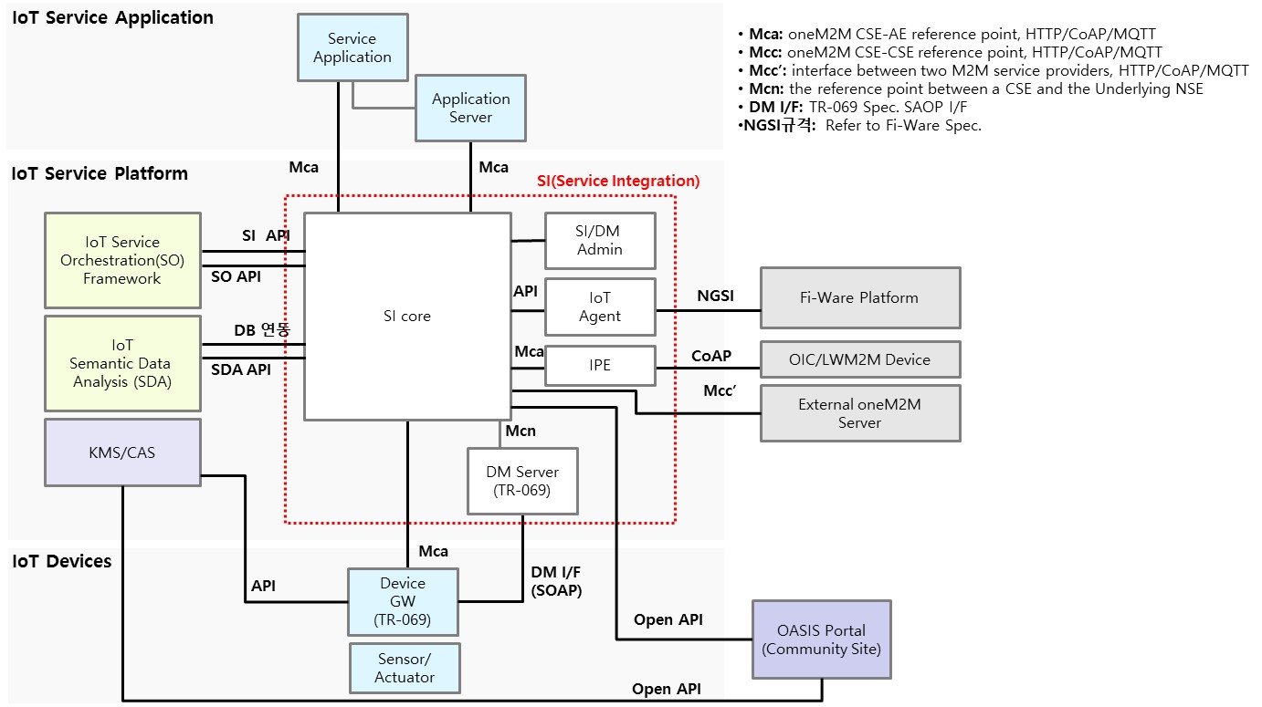

### Connectivity Structure



### Software Structure



### Features

* IN-CSE functions based on oneM2M Release 2.0
* Resource processing based on Release 2.0(TS-0004 2.7)
* Supports Mca, Mcc, Mca' reference points
* IN-CSE functions : Registration, Data Management Repository, Sub. & Notification, Discovery etc.
* Protocol Bindings : HTTP, MQTT, CoAP, WebSocket
* Serialization : XML, JSON, CBOR
* Address format : CSE-relative/SP-relative/Absolute , Hierarchical/Non-Hierarchical Addressing
* Semantic Descriptor support
* Interworking IPE function : OIC(OCF), LWM2M
* Device Management : mgmtObj, mgmtCmd
* Security : TLS, Creator default ACP, Basic Authentication
* Resource data management based on MongoDB

### Supported Addressing Format

* Structured SP relative addressing format
  + As a hierarchically structured service provider base address system, resource URI specification is as follows.
  + /{cse-id}/{cse-name}/{resource-name}/{resource-name}}/….
* Structured CSE relative addressing format
  + As a hierarchically structured address system composed of CSE standards and has the following resource URI specification.
  + /{cse-name}/{resource-name}/{resource-name}}/….
* Structured Absolute addressing format
  + As a hierarchically organized address system centered on a unique domain, resource URI specification is as follows.
  + //www.memprovider.com/{cse-id}/{cse-name}/{resource-name}/{resource-name}/….
* Unstructured SP relative addressing format
  + As a non-hierarchical address system from the viewpoint of the service provider, there has the following resource URI standard.
  + /{cse-id}/{cse-name}/{resource-id}
* Unstructured CSE relative addressing format
  + As a non-hierarchical address system from the CSE point of view, there has the following resource URI specification.
  + /{cse-name}/{resource-id}
* Unstructured Absolute addressing format
  + As an address system that is configured not to be hierarchical in its own domain, resource URI specification is as follows.
  + //www.memprovider.com/{cse-id}/{cse-name}/{resource-id}

### Supported Protocol Bindings

* HTTP
  + Refer to TS-0009-HTTP-Protocol Binding document in oneM2M specification
* CoAP
  + Refer to TS-0008-CoAP-Protocol Binding document in oneM2M specification
* MQTT
  + Refer to TS-0010-MQTT-Protocol Binding document in oneM2M specification
* WebSocket
  + Refer to TS-0020-WebSocket-Protocol Binding document in oneM2M specification

### Supported Serialization data format

* XML
  + Applicable to all of the above four protocol binding standards
* JSON
  + Applicable to all of the above four protocol binding standards
* CBOR
  + Applicable to all of the above four protocol binding standards

### Documentation

#### SI oneM2M Server source code package

|  |  |
| --- | --- |
| Package | Role and Function |
| net.herit.iot.db.mongo | The package responsible for the MongoDB connection pool. |
| net.herit.iot.message.onem2m | OneM2M is a package of constant values. They are OneM2M's Content-type, CSE type, Request type, Member type, and are also defined Response code for request processing and result of operation. |
| net.herit.iot.onem2m.bind | The package that defines the Binding Protocol. HTTP, CoAP, MQTT, and WebSocket are defined, and each protocol is implemented as a Client-Server model except for MQTT. (Broker, which is the server of MQTT, does not support it.) |
| net.herit.iot.onem2m.core | It is a package that defines Data Format Converter and Utility to treat with various types of data. They are JSON Converter and XML Converter, in CBOR, Encode/Decode operation is performed using library. |
| net.herit.iot.onem2m.incse | It consist of a manager package for initializing and CRUDN of oneM2M resource, and a dm package containing DM adapter and DM controller of oneM2M and TR-069. |
| net.herit.iot.onem2m.resource | A package that defines resources based on the oneM2M standard. oneM2M resource is configured as 1:1 mapped to a java file as one object, and is implemented by referring to the xsd schema defined by onem2m.org. |

#### Library Dependencies

The list of library dependencies for SI oneM2M Server

* scandium-1.0.0.jar
* element-connector-1.0.0.jar
* org.eclipse.paho.client.mqttv3-1.0.2.jar
* slf4j-api-1.7.13.jar
* logback-classic-1.1.3.jar
* logback-core-1.1.3.jar
* commons-codec-1.10.jar
* httpclient-4.5.1.jar
* httpcore-4.4.3.jar
* commons-logging-1.2.jar
* netty-all-4.0.33.Final.jar
* org.eclipse.persistence.core-2.4.2.jar
* org.eclipse.persistence.asm-2.4.2.jar
* org.eclipse.persistence.moxy-2.4.2.jar
* org.eclipse.persistence.antlr-2.4.2.jar
* joda-time-2.8.2.jar
* mongo-java-driver-3.1.1.jar
* commons-configuration-1.6.jar
* commons-collections-3.2.1.jar
* commons-lang-2.4.jar
* commons-digester-1.8.jar
* commons-beanutils-1.7.0.jar
* commons-beanutils-core-1.8.0.jar
* Java-WebSocket-1.3.0.jar
* jackson-mapper-asl-1.8.5.jar
* jackson-core-asl-1.8.5.jar
* xstream-1.4.7.jar
* xmlpull-1.1.3.1.jar
* xpp3_min-1.1.4c.jar
* json-20140107.jar
* json-simple-1.1.jar
* jackson-databind-2.8.7.jar
* jackson-annotations-2.8.0.jar
* jackson-core-2.8.7.jar
* jackson-dataformat-cbor-2.8.7.jar
* cbor-0.7.jar
* commons-httpclient-3.1.jar
* quartz-1.7.3.jar
* spring-core-4.3.10.RELEASE.jar

### Installation

* MongoDB

It is easy to operate because it has a scale-out structure and it is intuitive because it can be saved in JSON format. It also provides Query performance as powerful as SQL by using document-oriented Query Language. For this reason, SI is used as the database of oneM2M Server.

* Java 7

It is the fastest language except for Native Language. It is chosen as the main development language because it is needed much less development time than Native Language and is very efficient.

* Eclipse

It does not have to be Eclipse as a development tool, but it is optimized for Java development and is very convenient.

* Postman

It is an HTTP messaging tool provided by Chrome, which is very easy to install and use. SI oneM2M Server is used to check the installation completion and test.

* Mosquitto

The MQTT protocol is based on publishing messages and subscribing to topics of interest, where both Publisher and Subscriber act as clients to the Broker. Publisher is intended to publish a topic, Subscriber connects to the Broker server for subscribing to topics, and it is Mosquitto that acts the role of the Broker.

* SI oneM2M Server

It is a server in SI(Service Integration) area in OASIS platform, and is a server based on oneM2M which is an international standard. (IN-CSE role in oneM2M)

### Installation Order

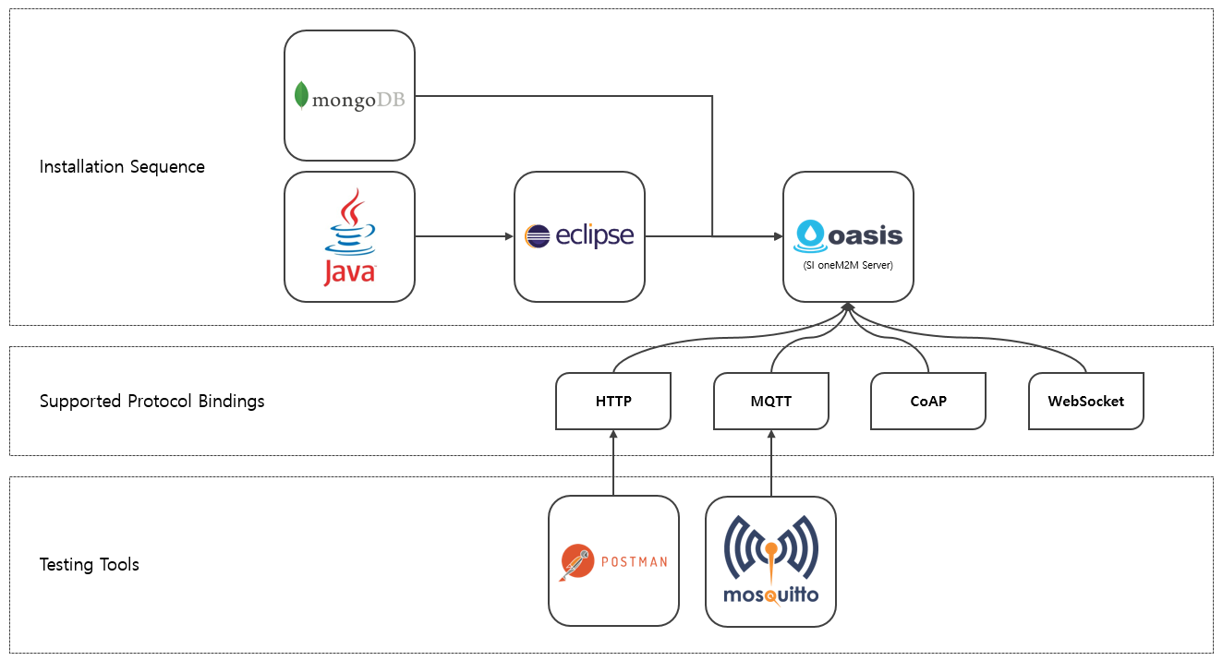

# SI oneM2M Server Installation

## Pre-requisites Installation for Windows

### MongoDB Installation

#### Download

* Download at <https://www.mongodb.com/download-center#community>

|  |
| --- |
|  |
| Figure 1. Part of the download page |

#### Install

* Press the Next button to proceed with the installation.

|  |
| --- |
|  |
| Figure 2. Installation Screen |

#### Configuration(Initial configuration)

* Since MongoDB needs to specify the path to save data, create 'data' folder on C drive (MongoDB installed main drive) and create 'db' folder in it.
* (In case of 'Figure-3', MongoDB is installed on drive D, so it creates a folder on drive D.)

|  |
| --- |
|  |
| Figure 3. Folder Creation Screen |

### Java Installation

#### Download

* Download JDK 7u80 version at [http://www.oracle.com/technetwork/java/javase/downloads/java-archive-downloads-javase7-521261.html](http://www.oracle.com/technetwork/java/javase/downloads/java-archive-downloads-javase7-521261.html%20)
* (Some features of SI oneM2M Server may not work if you do not use JDK 7)

|  |
| --- |
|  |
| Figure 4. List of JDK 7u80 by OS |

#### Install

* Click the Next button to proceed with the installation.

|  |
| --- |
|  |
| Figure 5. Installation Screen |

### Eclipse Installation

#### Download

* Download ‘Eclipse IDE for Java Developer’ at <http://www.eclipse.org/downloads/packages/release/Mars/2> (Used as Mars, which is a version of Eclipse that is compatible with JDK7)

|  |
| --- |
|  |
| Figure 6. Eclipse Download Page Part |

#### Configuration(Installed JREs)

* Click 'Preference' menu under 'Window' menu

|  |
| --- |
|  |
| Figure 7. Preferences Menu |

* Search 'Installed JREs' in the left search box and click 'Edit ...' button

|  |
| --- |
|  |
| Figure 8. Set Installed JREs in Preferences |

* If ‘jre’ is set to 'jre home', change to jdk by clicking ‘Directory ...' button

|  |
| --- |
|  |
| Figure-9. Before modification(left) of JRE home and after modification(right) |

### Postman Installation

#### Download and Installation

* Download at <https://chrome.google.com/webstore/detail/postman/fhbjgbiflinjbdggehcddcbncdddomop> (Chrome browser is required)

|  |
| --- |
|  |
| Figure 10. Postman Download Screen |

#### Configuration(Initial configuration)

* Run Postman to add script and click Import button

|  |
| --- |
|  |
| Figure 11. The Additional Button Location of Postman Script |

* Register the collection in the postman-collections folder contained in the SI oneM2M Server source code by drag and drop into the window displayed when clicking the 'Import' button in Figure 9.

|  |
| --- |
|  |
| Fig 12. Dragging and Dropping Collection |

|  |
| --- |
|  |
| Figure 13. Collection is normally imported |

### Mosquitto

#### Download

* Download mosquito at <https://mosquitto.org/download>

|  |
| --- |
|  |
| Fig 14. Part of the Download Page |

#### Install

* If you click Next in Figure 15, you will see the screen as shown in Figure 16. Because you need dll file of the OpenSSL and pthreadVC2.dll of pthreads, if you do not have these files, you will receive.

|  |
| --- |
|  |
| Figure 15. Installation Screen-1 |

|  |
| --- |
|  |
| Figure 16. Installation Screen-2 |

* Since OpenSSL installation is necessary, please visit 'http://slproweb.com/products/Win32OpenSSL.html' and download 'Win32 OpenSSL [Version] Light' and then install

|  |
| --- |
|  |
| Figure 17. Part of OpenSSL Download Page |

* During the download and installation, you will see the screen as shown in Figure 18. Select the OpenSSL binaries (/bin) directory at the bottom and then install. (easy to find dll files)

|  |
| --- |
|  |
| Figure 18. Part of the OpenSSL Installation Process |

* Since the library of pthreads is needed, please connect to ftp://sources.redhat.com/pub/pthreads-win32/dll-latest/dll/x86/ and download 'pthreadVC2.dll' file

|  |
| --- |
|  |
| Figure 19. ftp Directory with pthreads Library |

* Go back to the beginning and proceed to install mosquitto completely

|  |
| --- |
|  |
| Figure 20. mosquitto Installation Completion Screen |

* Copy and paste dll file of OpenSSL and pthreadVC2.dll that you received to the folder where mosquitto is installed before (If libeay32.dll and ssleay32.dll are not in the bin folder of the OpenSSL installation path, install Win32 OpenSSL v1.0.2n Light)

|  |
| --- |
|  |
| Figure 21. dll Files Copied to mosquitto Folder |

## SI oneM2M Server Installation

### Download

* Click 'Clone or download' button at https://github.com/iotoasis/SI to download

|  |
| --- |
|  |
| Figure 22. Part of github Screen |

### Importing Source code

* Import the downloaded SI source code after running Eclipse

|  |
| --- |
|  |
| Figure 23. Importing SI source code into Eclipse -1 |

|  |
| --- |
|  |
| Figure 24. Importing SI source code into Eclipse -2 |

|  |
| --- |
|  |
| Figure 25. Importing SI source code into Eclipse -3 |

### Maven Clean

* Project rightclick -> Run As -> Maven clean

|  |
| --- |
|  |
| Figure 26. Maven Clean Selection Screen |

### Maven Update

* Press Alt + F5 to update the project

|  |
| --- |
|  |
| Figure 27. Update Maven Project |

### Project Build

* Project rightclick -> Build Project

|  |
| --- |
|  |
| Figure 28. Build Project |

### Maven Install

* Project rightclick -> Run As -> Maven install

|  |
| --- |
|  |
| Figure 29. Maven Install Screen |

|  |
| --- |
|  |
| Figure 30. Maven Install Complete Screen |

## SI oneM2M Server Configuration

### Database Configuration

|  |
| --- |
| <database>  <host>localhost</host>  <port>27017</port>  <dbname>IITP-IOT</dbname>  <user>herit</user>  <password>qrwe1423</password>  </database> |

### Binding Protocol Configuration

|  |
| --- |
| <http>  <port>8080</port>  <sec-port>8443</sec-port> <!-- https port -->  <rest-port>8081</rest-port>  <netty>  <boss-threadPool-size>0</boss-threadPool-size>  <worker-threadPool-size>1024</worker-threadPool-size>  </netty>  </http> |
| ( HTTP ) |

|  |
| --- |
| <mqtt>  <supported>yes</supported> <!-- yes or no -->  <keepalive>1200</keepalive> <!-- seconds -->  <broker>tcp://10.10.202.146:1883</broker>  </mqtt> |
| ( MQTT ) |

|  |
| --- |
| <coap>  <supported>yes</supported> <!-- yes or no -->  <port>5683</port>  <sec-port>4433</sec-port> <!-- dtls port -->  <cse-unstruct>false</cse-unstruct> <!-- cse-relative unstructured addressing -->  </coap> |
| ( CoAP ) |

|  |
| --- |
| <websocket>  <supported>yes</supported> <!-- yes or no -->  <port>8887</port>  </websocket> |
| ( WebSocket ) |

### CSE Configuration

* Set SI oneM2M Server information and poa etc.

|  |
| --- |
| <cse>  <host>10.10.0.23</host>  <baseName>herit-cse</baseName>  <resourceId>herit-in</resourceId>  <poa>http://10.10.0.23:8080</poa>  <default-resource-expiration-time>3</default-resource-expiration-time> <!-- days -->  <allowed-subgroup-depth>3</allowed-subgroup-depth>  </cse> |

|  |  |
| --- | --- |
| Item | Role |
| host | IP of the server running SI oneM2M Server |
| baseName | CSE-Base Name to be used by SI oneM2M Server |
| resourceId | CSE Resource ID to be used by SI oneM2M Server |
| poa | poa |
| default-resource-expiration-time | Time(et) from creation of oneM2M Resource to expiration |
| allowed-subgroup-depth | Maximum depth when creating group in group |

### DM Configuration

* It is a setting for DM related function. If DM is not used, it is not necessary to input special value.

|  |
| --- |
| <dms>  <hitdm>  <address>http://10.101.101.107:8888</address>  </hitdm>  <tr69dm>  <address>http://10.10.0.23:7557</address>  <timeout>3000</timeout>  </tr69dm>  <onem2mAgent>  <address>http://10.10.0.81:1337</address>  </onem2mAgent>  </dms> |

|  |  |
| --- | --- |
| Item | Role |
| hitdm.address | Herit DM Server address |
| tr69dm.address | Address of ACS as a server of TR-069 |
| tr69dm.timeout | By default, 3000 is used for ACS response timeout (timeout). |
| onem2mAgent.address | address of oneM2M Agent |

## Run SI oneM2M Server

### Run MongoDB

* MongoDB(mongod.exe) run

|  |
| --- |
|  |
| Figure 31. MongoDB running screen |

### Run SI oneM2M Server

* Project rightclick -> Run As -> Java Application

|  |
| --- |
|  |
| Figure 32. Run As Java Application |

* Select 'incse' and click 'OK' button to run

|  |
| --- |
|  |
| Figure 33. Run InCse |

# SI oneM2M Server Test

## Test for HTTP Protocol

### Postman Usage for API testing

#### Select item

|  |
| --- |
|  |
| Figure 34. Select Item |

#### Editing URI

|  |
| --- |
|  |
| Figure 35. Editing URI |

#### Setting HTTP Headers

|  |
| --- |
|  |
| Figure 36. Setting HTTP headers |

#### Setting the Body

|  |
| --- |
|  |
| Figure 37. Setting the Body |

### CSE-Base Retrieve

#### Request URI

<http://localhost:8080/herit-in/herit-cse>

#### Request Header

|  |  |  |  |
| --- | --- | --- | --- |
| Key | Value | Description | Mandatory |
| Accept | application/json | Response Body Type | Optional |
| HOST | 10.10.101.193 | The FQDN or IP address of the Receiver CSE of the next hop in multi-hop communication scenarios. | Optional |
| X-M2M-RI | pm_1506031019180001 | The X-M2M-RI Header shall be mapped to the *Request Identifier* parameter of request and response primitives and vice versa. | Mandatory |
| X-M2M-Origin | //iot.herit.net/herit-cse/CAE0001 | The X-M2M-Origin header shall be mapped to the *From* parameter of request and response primitives and vice versa, if applicable. | Mandatory |

### AE Creation

#### Request URI

<http://localhost:8080/herit-in/herit-cse>

#### Request Header

|  |  |  |  |
| --- | --- | --- | --- |
| Key | Value | Description | Mandatory |
| Accept | application/json | Response Body Type | Optional |
| HOST | 10.10.101.193 | The FQDN or IP address of the Receiver CSE of the next hop in multi-hop communication scenarios. | Optional |
| X-M2M-RI | pm_1506031019180001 | The X-M2M-RI Header shall be mapped to the *Request Identifier* parameter of request and response primitives and vice versa. | Mandatory |
| X-M2M-Origin | //iot.herit.net/herit-cse/CAE0001 | The X-M2M-Origin header shall be mapped to the *From* parameter of request and response primitives and vice versa, if applicable. | Mandatory |
| Content-Type | application/vnd.onem2m-res+json; ty=2 | application/vnd.onem2m-res+[data_type]; ty=[resource_type] | Mandatory |

#### Request Body

|  |
| --- |
| {  "m2m:ae" : {  "lbl" : [ "hubiss", "admin" ],  "et" : "20181103T122321",  "apn" : "onem2mPlatformAdmin",  "poa" : [ "10.10.0.23" ],  "api" : "testapp",  "rr" : false  }  } |

### Container Creation

#### Request URI

<http://localhost:8080/herit-in/herit-cse/device0001>

#### Request Header

|  |  |  |  |
| --- | --- | --- | --- |
| Key | Value | Description | Mandatory |
| Accept | application/json | Response Body Type | Optional |
| HOST | 10.10.101.193 | The FQDN or IP address of the Receiver CSE of the next hop in multi-hop communication scenarios. | Optional |
| X-M2M-RI | pm_1506031019180001 | The X-M2M-RI Header shall be mapped to the *Request Identifier* parameter of request and response primitives and vice versa. | Mandatory |
| X-M2M-Origin | //iot.herit.net/herit-cse/CAE0001 | The X-M2M-Origin header shall be mapped to the *From* parameter of request and response primitives and vice versa, if applicable. | Mandatory |
| Content-Type | application/vnd.onem2m-res+json; ty=3 | application/vnd.onem2m-res+[data_type]; ty=[resource_type] | Mandatory |

#### Request Body

|  |
| --- |
| {  "m2m:cnt" : {  “rn” : “temperature”,  "lbl" : [ "hubiss", "admin", “key1” ],  "et" : "20181103T122321",  "mni" : 100,  "mbs" : 1024000,  "mia" : "36000"  }  } |

### contentInstance Creation

#### Request URI

<http://localhost:8080/herit-in/herit-cse/device0001/temperature>

#### Request Header

|  |  |  |  |
| --- | --- | --- | --- |
| Key | Value | Description | Mandatory |
| Accept | application/json | Response Body Type | Optional |
| HOST | 10.10.101.193 | The FQDN or IP address of the Receiver CSE of the next hop in multi-hop communication scenarios. | Optional |
| X-M2M-RI | pm_1506031019180001 | The X-M2M-RI Header shall be mapped to the *Request Identifier* parameter of request and response primitives and vice versa. | Mandatory |
| X-M2M-Origin | //iot.herit.net/herit-cse/CAE0001 | The X-M2M-Origin header shall be mapped to the *From* parameter of request and response primitives and vice versa, if applicable. | Mandatory |
| Content-Type | application/vnd.onem2m-res+json; ty=4 | application/vnd.onem2m-res+[data_type]; ty=[resource_type] | Mandatory |

#### Request Body

|  |
| --- |
| {  "m2m:cin" : {  "lbl" : [ "hubiss", "admin" ],  "et" : "20181103T122321",  "cnf" : “text/plain:0”,  "con" : 24  }  } |