
STATE UNIVERSITY OF MOLDOVA

FACULTY OF ECONOMICS
DEPARTMENT OF ACCOUNTING AND ECONOMIC COMPUTING

Author: Cristian Bagrin

Discipline holder: Ludmila NOVAC, dr., conf. univ.
Statistical research _______________________________
Content
 |  | Pag.
I. | Statistical observation | 3
 | - The purpose of statistical observation | 3
 | - Statistical population | 3
 | - Observation method | 3
 | - The observed sample | 3
 | - Statistical characteristics | 3
 | - Measuring scales | 3
 | - Data source | 3
II. | Systematization and presentation of observed data | 4
 | - Descriptive table | 4
 | - Classification of the observed statistical units and calculation of the weight in groups | 4
 | - Grouping statistical units according to a quantitative characteristic, using various intervals (discrete and continuous) | 5
 | - Graphic presentation of the distribution of the units observed on grouping intervals and of their structure | 11
III. | Inferential statistical analysis using central trend indicators | 18
 | - Average indicators (for each distribution / grouping). | 18
 | - Average position indicators (for each distribution / grouping). | 20
 | - Simple and synthetic indicators of variation (for each distribution / group). | 22
 | General conclusions from statistical research | 24
IV. | Analysis and adjustment of the time series of an economic / social phenomenon or process | 25
 | 4.1. The phenomenon studied, the data source and the target period. | 25
 | 4.2. Absolute & Relative change indicators | 26
 | 4.3. Average series indicators | 27
 | 4.4. Time series adjustment | 28
 | General conclusions in the analysis of the chronological series | 34

- STATISTICAL OBSERVATION
  - The purpose of my statistical observation is to determine the web preferences of the population of the Republic of Moldova.
  - The statistical population includes individuals who reside in the Republic of Moldova and use the internet, aged 0-100 .
  - The observation method will be performed in the form of a statistical survey.
  - The sample is random (50). The 50 individuals were selected from various sources such as social media, online forums, and physical questionnaires.
  - The statistical characteristics I will observe are:
- How old are you?
- On average, how many hours per day do you spend on the internet?
- Which devices do you use to access the internet? A. Desktop B. Laptop C. Smartphone D. Tablet
- How many hours do you spend a week on each type of activity? A. Browsing B. Social media C. Online shopping D. Videos or music E. Banking F. Gaming
- How frequently do you use social media? A. Daily B. Several times a week C. Several times a month D. Rarely
- On a scale from 1 to 5, how important are each of the following social media platforms? A. Facebook B. Instagram C. TikTok D. YouTube E. LinkedIn
- What do you usually purchase online? A. Clothing & Accessories B. Electronics C. Home Goods D. Health & Beauty E. Food
- On average, how many hours do you spend per week on each type of website? A. News B. Entertainment C. E-commerce D. Education & Research
- On a scale from 1 to 10, how satisfied are you with your internet usage and the time you spend on it?
  - Measuring scale:
Statistical feature | Measurement scale used
Age | Ratio scale
Internet time | Ratio scale
Device usage | Nominal scale
Internet activity | Ratio scale
Social media usage frequency | Ordinal scale
Social media platform importance | Ordinal scale
Online purchase type | Nominal scale
Time on websites | Ratio scale
Internet satisfaction | Ordinal scale
  - The data sources are primary, obtained from the application of my own questionnaire.
- SYSTEMATIZATION & PRESENTATION OF THE OBSERVED DATA
- Descriptive table
Following the application of the questionnaire, we obtained the following data:
Table 1. Record of answers to the questionnaire
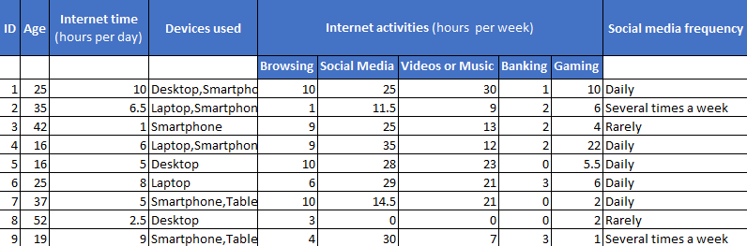
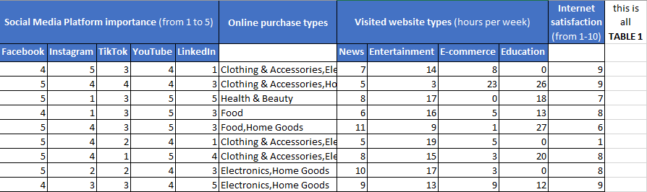

- Classification of the observed statistical units and calculation of the weight in groups:

- Classification of statistical units observed by Social Media usage Frequency:
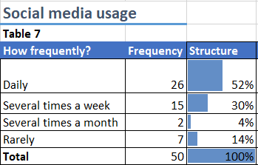

- Classification of statistical units observed according to How Important Each Platform is (1-5):
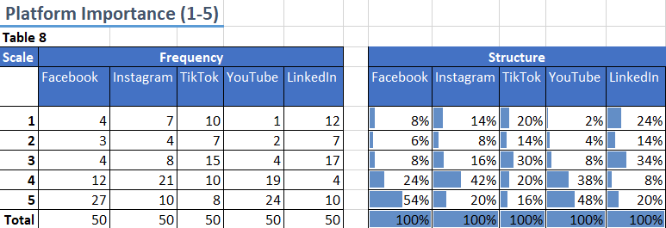

- Classification of the statistical units observed according to Devices Used:
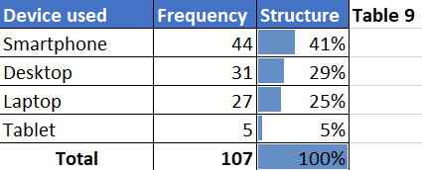
- Classification of the statistical units observed according to Types of Purchases made Online:
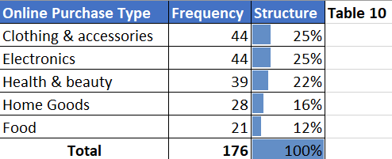

- Grouping statistical units according to a quantitative characteristic, using various intervals (discrete & continuous)
Table 2: Grouping of survey respondents according to Hours spent Online per day (continuous intervals, lower limit):
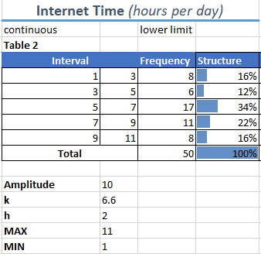
Table 2.1: Grouping of survey respondents according to Hours spent Online per day (continuous intervals, upper limit):
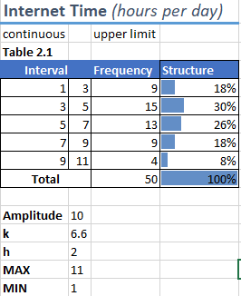
I will explain how I made the calculations once:
- $x_{max}=11$; $x_{min}=1.$
- $A=x_{max}- x_{min}=10.$
- $k=1+3,322*lg50=6,6≈7$
- $h=\frac{A}{k}=\frac{10}{6.6}=1.51≈2$
For most of the intervals, I didn’t follow the h & k values exactly. I instead used them as a reference point because it simply did not make sense for me to use their exact results.
Table 3: Grouping of survey respondents according to Age Distribution (discrete intervals, lower limit):
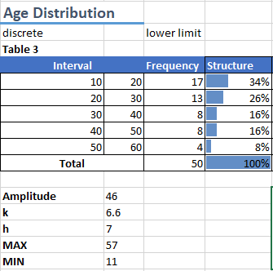
This is a perfect example of a situation where it didn’t make sense for me to use the exact h & k values. I only used them to guide me in the right direction.
Table 3.1: Grouping of survey respondents according to Age Distribution (discrete intervals, upper limit):
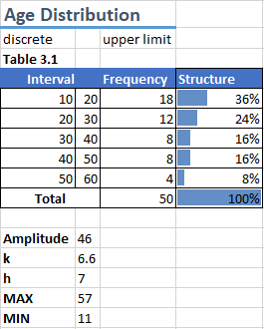

Table 4: Grouping of survey respondents according to Internet satisfaction from 1 to 10 (discrete intervals, lower limit):
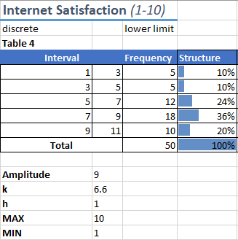
Table 4.1: Grouping of survey respondents according to Internet satisfaction from 1 to 10 (discrete intervals, upper limit):
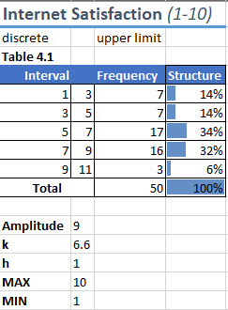

Table 5: Grouping of survey respondents according to Weekly hours spent on Internet Activities (continuous intervals, lower limit):
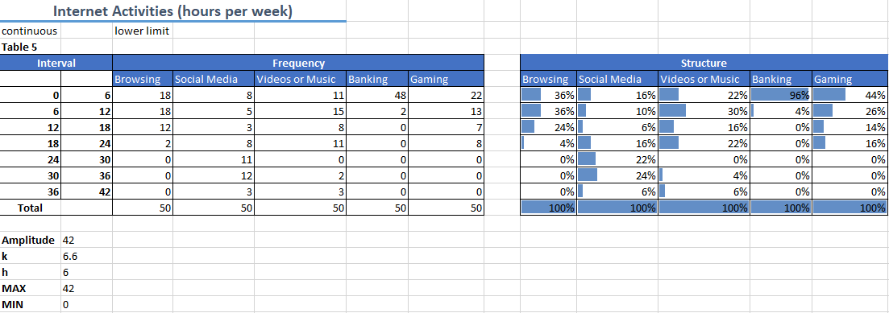
Table 5.1: Grouping of survey respondents according to Weekly hours spent on Internet Activities (continuous intervals, upper limit):
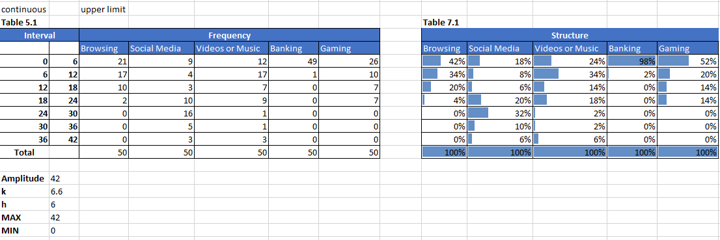

Table 6: Grouping of survey respondents according to Weekly hours spent on various Website Types (discrete intervals, lower limit):
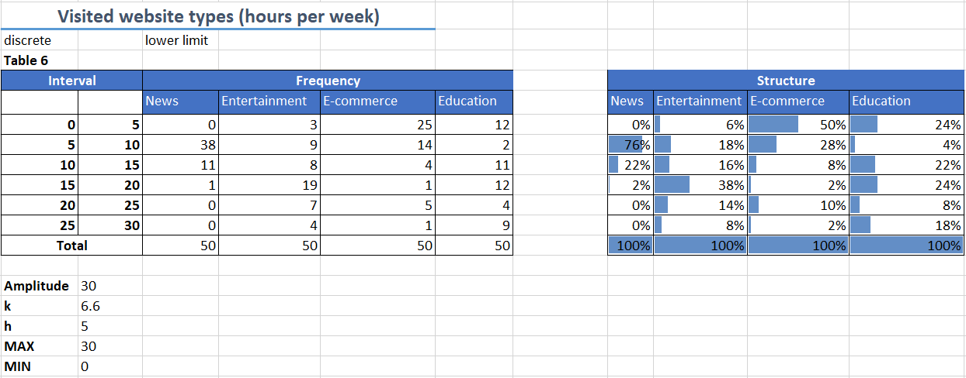
Table 6.1: Grouping of survey respondents according to Visited Website Types (discrete intervals, upper limit):
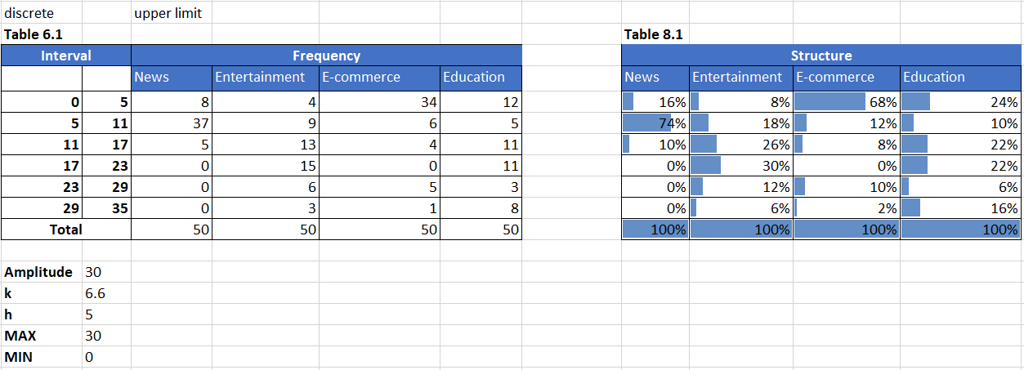

- Graphic presentation of the distribution of the units observed on grouping intervals & of their structure
Diagram 1: Distribution of respondents by groups according to Hours spent Online per day:
(according to table 2)
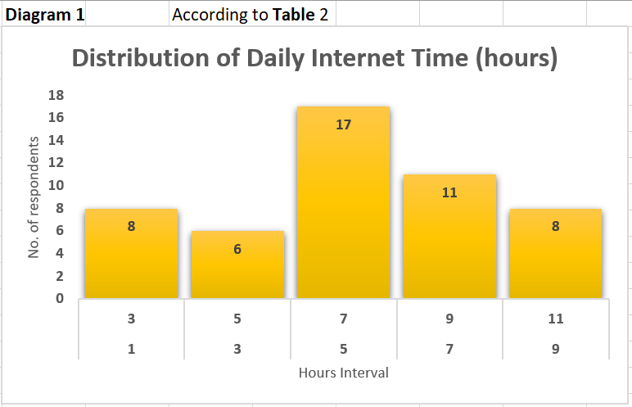
Diagram 1.1: Structure of respondents by groups according to Hours spent Online per day:
(according to table 2)
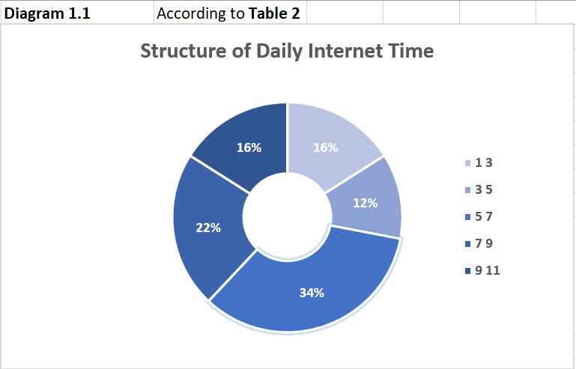
This data reveals that most of the people surveyed spend about 5 to 7 hours per day on the internet. This shows how big of a role the internet has in people’s lives.

Diagram 2: Distribution of respondents by groups according to Age:
(according to table 3)
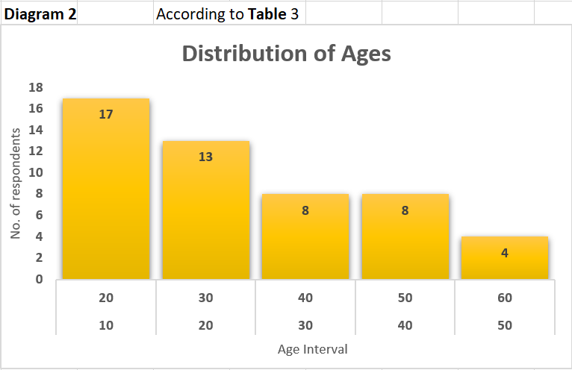
Diagram 2.1: Structure of respondents by groups according to Age:
(according to table 3)
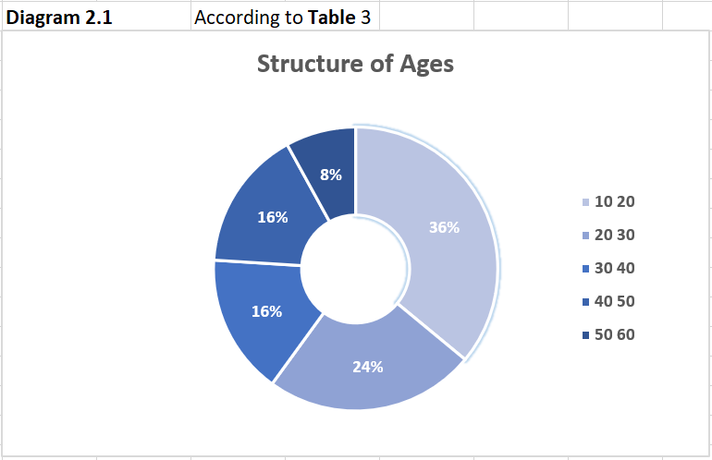
Most of the respondents are aged from 10 to 20. Additionally, we can notice that internet usage falls with age. This means that the internet is predominantly used by younger generations.

Diagram 3: Distribution of respondents by groups according to Internet Satisfaction from 1 to 10:
(according to table 4)
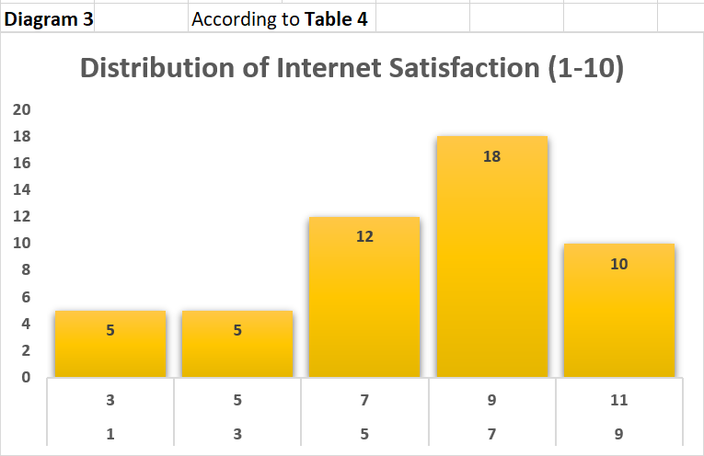
Diagram 3.1: Structure of respondents by groups according to Internet Satisfaction from 1 to 10:
(according to table 4)
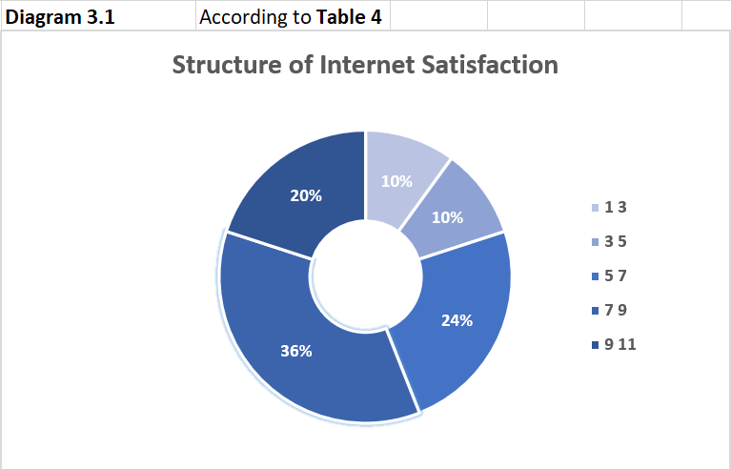
Most people are satisfied with their time online. But we can see also that they could be happier. There’s room for improvement.

Diagram 4: Distribution of respondents by groups according to Weekly hours spent on Internet Activities:
(according to table 5)
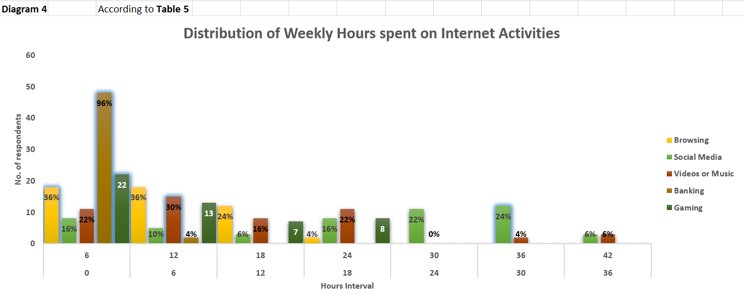
This is interesting. People typically spend about 0 to 12 hours a week browsing.
But when it comes to social media, people either barely spend 0 to 6 hours on it weekly OR they use it for 24 to 36 hours weekly! I am going to assume that these people fall into 2 categories: they either don’t care about social media, they just use it to text friends, or they’re addicted to it & spend too much time on it.
With videos, music & gaming, the numbers are more dispersed but either way, we can see a trend towards the lower-middle intervals. And as expected, few spend more than 6 hours a week banking online, which is why 96% fall in this category.

Diagram 5: Distribution of respondents by groups according to Weekly hours spent on various Website Types:
(according to table 6)
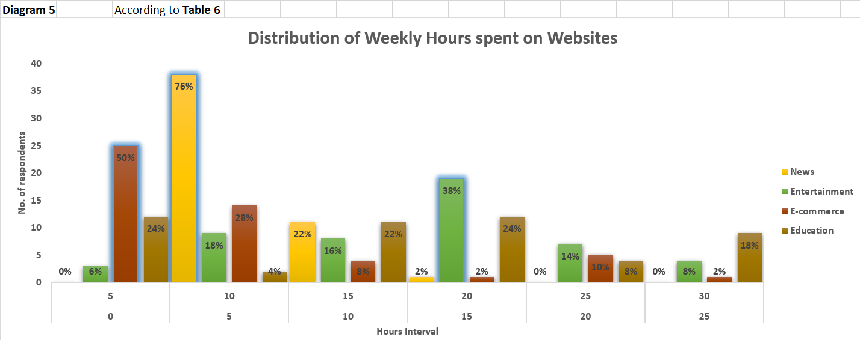
The results here are varied but certain trends are definitely evident. Most people (76%) that consume news, spend 5 to 10 hours a week on it. Expectedly, users spend more time on entertainment, as the content has a longer format—most fall in the category of 15-20 hours a week. E-commerce, like news doesn’t get many hours either because people don’t normally shop for long sessions.
Surprisingly, education is very dispersed. I do not have a theory for why this is, but it could be because everyone learns at different speeds & has different interests.

Diagram 6: Distribution of respondents by groups according to Social Media usage Frequency:
(according to table 7)
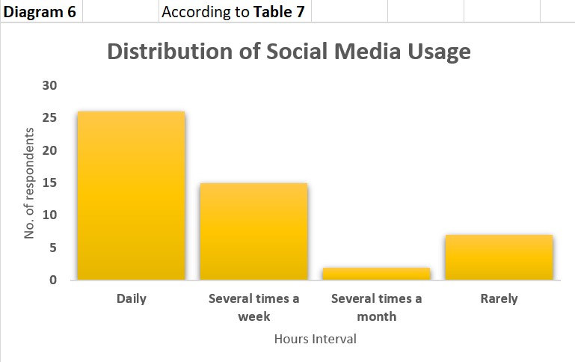
Diagram 6.1: Structure of respondents by groups according to Social Media usage Frequency:
(according to table 7)
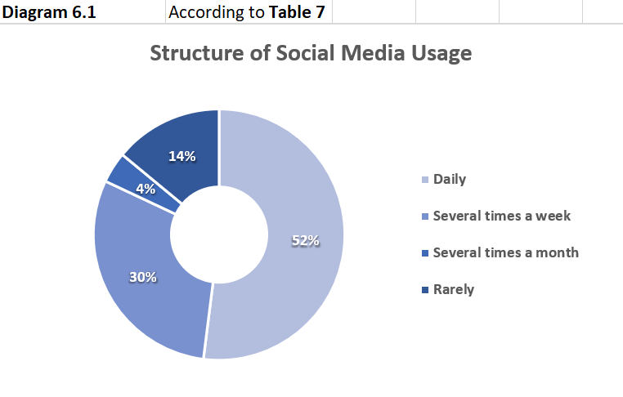
I expected these results because most people nowadays people cannot go on without social media. But again, I think my previous theory of people either spending a lot of time or no time on social media is confirmed by this graph. We notice that there’s a bit of a spike for people that „rarely” use social media. This means that most people either use it a lot or they simply don’t.

Diagram 7: Distribution of respondents by groups according to How Important Each Platform is (1-5):
(according to table 8)
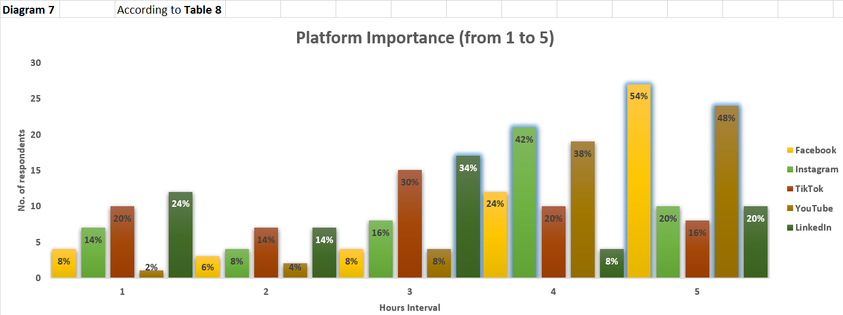
Facebook & Youtube seems to be of great value to people. Similarly, Instagram & LinkedIn also bring value to people, but not as much as the others mentioned. TikTok on the other hand seems to not be important to people, as most just use it to pass time & get aquick hit of dopamine.

Diagram 8: Structure of respondents by groups according to the Devices Used:
(according to table 9)
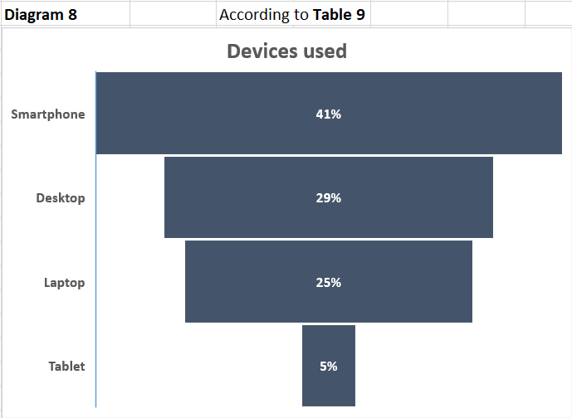

Diagram 9: Structure of respondents by groups according to What they purchase online:
(according to table 10)
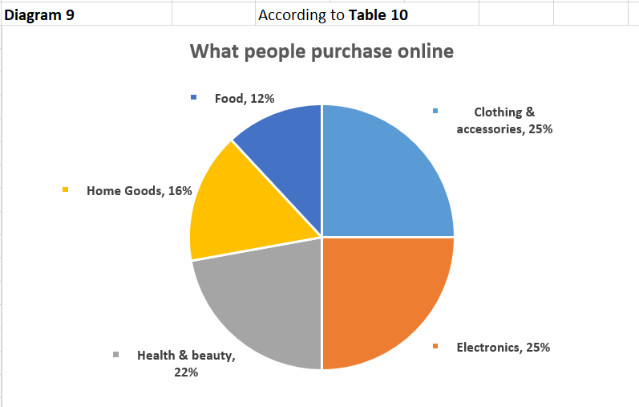
I was honestly doubting whether I should leave this question in here but this survey is about Web Preferences, after all. The results gathered closely align to my own speculation & experience. Few people purchase food & home goods online because it’s more of a hassle than a convenience. Convenience is the reason why people purchase all of the other items online (electronics, clothing...).

As a bonus, I wanted to also calculate what people spend the most time on, on the internet. This is interesting because it shows how important social media is today.
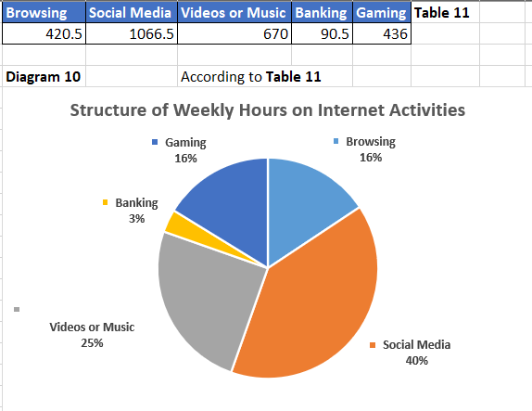

- CENTRAL TREND INDICATORS.
  - Average indicators (for each distribution / grouping)
- 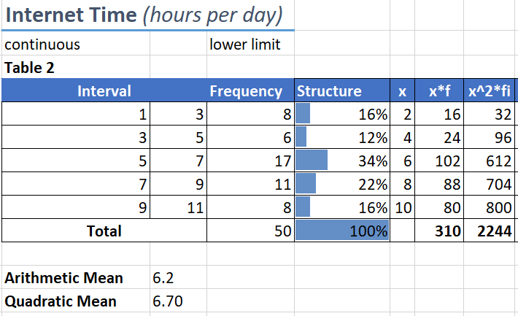
I will explain how I made the calculations once:
Arithmetic Mean = 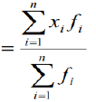
=310/50 = 6.2

Quadratic Mean = 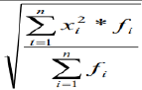
=SQRT(2244/50) = 6.7

The rest of the tables:
- 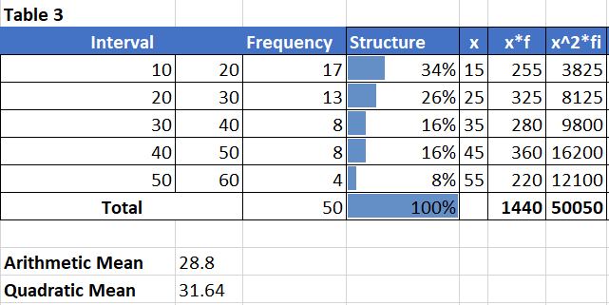
- 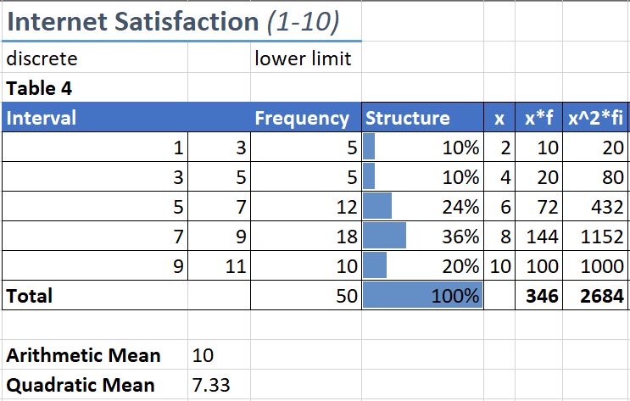
- 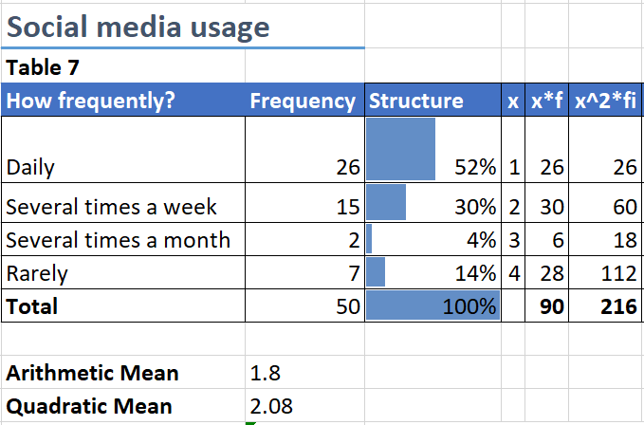

  - Average position indicators (for each distribution / grouping).
- 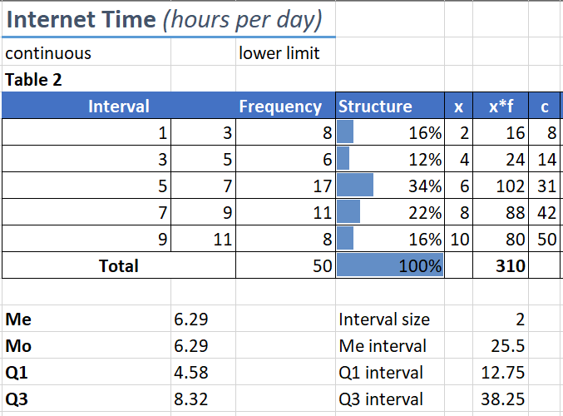
I will explain how I made the calculations once:
Median = 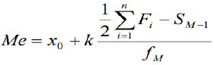
x0 - lower limit of the median interval;
k - size of the median interval;
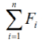 - total frequencies;
f M - frequency of the median interval;
S M-1 - sum frequencies of the intervals before the median.

=5+(2*(50/2-14)/17) = 6.29. This is the middle of the intervals.
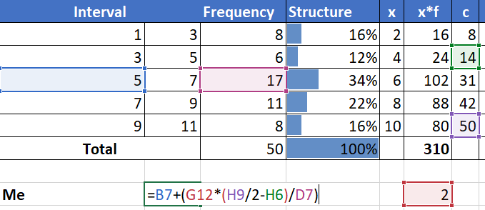

Mode = 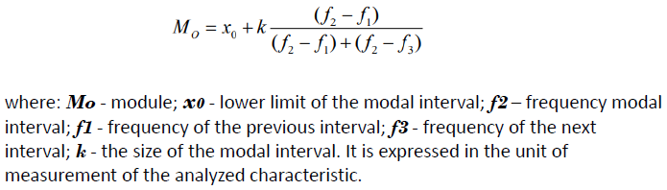
=5+2*(17-6)/((17-6)+(17-11)) = 6.29. The mode (most frequent value) is equal to the median. This means that the frequency distribution is symmetrical, it is a bell curve.
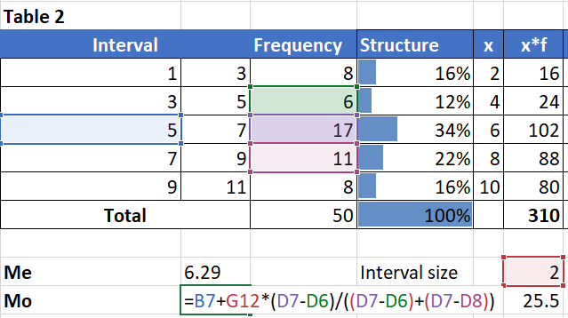

Quartiles
First quartile interval =(50+1)/4 = 12.75, where 50 is cumulative frequency.
Q1= 3+2*(12.75-8)/6 = 4.58.
Third interval is 12.75*3=38.25
Q3= 7+2*(38.25-31)/11 = 8.32.
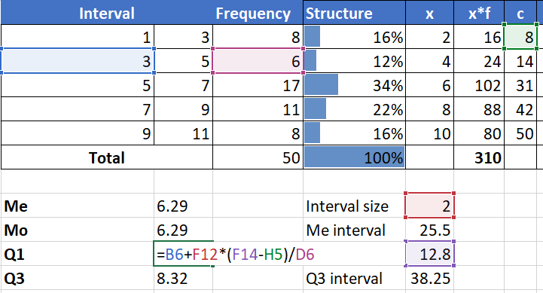

The rest of the tables:
- 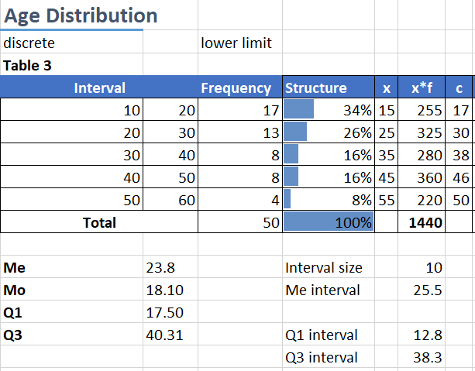
- 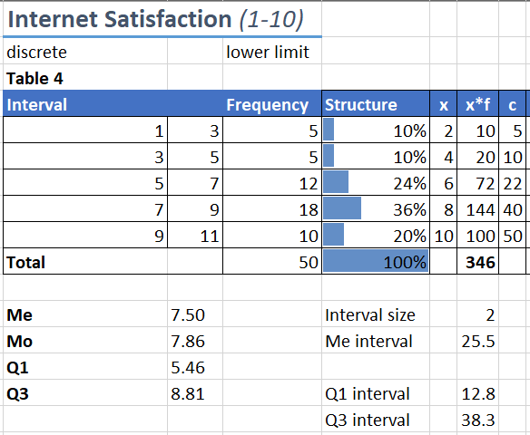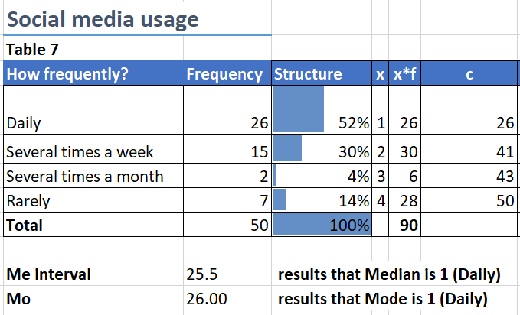
In this last example, Mode is simply the max frequency & the median is whatever value matches the median interval, which is =(50+1)/2.

  - Simple & concise indicators of variation (for each distribution / grouping).
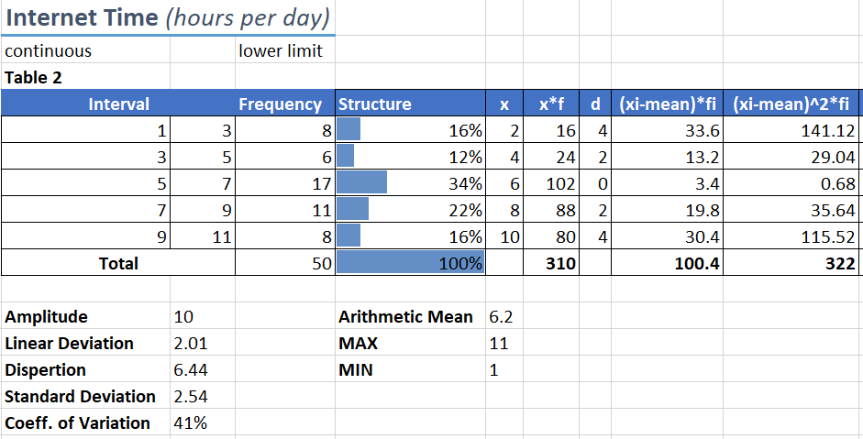
The simple indicators are: Amplitude (=max-min) & Individual Deviation (d=ABS(Xi-X mean)).
Synthetic indicators:
Linear Deviation. 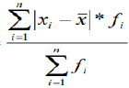
=100.4/50 = 2.01
Dispertion. 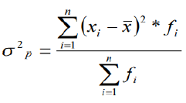
=322/50 = 6.44
Standard Deviation.
=SQRT(dispertion) = SQRT(6.44) = 2.54
Coefficient of Variation.
=(Standard Deviation/Mean)*100% = (2.54/6.2)*100% = 41%.
The 41% threshold means that the results are representative in a broad sense.

The rest of the tables:
- 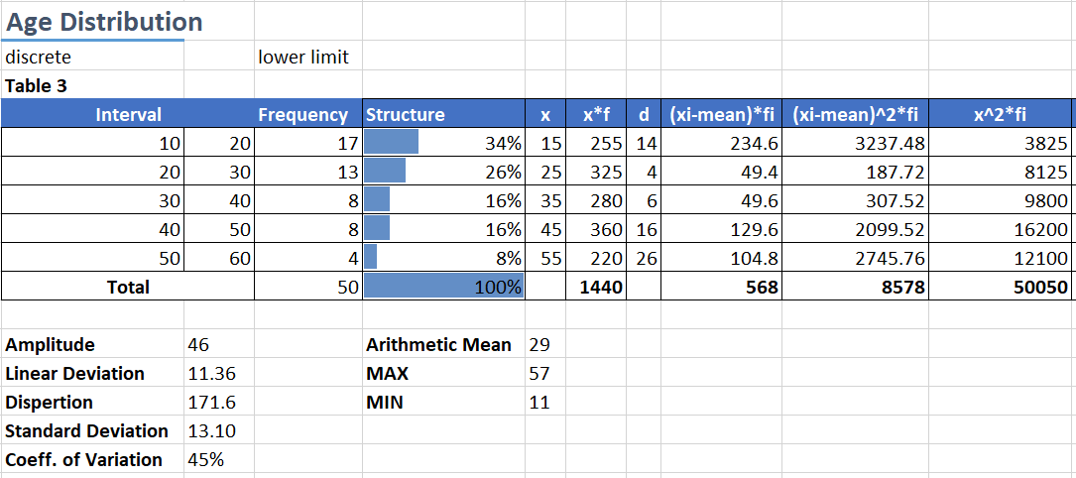
The 45% threshold means that the results are representative in a broad sense.
- 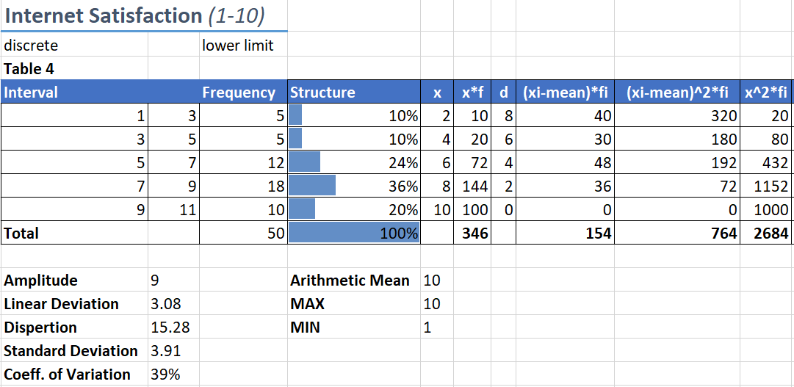
The 39% threshold means that the results are representative in a broad sense.

- 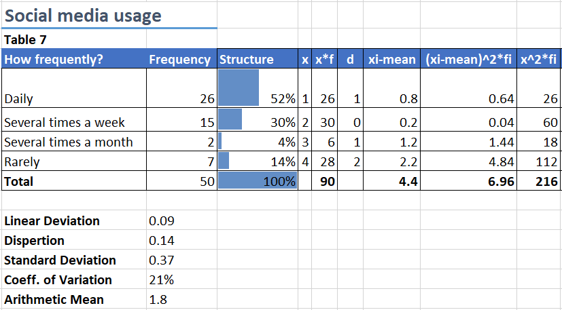
The 21% threshold means that the results are moderately representative.

General conclusions:
- This statistical research was very informative.
- Age can impact internet usage, with younger people tending to spend more time online.
- Most respondents spend a significant amount of time on the internet, with some spending up to 12 hours per day. This indicates that the internet has become an integral part of people's lives.
- Smartphones are the most commonly used device for accessing the internet, followed by laptops & desktops. Tablets are the least commonly used.
- Respondents spend the most time using social media, followed by streaming videos or music, browsing the internet, and gaming. Online shopping & banking are less popular activities.
- Social media usage: The majority of respondents use social media daily or several times a week. That being said, there was a spike in people that rarely use it. My theory is that people either don’t care about social media, they just use to text friends, or they’re addicted to it & spend too much time on it.
- Social media platform importance: Facebook & YouTube are the most important social media platforms to respondents, followed by LinkedIn & Instagram. TikTok is of less importance.
- Online purchase types: Clothing & accessories, along with electronics are the most commonly purchased items online, followed by health & beauty products and home goods. Food is not purchased online that much.
- Internet satisfaction: Most respondents are either somewhat satisfied or very satisfied with their internet usage, on rating scale from 1 to 10.
Overall, these conclusions suggest that the internet is a highly important aspect of people's lives, with most using it frequently for social media & consuming video or music content. Online shopping is also a popular activity, with clothing & accessories and electronics being tied for the most commonly purchased items. Facebook and YouTube are the most important social media platforms. Lastly, age plays a big role in the hours spent online.

- Analysis & adjustment of the time series of „S&P 500”
4.1 The phenomenon studied, the data source & the target period.
The phenomenon studied is the performance of the SP500 index over time.
The data source is the SP500 index, and the target period is from 2013 to the end of 2022. The SP500 is an index tracking the stock performance of 500 of the largest companies listed on stock exchanges in the United States. The data itself is divided into semi-annual snippets of the index’s value. Here is the data:
Date (Semi-Annual) | y (SP500 Value)
7/1/2013 | 1721.81
1/1/2014 | 1868.15
7/1/2014 | 1992.63
1/1/2015 | 2083.07
7/1/2015 | 2039.76
1/1/2016 | 2014.67
7/1/2016 | 2173.38
1/1/2017 | 2362.24
7/1/2017 | 2535.23
1/1/2018 | 2717.94
7/1/2018 | 2774.26
1/1/2019 | 2802.97
7/1/2019 | 3020.3
1/1/2020 | 2993.28
7/1/2020 | 3437.17
1/1/2021 | 4027.23
7/1/2021 | 4511.89
1/1/2022 | 4284.76
7/1/2022 | 3916.67
Total | 53277.41

Notice that the trend is not linear, it is parabolic. This will be important soon.

  - Absolute & Relative change indicators
Date (Semi-Annual) | y (SP500 Value) | ∆ t/1 | ∆ t/t-1 | I t/1 | I t/t-1 | R t/1 | R t/t-1 | A t/1 | A t/t-1
7/1/2013 | 1721.81 | 0 | - | 100% | - | 0.0% | - | - | -
1/1/2014 | 1868.15 | 146.34 | 146.34 | 108% | 108% | 8.5% | 8.5% | 17.2 | 17.22
7/1/2014 | 1992.63 | 270.82 | 124.48 | 116% | 107% | 15.7% | 6.7% | 17.2 | 18.68
1/1/2015 | 2083.07 | 361.26 | 90.44 | 121% | 105% | 21.0% | 4.5% | 17.2 | 19.93
7/1/2015 | 2039.76 | 317.95 | -43.31 | 118% | 98% | 18.5% | -2.1% | 17.2 | 20.83
1/1/2016 | 2014.67 | 292.86 | -25.09 | 117% | 99% | 17.0% | -1.2% | 17.2 | 20.40
7/1/2016 | 2173.38 | 451.57 | 158.71 | 126% | 108% | 26.2% | 7.9% | 17.2 | 20.15
1/1/2017 | 2362.24 | 640.43 | 188.86 | 137% | 109% | 37.2% | 8.7% | 17.2 | 21.73
7/1/2017 | 2535.23 | 813.42 | 172.99 | 147% | 107% | 47.2% | 7.3% | 17.2 | 23.62
1/1/2018 | 2717.94 | 996.13 | 182.71 | 158% | 107% | 57.9% | 7.2% | 17.2 | 25.35
7/1/2018 | 2774.26 | 1052.45 | 56.32 | 161% | 102% | 61.1% | 2.1% | 17.2 | 27.18
1/1/2019 | 2802.97 | 1081.16 | 28.71 | 163% | 101% | 62.8% | 1.0% | 17.2 | 27.74
7/1/2019 | 3020.3 | 1298.49 | 217.33 | 175% | 108% | 75.4% | 7.8% | 17.2 | 28.03
1/1/2020 | 2993.28 | 1271.47 | -27.02 | 174% | 99% | 73.8% | -0.9% | 17.2 | 30.20
7/1/2020 | 3437.17 | 1715.36 | 443.89 | 200% | 115% | 99.6% | 14.8% | 17.2 | 29.93
1/1/2021 | 4027.23 | 2305.42 | 590.06 | 234% | 117% | 133.9% | 17.2% | 17.2 | 34.37
7/1/2021 | 4511.89 | 2790.08 | 484.66 | 262% | 112% | 162.0% | 12.0% | 17.2 | 40.27
1/1/2022 | 4284.76 | 2562.95 | -227.1 | 249% | 95% | 148.9% | -5.0% | 17.2 | 45.12
7/1/2022 | 3916.67 | 2194.86 | -368.1 | 227% | 91% | 127.5% | -8.6% | 17.2 | 42.85
Total | 53277.41 | Total | 2194.9

There are comments for each calculation in the Excel File of this work but I will nevertheless explain each calculation.
- ∆ t/1 y – y1 This measures how much the value changed in comparison to the first time period, in absolute terms.
- ∆ t/t-1 y – (y-1). Note: „y-1” is the previous „y” value. This is how much the value changed in comparison to the previous time period, in absolute terms.
- I t/1 (Y / Y1) * 100 This measures how much the value changed in comparison to the first time period, in relative terms.
- I t/t-1 (y / (y-1)) * 100 This is by how much the value changed in comparison to the previous time period, in relative terms.
- R t/1 (I t/t1) - 100 This is the rate of change from the first time period to the current one.
- R t/t-1 (I t/t-1) - 100 This is basically the rate of change, in comparison to the previous time period. Very important indicator.
- A t/1 (∆ t/1) / (R t/1)
- A t/t-1 (∆ t/t-1) / (R t/t-1)
I hope these formulas were clear enough.

  - Average series indicators
Note: "hat" is the line above the indicator (like you can see for ŷ).

n = 19. This is the number of available values.
- ŷ (mean)= 53277.41 / 19 = 2804.07 ∑yt/n

- ∆ hat = 2194.9 / 18 = 121.9 (∆ t/t-1) / (n-1)
This is a very useful indicator. It answers this question: „By how much does the SP500 index increase/decrease every half year, on average?”
- I hat = (3916/1721)^(1/18) = 1.05 (I n/1) ^(n-1)

- R hat = (1.05 – 1)*100% = 5% (I hat - 1) * 100%
This indicator is the same as ∆ hat, but in relative terms. The index increases, on average, by 5% every half year, which is in line with most external sources.
  - Time series adjustment

- First, I will explore two Analyical methods.
The final results from both:
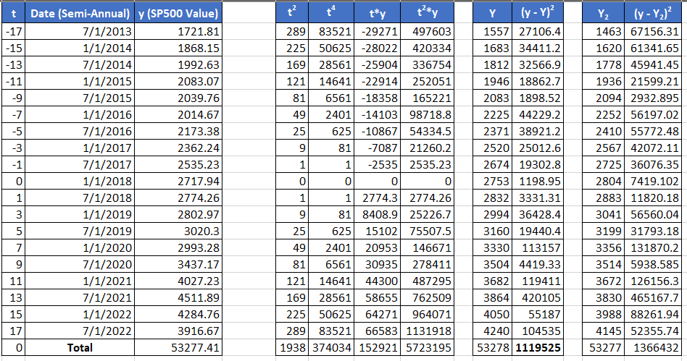
- First method. Parabolic trend method.
How do you calculate Y (theoretical values)?
Here is the formula:
Y = a + b*t + c*t²
Now here is how to calculate the values a, b, and c:
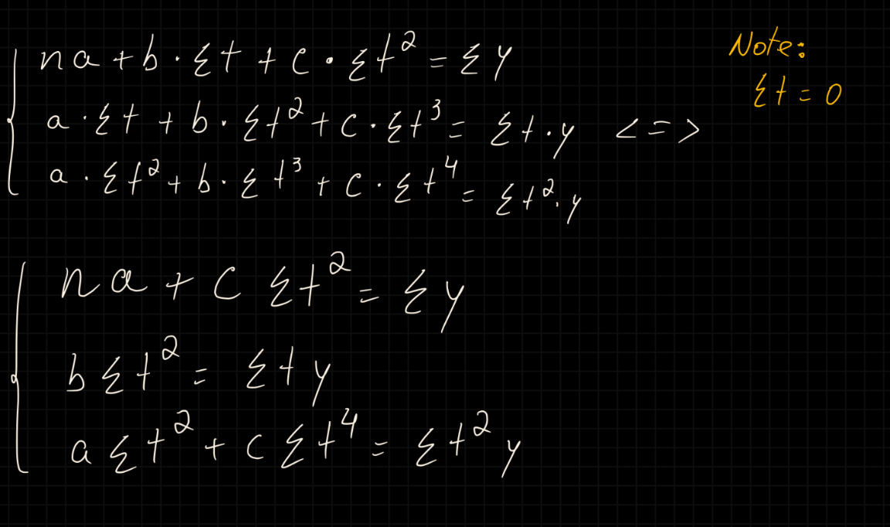
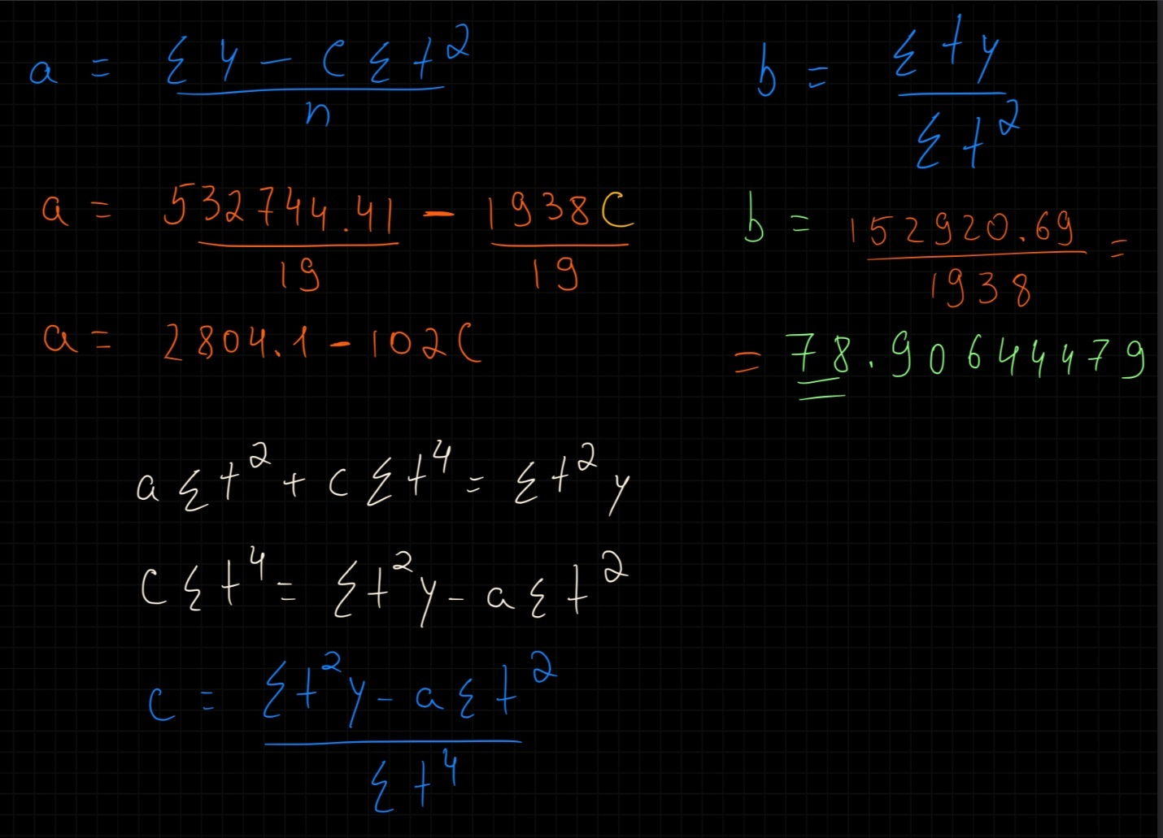
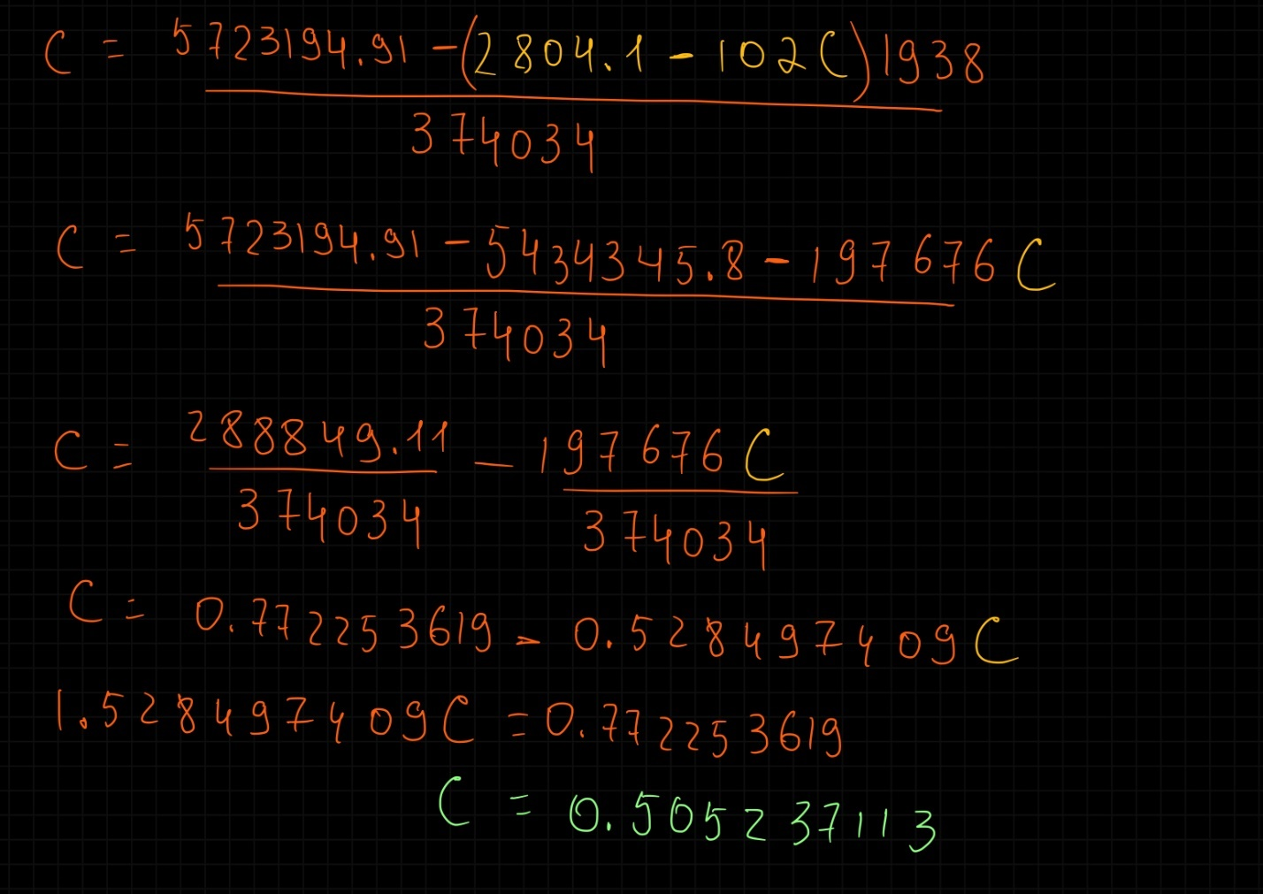
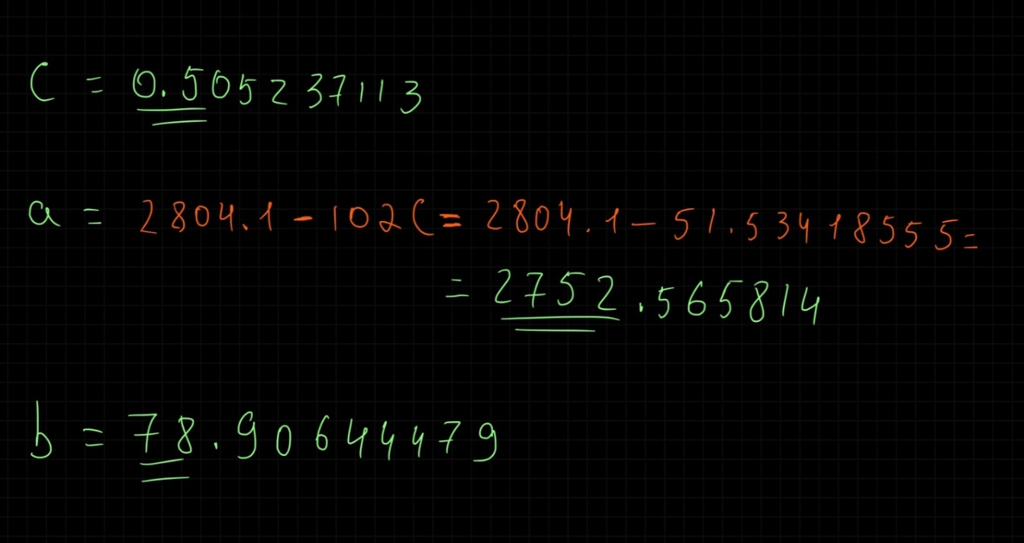

n= 19 (this is here simply as a reminder)
Results:
a= 2752.56
b= 78.9
c= 0.5

With these results, we calculate Y & the squared difference between our empirical “y” values & our theoretical “Y” values. The method that yields us the lowest sum of differences, is the better method.
 | y | Y | (y - Y)²
 | 1721.81 | 1557.2 | 27106.4
 | 1868.15 | 1682.6 | 34411.18
 | 1992.63 | 1812.2 | 32566.86
 | 2083.07 | 1945.7 | 18862.66
 | 2039.76 | 2083.3 | 1898.521
 | 2014.67 | 2225 | 44229.17
 | 2173.38 | 2370.7 | 38921.18
 | 2362.24 | 2520.4 | 25012.57
 | 2535.23 | 2674.2 | 19302.82
 | 2717.94 | 2752.6 | 1198.947
 | 2774.26 | 2832 | 3331.309
 | 2802.97 | 2993.8 | 36428.41
 | 3020.3 | 3159.7 | 19440.44
 | 2993.28 | 3329.7 | 113156.6
 | 3437.17 | 3503.6 | 4419.328
 | 4027.23 | 3681.7 | 119411.4
 | 4511.89 | 3863.7 | 420105.3
 | 4284.76 | 4049.8 | 55187.01
 | 3916.67 | 4240 | 104535.1
Total: | 53277.41 | 53278 | 1119525

Our sum is 1119525. Now we will have to calculate Y using the second method & see which method is better suited for our needs. The answer should be obvious though, as we do not have a linear trend in our case study.

- Second method. Linear trend method.
How do you calculate Y (theoretical values)?
Here is the formula:
Y₂ = a + b*t

Now here is how to calculate a & b:
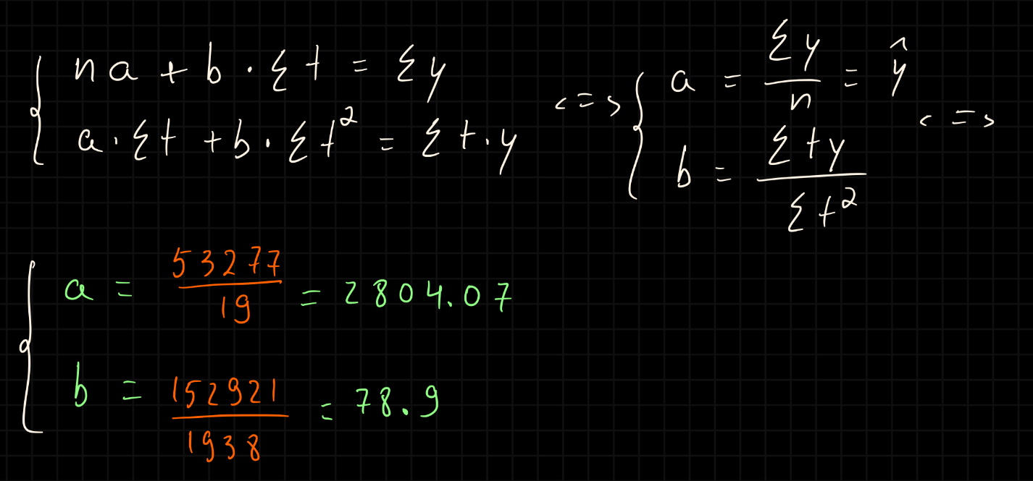
Results:
a= 2804.1
b= 78.9
We now once again calculate Y & the squared difference between our empirical “y” values & our theoretical “Y” values.
 | y | Y₂ | (y - Y₂)²
 | 1721.81 | 1462.7 | 67156.313
 | 1868.15 | 1620.5 | 61341.648
 | 1992.63 | 1778.3 | 45941.452
 | 2083.07 | 1936.1 | 21599.206
 | 2039.76 | 2093.9 | 2932.8948
 | 2014.67 | 2251.7 | 56197.015
 | 2173.38 | 2409.5 | 55772.484
 | 2362.24 | 2567.4 | 42072.112
 | 2535.23 | 2725.2 | 36076.355
 | 2717.94 | 2804.1 | 7419.1022
 | 2774.26 | 2883 | 11820.181
 | 2802.97 | 3040.8 | 56560.039
 | 3020.3 | 3198.6 | 31793.185
 | 2993.28 | 3356.4 | 131870.17
 | 3437.17 | 3514.2 | 5938.5848
 | 4027.23 | 3672 | 126156.31
 | 4511.89 | 3829.9 | 465167.66
 | 4284.76 | 3987.7 | 88261.944
 | 3916.67 | 4145.5 | 52355.742
Total: | 53277.41 | 53277 | 1366432.4

Conclusion & Forecast:
We see that 1366432.4 is bigger than our previous 1119525. This means that the first method, the „Parabolic trend” method was better for our purposes today.
The reason why we calculated these trends in the first place was so that we could make a Forecast that is as accurate as possible. We do this by simply plugging in the a, b, and c values into the Y formula & we only replace the future „t” values. For example, for 1/1/2023, the next „t” value would be 19 (we add 2 each time), so the forecast formula would look like this, according to the Parabolic method:
2752.6 + 78.9 * 19 + 0.5 * 19² = 4434
t | Date | Forecast Value
19 | 1/1/2023 | 4434.179
21 | 7/1/2023 | 4632.411
23 | 1/1/2024 | 4834.684
25 | 7/1/2024 | 5041

- Mechanical methods
Next, we’re moving from the analytical trend-analysis methods that we’ve covered so far to 2 mechanical adjustment methods.
First, here are the final results from these methods:
t | Date (Semi-Annual) | y (SP500 Value) |  | Y | (y - Y)² |  | Y₂ | (y - Y₂)²
1 | 7/1/2013 | 1721.81 |  | 1721.8 | 0 |  | 1721.8 | 0
2 | 1/1/2014 | 1868.15 |  | 1843.7 | 595.52268 |  | 1802.2 | 4342.956
3 | 7/1/2014 | 1992.63 |  | 1965.7 | 726.12284 |  | 1886.4 | 11275.1
4 | 1/1/2015 | 2083.07 |  | 2087.6 | 20.7025 |  | 1974.6 | 11770.95
5 | 7/1/2015 | 2039.76 |  | 2209.6 | 28830.908 |  | 2066.8 | 732.4338
6 | 1/1/2016 | 2014.67 |  | 2331.5 | 100377.02 |  | 2163.4 | 22114.85
7 | 7/1/2016 | 2173.38 |  | 2453.4 | 78428.002 |  | 2264.4 | 8293.5
8 | 1/1/2017 | 2362.24 |  | 2575.4 | 45422.976 |  | 2370.2 | 63.97352
9 | 7/1/2017 | 2535.23 |  | 2697.3 | 26267.765 |  | 2481 | 2944.117
10 | 1/1/2018 | 2717.94 |  | 2819.2 | 10261.69 |  | 2596.9 | 14656.65
11 | 7/1/2018 | 2774.26 |  | 2941.2 | 27861.174 |  | 2718.2 | 3143.259
12 | 1/1/2019 | 2802.97 |  | 3063.1 | 67674.554 |  | 2845.2 | 1781.928
13 | 7/1/2019 | 3020.3 |  | 3185.1 | 27142.563 |  | 2978.1 | 1780.578
14 | 1/1/2020 | 2993.28 |  | 3307 | 98411.873 |  | 3117.2 | 15364.36
15 | 7/1/2020 | 3437.17 |  | 3428.9 | 68.007511 |  | 3262.9 | 30383
16 | 1/1/2021 | 4027.23 |  | 3550.9 | 226928.38 |  | 3415.3 | 374463.2
17 | 7/1/2021 | 4511.89 |  | 3672.8 | 704077.62 |  | 3574.9 | 878042.8
18 | 1/1/2022 | 4284.76 |  | 3794.7 | 240126.13 |  | 3741.9 | 294741.3
19 | 7/1/2022 | 3916.67 |  | 3916.7 | 0 |  | 3916.7 | 3.31E-24
 | Total | 53277.41 |  | 53566 | 1683221 |  | 50898 | 1675895

- First method. Absolute mean change method.
How do you calculate Y (theoretical values)?
Here is the formula:
Y = y + (t - 1)*∆ hat
Now, from our previously calculated data, we know the value of the average indicator „∆ hat”. It is ∆ hat = 121.9.
This means that all we have to do this time is just plug in the values. The difference is that our „t” values simply start from 1 to whatever the last year’s number (count) is.
t | y | Y | (y - Y)²
1 | 1721.81 | 1721.8 | 0
2 | 1868.15 | 1843.7 | 595.52268
3 | 1992.63 | 1965.7 | 726.12284
4 | 2083.07 | 2087.6 | 20.7025
5 | 2039.76 | 2209.6 | 28830.908
6 | 2014.67 | 2331.5 | 100377.02
7 | 2173.38 | 2453.4 | 78428.002
8 | 2362.24 | 2575.4 | 45422.976
9 | 2535.23 | 2697.3 | 26267.765
10 | 2717.94 | 2819.2 | 10261.69
11 | 2774.26 | 2941.2 | 27861.174
12 | 2802.97 | 3063.1 | 67674.554
13 | 3020.3 | 3185.1 | 27142.563
14 | 2993.28 | 3307 | 98411.873
15 | 3437.17 | 3428.9 | 68.007511
16 | 4027.23 | 3550.9 | 226928.38
17 | 4511.89 | 3672.8 | 704077.62
18 | 4284.76 | 3794.7 | 240126.13
19 | 3916.67 | 3916.7 | 0
Total: | 53277.41 | 53566 | 1683221

The summed up value from the difference is 1683221. Remember that.

- Second method. Average Dynamic Index method.
How do you calculate Y (theoretical values)?
Here is the formula:
Y₂ = y * I hat^{t-1}
Just like the previous „∆ hat”, we already know „I hat” as well. I hat = 1.05. We once again just plug in the values.

t | y | Y₂ | (y - Y₂)²
1 | 1721.81 | 1721.8 | 0
2 | 1868.15 | 1802.2 | 4342.956
3 | 1992.63 | 1886.4 | 11275.1
4 | 2083.07 | 1974.6 | 11770.95
5 | 2039.76 | 2066.8 | 732.4338
6 | 2014.67 | 2163.4 | 22114.85
7 | 2173.38 | 2264.4 | 8293.5
8 | 2362.24 | 2370.2 | 63.97352
9 | 2535.23 | 2481 | 2944.117
10 | 2717.94 | 2596.9 | 14656.65
11 | 2774.26 | 2718.2 | 3143.259
12 | 2802.97 | 2845.2 | 1781.928
13 | 3020.3 | 2978.1 | 1780.578
14 | 2993.28 | 3117.2 | 15364.36
15 | 3437.17 | 3262.9 | 30383
16 | 4027.23 | 3415.3 | 374463.2
17 | 4511.89 | 3574.9 | 878042.8
18 | 4284.76 | 3741.9 | 294741.3
19 | 3916.67 | 3916.7 | 3.31E-24
Total: | 53277.41 | 50898 | 1675895

Conclusion & Forecast:
We see that the second method—the Average Dynamic Index method—yielded us a lower number than the Absolute mean change method. This means that it is more viable in this situation. It is the better & more accurate method of adjusting our time series.
Based on this, we can very accurately forecast the index’s value. Just like the previous time, we simply follow the Average Dynamic Index formula, instead this time we increase the „t” value by 1 for each additional time period. I will make this concrete with an example calculation for the next time period—1/1/2023:
1721.81 * 1.05²⁰⁻¹ = 4099.6
t | Date | Forecast Value
20 | 1/1/2023 | 4099.648
21 | 7/1/2023 | 4291.173
22 | 1/1/2024 | 4491.647
23 | 7/1/2024 | 4701.486

  - General conclusions in the analysis of the chronological series
Based on the analyzed data, we can make several conclusions:
- The value of the SP500 index, on average, increases its value by $122 every half year (∆ hat), or by 5% (R hat).
- From the analyzed period, the index experienced the fastest growth in 2020 & the first half of 2021, with a peak growth rate of 17.2% in 1/1/2021, in comparison to the previous semester. This was due to the COVID-19 pandemic, which massively staggered economic growth worldwide, not just in the U.S. As a result, the U.S. economy swiftly recovered, which accelerated the growth rate of the SP500 index, which measures the value of the top 500 largest companies in the U.S.
- I used 4 methods to adjust the time-series. First, I used 2 analytical methods: parabolic & linear trend. Then, I used 2 mechanical methods: absolute mean change & average dynamic index. In this case study, what proved to be of most use were the parabolic & average dynamic index methods. With their help, I managed to forecast the values of the index 2 years into the future, the results of which showed that the index is very likely to steadily increase at about the same rate, as it always has. However, as this is simply a projection, there may be some significant events that are unpredictable or unavoidable.

