Dear Tom Peterson and Leroy Wegmann,HOF President:
I have attached the resume of Francis Foley for your consideration into the Iowa Men's Fastpitch Hall of Fame.
Francis Foley's contact information:
1305 Morningside Ave.
Sioux City, IA 51106
(712)274-0792
My contact information:
Ray Loraditch
3421 Transit Ave
Sioux City, Ia 51106
(712)274-0792 or (712)898-5622
rsconstruct6@q.com
Thank you for your consideration
Sincerely,
Ray Loraditch

Francis Foley Resume
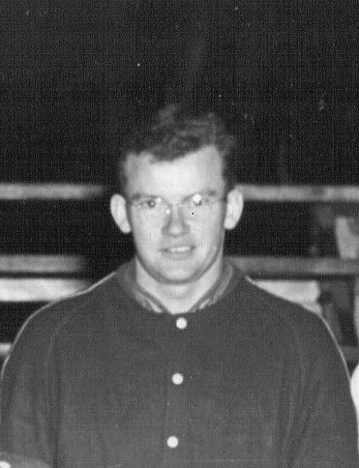
Francis began training for his career at an early age. Growing up on a farm near the small town of Charter Oak Iowa during the depression his family was unable to purchase the proper equipment (ball, glove or bat). Once he saved the pennies required to purchase a ball he practiced pitching it against the farmhouse steps for hours upon hours until the skin of the ball was worn out. He stopped long enough to repair it by wrapping it with twine and resumed his practice. Francis continued practicing hours upon hours day after day during his childhood perfecting his skill.
Francis and his family moved to Sioux City where he pitched for several teams. He quickly became known as one of the best pitchers in the Siouxland area. He helped win many local, state and regional titles with his pitching skills. When he pitched a game the bleachers would fill with spectators anxious to see him demonstrate his pitching skills and to see one of Siouland’s best.

Career Highlights:
- Francis career spanned twenty one years (1942 – 1963) retiring at the age of forty.
- Pitched for various teams in and around the Sioux City IA – Solomon Foods, Burnett Motors, LeMars Eagles, Johnson Biscuit, & Blue Bunny
- Pitched 20 no hit – no run games
- Pitched 6 perfect no run –no hit games
- Pitched 33 one hit games
- Pitched 37 two hit games
- Pitched 80 shutouts
- Pitched 75 games with only one run allowed
- Struck out 2849 batters
- Earned Run Average of 1.51
- Pitched 300 wins
- Pitched on 15 sanctioned ASA tournaments winners
- Pitched in 4 western regionals
- Pitched in 7 state tournaments (1946, 1947, 1948, 1949, 1950, 1952, 1953) won 11 games, lost 3 games. Pitched 5 shutouts, two 1 run games, and one 1 hitter game.
- State Champs 1949 & 1952 pitching five of these games giving up 1 earned run, pitching 3 shutouts and one relief appearance of hitless & run less innings
- Western Regional Champs 1952. Pitched winning game over Lincoln Nebraska.
- Pitched in 1952 World ASA tournament losing 4 to 2 against Lackland Air Force Base
- Lifetime Batting Average of .263
- 1995 during the ISC World Championship Tournament the ISC World Francis was presented a plaque from Siouxland Fans for his support and participation of softball.
- 2000 Received the NCC Honor Award for his support of Morningside College athletics

