The unbelievable path of Texas softball coach Mike White

Mike White went from a management career in New Zealand, to owning small businesses in Iowa, to coaching Texas' softball team to the Women's College World Series. Joshua R. Gateley/ESPN Images
- 
Dave Wilson, ESPN Staff WriterMay 26, 2023, 07:00 AM ET
- 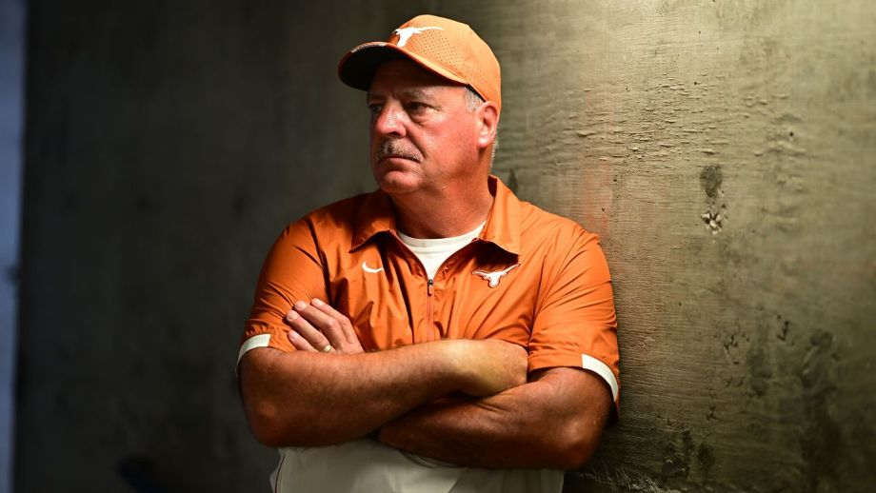print
AS A KID, Mike White dreamed of playing for the New Zealand soccer team, only to see his invitation upended by civil unrest in Fiji. As a teenager, he embarked on a management career for a courier company, the Kiwis' equivalent of UPS or FedEx. As an adult, he got a business degree from a small college in the Midwest and became a small-business owner in Iowa.
In 2023, Mike White is the softball coach of the Texas Longhorns, a place where they not only hope you can challenge Oklahoma, but they expect you to. And the 55-year-old White, who has already proved to be an overachiever in each of his several lives and has won 78% of his games in his first two head-coaching jobs at Oregon and Texas, is just fearless enough to try. His life has already been full of surprises, so why not attempt one more trick, akin to taking the USC basketball job when John Wooden was at UCLA?
"There's been so many forks in the road, so to speak, where things could have gone a different way," White said.
But they haven't. They've basically only gone White's way. A star pitcher in Wellington, New Zealand, he left to embark on a career in the United States as a hired hand, an ace ringer for teams like Ed Smith Welding of Bakersfield, California, or Teleconnect of Cedar Rapids, Iowa. All he did then, during the halcyon days of men's fastpitch softball in the 1980s and 1990s, was become the greatest pitcher in the world, someone who won more games in world fastpitch tournaments between 1980 and 2006 (70) than anyone else, according to the International Softball Congress.

Follow ESPN's softball coverage
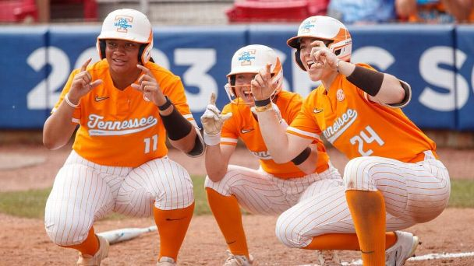
Complete schedule and TV info »
How each team can make the WCWS »
Valerie Cagle's painful road to stardom »
College softball rankings: Top 25 poll »
It wasn't until a conversation with legendary Tennessee co-coach Ralph Weekly more than 25 years ago sent him down a path to coaching.
That led White to Oregon, where his first head-coaching position came at one of the toughest jobs in the country for a school that had never won a conference title since the program began in 1974, and where White won five in nine seasons. Now, White is facing perhaps the biggest challenge any coach has today: stopping the Sooners' dynasty. And, given his history, it's not a surprise that he believes it's within reach.
"I believe that we can eventually unseat Oklahoma," White said last week. "I don't know if that will happen or not, but I believe we can do it. Nothing lasts forever."
BEFORE WHITE CAN set his sights on the two-time defending champion Sooners, the No. 13 Longhorns will have to get past No. 4 Tennessee in the best-of-three super regionals beginning Friday (4 p.m. ET, ESPN2). The Lady Vols are currently coached by Weekly's wife, Karen. (Ralph and Karen were co-coaches until 2021, when Ralph stepped down and left the program in Karen's sole possession.)
Ralph Weekly met White in Hawaii in 1997 while working with USA Softball as the director of its national teams. He knew of him because of his prowess as a pitcher, but really hadn't spent any time with White. But what he saw impressed him.
"He or she who has the best pitcher usually wins," Weekly said, "and he was the best pitcher in the world. He was a leader, and you can't really be a good coach if you're not a good leader. People have to look up to you and they have to be able to follow you. He knew the game because he had played it since he was young in New Zealand, and New Zealand was really where fastpitch started."
So he made a few calls. Weekly is adamant that he's not taking any credit for White's success, just that he was able to help him overcome a lack of experience to get his foot in the door. That was valuable for White since he was running his two businesses in Iowa, where he had pitched for several fastpitch teams, including leading Cedar Rapids Teleconnect to a world title in 1987 in Saskatoon, Saskatchewan, Canada. He went 6-0 in the world championship with five shutouts, three two-hitters, one one-hitter and had 63 strikeouts in 45 innings while his team hit just .139.
Unlike a lot of men's fastpitch players who bounced around to the highest bidder, White stayed a little while and became part of the community, according to J.R. Ogden, the sports editor of the Cedar Rapids Gazette, who has worked there for 45 years and covered many of White's exploits.
"There were a lot of teams here that had guys come in from New Zealand for years," Ogden said. "The majority of these guys would come in and they play one season here and then they'd go to Decatur or Sioux City, or someplace else that maybe offered them a little bit more money the next year. But Mike was different right from the start. He got really engaged in the community, went to one of the small colleges we have here in town, met a girl and married her."
White married his wife Lisa, earned a marketing and management degree from Mount Mercy College in Cedar Rapids in 1989 and became a U.S. citizen in 1994. He and Lisa had three daughters, Nyree, Kenzie and Sidney, all born in Iowa. But he wasn't sure running resale shops was scratching his itch.
"It was 24/7," White said, laughing. "We think coaching is a full-time job? You want to try retail sales."
He wasn't in much of a position to start trying to climb a coaching ladder, however, with a family to provide for.
"I didn't want to start at a traditional bottom rung," White said. "If someone wanted to take a gamble on me and get me into like a Power 5 program or a top D-I program, I was willing to make that jump."
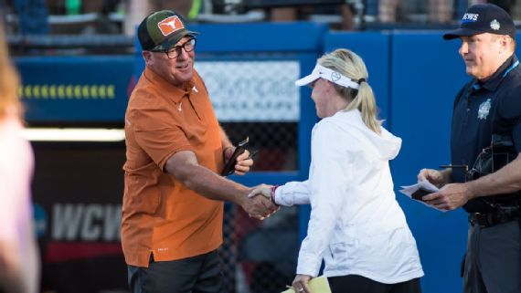
Texas had been eliminated in six straight regionals before Mike White took over the program. Last year, he led an unseeded Longhorns team to its first WCWS championship series appearance. Brett Rojo-USA TODAY Sports
WITH WEEKLY SPREADING the word, and a reputation as a stellar pitcher, a door opened at Oregon, which offered him a job as a pitching coach. He decided to do it, although it paid just $27,000, a pay cut from his businesses. After two years in 2003-04, he decided maybe assistant coaching wasn't for him, either. He chose to spend more time with his daughters, coaching their youth teams and doing private instruction on the side. And then another huge break came: Oregon called back about its head-coaching job in the summer of 2009, despite just two years of assistant coaching experience six years prior.
The hire paid immediate dividends, with White taking over a team that went 16-34 and 3-18 in the Pac-12. His first year, in 2010, Oregon went 36-21 and made an NCAA super regional. By Year 3, he took the Ducks to the Women's College World Series.
"What he did at Oregon ... he was ranked No. 1 in the country with the worst softball facility in the nation. We're talking locker rooms, we're talking field," said Renee Baumgartner, now the athletic director at Santa Clara, who made an impassioned plea to hire White when she was a senior sports administrator overseeing the Ducks' softball program. "I was just determined to hire him because I knew he was special and that he could build anything, any program."
And build he did, including Oregon opening a new $17.2 million softball stadium in 2015. White's success -- he was a three-time Pac-12 coach of the year and took the Ducks to five College World Series appearances -- drew the attention of the Longhorns, who had slipped behind the Sooners after winning four Big 12 titles between 2002 and 2010, but none since.
"They were perennially dead last when he got there," Texas athletic director Chris Del Conte said of Oregon at White's introductory news conference. "They were god-awful."
White has made a similar impact with the Longhorns, winning 75% of his games and taking a 190-61-2 record into this year's super regionals against Tennessee. He has a big new contract that pays him $625,000 annually after becoming the first coach in NCAA history to take an unseeded team to the WCWS finals last year.
Just one of those 190 wins, though, have come against Oklahoma, and last year's magical run in Oklahoma City ended with a sweep by -- who else? -- the Sooners. But all White can do is keep chipping away.
"I knew it was going to be tough facing that traditional power," White said. "[Patty Gasso is] in her 29th season and built that program to what it is, like a dynasty. The thing about Oklahoma is they're not staying status quo. They keep getting better, they keep pushing the envelope, which I admire. They're out there recruiting, they're out there doing all the things you need to do to stay on top.
"I kind of wish they'd take a year off but tht's not what's going to happen."
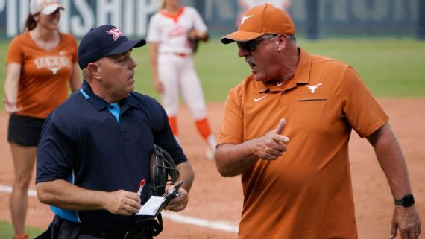
Mike White's ability to poke the bear that is Oklahoma softball was part of the reason why one columnist for The Oklahoman labeled him "college softball's villain." AP Photo/Sue Ogrocki
WHITE ISN'T AFRAID to battle the Sooners off the field, either.
He poked the bear this year in an off-the-cuff remark during an interview before the Longhorns and Sooners met in late March on how difficult it is to keep up with them.
"They keep finding ways to reload and I'm not quite sure all of it is, you know. ... Whatever, I won't say anymore," White said. "They want to be the bully on the block, and they've done a pretty good job of it."
Eyebrows were raised in Oklahoma, with some hypothesizing that White suggested the Sooners were cheating -- White says Gasso didn't take it that way -- but he says the comments were short on context when he was discussing bigger issues, like name, image and likeness, and how the rich keep get richer as a result.
"Truthfully, I wish we had the same resources so we could use it the same way to be able to enable players to make some money out of it," White said this week. "I'm not sure how they're using it, but it is becoming a big part of the game."
White's white-hot competitive streak can sometimes lead to controversy, be it with his gamesmanship (stalling for a tie in a matchup against Kentucky this year when the game had a drop-dead ending time) or his temper, like when he had to apologize after getting ejected from a game and flipping two middle fingers to the umpires before leaving the field.
"There's a whole bunch of people that you make yourself up [of]," White said, naming coaches like Wooden and Alabama's Nick Saban, "but I can't be them. I've got to be who I am. You always have those regrets as afterthoughts. I'm working on controlling that, but yet not changing what makes me effective. I've got to work on being a little more eloquent with it."
The Oklahoman called White "college softball's villain," also referencing White's comment that Oklahoma's NIL program was "a case of the haves and have-nots," incredulously noting that someone from Texas, of all places, would complain about a financial disadvantage. And yet, White still couldn't resist one more opportunity.
"The thing is, why are they upset about it if they're doing everything legal?" he said.
​​The 45-13-1 Longhorns went 0-4 against the Sooners this season. But they also went 3-0 in their regional, including beating another rival, Texas A&M, twice and sending the Aggies home while cementing Texas' fourth straight super regional appearance. Prior to White's arrival, the Longhorns had made just four supers since 2005. In 13 regional appearances as a head coach, White has never been eliminated.
Now with his sights set on another run to the WCWS, White knows all roads lead through Oklahoma.
"It's been a slow process, slower than I imagined," White said. "We went pretty quickly at Oregon. ... This one has been incrementally harder. I think I've got good coaches around me and we're getting some good recruiting classes coming in. I'm not afraid of anything. I'm not afraid of a challenge and I believe I can do anything. We've got to get an inroad. We won a game against them last year, so it's going to be inch by inch."
FROM NEW ZEALAND, to Iowa, Eugene and Austin, White has become one of the must-watch characters in a booming sport, and a little Oklahoma-Texas heat is never bad for business. But even if White never slows the Sooners' onslaught, his road to being one of softball's biggest names has been remarkable, a series of sliding doors that led to this point.
White says in 1979 he had been training hard -- in soccer -- hoping to land a spot on his country's national team. But when he finally got that shot, he said a planned trip to Fiji and New Caledonia was scuttled because of protests in Fiji.
"About the same time I ended up getting a call from the United States asking if I'd be interested in going over," White said. "I was 18 and decided to take that jump. I thought it would be my only chance to come to the United States and play."
White made the most of that trip. Over his career, he pitched for 11 teams that won American Softball Association or International Softball Congress championships, including five MVP awards. He has been inducted into seven different softball Halls of Fame, including those organizations, statewide halls of fame for Oregon, Missouri and Iowa and the New Zealand Softball Hall of Fame. But those are all his own individual awards and now he's focused on growing the game and helping his players forge for their own paths, albeit with one giant mountain left for White to climb.
"I haven't won a national title yet," White said. "I definitely want to try and win one but if it doesn't happen, then it's been very fulfilling to watch these young women achieve some of their dreams."
His believers, like Weekly and Baumgartner, who still DVRs every Texas softball game she can watch from California, say he's on the right path.
"It's not even a Cinderella story," Baumgartner said. "It's just a great story for softball. This is just the beginning of great things to come for Texas softball, I have no doubt."

