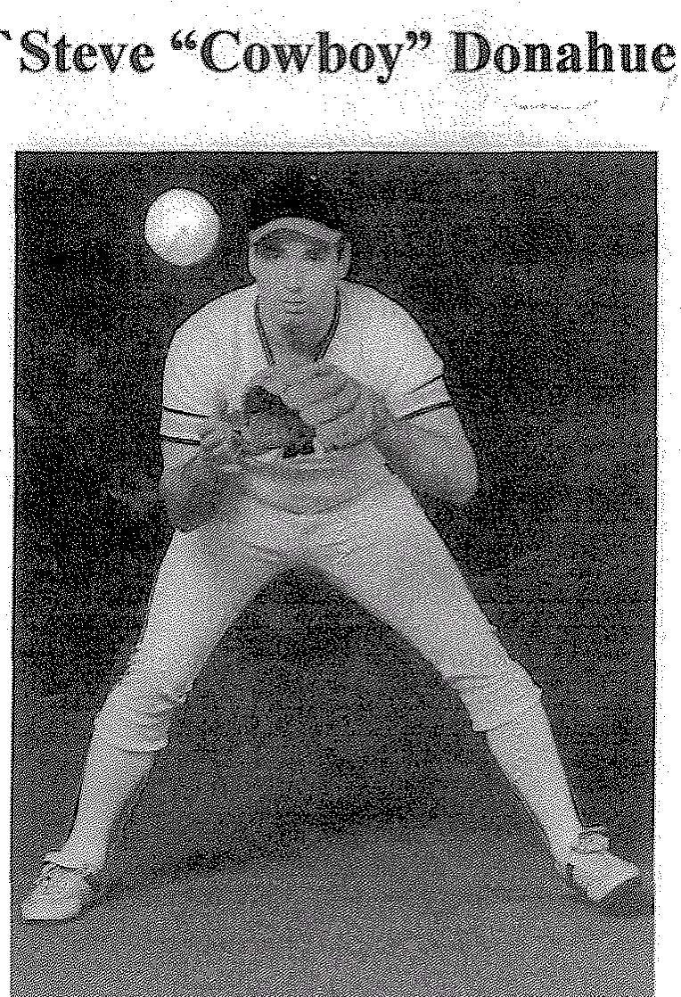
During the 1950s, every small town in central Iowa seemed to have a men's fastpitch softball team. These small communities had quality diamonds with lights, and quality players. Usually the entire community, dogs and all, attended the games. Picture a small town, just outside of Webster City, called Kamrar. Fewer than 300 residents lived there, but many were top-notch athletes. Kamrar had a reputation for producing winning girls' basketball teams. In fact, Cowboy's mother, Dorothy Welp Donahue, is the former all-state guard and all-state forward (and recently inducted to the All American Flail of Fame) with the Kamrar clubs that dominated girls' basketball for a time. Kamrar also was known for hosting fastpitch softball teams. Many well-known players, such as Hall of Fathers Andy Yates and Lawrence Cheney, competed against each other on that Kamrar softball field.
In the early 1960s, attending the Kamrar softball games was a family event. It was a time of popcorn, snow cones, and swatting mosquitoes. Outfielders had to be careful when chasing down balls as there were cow pies to avoid. Kids raced against each other to chase down foul balls (for the nickel the manager gave them). When Steve was not playing catch near the field, he was often the best foul ball retriever.
Fast-forward to 1973. Steve had been a standout athlete in high school. He lettered all four years in baseball, basketball, track and football. Steve began college in the fall of 197, and in the summer of 1973 began to play fastpitch softball with the Webster City Merchants.
The Webster City Merchants had several strong years, doing well in the state tournament as well as other tournaments in the area. Cowboy was a part of this.
In 1976, Steve played with teams in the Cedar Rapids area. It was at this time he became known as "Cowboy" and there are many stories as to the nickname stuck. The most frequently told version it was because he usually wore cowboy boots. In a newspaper article, he claimed, "I got my first exposure to Cedar Rapids softball through Jocko (Hinderks)." Jocko is a former Kamrar native who played extensively in the Cedar Rapids area.
Modem Piping of Cedar Rapids won the state title in 1977 due in part to Cowboy's home run in the championship game.
Softball also allowed Cowboy to travel. In the summer of 1979, he met Loran Algar, one of the fastest pitchers from New Zealand. Loran was pitching for another Cedar Rapids team. Loran invited Cowboy to live in New Zealand and play with his team, the Porirua. Cowboy started every game, playing right field, and was usually the cleanup batter, being one of two hitters on the team. In a New Zealand newspaper clipping concerning the Quantel Cup championship game, Cowboy and Loran were given much of the credit for the title victory. The Quantel Cup was one of the biggest tournaments in the entire country and was carried nationwide on television. In the 15th inning, Cowboy started things rolling with a two-base hit to deep left field, and he scored the only run of the game when he beat a throw to home.
Another highlight was the ISC tournament in 1981, where Cowboy batted .615 in the tournament and earned a place on the All World Team as an outfielder. His batting average set a record.
Cowboy eventually relocated to Illinois, and softball no longer figured so prominently in his life.
During his career in Iowa, even when his team was eliminated, Cowboy was often picked up by other teams to round out their tournament rosters. That in itself speaks highly of Cowboy as a person and an athlete.
Testimonials
When trying to locate statistics on Cowboy's career, many people were contacted. They did not have statistics but did have comments. One, by Leroy Wegmann, summed his remembrances:
"My personal opinion is that Steve is a very legitimate candidate and will be given a very strong consideration for induction."
Paul Espinosa remembered Cowboy:
"Steve was a really good player. We had several veterans on our team and we wouldn't have had Steve if he wasn't good with great potential."
Hall of Fame pitcher Andy Yates:
"I played with Steve for 3 years. I always felt confident that he would put the bat on the ball and something would happen. In my opinion, Steve deserves to be in the Hall of Fame.
Mark Yates, Andy's son, retails:
"Of course I remember Cowboy...As a kid I remember Cowboy being the most exciting player to watch. He played some outfield and third base. But the thing about Cowboy was his amazing full hip turning power that he hit the ball with. He definitely belongs in the Hall. I never got to play with him, like Dad did, but I played against him on occasion. He terrified every third baseman he faced.....As a kid. Cowboy was a definite hero of mine. I would be proud to help the cause."

Teams
1973 – Webster City Merchants 1974 – Webster City Merchants 1975 – Webster City Merchants 1976 – Cedar Rapids Modern Piping 1977 – Cedar Rapids Modern Piping
1977 – State Champions 1978 – Clear Lake Buttr Top
1978 – State Champions
1979 – Cedar Rapids Midwest Gallery
1979 – 5th Place in ISC
1980 – Cedar Rapids Midwest Gallery
1980 – 2nd Place in ASA
1979-1980 - New Zealand Porirua Team
1979 - Quantel Cup, New Zealand
1980 –
1981 – Cedar Rapids Midwest Gallery
1981 –16th Place in ISCAWARDS
1979 – Major Open Batting Champion
1979 – Riley Dunn Memoriall Tournament
1979 – Little Natiouals All State Team
1981 – ICS All-World Team
1981 – ASA All Star

