Charles “Junior” Nichols, Jr.
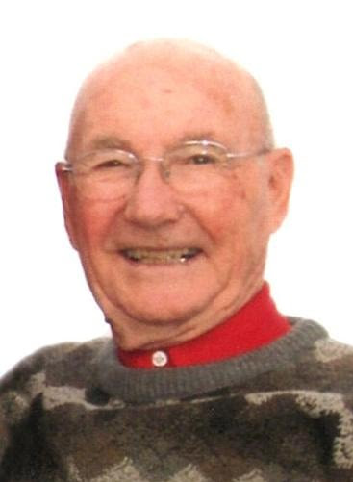

Charles Nichols, Jr., 92, of Knoxville passed away Jan. 27, 2021. Private family services will be held on Tuesday, Feb. 2, 2021. Pierschbacher Funeral Home will be handling the arrangements. In lieu of flowers, memorials are requested to the Columbia United Methodist Church in Columbia, Iowa. You may join the family via livestream on Jr.’s tribute page at https://my.gather.app/remember/charles-junior-nichols.

Jr. was born on March 3, 1928 in Marion County, Iowa. He was the second son born to Charley and Clara (Kingery) Nichols. He attended various country schools and graduated from Knoxville High School in 1947. He lived in Marion and Lucas counties all his life, except during his two years in the U.S. Army, 1950-1952.
During a furlough, before being sent to Korea, he was married to Carolyn Garrett on March 5, 1951 at the Little Brown Church in Nashua, Iowa. March 2021 would have been their 70th wedding anniversary.

After his discharge from the army, Jr. worked at the Iowa Packing Plant in Des Moines. He then drove a tank truck and delivered fuel to farmers for 37 years (1953-1990) in the Belinda/Pleasant Prairie community. He also drove a school bus for the Chariton Community Schools for 34 years, 1958-1993.

He was a member of the Columbia Methodist Church and later the Pleasant Prairie Methodist Church, where he served on several committees. In November 2008, Carolyn and Jr. sold the farm they had lived on for 48 years and moved to Chariton. They became members of the First United Methodist Church. In October 2014, they moved to Knoxville and transferred their membership to the Columbia Methodist Church. He and Carolyn resided at Homestead Assisted Living in Knoxville at the time of his death.

Jr. was an outstanding softball pitcher for 26 years for the Belinda softball team. In August 1994, he was inducted into the Iowa Softball Hall of Fame. After retiring from softball, he became an avid golfer. He has many trophies from his softball and golf years. When not golfing, he enjoyed playing cards with his buddies.

Jr. is survived by his wife, Carolyn; one daughter, Julie Ann (Ron) Rees of Knoxville and one son, Dennis Jay (SuIm) Nichols of Columbus, Georgia; three grandsons: Chad Irving of Knoxville, Luke Irving of Knoxville and Joshua Nichols of Columbus, Georgia; and three great-grandchildren: Carson, Natalie and Carter Irving and another due in April. He is also survived by one sister, Phyllis (Ben) Willetts of Knoxville. Also surviving are his in-laws: Jim (JoAnn) Garrett and Eldon Reed of rural Chariton, Joanne (Dean) Sellers of Ankeny, and Joanne Nichols of Winterset; and many nieces and nephews.

He was preceded in death by his parents; brothers: Bob Nichols of Columbia and George Nichols of Winterset; sisters-in-law: Linda Reed of Chariton and Leta Nichols of Columbia; and son-in-law, Cole Irving of Columbia.

