Darrel Zunkel
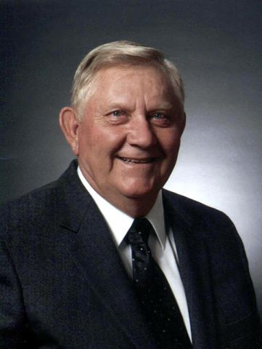
1
Darrel Zunkel
September 26, 1934 - June 11, 2015
Darrel Zunkel, 80, of Ames, died Thursday, June 11, 2015 at Israel Family Hospice House. The family will receive friends from 4:00 to 7:00 p.m. Monday, June 15 at Adams Funeral Home in Ames. Funeral services will be at 10:30 a.m. Tuesday, June 16 at First United Methodist Church in Ames. Burial will be in the Pilot Mound Cemetery.
Darrel Dean Zunkel was born September 26, 1934 to Paul and Ella Zunkel in Pilot Mound, Iowa. He graduated from Pilot Mound High School in 1952. Darrel farmed in Pilot Mound where he lived most of his life before retiring and moving to Ames in the fall of 1998. Darrel and Judith Smith were married on March 7, 1959 in Madrid, Iowa. Darrel served many years as a volunteer fireman for the Pilot Mound Fire Department, served on the Grand Community School Board, and was involved in various positions within the Pilot Mound Methodist Church and at First United Methodist Church in Ames.

Darrel began playing men’s fastpitch softball when he was 14 years old. He played for the Boxholm Swedes, Boone Merchants, Des Moines Bombers, and many tournaments for surrounding towns. In 1981, Darrel was inducted into the Iowa Men’s Fastpitch Softball Hall of Fame, where he later served as a board member.
Darrel is survived by his wife of 56 years, Judy Zunkel; his sons, Gary (Karen) Zunkel, of Ames, Gayle Zunkel, of Nevada, Jon (Noel) Zunkel, of Madrid and Kurt (Angie) Dickerson, of Phoenix, Arizona; his daughter, Denise (Brian) Fowler, of Pleasant Hill; his grandchildren, Paul and Jacob Zunkel, Owen and Daniel Zunkel, Jordan and Bryce Dickerson and Jessica and Lindsay Fowler; his sisters, Pauline Kuhl and Janet Elliott; his brother-in-law, Larry (Kaye) Smith; his sisters-in-law, Sherry (Fred) Good and Ruth Ann (Frank) Walker; and many nieces and nephews.
He was preceded in death by his parents; Judy’s parents, Dwight and Ruth Smith; a brother-in-law, Don Kuhl; and brother and sister-in-law, Ronald and Nancy Dickerson.
Darrel never met a stranger and will be missed by his many friends and family members.
In lieu of flowers, memorial may be directed to the Bliss Cancer Center, Israel Family Hospice House, or First United Methodist Church.
Adams Funeral Home is assisting the family with arrangements. Condolences and photos may be shared at www.adamssoderstrum.com

