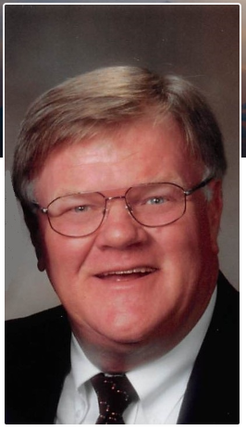

David Eugene Temple, 74, of Ames, completed his journey to be with the Lord on Sunday, July 14, 2019, in the tender care of the Israel Family Hospice House. Dave was born on November 15, 1944 to John and Ruby (Anfinson) Temple. After his childhood in Gilbert, Dave attended Iowa State University where he played baseball and graduated with a bachelor's degree in physical education in 1968.

He served our country in the army during the Vietnam War, stationed in Germany. Dave took great pride in refereeing for football and basketball games around the state. Dave was at home on almost any fast-pitch softball field in the Midwest. He was a pitcher, catcher and player-coach on numerous teams for several decades. His daughters-in-law were continually amazed at his ability to recollect every detail of every game - from the temperature at the first pitch to the quality of the hot dogs at the concession stand to the pitch count at every batter on the roster.

Dave's genuineness and compassion will be remembered by all his clients at Alliance General Insurance. His rolodex overflowed with clients who became friends. His devout faith was admired by many. He served his community doing jail ministry at the Story County Jail. Dave enjoyed spending time with his family. He received great joy from watching his granddaughter on a dance competition stage and leading the cheer squad. He beamed with pride admiring his grandson play in the orchestra. He loved cheering on his grandsons on the baseball diamond and basketball court. But simple things like enjoying an ice cream cone with any of them brought the best smiles to his face. Dave enjoyed traveling with his wife Cheri and no matter where they went, Dave was sure to encounter someone on his very long list of lifelong friends whom he could easily pick up a conversation as if no time had passed since he last saw them.

Dave married Cheryl Briley on April 23, 1983. Together they raised two sons, Scott and Nathan. Dave is survived by his wife, Cheri; his sons, Scott (Bobbi Jo) and Nathan (Andrea); four grandchildren, Malorie, Ian, Kyle and Sawyer; one sister, Linda Sills of Des Moines; and two brothers Jerry Temple of Summerville, SC, and Roger (Joanne) Temple of Boone. He was preceded in death by his parents; two sisters, Nancy Temple and Sandra Harriman; and one brother, Mike Temple.

Dave's family will greet visitors at St. Cecilia Catholic Church, 2900 Hoover Ave, Ames, on Thursday evening, July 18 from 4:00pm to 6:00pm with a vigil service beginning at 6:00pm. Mass of Christian burial will be held on Friday, July 19 at 10:30am at St. Cecilia Catholic Church. A private burial for family will be held at a later date at the Ames Municipal Cemetery. In lieu of flowers, memorials may be directed to the family. Online condolences are welcome at www.grandonfuneralandcremationcare.com.

