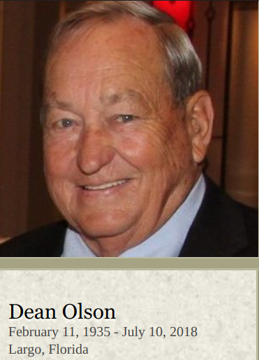

Dean Olson, 83, passed away at the Suncoast Hospice in Largo, Florida on July 10, 2018.
A memorial service will be held 1:30 p.m., Saturday, July 21, 2018, at Emanuel Lutheran Church in Dayton. Private burial will be in the Dayton Cemetery. A celebration of life will take place in Florida at a later date. For online obituaries & condolences visit: www.carsonstappfuneralhome.com
Dean was born on February 11, 1935 in Boone County to Rudolph and Anna (Johnson) Olson. He married Joyce Jensen on June 9, 1956 and they made their home in Dayton, Iowa where they raised their 2 daughters. He worked at Jensen Dairy, Hormels, and owned Olson Construction.
Dean enjoyed hunting, fishing, playing cards, and looking for mushrooms. He excelled in all sports, but watching Dean hurl the softball was pure entertainment. Dean started his softball competition with the Boxholm Swedes in 1952 after completing an outstanding career in high school basketball and baseball at Boxholm High School. He was inducted into the Iowa Softball Hall of Fame in 1986. He passed on his love of many sports to his daughters and grandkids.
Dean is survived by his wife of 62 years, Joyce Olson, daughters Julie (Jeff) Semprini, Susan (Jeff) Muench; grandchildren, Sara, Rachel, Chelsey, Nathan, Nolan; great grand daughter Julia; siblings Jeanette Sprecher, Bill Olson, Bob Olson, Gene Olson, and Judy Outtrim and extended family and friends. Dean was preceded in death by his parents and two sisters, Janice Doran and JoAnn Anderson.
Memorials in Dean's name may be directed to Suncoast Hospice.
Suncoasthospice.org

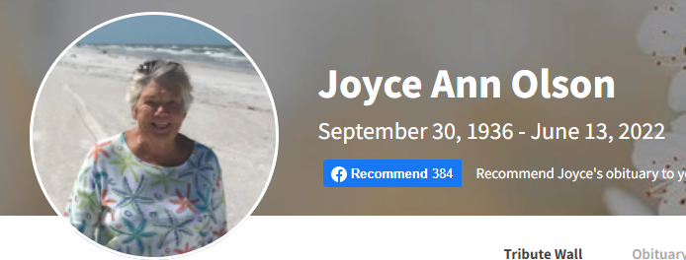Joyce Ann Olson, 85, passed away peacefully on June 13, 2022, under the care of Hospice in Pinellas Park, Florida.

Joyce was born on September 30, 1936, in Hampton, Iowa to Walter and Alvina Jensen. She has one sibling, Dennis Jensen of Aubrey, Texas.

She graduated from Dayton High School in 1954 and earned her teaching degree from Iowa Teachers College and Drake University. Teaching was her true passion and she taught first grade for 42 years at Boxholm and Dayton Elementary Schools before retiring in 1996.

Joyce and Dean Olson were united in marriage on June 9, 1956. They resided in Dayton for 54 years before making Fairway Village in Largo, Florida their permanent home. They were blessed with two daughters, Julie (Jeff) Semprini, Susan (Jeff) Muench. Five Grandchildren, Sara Semprini, Rachel Semprini (Vin Sol), Chelsey (John) Blough, Nathan (Stacy) Muench, Nolan (Amy) Muench and seven Great Grandchildren.

Joyce always enjoyed playing cards, traveling, dining out and gathering with friends and family. She loved traveling to Dean's softball tournaments and was the biggest fan for every event of her daughters, Grandchildren and Great Grandchildren. Once they moved to Fairway Village, daily visits to the pool to tread water for hours became her happy place. She was loved by so many and always made the most of every day.

We will always cherish and remember her fun, upbeat personality, her friendly smile, and her love of a good party with family and friends.

She was preceded in death by her husband of 62 years, Dean Olson, her parents and many dear friends and relatives.

A celebration of life gathering in Florida, will be held on Saturday, June 18, 2022 at Fairway Village.

https://www.carsonstappfuneralhome.com/obituaries/Joyce-Ann-Olson?obId=25148416

