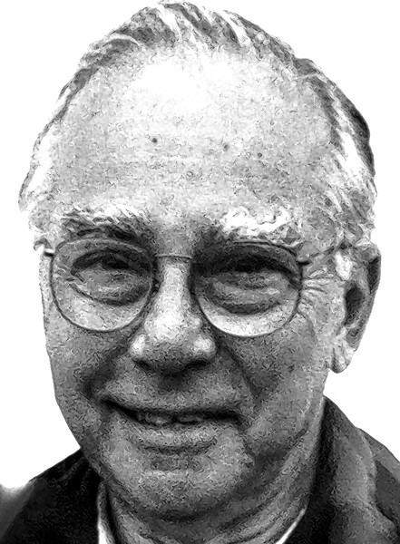
Gordon Mollman
Posted: April 22, 2014
Date: April 22, 2014
GORDON MOLLMAN
Cedar Rapids
Gordon "Gordy" Robert Mollman, 89, of Cedar Rapids, passed away peacefully Monday, April 21, 2014, at the Dennis and Donna Oldorf Hospice House of Mercy, Hiawatha. There will be a Memorial Service at Murdoch-Linwood Funeral Home & Cremation Service, Cedar Rapids, at 1 p.m. Wednesday, April 23. Family will greet friends one hour before the service.
Survivors include his two sons, Michael (Sannia) of Corte Bella, Ariz., and Greg (Cindy) of Anamosa; grandchildren, Chad of Chicago, Sarah (Marty) Lane of Elkhorn, Neb., Emily (Clint) Walter of Kalamazoo, Mich., Kristin (Adam) Koppes of Alburnett, Alison of Montgomery, Ala., and Jacob of Pella; and brothers, Walter of Cedar Rapids and Lee Cole of Osage Beach, Mo. Gordon had seven great-grandchildren.
Gordon was preceded in death by his parents, Irene Cole and Melvin Mollman; and brother, Wilbur Mollman.
Gordon was born Dec. 15, 1924, in Cedar Rapids. Following graduation from McKinley High School, where he was senior class president, Gordon proudly served three years in the U.S. Navy during World War II with one year in the South Pacific with Submarine Division 222. Upon returning from the service and attending business college, Gordon married Helen (King) Mollman on Oct. 23, 1948.
Gordon spent his entire career as an accountant, public bookkeeper and income tax preparer. For the last 20 plus years of his career, he owned and led Gordon R. Mollman and Asso-ciates. Gordon's clients very much respected his professionalism and dedicated service particularly around tax time.
Gordon was a member of the Elks Club and a longtime member of the Noon Lions Club, having twice held the position of president. Gordon was also a member of the Accountants Association of Iowa.
Gordon enjoyed all sports and always found time to attend his grandchildren's sports and school activities. He was a lifetime fan of the Chicago Cubs and Iowa Hawkeyes. He was an avid bowler and played Fast and Slow Pitch Softball for many years. Gordon was inducted into both the Iowa Fast Pitch and the Cedar Rapids Softball Hall of Fame having been a member of Iowa State Championship teams in 1950 and 1953.
Above all, Gordon was a loving father, grandfather and great-grandfather. He will be dearly missed by his family.
Memorials may be directed to the Cedar Rapids Lions Memorial Fund.
Please sign the online guest book for Gordon at
www.murdochfuneral
home.com under obituaries.
Read more: http://thegazette.com/article/20140422/Obituaries/304229985#ixzz2zd75MCfY

