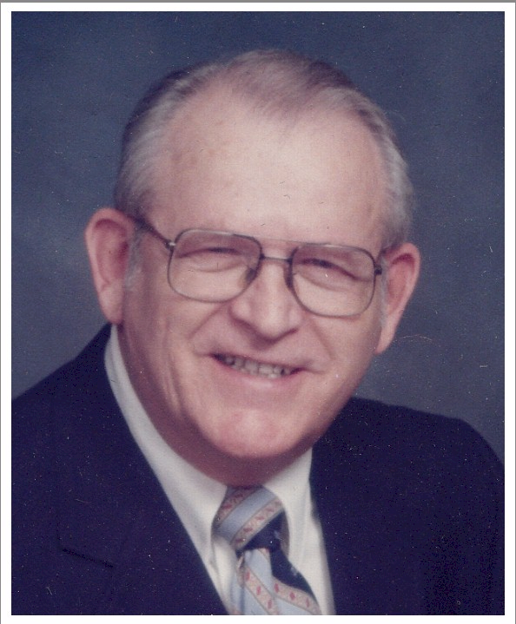
Howard L. Merryman

Dates:
Birth date: April 22, 1924
Death date: September 26, 2011

Obituary:
Howard Larkin Merryman passed away on Monday, September 26, 2011 at The New Homestead, Guthrie Center, Iowa from complications of Parkinson’s disease. He was born in Fort Dodge, Iowa on April 22, 1924 to Larkin O’Neil Merryman and Nellie (Leamon) Merryman. He was their only child. He attended elementary through senior school until the age of sixteen when he entered Fort Dodge Community College. He attended college and played basketball for their team until being drafted into the Army for World War II. He met Betty Jean Richardson, the love of his life, and they were united in marriage in LosAngeles on January 9, 1943. They enjoyed 68 years of memories and love. To this union two children were born, Neil Larkin Merryman who married Barbara Boes and daughter Merle Anne Merryman who married Steve Steensen. Neil and Barb presented Howard and Betty with three grandchildren, Brian Neil Merryman of Boise, Idaho, Angela Lynn (Merryman) Banks of Seymour, Iowa, and Barry Christopher Merryman of Denver, Colorado. Angela married Ray Banks and they have three much loved great-grandchildren named, Adriana Kailin, Eli Larkin, and Nellie Benecia. Steve and Merle Anne brought two grandchildren into the family, Jennifer Sue Steensen and Ian Michael Steensen. Also left to honor his memory is Margaret M. Nelson, nieces, numerous cousins and neighbors and friends.

Following Howard’s service to his country, he returned to Fort Dodge to own and run a neighborhood grocery store, Merryman’s Grocery, with Betty. It was during this time that Howard enjoyed many evenings and weekends of fast pitch softball games. He played for Frantz Brothers, VFW, Economy Forms, Tony’s Famous Foods, Boxholm, Duncombe, Hormel Local 31 and the Coralville Cardinals. One of the teams even journeyed to Arizona for the National Championship. The award Howard was most proud he received at the 1951 State Tournament and it was the Sportsmanship award. Howard was inducted into the Iowa Softball Hall of Fame in 1976.

Howard’s first job, following the war, was with Fort Dodge Laboratories. He clerked for a local auctioneer, held a rural mail route and finally became an assistant manager at the Rose Bowl Bowling Lanes. This association led him to move his family to Guthrie Center Iowa to build Merry Bowl Lanes there in 1965. Howard enjoyed the next twenty years working the bowling business and especially enjoyed teaching children and adults how to bowl until, due to his health, he sold the business. He and Betty then moved to Bedford Iowa and purchased the Sears Catalog Store and remained in Bedford until 1985. He and Betty then returned to Guthrie Center to run Merry Bowl Lanes for an additional few years and then sold it to Craig Heckman and then they retired to Guthrie Center.

Howard was a member of the First Christian Church and held office on the board and also was both deacon and elder. He also served on the Board of Directors for The New Homestead. After moving to Guthrie Center Howard enjoyed learning to play golf and was a member of the Guthrie Center Golf Club. He was a member of the Iowa Softball Hall of Fame Selection Committee.

Howard was preceded in death by his beloved granddaughter, Jennifer and his mother and father, Larkin and Nellie Merryman.

Memorials:
In leiu of flowers please contribute in Howard's memory to the following:

First Christian Church
105 N. 4th St.
Guthrie Center, IA 50115

Iowa Hospice
5399 Chimra Road
Panora, IA 50216

Visitation:
4:00 pm to 8:00 pm on Thursday, September 29, 2011 at Twigg Funeral Home - Guthrie 506 Prairie Street Guthrie Center Iowa 50115 (map/driving directions)
Family will be present from 6 to 8:00 PM

Service:
10:00 am to 11:00 am on Friday, September 30, 2011 at First Christian Church 105 N 4th Street Guthrie Center Iowa 50115 (map/driving directions)

Cemetery:
Graveside services will be 1:30 PM Friday September 30, 2011 at Fort Dodge Memorial Park in Fort Dodge, Iowa.Fort Dodge Memorial Park 3242 5th Ave South Fort Dodge IA 50501

