James R. "Jim" Ciesielski

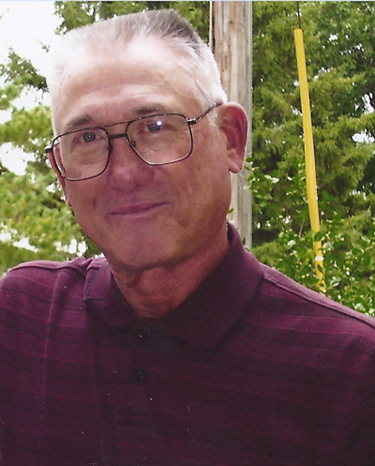
Flowers & Gifts
White Funeral Home
1315 Main Street
Jesup, Iowa 50648
Waterloo – James Russell “Jim” Ciesielski, 72 years old of Waterloo, IA, died Monday, June 13, 2011, at Southwest Regional Medical Center- Cardio Vascular Center in McComb, MS. He was born, December 14, 1938, in Independence, IA, the son of Paul Albert Ciesielski and Mary Calista (Merkel) Ciesielski. He graduated from Jesup High School, Jesup, IA with the class of 1957, following which he served in the US Army. On November 16, 1967, Jim and the former Judith Mae Miller were married at St. John’s Catholic Church Chapel, Independence, IA. They have made their home in Waterloo during their married life and both were employed at John Deere. Jim retired from Deere and Co. in 1993. Jim was an avid UNI booster and sports enthusiast. He was an outstanding athlete and enjoyed playing baseball for the Independence Indians as a young man. He also was active in fast pitch softball and was a manager and player on many teams over the years. In 1993 he was inducted into the Iowa Softball Hall of Fame by the Iowa Softball Association. Jim enjoyed stock cars. He owned the #37c stock car and managed the racing team. Jim played in several golf leagues in the Waterloo area, as golfing with friends was a big part of his retirement. Jim was a member of Sacred Heart Catholic Church and Knights of Columbus Council 700, also UAW Local 838 all in Waterloo.
Jim is survived by his wife, Judy of Waterloo, IA; one son and daughter in law, Roger and Cindy Ciesielski of Waterloo, IA, two granddaughters, Hannah and Hailee Ciesielski; also one brother and sister in law, Ronald and Fran Ciesielski of Independence, IA. In addition to his parents, one brother and one sister, in infancy and one adult brother, Eugene Ciesielski preceded him in death.
Funeral services will be 11:30 a.m. – Saturday, June 18, 2011, at Sacred Heart Catholic Church, Waterloo, IA with Fr. Louis Jaeger as Celebrant. Burial will be at St. John’s Catholic Cemetery, Independence, IA.

