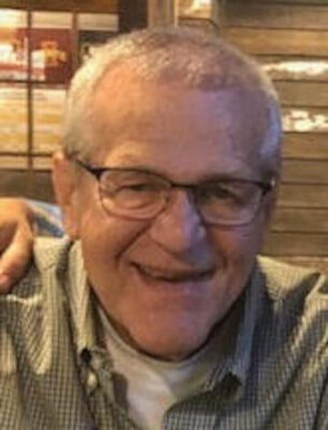

Joey Arthur Smith, age 74, passed away July 23, 2023 in Norwalk, Iowa. Joe was born on December 10, 1948 in Des Moines, Iowa to Harold (Smitty) and Marian Smith. Joe grew up in the Highland Park area of Des Moines, graduating from North High School in 1967, then attended Grandview College. He married the love of his life, Pam (Henry) Smith on October 16, 1971. Joe had a long career in the waterworks business and retired from HD Supply in 2014. Early during his retirement, he enjoyed working part time driving cars for Enterprise Rent-A-Car.
For many years, Joe was also a very respected fast pitch umpire. In 1989, he was inducted into the Iowa Fast Pitch Hall of Fame. Joe was a rule follower and didn’t let the players get away with anything, he often made the women with earrings take them out, even if they were new. Ever since he was a little boy, he loved the Chicago Bears and he would say, ‘and that was a long time’. Joe was also a lifelong Iowa Hawkeye fan and on game days, he would often scare the dogs while cheering or yelling at the Hawks on TV. While Joe loved fishing, hunting, sports and many other things, his greatest accomplishment and greatest love was his family. His wife, children and grandchildren were his world and he loved being called “Papa Joe” by Lily and Jack. Family time at Lake Thunderhead created some of the best memories.
Joe was preceded in death most recently with the heartbreaking loss of his Son, Jeff Smith. He was also preceded by his parents, Father-in-Law Donald Henry and Brother-in-Law Jeff Henry.
Joe is survived by his wife, Pam of Norwalk, Daughter Stacy (Tony) Braun of Chandler, AZ, Daughter-in-Law Missy Smith, Grandchildren Lily and Jack Smith all of Norwalk, Brother Jim (Luz) Smith of Tulsa, Ok., Mother-in-Law Barb (Dale) Wakefield of Jupiter, FL, Brother-in-Law Donald (Dawn) Henry Jr of Watsonville, CA, Sisters-in-Law Kim (Joe) Rice, Karen (Mike) Cataldo, Kelly (Dave) Fini all of West Des Moines and many nieces, nephews and other family and friends.
Joe’s family would like to thank Dr. Jason Brehmer for the great care he gave Joe over the years and through this difficult year. Also, thank you to the Holland Farms team for his care this year.
Visitation will be at Iles Norwalk Chapel, 1020 Main Street, Norwalk, Iowa on Thursday, July 27, 2023 at 10am with the memorial service following at 11am.
Memorials may be made in his honor to the Norwalk Fire Association.
Posted online on July 25, 2023
Published in Des Moines Register

