Robert Raymond Nissly (1929 - 2014)

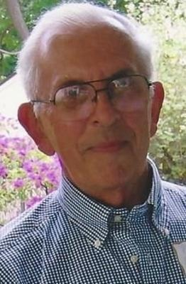
Robert Raymond Nissly
Dallas Center 1929 - 2014
R. Raymond Nissly, age 85, peacefully passed away Tuesday morning, August 19, 2014, at Methodist Hospital in Des Moines, IA. Memorial services will be held at 10:00 am, Monday, August 25th at First Presbyterian Church in Dallas Center, where the family will receive friends one hour prior to the service.
Ray was born June 9, 1929, to Noah C. and Anna (Wenger) Nissly, the youngest of thirteen children. He graduated from Dallas Center High School in 1946 and was a resident of Dallas Center, IA his entire life.
Ray enlisted in the US Army in 1951, served during the Korean War and was a member of the Dallas Center American Legion Post #49. Shortly after he returned home in 1953, he met and married the love of his life, Imogene (Butler) Nissly. He farmed for 16 years until Ray and Imogene purchased Center Bowl in Dallas Center where they successfully ran a restaurant/bowling alley from 1977 until 2000. Being the hard worker that he was, he was also a rural mail carrier for the United States Postal Service in Dallas Center from 1976 until he retired in 2006.
During Ray's earlier years, he enjoyed great success as a softball pitcher for the Dallas Center Merchants, pitching to his brother Don through the 1950's and 1960's. He came out of retirement to pitch his final tournament in 1977 at the age of 48. His success earned him induction into both the city and state Men's Fast Pitch Softball Hall of Fame.
It was the little things in life that meant the most to Ray. He was an avid history buff and had a passion for reading. Ray enjoyed golf, yard work, jigsaw puzzles, and was a lifelong Chicago Cubs fan. He enjoyed "donating" funds to Prairie Meadows which Imogene in turn brought back home. But he took the greatest joy in spending time with his family.
Left to cherish his memory are his wife of 60 years, Imogene, and four children. Sandy (Al) Clinkinbeard of Dallas Center, Karen (Chuck) Nielsen of Adel, Steve (Janae) Nissly of Dallas Center, and Mike (Judy) Nissly of Waukee; eight grandchildren, Jay (Nichole) Clinkinbeard and Justin (Sam) Clinkinbeard, both of Omaha, NE, Meg (Noel Peggs) Ryan and Eric Ryan, both of Grimes, Stephanie Nielsen of Madison, WI, Ben Nielsen of Cedar Rapids, Desi (Matt Weiser) Nissly of Adel, and Sam Nissly of Dallas Center; four great-grandchildren, Grace, Sophia, Katherine, and Oliver all of Omaha, NE; two siblings, Don (Nancy) Nissly of Perry, and Edith (Tom) Inouye of Los Angeles, CA. Ray is also survived by many wonderful nieces and nephews whom he cherished. He is preceded in death by his parents and ten siblings.
Ray held the National Hemophilia Foundation close to his heart in support of his great-grandson, Oliver, who has the condition. In lieu of flowers, contributions can be made to the Nebraska Chapter, National Hemophilia Foundation, 215 Centennial Mall South, Suite 512, Lincoln, NE, 68508.

