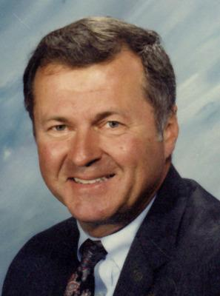
Roger Aceto
Roger Aceto, 79, of Urbandale, passed away October 23, 2015 at VA Hospital in Des Moines after a brief fight with cancer. Services are scheduled for 3:00 pm on October 31, 2015 at Iles Westover Chapel in Des Moines. Burial will be completed privately at a later date.

Roger was born September 10th, 1936, to Vince and Jean (Kroll) Aceto in South Milwaukee, WI and grew up in Racine, WI. He excelled in athletics and accepted a football scholarship to Drake University, where he played three years and was a nationally ranked pass receiver. He then signed a professional baseball contract with the Kansas City Athletics organization, for which he played for three seasons. He returned to Drake to earn bachelors and masters degrees, and met his wife of 54 years, Sandy (Severson). He played for championship fast pitch softball teams, winning multiple state titles with Des Moines area teams in the 1960's, and a national title with Cedar Rapids Welty Way in 1971. He is a member of the Des Moines Fast Pitch Softball Hall of Fame, the Iowa Men's Fastpitch Softball Hall of Fame, and the B'nai B'rith Sports Hall of Fame. Roger had an extensive career as an athletics official, as he officiated football, baseball, basketball and softball at high school and collegiate levels for 32 years.

Roger was a teacher and administrator in the Des Moines Public Schools for 38 years, and was proud of the relationships he developed with his students and the lives he touched. He was an Army veteran and an accomplished musician who played clarinet and sax in numerous bands, including the Iowa Military Veterans Band, Urbandale Community Adult Band, Za-Ga-Zig Shrine Band, and the First Baptist Orchestra. He was an avid horse racing fan, a lover of classical and big band music, and enjoyed being active with golf, biking, and all sports. He was a member of the Za-Ga-Zig Shrine, the Iowa Thoroughbred Breeders and Owners Association, and a longtime Drake University football season ticket holder.
He was most passionate of his relationships with his grandchildren, which meant everything to him.

Roger is survived by his wife, Sandy, of Urbandale, sons Tom (Marianne) of Evergreen, CO, Mike (Shannon) of Urbandale, and Joe (Jenney) of Shawnee, KS, brother Jon of New York, NY, and six grandchildren, Dani (Robbie) Greiner of Iowa City, John Aceto of Ames, Nick Aceto of Boulder, CO, Matt Aceto of Evergreen, CO, and Samantha and Audra Aceto, both of Shawnee, KS. He was preceded in death by his parents and his grandson, Sam.

