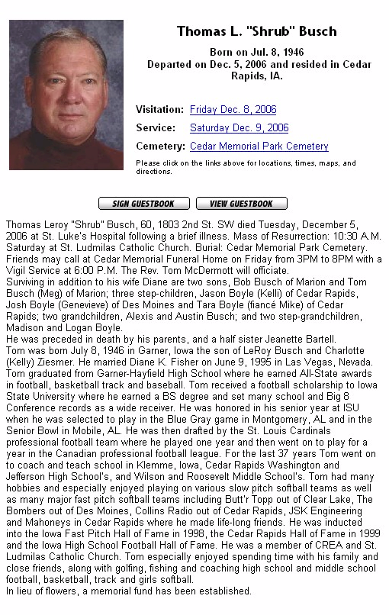

Tom Busch - Remembered
December 5, 2006

Tom Busch, 1998 inductee into the Iowa Fastpitch Hall of Fame, passed away this morning from cancer.
Our sympathies go out to this wife, Diane, and the entire Busch family.
Funeral arrangements in Cedar Rapids are pending but with funeral likely Saturday.
Dennis, please pass on to us visitation and funeral information as it becomes available.
Leroy, are you able to arrange for flowers from the HOF?
Tom (Tom.Peterson@uni.edu)

Tom,
Sad news. I remember Tom when he played for Buttertopp. He was a physical specimen. A large man that could run like a deer. He was one of the players I was in awe of as a kid. He was a one hundred percent hard nosed hustling player. He always slid head first, and dove for balls if he had to. He played against my Dad, Andy for many years. The Webster City Merchants, and the Clear Lake Buttertopp teams had some epic battles over the years. It was rumored that Tom was an outstanding football player as well. I always heard that he had played professionally, but I am not sure. Another hero leaves us far too young. My condolences to the family and friends.
Mark Yates (bfrbear@austin.rr.com)

This is a sad day for the HOF. Heaven apparently needed more than a great softball player but also the character of a tremendous human being. We will miss him greatly. I will take care of flowers on behalf of the HOF.

Leroy Wegmann (lwegmann@acromfg.com)

I remember playing against Tom Busch too but remember more warmly of when we played together with the Des Moines Bombers. Tom was a big and strong man with unbelievable quickness. He just loved to hit the long ball and we constantly teased him to just lay down a bunt (as that was a sure hit with his speed) and the rest of us would knock him in as we just needed him to be a base runner. He had the ability to go from dead stop to full speed in one step and then just glide down the line seemingly without effort, truly a joy to watch as only a few have this gift of size, quickness and raw speed. I can hear him calling me, “Petie”.

Tom (Tom.Peterson@uni.edu)

Mark,

Tom, nicknamed Shrub for obvious reasons, was indeed a fine football player for
Iowa State and went on to play for the St. Louis Cardinals. I first faced him
in 1970 (he would have been 24) just after he finished his football career, and
he was awesome as you said. Tremendous power, but could bunt for base hits
anytime he wanted to do so.

Later in our careers, we played with each other in the over 40 tournies and he
still was one of the fastest players around even with some extra weight. I
also played one year with his son Tom and he also could run like the wind.

I saw Shrub yesterday in the Cedar Rapids hospital and had talked with him by
phone a few weeks ago. He was in bad shape, but we had a great visit about all
the fun we'd had on and off the field. We always knew how to have a good time
after we got done playing, whether we were teammates or on opposing teams.
That was the great thing about softball.

Sad to see Shrubbie go; like Mike Palleson (The Hammer), he died way too
young. We all should enjoy every minute that we have.

By the way, I remember your dad Andy and Lawrence Cheney well. We had a lot of
fun in Webster City at that old ballpark. A lot of fun.

Best regards.

Denny

Dennis W. Linderbaum, President
Iowa Health Foundation
(515)241-5996 office
(515)205-3093 cell
www.iowahealthfoundation.org

I remember playing against Tom Busch and he may have lost a step (maybe half a step) when we did battle, but he was still quick. We never played on the same team and that was my loss. It was rare to see that combination of quickness and size on the fastpitch softball field. I met Tom in the 80's when he played with a number of Cedar Rapids teams. In victory and in defeat, he was always a gentleman and a first class individual. He made the same impression on all of the members of the Waterloo teams. He will be missed and my heart goes out to all of his family and friends.

Reggie (pburnett44@gmail.com)

From www.cedarmemorial.com:
I want to express my sympathy to all of Tom's family and friends. I played fast-pitch softball with and against Tom for many years. Tom one was one of the finest hitters and all around players in the game. Tom was an even better teammate and good man. I enjoyed the years we played together. Speaking for all the members of The Cedar Rapids Softball Hall of Fame, I want you to know all of you are in our prayers. Steve Anderson President Cedar Rapids Softball Hall of Fame.
Steve Anderson Dec 6, 2006 Cedar Rapids, IA

I remember him as one the great softball hitters in the midwest. He was one the best clutch hitters I ever played against. He will be missed in the softball world. He is probably playin on a better team, now.

Richard E. Buckley
Dec 7, 2006
Thomson, IL

I was one of the fortunate people who knew Shrub on and off the field. We had so many good times. Softball was were allot of us met and become as one big family out of town. He was heads above most the people that played. Dangerous at any time. Loving to see him come up a clutch times. Playing bean bag in between tournament games. Him and his friend Dick Burns tried oh so hard to beat to beat us. Of course a beer or two made them think they were world beaters. It was nice taking there money. Hee hee Always a nice guy and am very proud to say he was a FRIEND. God be with him

Roy Steichen
Dec 6, 2006
Cedar Rapids, IA

