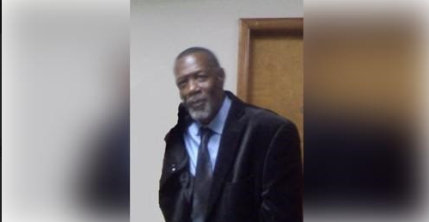

WILLIE HERNDON OBITUARY

Willie passed away on April 8, 2023. Funeral services are planned for Saturday, April 15, 2023 at the Henderson's Chapel starting at 2:00pm.

