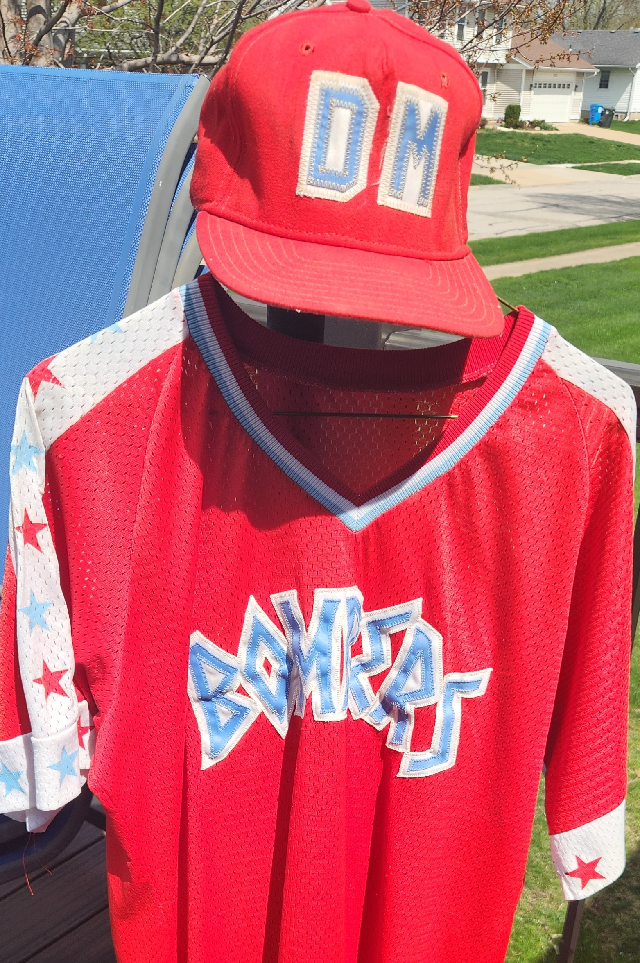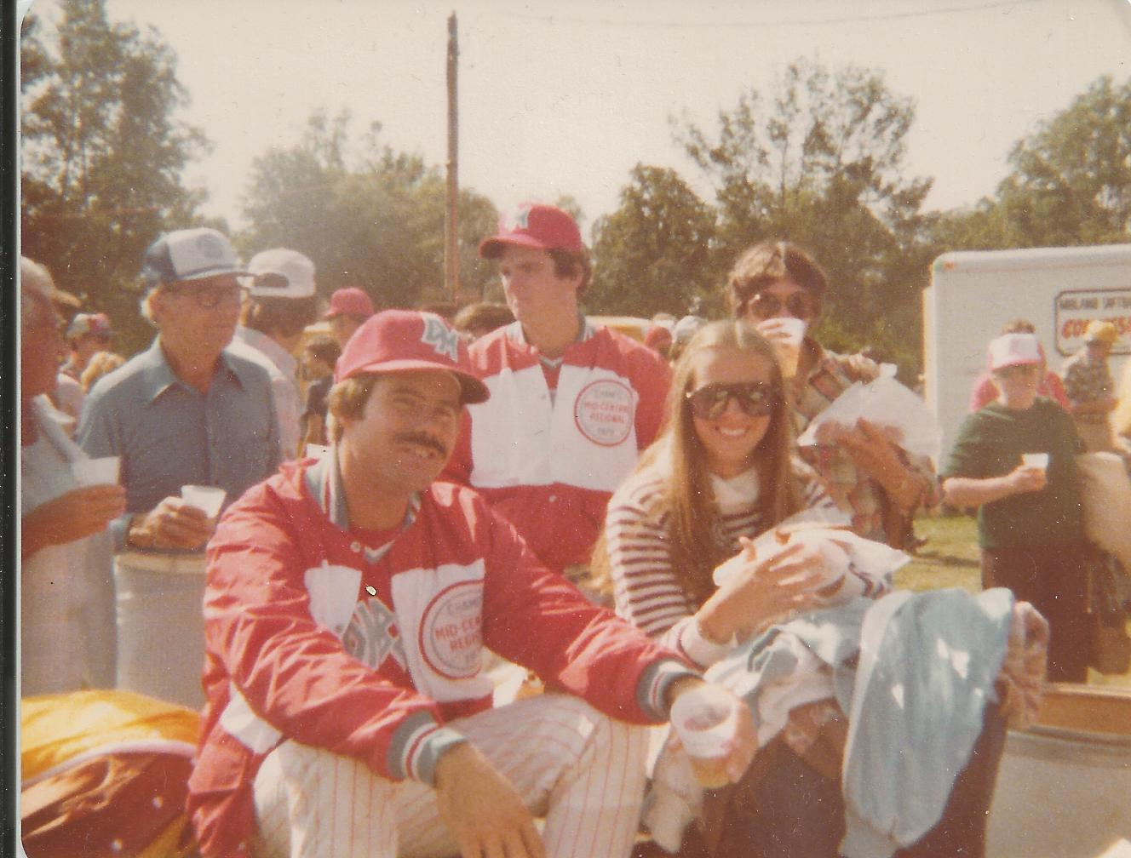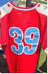
Fast Pitch Softball Resume for Tom Peterson
During my softball career, I have had the distinction of playing in consecutive A.S.A state tournaments from 1971 through 1987 (except in 1980 when we were defending the regional champions). I played in the A.S.A. state tournament again in 1991 with the B-40 (over 40 years of age) Bomber team.
I started my softball career with Hall of Fame Coach Everett Long's Boone Merchants in 1971. In 1974, the Boone Merchant "dream" team broke apart in the middle of the season shortly after Al Rausch was persuaded to join a powerful Cedar Rapids - Welty Way team. After the Boone club breakup, I accepted an offer to join the Ames - Palmas team for the remainder of the 1974 season. Shortly after joining Ames, I was asked to join the Des Moines Bombers by Hall of Famers sponsor, Bill Peters and Bomber coach, Clark Menough, but remained with the Ames - Palmas team. Unfortunately, although the Ames Team qualified for the state tournament that year, the Des Moines Bomber team went on to repeat as state champions.
The following spring I contacted Hall of Famer Dean Olson and asked him how I would go about getting a "tryout" with the Des Moines Bombers (Dean said, "he'd see what he could do"). That led to my not so brief stint of many years of wearing number "39" for the Des Moines Bombers.
After making the team I worked hard to become the Bomber's cleanup hitter. I thought that this was quite a distinction until I realized that being in the batting order behind Tom Stokesbary was very dangerous. What I went into thinking was a distinction had actually become, who is the fool that is dumb enough to try to avoid Stokebary's bat flying back to the dugout when he didn't get on base because some pitcher "couldn't throw the ball hard enough to break a plane of glass". As an aside, Stoke's and I signed that petition outlawing the change-up every year we played together.

Due to threatening severe thunderstorms in 1979, the Bombers shared the state tournament title with Cedar Rapids - Modern Piping. In that tournament, I received M.V.P. honors for hitting .429 in five games, smacking a homer and driving in 5 runs. We went on to win the Mid-West Regional in Omaha and then we participated in the A.S.A. National Tournament in Midland, MI, where I led the tournament in batting average (Ron German may have actual average) but was a single at bat short of qualifying for the official title. Also in that tournament the Bomber team finished 9th in the nation. In 1980, we represented the C.I.C. conference in the I.S.C. National Tournament in Tempe, AZ.

After the 1980 season, Bill Peters retired from sponsoring the Bomber team and many of the players joined the Reames Noodle team. In one of my memorable games in the 1981 season, the Bombers defeated the New Zealand National team when Dean Olson pitched a perfect game and I hit a solo home run off one of the toughest pitchers in the world, Kevin Herlihy. In 1982, the team became the Coors Bombers. In the early 1980's I played during the week with Jim Cielieski's Waterloo team and joined the Des Moines Bomber team on the weekends. In 1984, I was honored by receiving my second for the Iowa A.S.A State Tournament M.V.P. honored for having four homeruns and 13 RBI in the tournament. Also in 1984, I was picked up by the Cedar Rapids Vigortone team for post season participation in the I.S.C. World Tournament held in Allentown, PA. The next year, I joined the Cedar Rapids Vigortone team and went with them to the 1985 I.S.C. World Tournament held in Kimberly, WI. I joined Jim Cielieski's Waterloo Turf Control team full time for the 1986 season. In 1987, I rejoined the LaPizza House Bombers for my last season before having knee surgery in the winter of 1987.
In 1990, I joined many former Bomber teammates on the Des Moines B-40 Bombers and participated in A.S.A. National Tournament Men's Masters 40-Over in Omaha, NE. I received 1st Team All-American Honors for my accomplishments in that 1990 tournament. The B-40 Bombers have finished 5th in the Masters tournament in both 1990 and 1991.

Teams
1971 - Boone Merchants
1972 - Boone Merchants
1973 - Boone Merchants
1974 - Boone Merchants & Ames Palmas
1975 - Des Moines Peters Bombers
1976 - Des Moines Peters Bombers
1977 - Des Moines Peters Bombers
1978 - Des Moines Peters Bombers
1979 - Des Moines Peters Bombers
1980 - Des Moines Peters Bombers
1981 - Reames Noodles
1982 - Des Moines Coors Bombers
1983 - Des Moines Like Bombers
1984 - Des Moines Like Bombers
1985 - Cedar Rapids Vigortone
1986 - Waterloo Turf Control
1987 - Des Moines LaPizza Bombers

AWARDS
1994 - Member - Iowa Men’s Fastpitch Hall of Fame
1993 - Member - Des Moines Men’s Fastpitch Hall of Fame
1992 - Member - Des Moines Men’s Fastpitch All Decade Team 1970s
1990 - First Team All American Selection - A.S.A. National Tournament Men's Masters 40-Over (Des Moines - B-40 Bombers)
1985 - M.V.P. - Cedar Rapids Gazette Tournament (Cedar Rapids - Vigortone)
1985 - Team Participation in I.S.C. National Tournament - Kimberly, Wisconsin (Cedar Rapids - Vigortone)
1984 - Team Des Moines Sub State Champs (Des Moines - Like Bombers)
1984 - Team State Runner-up - A.S.A. Men's Major Fast Pitch (Des Moines - Like Bombers)
1984 - M.V.P. - Iowa Amateur Softball Association Men's Major Fast Pitch Cedar Rapids, IA (Des Moines – Bombers; Hit four homeruns plus 13 RBIs in the tournament)
1984 - Team Participation in A.S.A. National Tournament - Allentown, Pennsylvania (Cedar Rapids - Vigortone)
1983 - All Tournament Selection - I.S.C. Area Tourney (Des Moines - Coors Bombers)
1982 - Team State Champion - Iowa Amateur Softball Association Men's Major Fast Pitch (Des Moines - Coors Bombers)
1981 - C.I.C. All Star Team Selection (Des Moines - Bombers)
1980 - Team Runner Up – Twelfth Annual Old Style Early Bird Tourney Sioux Falls (Des Moines - Bombers)
1980 - M.V.P. - Twelfth Annual Old Style Early Bird Tourney Sioux Falls
(Des Moines - Bombers)
1980 - All Star Team Selection - Reames Tournament (Des Moines - Bombers)
1980 - Team Participation in I.S.C. National Tournament - Tempe, Arizona
(Des Moines - Bombers)
1979 - All Star Team Selection - Little Nationals (Des Moines - Bombers)
1979 - C.I.C. Homerun Champion (Des Moines - Bombers)
1979 - C.I.C. All Star Selection (Des Moines - Bombers)
1979 - M.V.P. Selection - Iowa A.S.A. Men's Major Open Fastpitch (Des Moines – Bombers; Hit .429 in five games, hit a homerun and drove in 5 runs)
1979 - Team Mid-America Regional Championship - Men's Major Fast Pitch - Omaha (Des Moines - Bombers)
1979 - Team Participation in A.S.A. National Tournament - Midland, Michigan (Des Moines - Bombers)
1979 - Highest Batting Average - A.S.A. National Tournament - Midland, Michigan (Des Moines - Bombers)
1978 - Team Championship - Sooland Hall of Fame Champion (Des Moines - Bombers)
1978 - Team Des Moines Sub State Champs (Des Moines - Bombers)
1978 - Team State Runner-up - A.S.A. Men's Major Fast Pitch (Des Moines - Bombers)
1977 - Team State Runner-up - A.S.A. Men's Major Fast Pitch (Des Moines - Bombers)
1976 - Team Des Moines City Champs (Des Moines - Bombers)
1976 - Team State Runner-up - A.S.A. Men's Major Fast Pitch (Des Moines - Bombers)
1975 - Most Homeruns - Iowa A.S.A. State Softball Tournament (Des Moines - Bombers)

