Sensor summary comparison
FICTIONAL SAMPLE DATA — NOT A FIELD TRIAL

Meeting takeaway
Across three fictional station summaries, follow-up values are lower at A (18 to 16), higher at B (17 to 24), and slightly higher at C (18 to 19). Station B has the largest observed increase (+7 arbitrary units); A decreases by 2 and C increases by 1. These are descriptive differences only: the summaries do not establish why values changed or whether the changes are meaningful.

Comparison
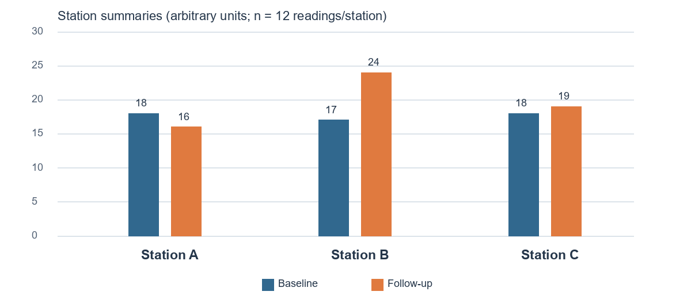
Figure 1. Baseline and follow-up station summaries. Source: sources/sensor-summary.json; 12 readings per station. Values are in arbitrary units.
Station | n | Baseline → follow-up | Difference
A | 12 | 18 → 16 | −2
B | 12 | 17 → 24 | +7
C | 12 | 18 → 19 | +1
The counts are reported as readings, but the source does not say whether baseline and follow-up observations are paired, independent, or how they were aggregated. No pooled estimate is calculated.

Interpretation, limitations & next steps
What this supports. The summaries support a clear ordering of the supplied station-level values and a comparison of their reported baseline and follow-up figures. They are useful for planning what evidence to request next—not for evaluating sensor performance or attributing change to an intervention.

Limitations
- No raw individual readings or timestamps are supplied, so distribution, outliers, temporal patterns, pairing and aggregation cannot be checked.
- Calibration records, measurement units beyond “arbitrary units,” and matched environmental conditions are absent; differences may reflect measurement or context rather than a real underlying change.
- There is no uncertainty estimate, control assignment, or documented independent replication. The sample size label (12 readings per station) alone cannot establish precision or independence.
- The source explicitly describes the data as synthetic and intended for document demonstration; do not present them as field evidence or claim a causal/treatment effect.

Recommended next steps
1. Obtain provenance — Request original timestamped readings, the data dictionary and the calculation/aggregation method for each summary.
2. Verify measurement quality — Collect sensor IDs, calibration certificates and maintenance history; confirm units and check for drift or missing values.
3. Match conditions — Record environmental and operational conditions at each observation and clarify whether baseline/follow-up readings are paired.
4. Analyze transparently — Review raw data, plot paired observations where appropriate, assess uncertainty and document exclusions before interpreting differences.
5. Decide after review — Only consider causal interpretation if the design, controls and replication support it; otherwise report descriptive associations with caveats.

Source basis
Prepared from sources/sensor-notes.md and sources/sensor-summary.json. Both identify this as fictional synthetic sample data. Original source files were not modified.

