Sensor field review
Illustrative reference report · fictional data for a layout example

Executive summary
Station B has the highest follow-up mean in this fictional sample: 24 arbitrary units, compared with 19 at Station C and 16 at Station A. These are descriptive summaries. They do not establish a treatment effect, statistical significance or sensor reliability.
The useful next decision is to verify calibration and recover the underlying paired observations before interpreting the differences. Equal observation counts make the summary easier to compare, but do not establish equivalent sampling conditions.

Evidence at a glance
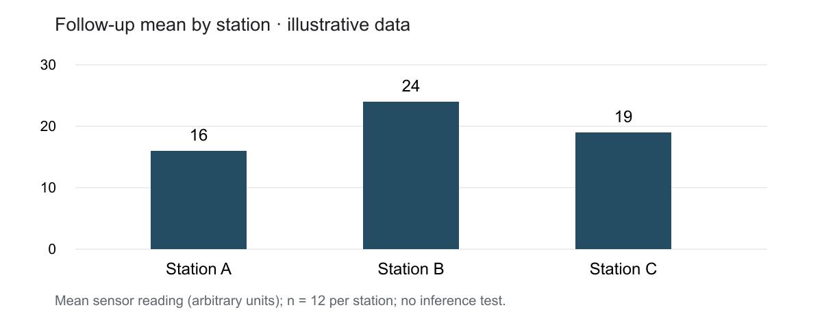
Figure 1. Follow-up means from reference-source.json. Units are arbitrary; all observations are fictional. No confidence intervals or significance tests are available.

Recorded observations and method
The source records three stations, twelve observations per station and baseline and follow-up means. The table retains every recorded summary value, including the baseline, so the reader can inspect the arithmetic rather than infer it from the chart.
Station | n | Baseline mean | Follow-up mean | Change
A | 12 | 18 | 16 | -2
B | 12 | 17 | 24 | 7
C | 12 | 18 | 19 | 1
Table 1. Means and differences in arbitrary units. Change = follow-up mean minus baseline mean.

Interpretation
Station B increases by seven units between the two summaries; Station C increases by one and Station A decreases by two. This ordering is supported by the supplied values. The source lacks individual observations, variation estimates and environmental context, so these differences should remain exploratory.
A common axis in Figure 1 allows direct comparison of the follow-up means. The full table supplies the baseline context. Neither view supplies the missing sampling or calibration evidence; the document retains that limitation rather than using visual emphasis as a substitute for inference.

Limitations that affect the decision
No calibration records, timestamps or individual measurements accompany the summaries. The reference cannot establish whether the stations were sampled under comparable conditions. The twelve observations per station are a recorded count, not a claim of independent replication.
The source also lacks a variance estimate. Confidence intervals and hypothesis tests would therefore be invented if added here. The report separates the observed ordering from explanations that need further evidence.

Recommended next steps
Action | Evidence needed | Purpose
Verify calibration | Instrument records | Check whether readings are comparable
Recover paired observations | Timestamped source rows | Inspect spread and pairing
Review sampling conditions | Protocol and environment | Assess alternative explanations

Source and reproducibility
reference-source.json contains the fictional input summaries. The builder computes the differences and the chart from those same values. The DOCX preserves native headings, paragraphs, a page-number field and editable tables; only the source chart is an image.
The report uses natural pagination, a coherent style hierarchy and repeatable table headers. Review the PDF, individual page images and contact sheet before reusing its design. Adapt the structure to the actual task; sample content and page count are not requirements.

