OPAL 1: plant growth by recorded label
Exploratory analysis • research meeting report • 15-minute briefing

Executive summary
The effect of nickel on growth is undetermined from the available OPAL Experiment 67 export. Six recorded values (0, 50, 100, 200, 500, 1000) are categorical labels only: the supplied records do not establish nickel identity, dose units, or a confirmed control. Label 0 must not be treated as a control.
Exploratory projected-area comparisons show substantial plant-to-plant variation and no consistent penalty pattern; per-plant slope IQRs span zero for all six labels. This is descriptive—not a causal or genotype-adjusted treatment estimate. Interpretation is further limited by an unexplained early discontinuity in the vendor digital-biomass proxy relative to projected area, despite empty feature QC flags and “Ok” statuses for the early rounds.

Question and scope
Question: do the saved observations establish that nickel exposure affects plant growth? This synthesis uses the saved OPAL 1 exploratory analysis, reviewed meeting summary, metadata, summary tables and existing figures. It does not reassign treatment semantics or make new inferential claims.

Dataset and design
Experiment 67 is identified as 2026.04.09_OPAL.0002_Weston_PC (APPL-CORE export v6). The S3D design contains 359 plants across 12 genotypes and six categorical labels: n=60 (0), 59 (50), 59 (100), 59 (200), 60 (500), and 60 (1000). Genotype-by-label cells contain 4–5 plants. Observations span 22 rounds from 2026-04-08 through 2026-05-07; timestamps have no UTC offset, and no timezone conversion was applied.

Measures and processing
Outcomes are projected_area_mm2 (plant area projected to a reference plane; mm²) and digital_biomass_mm3, the vendor height × area proxy (mm³), not measured plant mass. Proxy geometry was not independently recomputed. Analysis metadata reports 7,794 plant-date-trait rows after selection. Repeated same-day scans are averaged within unit × trait before trajectory/slope calculations; counts indicate no duplicates were collapsed in this extract.
All 3,897 S3D feature rows have empty qc_flags; zero rows were excluded for QC. Five exact-zero projected-area values were retained because the export does not flag them as missing. Source outliers were not clipped. 20 rounds are marked Ok and two Warning (April 21 and April 30); all rows have round_done=1. Early April 8–14 rounds are Ok. IQR bands are 25th–75th percentiles, not confidence intervals, and sample counts vary by date.

Findings

Projected area: heterogeneous trajectories
The existing small-multiple plot shows median trajectories and IQR bands for each recorded label over the full period. Early increases followed by declines and late rebounds differ among groups; wide within-label spreads and irregular observations argue against a simple uniform response.
Robust summaries report median per-plant linear slopes of −4.03, +7.06, −13.34, −11.43, +1.60 and +8.18 mm²/day for labels 0, 50, 100, 200, 500 and 1000. Every corresponding slope IQR spans zero. These plant-level descriptive slopes use elapsed days from each plant’s first timestamp—not treatment effects.
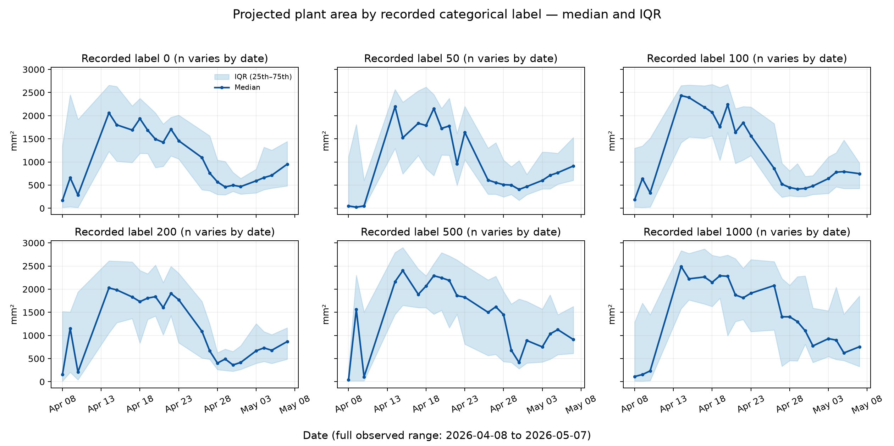
Figure 1. Projected-area median and IQR by recorded categorical label; full range 2026-04-08–2026-05-07; n varies by date. Label meanings are unconfirmed. Source: saved OPAL 1 figure.

Digital-biomass proxy: early break limits rate interpretation
Across observations, median proxy falls from 44,553 mm³ (April 10) to 20,820.85 mm³ (April 14), while median projected area rises from 174 to 2,164.5 mm². Among 108 plants present on both dates, median within-plant proxy change is −33,240.65 mm³ (median percentage change −68.01%), whereas median projected-area change is +889.5 mm². This discordance is not a defensible estimate of biological biomass loss. Cause is not established: status/QC metadata do not flag the early break, and the saved sources cannot distinguish acquisition, analyzer, segmentation, timing or other explanations.
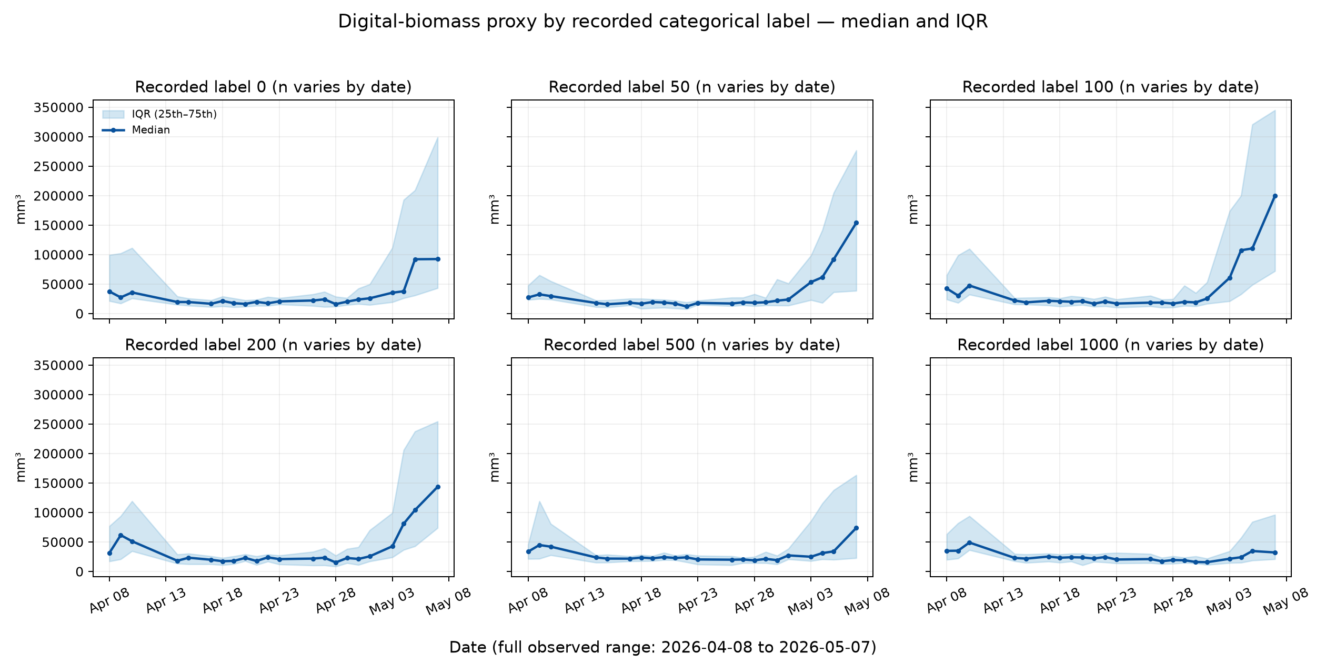
Figure 2. Vendor digital-biomass-proxy median and IQR by recorded label. Proxy is height × area, not measured mass; early discontinuity remains unexplained.

Interpretation, limitations and decision
- Treatment mapping is unresolved: no evidence confirms nickel identity, dose units or control assignment. Do not call label 0 the control.
- Comparisons are descriptive and unadjusted for genotype; genotype × label cells have only 4–5 plants. No causal dose-response inference is supported.
- IQRs describe distribution spread, not treatment-effect uncertainty. Coverage varies by date; source zeros and outliers were retained.
- An early proxy discontinuity compromises growth-rate interpretation; its cause and any unexported analyzer/acquisition quality details require owner clarification.
- Timestamp strings lack timezone offsets; these observations do not resolve timezone or cross-sensor alignment.
Decision: do not conclude that nickel does or does not harm growth from this export. Treat the biological effect as undetermined pending verified treatment metadata and resolution of the proxy discontinuity. The trajectories prioritize data-quality follow-up, not dose recommendations.

Provenance and reproducibility
Source basis: sources/meeting-summary-reviewed.md, sources/nickel-growth-exploratory-report.md, sources/opal-export-onboarding-summary.md, sources/analysis_metadata.json, sources/group_growth_summary.csv, sources/design_balance.csv, sources/coverage_by_date.csv and the two saved small-multiple figures. The analysis records schema validation and matching loader/view fingerprints. These deliverables synthesize existing evidence; sources/ was not modified. Source export manifest SHA-256 recorded in the analysis is 76bf90275f7a98392fc6d1363b46cc3a28142ebfd219c8705e19636604771757.

Recommended next steps
- Ask the experiment owner to map each recorded label to treatment identity, control status and concentration/dose unit; retain a documented mapping.
- Investigate the April 10–14 proxy discontinuity with APPL/S3D owners: acquisition settings, analyzer/segmentation versions, geometry inputs, round-specific warnings and raw surface artifacts.
- After resolving semantics and quality, preregister a genotype-aware repeated-measures analysis with plant as experimental unit; report estimates and uncertainty, inspect date coverage and conduct sensitivity analyses.
- Confirm timestamp timezone and validate cross-sensor joins before temporal integration.

