Assignment 3
Simon Schindler 3538650

Task 2 (a)
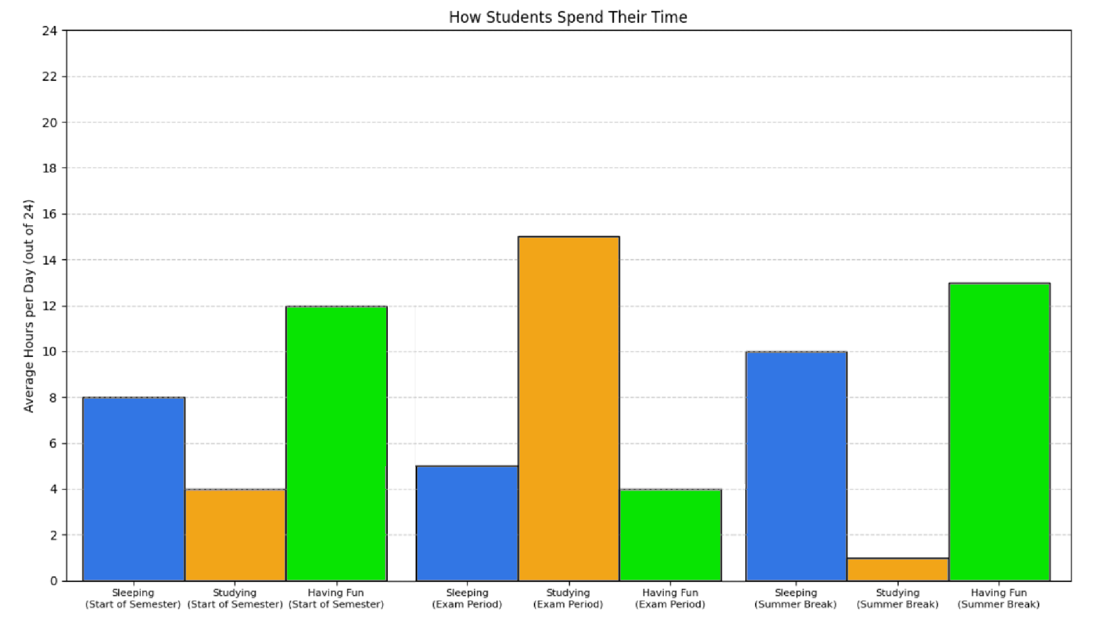

Task 3 (c)

Quality: Perfect Quality … Poor Quality – Failed rod

Task 3 (d)
100 °C
70 °C
30 °C
50 °C

