 modbus_module 设计概要

1. 代码结构
   1. 源码结构
   2. 主机模式
   3. 从机模式
2. 数据类型
3. 接口设计
4. 移植/应用
   1. 回调接口
   2. 移植接口

**modbus_module** 设计概要

1. 代码结构
   1. 源码结构

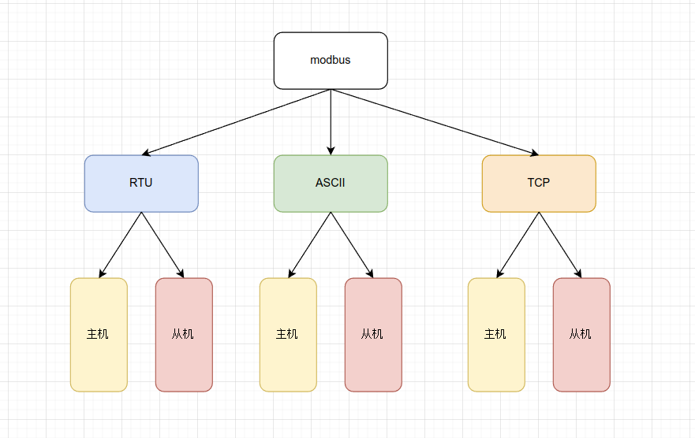

* 1. 主机模式

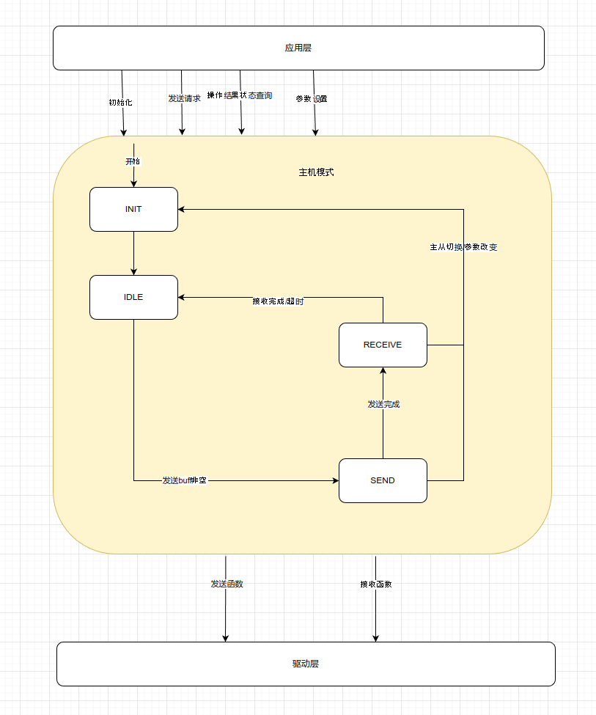

* 1. 从机模式

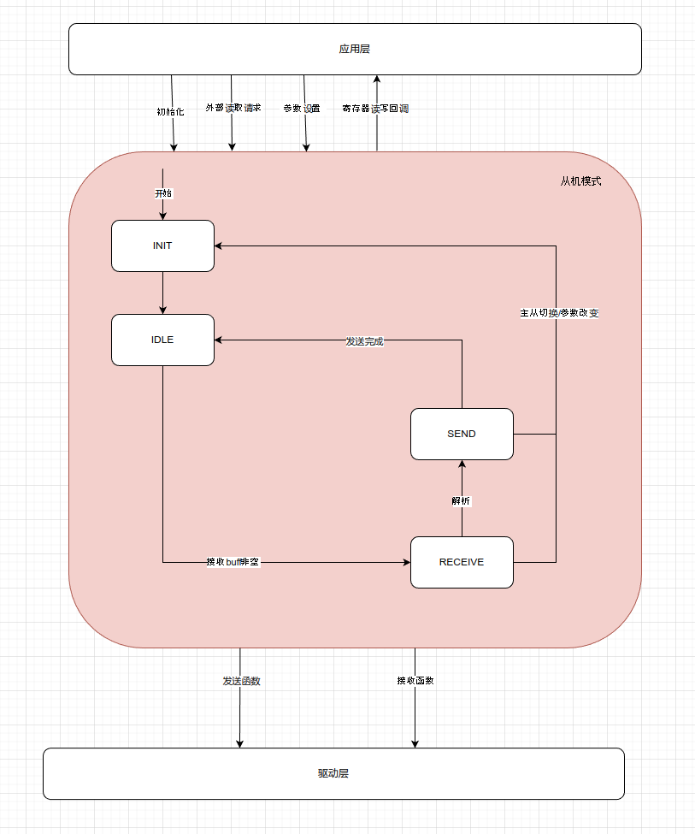

typedef struct Modebus_RTU_Fun_Table

{

uint8_t fcode;

int8_t (*request)(stModbus_RTU_Handler *handler, stModbus_RTU_Sender *sender); int8_t (*slave_parse)(stModbus_RTU_Handler *handler, uint8_t *buff, uint16_t

len);

1. 数据类型

int8_t (*master_parse)(stModbus_RTU_Handler *handler, uint8_t *buff, uint16_t len);

}stModebus_RTU_Fun_Table;

typedef struct Modbus_RTU_Handler

{

uint8_t dev_addr;

stModbus_RTU_State state, last_state; // send/receive switch judge

emModebus_RTU_Mode mode, last_mode; // slave/master switch judge

uint32_t last_call_tick; uint8_t tx_buff[300];

uint16_t tx_len;

uint8_t rx_buff[300]; uint16_t rx_len;

uint16_t *master_parse_addr; // master parse address(master mode use only)

uint32_t Master_Wait_Count; // master wait recv time count(master mode use only)

uint32_t Master_Wait_Recv_Limt; // master wait recv limit(master mode use only)

stModebus_RTU_Fun_Table *fun_table; // callback function table

uint8_t fun_table_items;

int8_t (*send)(uint8_t *buff, uint16_t len); int8_t (*recv)(uint8_t *buff, uint16_t *len);

int8_t reg_map_id; // reserve for

select register map table

int8_t (*read_input)(stModbus_RTU_InputReader *reader); int8_t (*read_hold)(stModbus_RTU_HoldReader *reader);

int8_t (*write_hold)(stModbus_RTU_HoldWriter *writer);

}stModbus_RTU_Handler;

typedef struct Modbus_RTU_Handler_Attribute

{

uint8_t dev_addr;

emModebus_RTU_Mode mode;

int8_t (*send)(uint8_t *buff, uint16_t len); int8_t (*recv)(uint8_t *buff, uint16_t *len);

int8_t reg_map_id; // reserve for

select register map table

int8_t (*read_input)(stModbus_RTU_InputReader *reader); int8_t (*read_hold)(stModbus_RTU_HoldReader *reader);

int8_t (*write_hold)(stModbus_RTU_HoldWriter *writer);

stModebus_RTU_Fun_Table *fun_table; // callback function table

uint8_t fun_table_items;

}stModbus_RTU_Handler_Attr;

1. 接口设计

int8_t (*send)(uint8_t *buff, uint16_t len);

int8_t (*recv)(uint8_t *buff, uint16_t *len); int8_t reg_map_id;

// 驱动层读接口

// 驱动层写接口

// reserve for select

/**

* @brief modbus rtu init
* @param handler: modbus rtu handler
* @param bus: modbus rtu bus
* @param attr: modbus rtu handler attr
* @return 0: success, -1: fail

*/

int8_t modbus_rtu_init(stModbus_RTU_Handler *handler, emModebus_RTU_Bus bus, stModbus_RTU_Handler_Attr *attr);

void modbus_rtu_run(stModbus_RTU_Handler *handler);

/**

* @brief 读取寄存器
* @param bus 总线编号
* @param dev_addr 设备地址
* @param reg_addr 寄存器地址
* @param reg_num 寄存器数量
* @param reg_data 寄存器数据地址
* @return 0 成功，-1 失败

*/

int8_t modbus_rtu_read_hold(emModebus_RTU_Bus bus, uint8_t dev_addr, uint16_t reg_addr, uint16_t reg_num, uint16_t *reg_data);

/**

* @brief 读取上次操作完成状态
* @param bus 总线编号
* @return 0 完成，1 未完成 -１失败

*/

int8_t modbus_rtu_opt_status(emModebus_RTU_Bus bus);

1. 移植**/**应用
   1. 回调接口

register map table

int8_t (*read_input)(stModbus_RTU_InputReader *reader);

器回调

int8_t (*read_hold)(stModbus_RTU_HoldReader *reader);

器回调

int8_t (*write_hold)(stModbus_RTU_HoldWriter *writer);

器回调

// 应用层读输入寄存

// 应用层读保持寄存

// 应用层写保持寄存

* 1. 移植接口

uint32_t modbus_port_get_time_ms();