**Capstone Project Research Summary**

**Team Name**

Trace Fast and Furious (분노의 추적)

**Project Name**

Analysis of Reduced Precision Floating Point for Ray Tracing

**Project Motivation**

Ray tracing is a widely used rendering technique in computer graphics, due to its ability to generate photorealistic images. It simulates the behavior of light to determine the color of pixels by tracing rays from the camera origin to each pixel and following their paths. Numerous applications utilize ray tracing to depict lifelike visual effects (e.g., shadows, lighting effects) within an image. However, its adoption is currently limited to real-time or mobile applications due to the significant computational and memory demands for tracing a large number of rays.

Figure 1 The Concept of Ray Tracing *(GIF)*

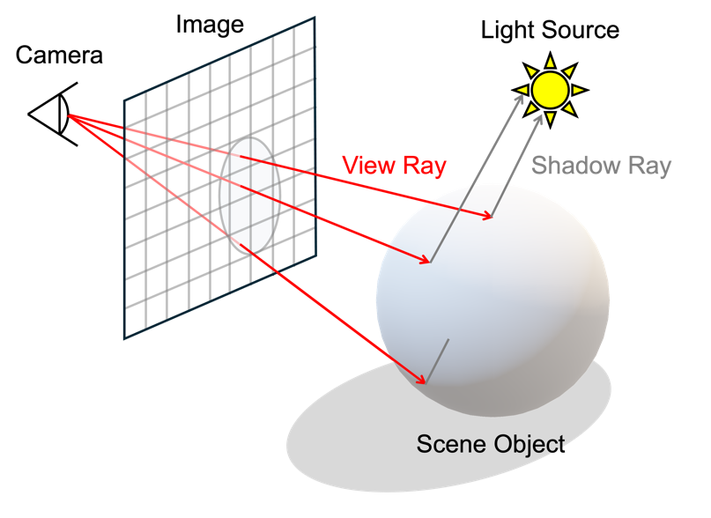

Figure 2 The Concept of Ray Tracing

**Project Solution**

Many previous works in ray tracing have employed “reduced precision" to address its long computation time and high memory usage issues. Reduced precision refers to decreasing the number of bits used in data types within computer programs. For floating point data types, this means to reduce the number of exponent and mantissa bits. Nowadays, reduced precision computation is utilized to enhance computation and memory efficiency in various applications, including artificial intelligence training and inferencing. As a result, active research is being conducted to determine the most suitable precision for each specific application and to develop hardware that supports it.

However, most previous studies on ray tracing using reduced precision have been limited to applying reduced precision only to certain operations within the whole process. Therefore, this study aims to analyze and propose optimal precision applicable to the entire ray tracing process. By doing so, we aim to address the issues with ray tracing and contribute to the development of dedicated hardware for ray tracing.

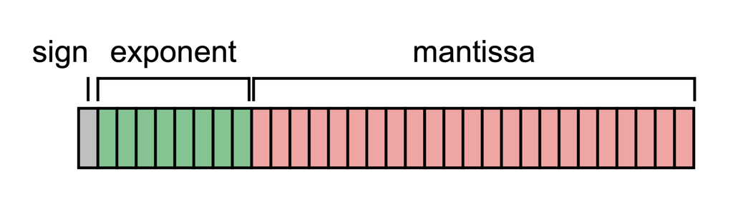

Figure 3 Floating Point (FP) Format

**Evaluation Result**

This research delved into the utilization of different reduced precisions in ray tracing, specifically focusing on assessing image quality in terms of fidelity when compared to the conventional FP64 ray tracing. Employing the 'Structural Similarity Index Measure (SSIM)' as the evaluation criterion, the study examined how closely the resulting images resembled each other to gauge fidelity. The findings highlighted the substantial influence of the mantissa over the exponent in ray tracing operations, indicating that these operations predominantly involved data within similar ranges. Furthermore, it revealed that a minimum of 6 bits for the exponent and 20 bits for the mantissa are essential for generating high-quality images. Based on the SSIM score analysis for various precisions, this research recommends the use of '6-bit exponent and 20-bit mantissa' precision as a practical solution.

Figure 4 Graph of SSIM (Structural Similarity Index Measure) for images based on various reduced precisions