2024.06.04
1. BT for ROS2
- resolved problem with repo https://github.com/BehaviorTree/BehaviorTree.ROS2/issues/74
by
https://github.com/BehaviorTree/BehaviorTree.CPP/pull/804/commits/6e3ba41b3f6048e35c9fa9ab74 16bd0532f7ae18

2. Groot2 for BT & ROS2
- path: home/Groot2/bin/groot2, open with double click

3. Groot1
- path: home/Groot/Groot/build

- launch Groot with ./Groot

- Problem with Groot1: not compitable with BT4 + → Have to use Groot2 instead

4. Subscriber terminal
- in one terminal
~/bt_ws$ ros2 run btcpp_ros2_samples subscriber_test
in another terminal
ros2 run demo_nodes_cpp talker --ros-args --remap chatter:=btcpp_string

TODO:
- customize BT to subscribe to topic ‘/base/twist_controller/command’?

- call /behavior/setLightGreen → Type: std_srvs/Trigger in leaf node

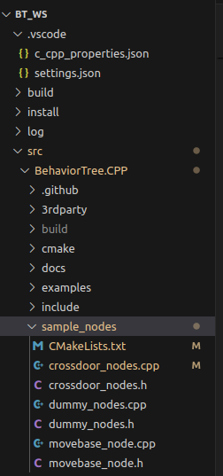
2024.06.05
1. BT for cob_light control
- ~/bt_ws$ ros2 run btcpp_ros2_samples cob_light_test

- start BT from node cob_light_test directly. When using launchfile from 06.04, the nodes have to be constructed in BehaviorTree.Cpp/sample_nodes

- Example from repo:
https://github.com/KaiYuanBu/ClimbingMonkey/blob/a336ba0b7a82d03401c3935f68474ef1e101f9aa/FinalPackages_forUploadGitHub/src/monkey_client/src/monkey_client.cpp

2. Update BT for light & sound control
- First call base/drive/init (type: std_srvs/Trigger), if success=True, set light CyanBreath

- if Navigation goal received & robot moving, set light CyanSweep

- if NaviGoal reached, set light Green

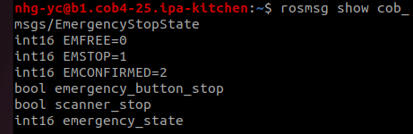
- subscribe to topic cob_msgs/EmergencyStopState, if emergency_state = 1, set Light Red

TODO:
- how to check wether navigation goal is reached? Know check from action, not topic/ service

2024.06.06
1. Meeting with Nadia

With Data Analysis:
- .ros1 .ros2 & .rossystem file all belong to design phase, but should be tracked differently; for RosTooling approach, implementation should only be cleaning up the generated launch file and get system to running (which is expected to be short), therefore only less time will be further spend on testing

- Errors: type mismatch only with traditional approach; wrong behavior: bad behavior with e.g. navigation, it should be counted for both approaches;

- For RosTooling approach, design is also documentation by MDD

With Use Case 3:
- use 1 camera on torso for detection and classification, then try with multiple cameras afterwards

- check head functions, if not working, connect head camera & speake with torso-PC using jump wires

