2024.04.02
1. changed wheel collision geometry to thin plate (create new urdf cob4-25_0402.urdf)
<cylinder radius="0.0782" length="0.005"/>
have to change origin angle
origin rpy="-1.57 0 0" xyz="0 -0.0 0"/>
→ didn’t work fine, the robot does not move after the wheel collisions are changed :(

2. changed base_link mass to 10 kg
<mass value="10"/>
→ robot moves faster after change

3. nav2 example: articubot
- ros2 launch articubot_one launch_sim.launch.py world:=./src/articubot_one/worlds/obstacles.world
- ros2 run rviz2 rviz2 (open rviz and add map & laser & camera)
- ros2 run teleop_twist_keyboard teleop_twist_keyboard (use teleop to control the motion of articubot)
- ros2 launch slam_toolbox online_async_launch.py params_file:=./src/articubot_one/config/mapper_params_online_async.yaml use_sim_time:=true
- ros2 launch nav2_bringup navigation_launch.py use-sim_time:=true

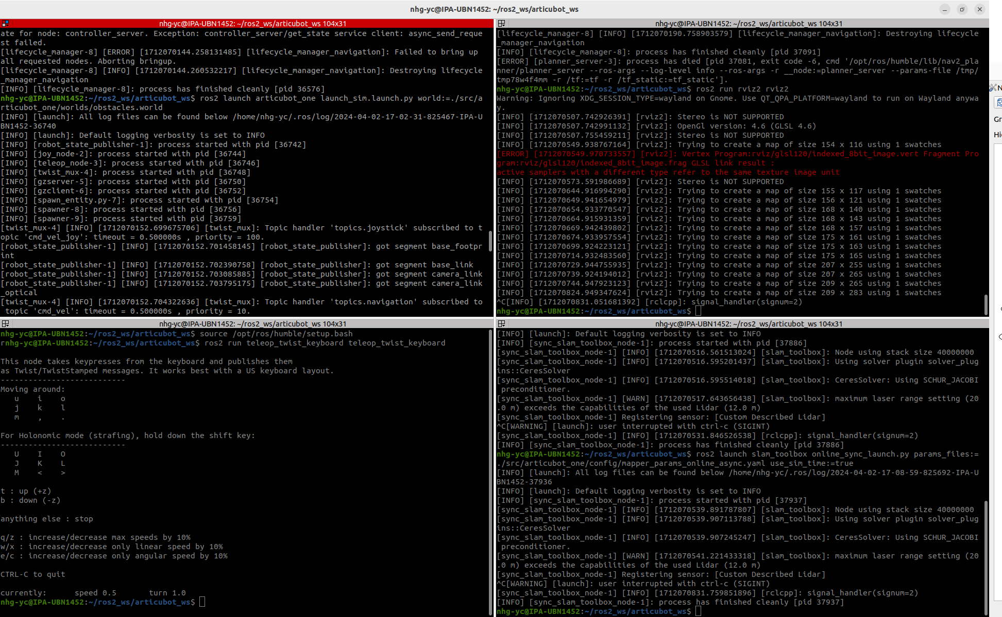
TODO: use controller spawner to launch controller for tricycle

manual setup teleop → 2 hours (16:00 – 18:00, 2024.04.02)

TODO: when using teleop_key, robot don’t go straight line (check robot kinematic)

2024.04.03

1. Apply tricycle_steering_controller to tricycle_demo
~/ros2_ws/tricycle_ws$ ros2 launch tricycle_sim tricycle_steering.launch.py
~/ros2_ws/tricycle_ws$ ros2 run rviz2 rviz2
~/ros2_ws/tricycle_ws/src/tricycle_sim/src$ python3 cmd_vel_bridge_node.py
ros2 run teleop_twist_keyboard teleop_twist_keyboard

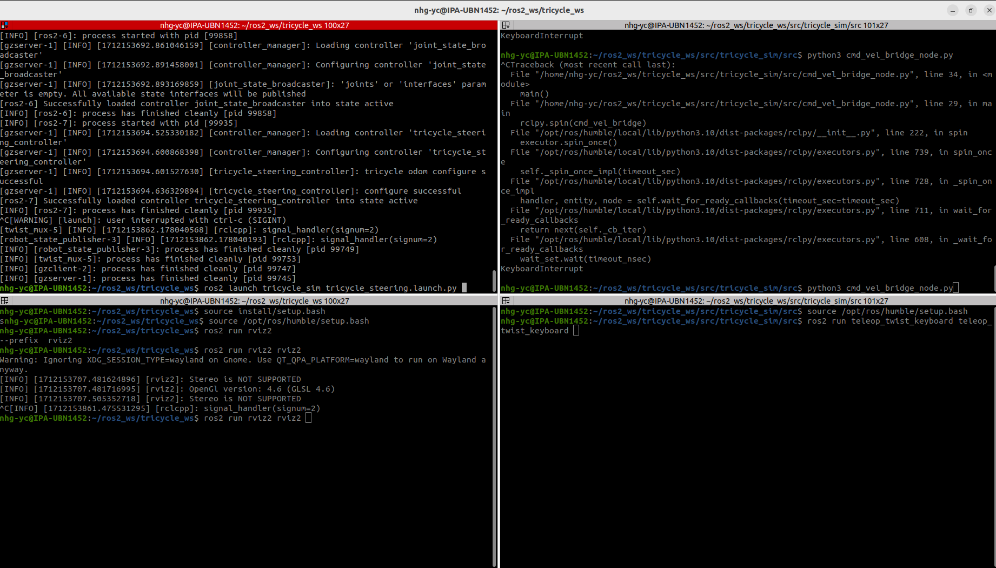
Python node is created to publish tricycle_steering_controller/reference to tricycle_steering_controller
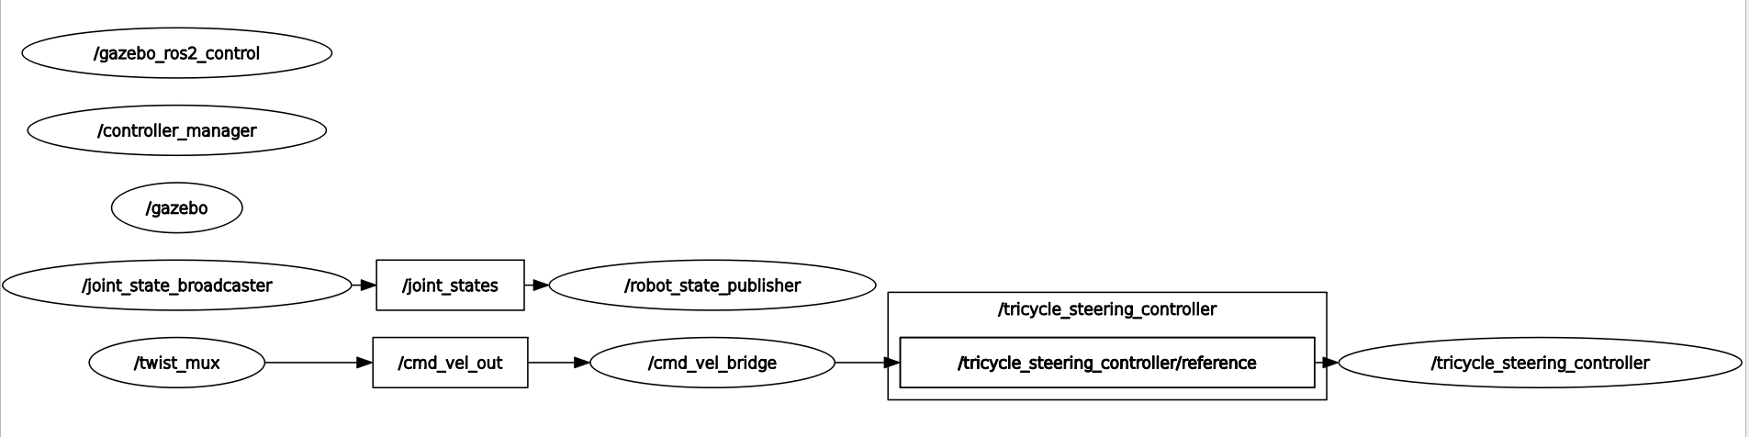
Time spend on /cmd_vel_bridge and topics: 2 hours
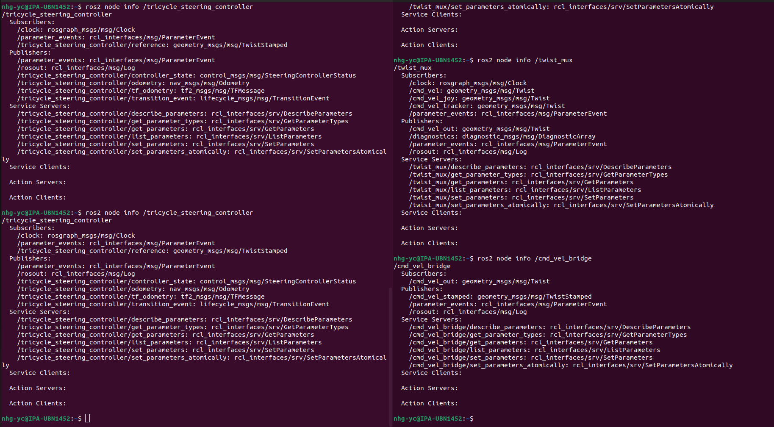

2. Teleop_joy
ros2 launch teleop_twist_joy teleop-launch.py joy_config:='xbox'
hold ‘triangle’ button on joystick for enable

TODO:
rewrite cob.urdf following minimum tricycle model0
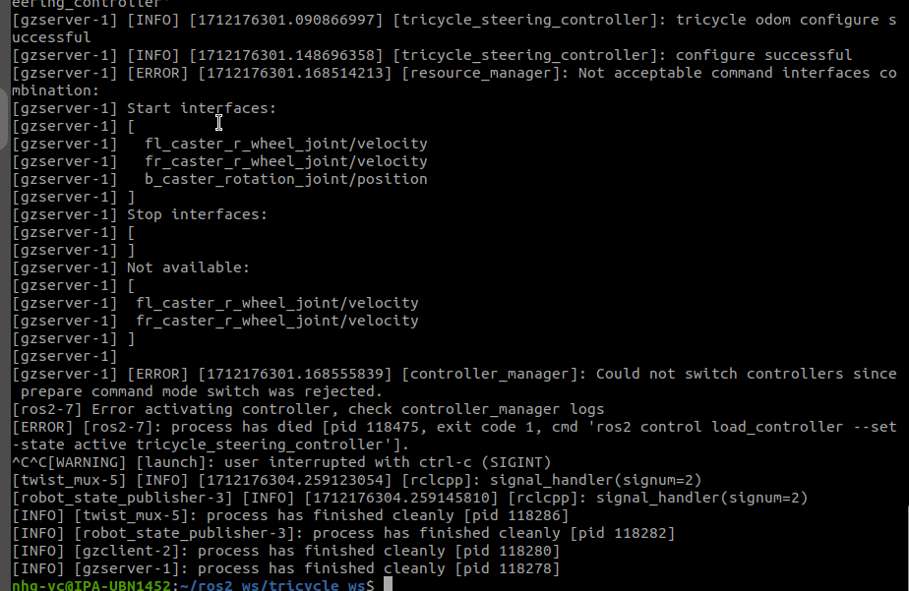

2024.04.04
1. add python node cmd_vel_bridge_node.py to CPP/Python mixed package

Attention:
Add the Python source file to my_package/scripts
- Add this line at the top of ^that file: #!/usr/bin/env python3
- Make it executable with chmod +x my_python_file.py
- Add an empty __init__.py file in my_package/scripts
- Add this to CmakeLists:
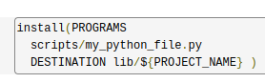
(link: https://answers.ros.org/question/299269/ros2-run-python-executable-not-found/ )
then the python node can be found using ros2 run - command

2. Parameters of tricycle_steering_controller

The tricycle_steering_controller uses the same parameter-set as bicycle and ackermann controller, which is different from tricycle_drive_controller!
(link: https://control.ros.org/master/doc/ros2_controllers/steering_controllers_library/doc/userdoc.html#parameters )

use_stamped_vel: true # /tricycle_steering_controller/reference -> geometry_msgs/msg/TwistStamped
# use_stamped_vel: false # /tricycle_steering_controller/reference_unstamped -> geometry_msgs/msg/Twist
The controller can also use normal geometry_msgs/msg/Twist Type

3. Modify cob4-25_0404.urdf to use tricycle_steering_controller

The urdf is modified according to minimum tricycle model(test_tricycle_steering.xacro.urdf) Changes: fl_caster_r_wheel_joint and fr_caster_r_wheel_joint are directly connected to base_chassis_link, rather than on rotation_link in original urdf.
The wheel_joints have <axis xyz="0 0 1" />.
The “origin xyz & rpy” have to be changed accordingly.
Hypotheses: When using tricycle_steering_controller, it only recognize joints on ‘z’ axis
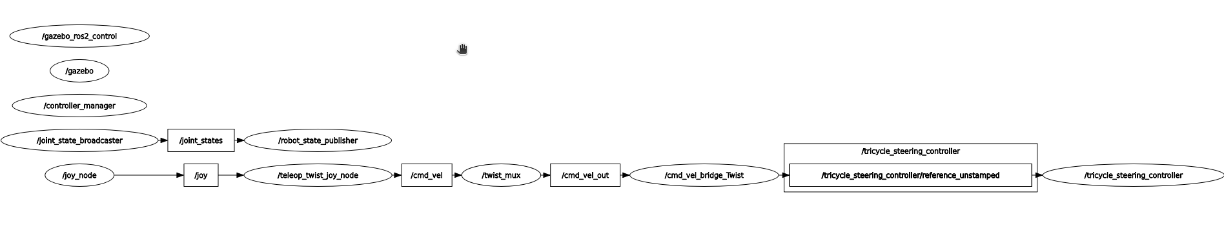

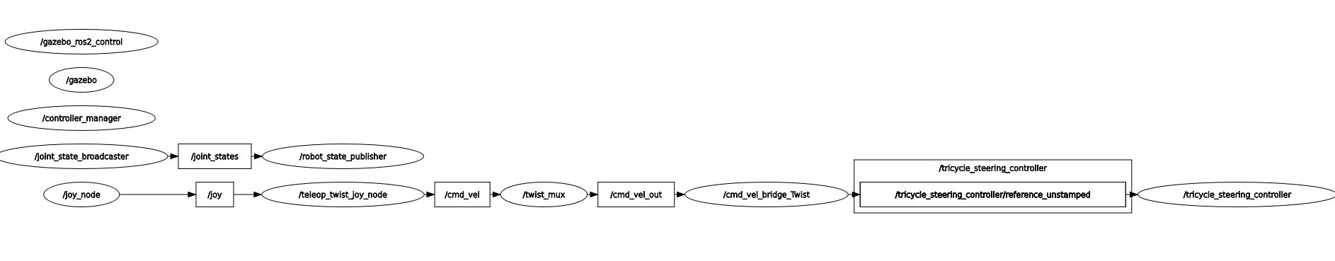
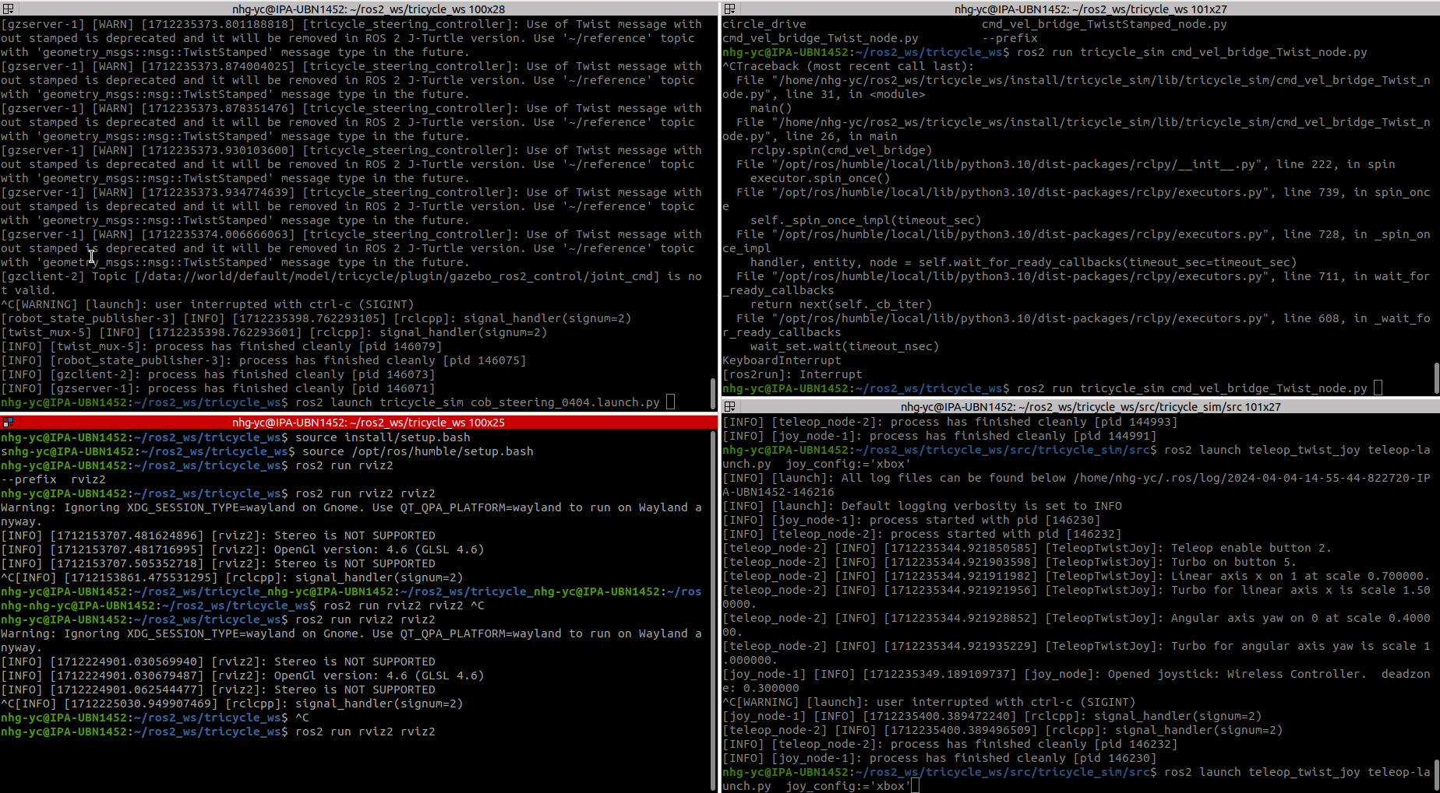
4. remapping mechanism
(link https://www.youtube.com/watch?v=bjH5qmKKpRk )
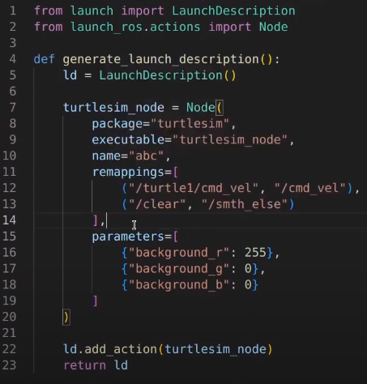
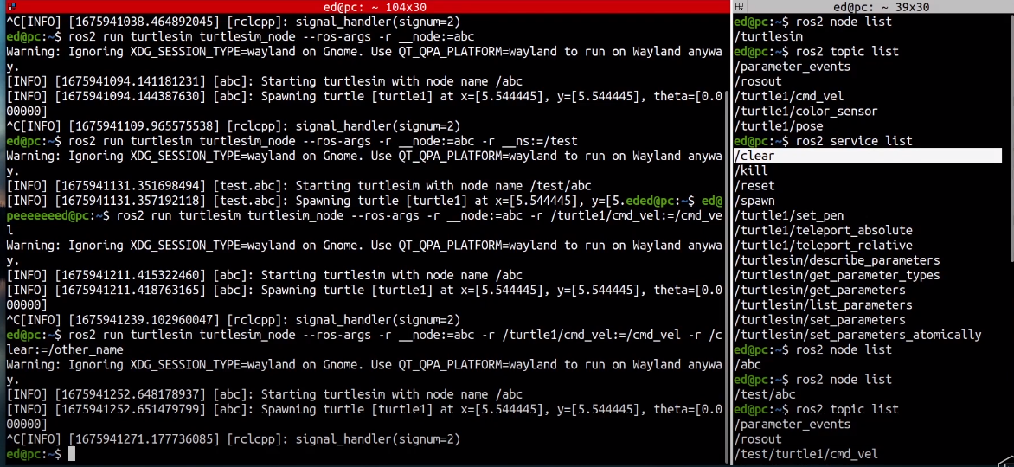

Remapping in command line:
ros2 run turtlesim turtlesim_node –ros-args -r __node:=abc -r /turtle1/cmd_vel:=/cmd_vel
-r → remapping
features to be remapped: node name, namespace, topics, services

