1. migration
- sick_flexisoft
- bms
- cob_omni_drive_controller

2. cob-simulation
- URDF & xacro
- roslaunch cob_bringup robot.launch robot:=cob4-25 sim:=true
-
3. pal-simulation

Solutions:
1. directly control base frame of cob-base for simulation instead of controlling wheels and angles
2. modify the xacro file for cob4-25, update features
3. use only base and sick-300 for gazebo
4. In cob-hardware-config, cob4-25-urdf-base.xacro is used for only base

- if gazebo won’t start

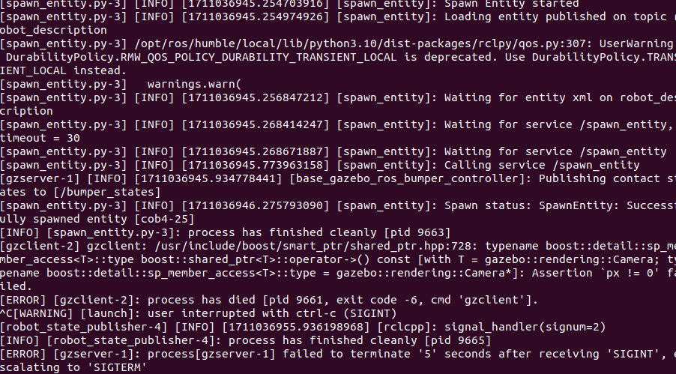
source gazebo setup in command line
. /usr/share/gazebo/setup.sh

- if mesh of robot not showing, replace directory of mesh files
<mesh filename="package://cob_description/meshes/cob4_base/base.dae"/> works fine for the display in rviz, but the meshes won't be loaded in gazebo. After changing package://cob_description into file://$(find cob_description), the meshes will work for both gazebo and rviz. However, in pal_simulation, gazebo works fine with the package://packagename syntax, and I can not explain why (https://github.com/ros-simulation/gazebo_ros_pkgs/pull/1284#issuecomment-1028393652)

