1. start gazebo and rviz
- first launch gazebo, then start rviz with
ros2 run rviz2 rviz2
the folder should contain robot_description (the folder should be cob_ws)
After the launch of rviz, add RobotModel (set description topic to /robot_description) and TF
save config so the configuration will be auto-launched next time
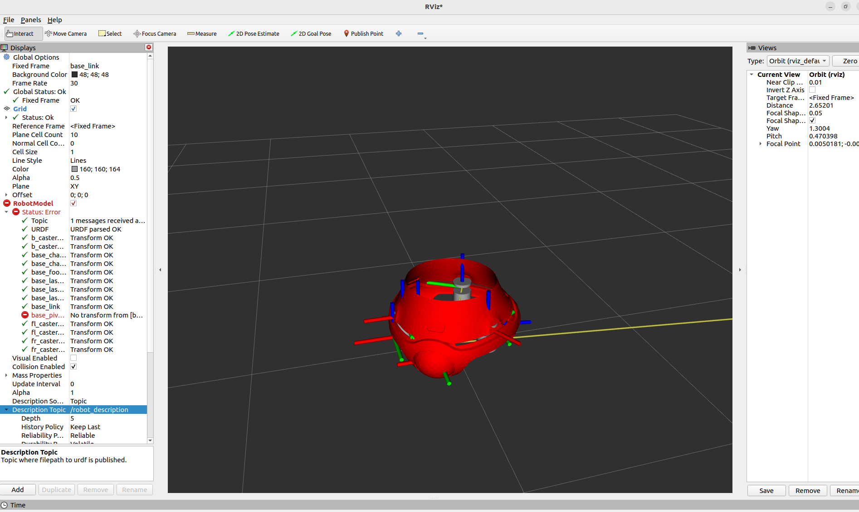

2. Tips for resolving robot moves slow:
- reduce mass of base_link and robot (100 kg → 10 kg)
- replace wheel collision with a really thin cylinder (plate) to reduce contact area

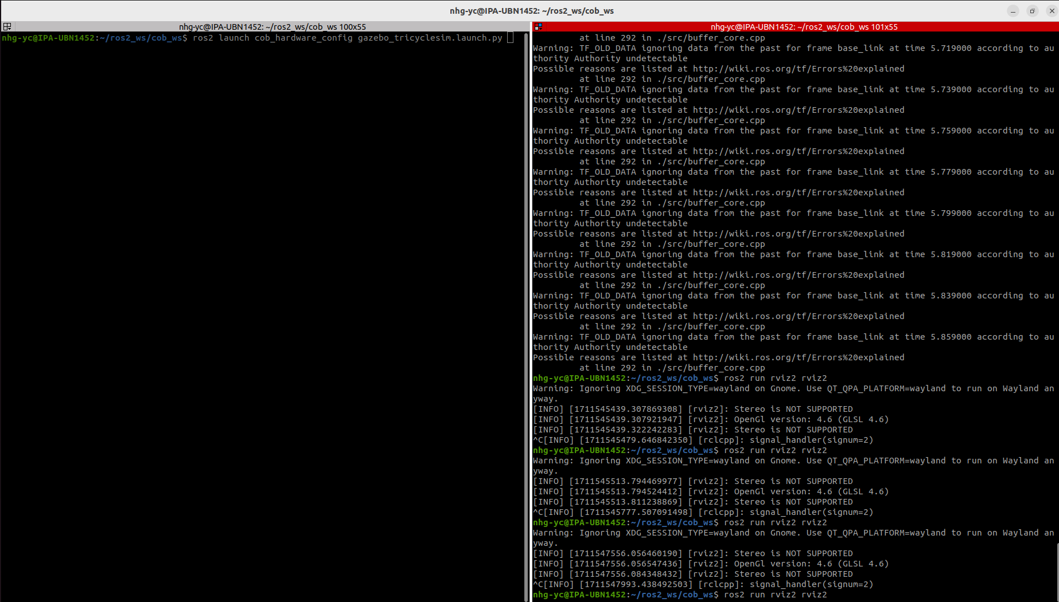
publish topic
ros2 topic pub /tricycle_controller/cmd_vel geometry_msgs/msg/Twist "{linear: {x: 50.0, y: 0.0, z: 0.0}, angular: {x: 0.0, y: 0.0, z: 10}}"

Error using xacro file: hardware_interface::parse_control_resources_from_urdf
solution: xacro cob4-25_base.urdf.xacro > cob4-25_0327.urdf
Generate urdf from xacro manually and delete commented lines
<!-- Controller: 10.0, Driver: 12.0, Elmo: 15.0 -->

force to close gzserver
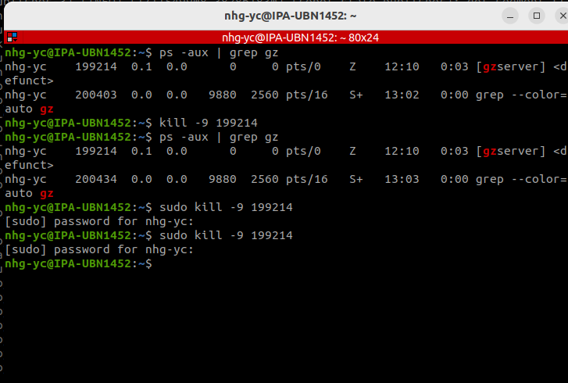
cob_ws
colcon build --packages-up-to cob_hardware_config --allow-overriding cob_description -- symlink-install
source gazebo setup in command line
. /usr/share/gazebo/setup.sh

