2024.05.01
1. Parameters with Ros-Tooling
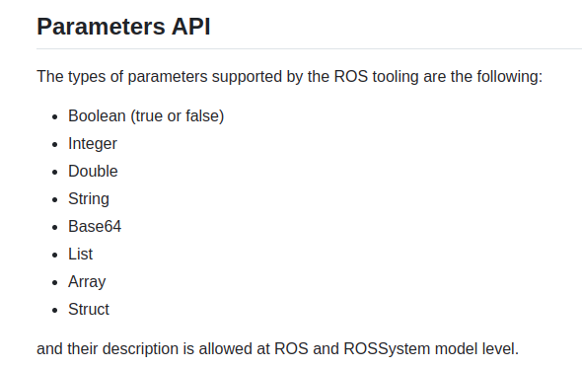
But does Tooling support yaml dictionary?
How to redefinete dictionary as following?
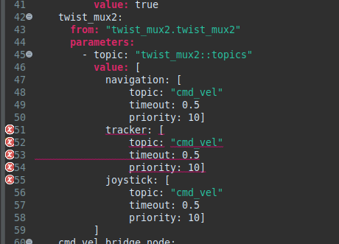
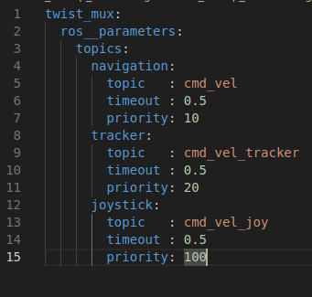
- Can Tooling generate parameter description in dictionary syntax?

- Using ros2model to auto-generate description file at runtime, in auto-gemerated .rossystem file, the parameters have to be redefined to fit Tooling-syntax (artifact_name::parameter_name)
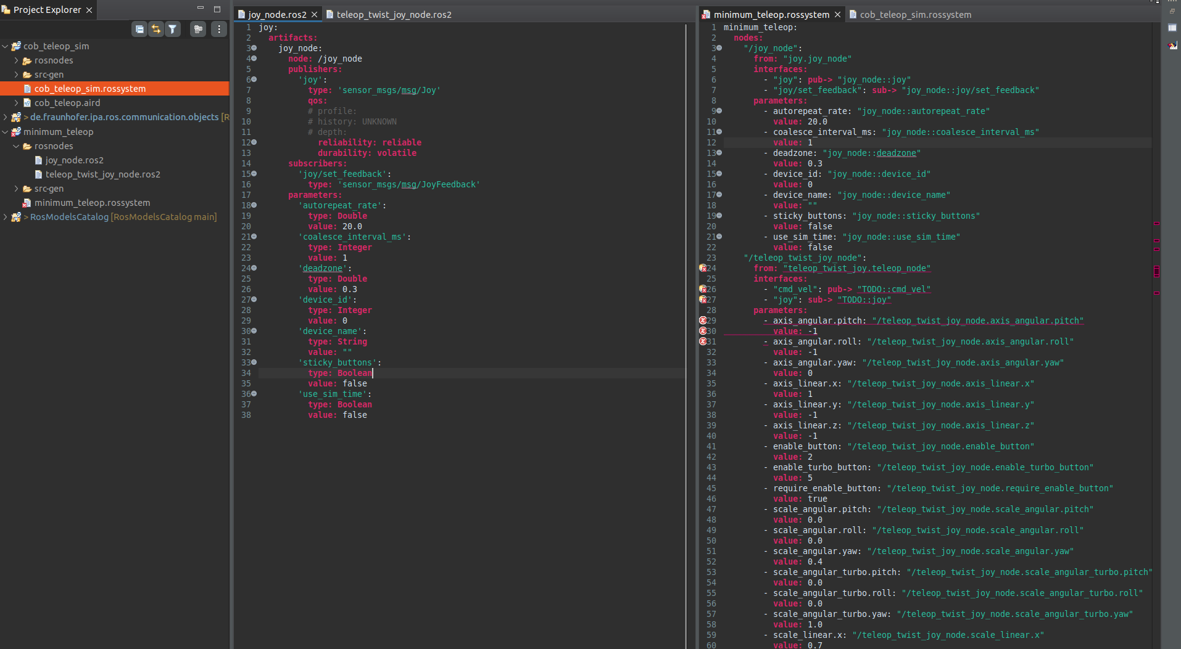
In minimum_teleop, the description is auto-gemerated with ros2model from
ros2 launch teleop_twist_joy teleop-launch.py joy-config:=xbox

which only contains 2 nodes (joy_node & teleop_node)

- The ‘xbox-config’ is not correctly parametrized using the Toolchain!

2024.05.02
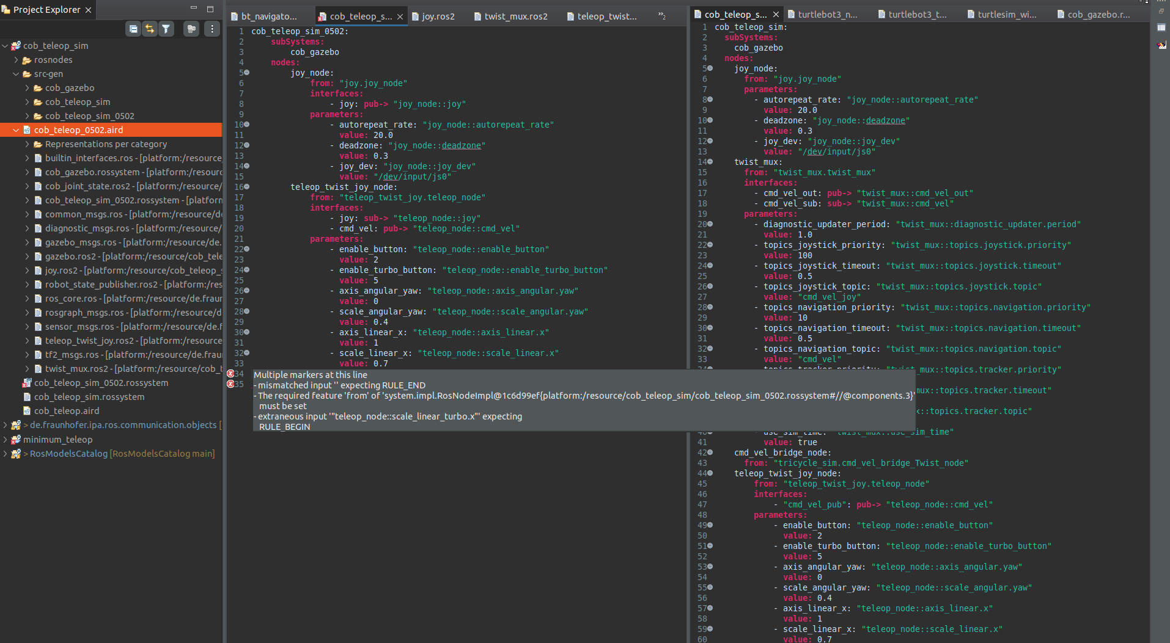
cob_teleop_sim_0502
Total time: 40 min
problem: copy & paste format error

2024.05.04
1. mappin & localization with slam_toolbox
- configuration file ‘mapper_params_cob_0409.yaml’ is used

- when mapping,
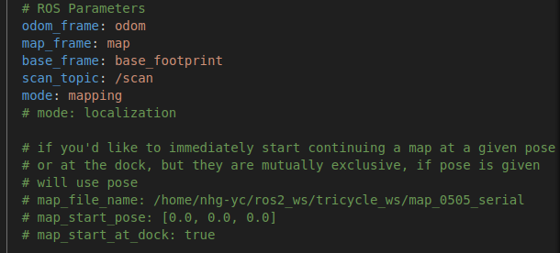
when executing localization
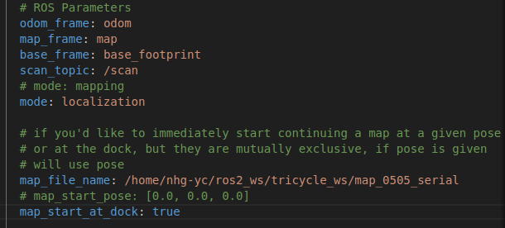
after mapping, save the map ‘map_0505’ & map_0505_serial with slam_toolbox panel

2024.05.06
1. parameter remapping for single node using tooling
- ? Parameter remapping only works for a pair of existing nodes? (with the help of ‘connections’)

- in ‘cob_slam_sim’, the pub-interface ‘tricycle_steering_controller/reference_unstamped’ of ‘cmd_vel_bridge_node’ needs to be remapped to "tricycle_controller/cmd_vel"
→ in Tooling, the interface can only be remapped in pairs?
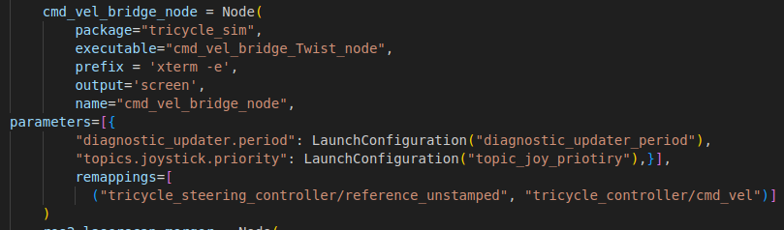
On the other end of this msg is ‘tricycle_controller’, which is used as component of blackbox subsystem ‘gazebo’ (‘cob_gazebo_slam_base.launch.py’). The node is mean to be started using ‘ros2 control load_controller’ but not to be start alone→ No existing node model for tricycle_controller

TODO: abstruct contoller_manager & tricycle_controller to .ros2 models

1. launch cob_gazebo_0506.launch.py (start only rsp-including controller manager, gazebo, spawn_entity)
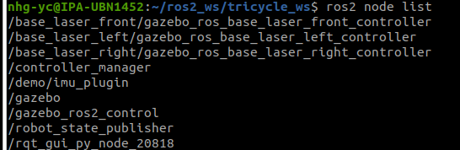
2. activate triycle_controller with
ros2 run controller_manager spawner tricycle_controller --controller-manager /controller_manager
afterwards:
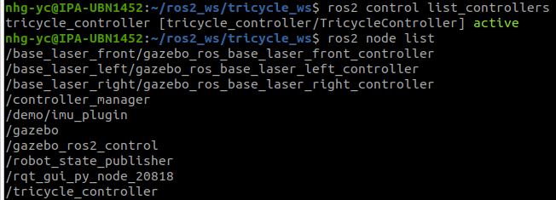
2. Remapping ros2_control
- https://github.com/ros-controls/ros_controllers/issues/126

- controller_manager & tricycle_controller seems to be difficult to be remapped → sub: /tricycle_controller/ cmd_vel

- potential resolution: remap another end
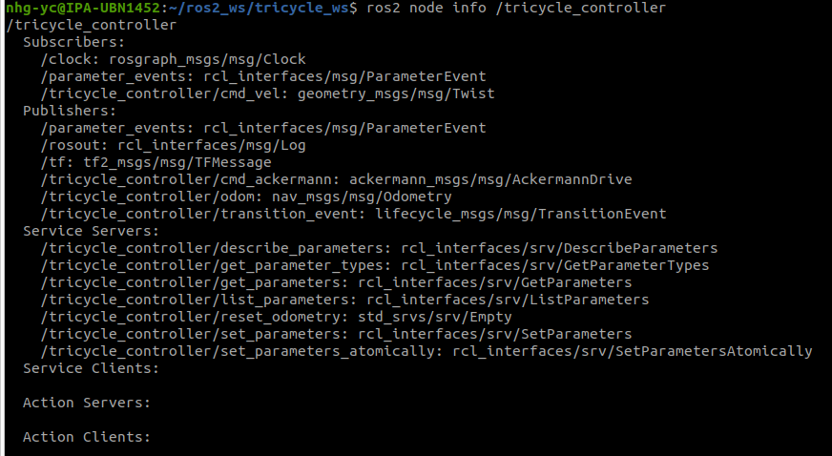

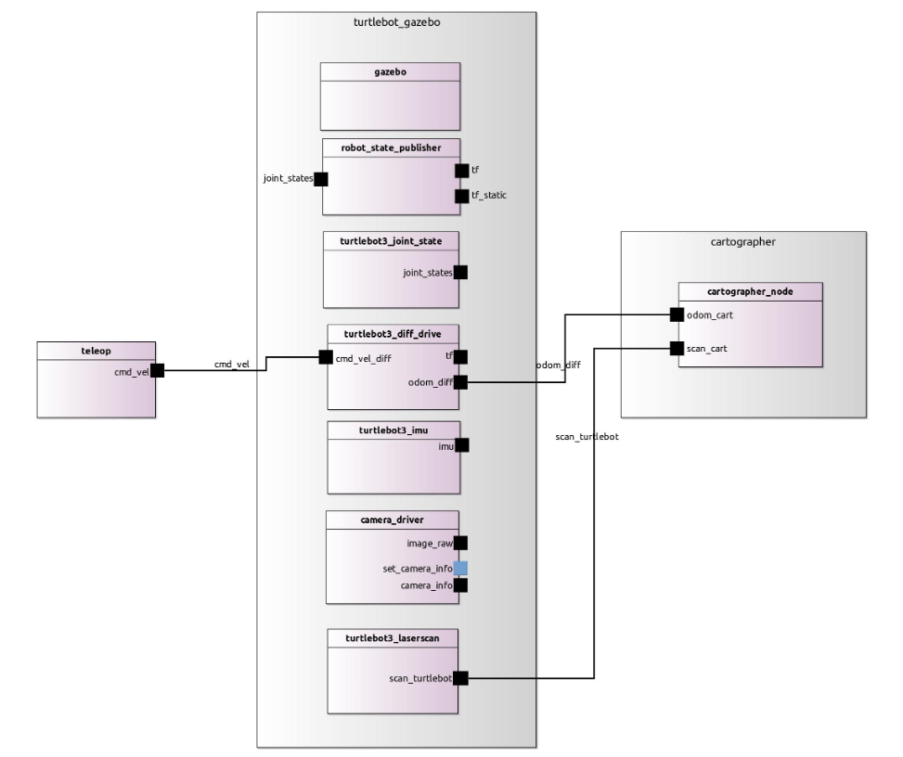
such remapping is hard to archieve with ros2_control stack
(turtlebot3_diff_drive) is a customized node

2024.05.07
1. BehaviorTree
- create project folder, create /build inside project folder
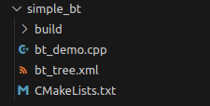
- in /build folder, do cmake ..

- in /build folder, do make

- in /build folder, run executable with ./<executable name>

- Attention: the executable will be started from /build, therefore the relative path should also start from /build (if the .xml is stored out of /build, have to quit current folder first)

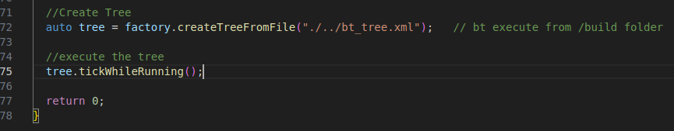
2. Hybrid system
TODO: lauch physical robot with rviz viusalization → bridge following info

- in simulaiton:
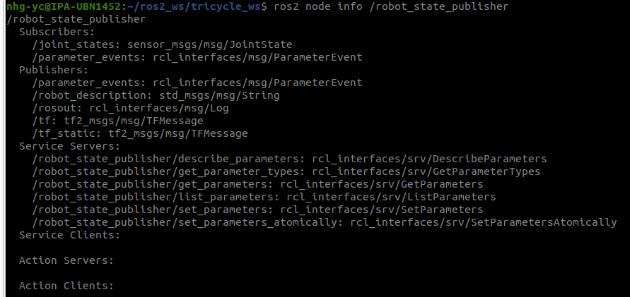
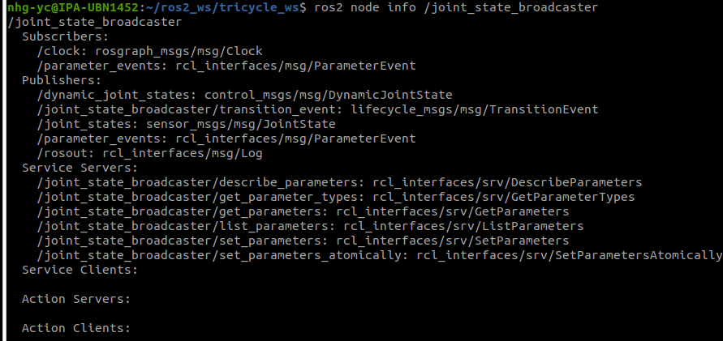
-

2024.05.08
1. manual approach cob_slam with physical robot.launch
- start rviz & robot_state_publisher with launchfile
nhg-yc@IPA-UBN1452:~/ros2_ws/cob_ws$ ros2 launch cob_hardware_config display_robot_0508.launch.py robot:=cob4-25

- launch ros1 robot bringup & ros1_parameter_bridge with bridge_cob_base.yaml
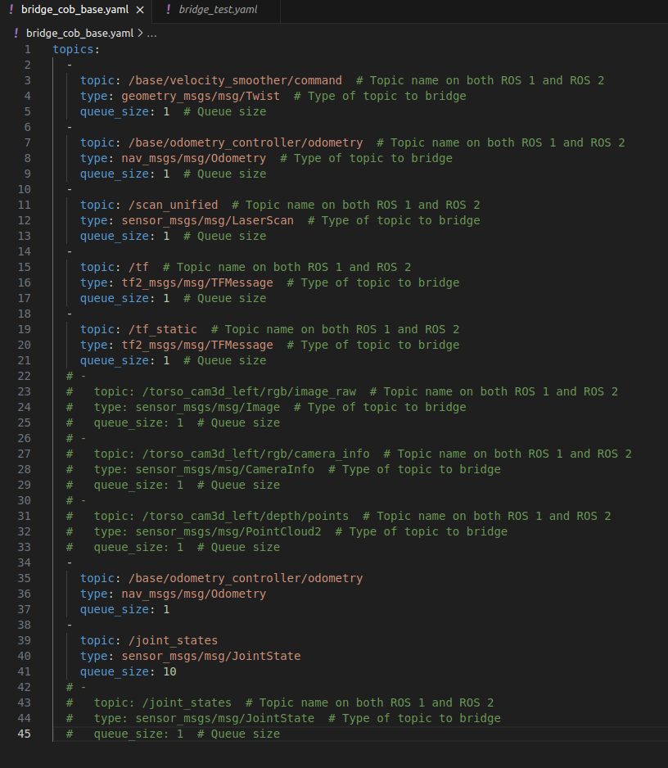
- start teleop node with
ros2 launch teleop_twist_joy teleop-launch.py joy_config:='xbox' joy_vel:=base/velocity_smoother/command
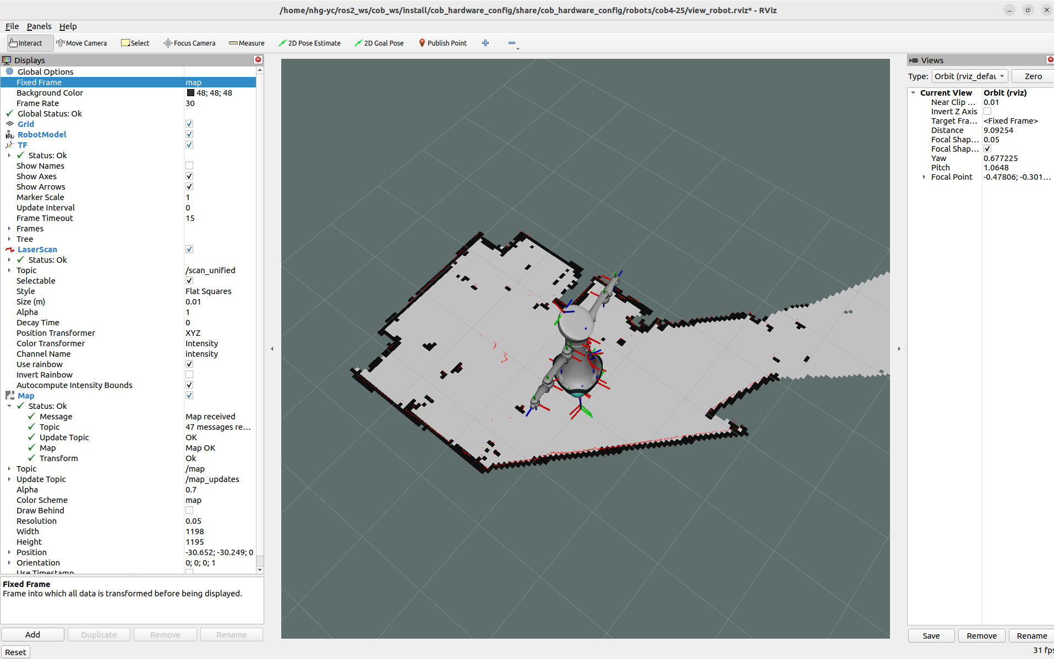

2024.05.10
1. Manual configuration launch file for cob_slam with robot
- time: 1 hour
- Error: wrong parameter file path (wrong typing)
time to fix the error: 10 min
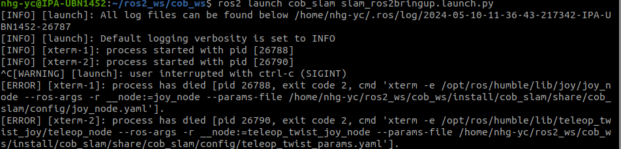
- Error2: maually adjusting launch order with RegisterEventHandler
- Error: failed to launch starter node
- time to fix: 30 min

2. ros1_bridge launch with launchfile
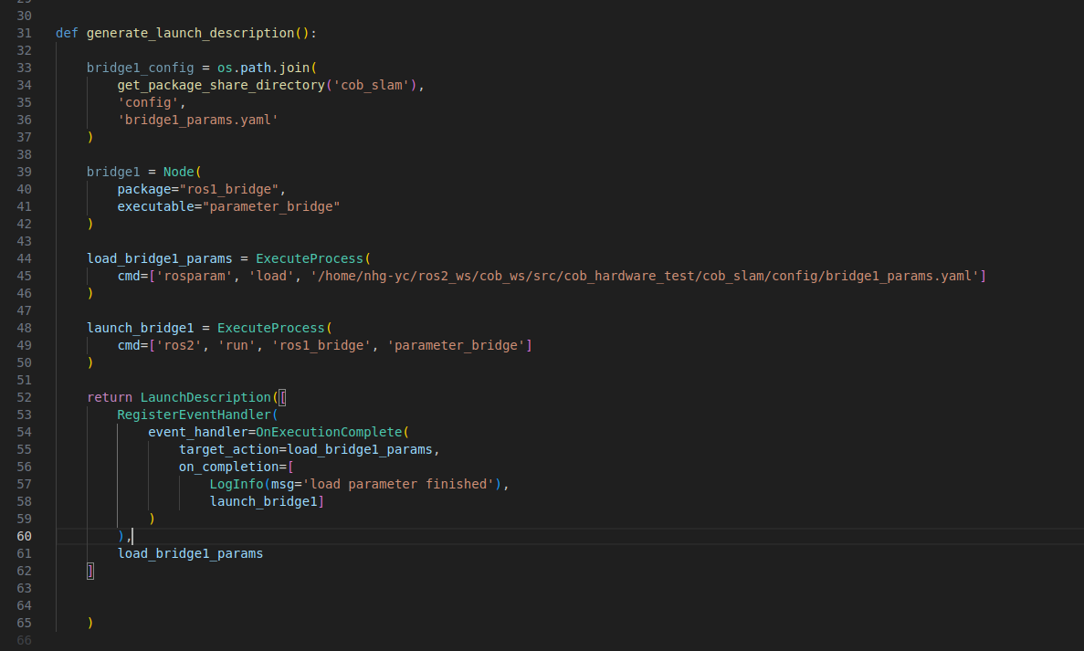
- ros2_bridge parameter_bidge cannot be launched with ‘package’ + ‘executable’, error log:
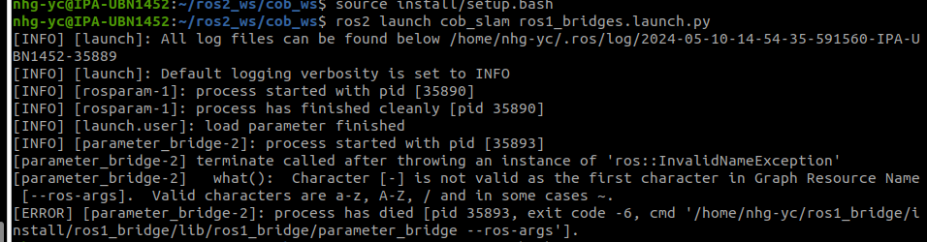
- solution: use ExecuteProcess to configure the command directly.

3. RegisterEventHandler mechanism
- in example:
RegisterEventHandler(
event_handler=OnExecutionComplete(
target_action=load_bridge1_params,
on_completion=[
LogInfo(msg='load parameter finished'),
launch_bridge1]
)
),

→ when target_action is completed/ Exits, then execute other process in ‘on_completion’
→ but the target_action have to be started seperatly!
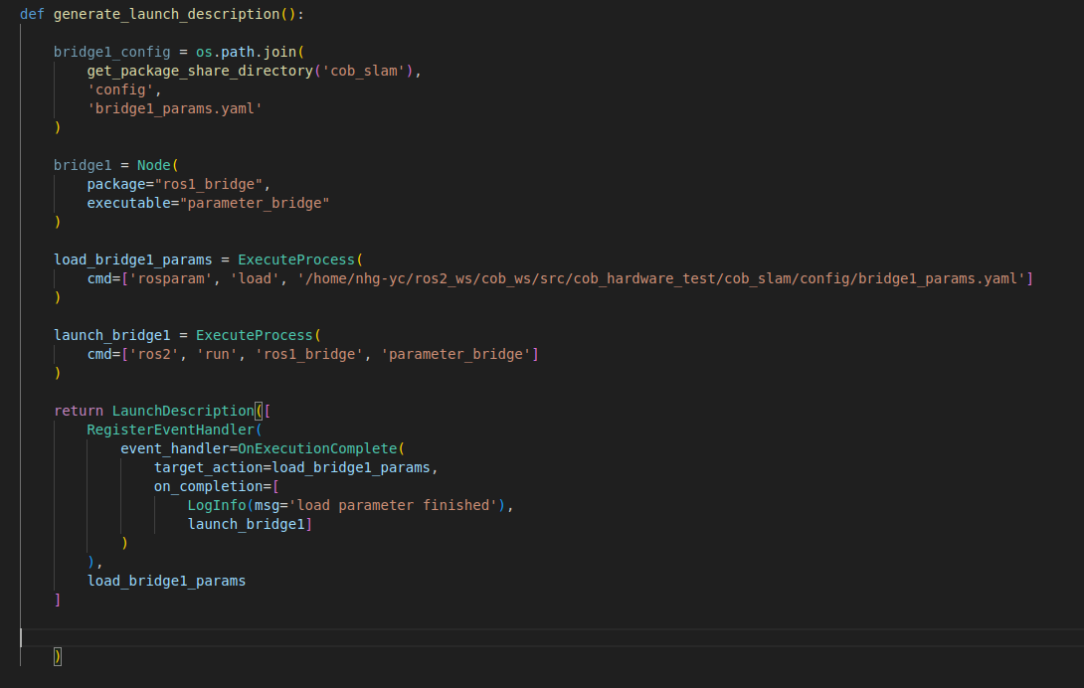
https://docs.ros.org/en/humble/Tutorials/Intermediate/Launch/Using-Event-Handlers.html

3. Analysis cob_hardware
- service safety_controllersetmode:
in total 4 modes, → check source code for modes!
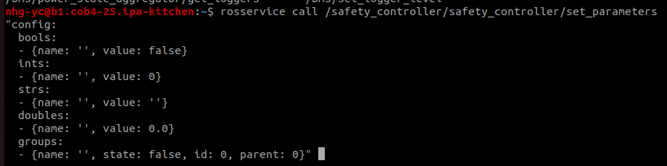

2024.05.13
1. Remapping issue with ros1_bridge
- Resolution: https://github.com/ros2/ros1_bridge/issues/316#:~:text=To%20the%20following%20(switching%20the%20order%20of%20the%20two%20init%20functions)%3A

- when launching from shell, do
ros2 run ros1_bridge parameter_bridge __name:=bridge1
ros2 run ros1_bridge parameter_bridge __name:=bridge2
in different terminals, and both bridge nodes will be launched

- time to fix the issue: 40 min

2. docking function in cob ros1
- when copying folder/ file from computer1 to laptop, → permission denied / connection refused

2024.05.14
1. Further development cob_slam_sim
- Spent 1.5 hour on implementing blackbox (cob_gazebo subssystem), fufillment .ros2 components and adjustment .rossystem file
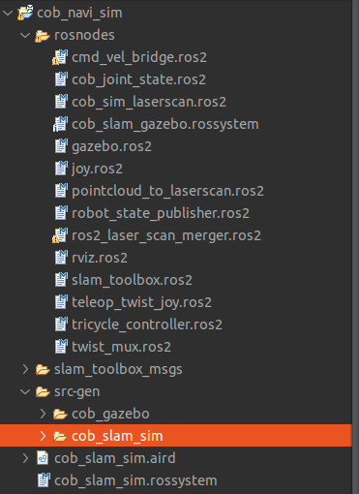
- Problem: For a proper visualization of UML graph, connections are created with [XX_pub, XX_sub] command. But when XX_pub is inside blackbox, then XX_sub have to use the same topic name as the publisher. Current syntax doesn’t support [XX, XX] connection (with same name)

2. RosTooling add navi to cob_slam_sim
- spend 1 hour on implementation cob_navi_sim with RosTooling approach

2024.05.15
1. cob_docking for user story NAMO
- Plan: get the docking station and check how it interact with flexisoft

- sick_flexisoft is hardcoded hardware, so even base_footprint have been changed, the flexisoft will still prevent the robot from contacting with obstacle

2. Definition MBE, MDE, MDD, MDA
- https://coresense.eu/wp-content/uploads/2023/11/CORESENSE_D4.1-State-of-the-Art-Analysis.pdf

- MDD (Model driven development) is specific for using models to develop software system; MDA is a sub-definition under MDD

2024.05.17
1. create new Tooling-project cob_teleop_robot
- design: create .ros & .ros1 files from Nadia’s repo to describe interfaces and components
Time for design: 30 min

2024.05.21
1. cob_teleop_robot
- time for implementation: 40 min
time for testing: 40 min
2. Problems with RosTooling (after latest update)
- missing header files for both launch.py
from ament_index_python.packages import get_package_share_directory
from launch.actions import IncludeLaunchDescription, DeclareLaunchArgument, ExecuteProcess, RegisterEventHandler, LogInfo
from launch.event_handlers import OnProcessExit, OnExecutionComplete

- miss ‘’ when loading parameter using rosparam load command
load_bridge_params = ExecuteProcess(
cmd=['rosparam', 'load', cob_teleop_robot_ros1_bridge_config]
)

- miss ‘)’ when launching ros1_bridge
load_bridge_params = ExecuteProcess(
cmd=['rosparam', 'load', cob_teleop_robot_ros1_bridge_config]
)

- load_bridge_params for twice in bridge launch file
return LaunchDescription([
RegisterEventHandler(
event_handler=OnExecutionComplete(
target_action=load_bridge_params,
on_completion=[
LogInfo(msg='Load bridge parameter finished'),
LogInfo(msg='launching bridge for topics'),
ros1_topic_bridge_parameter_bridge,
load_bridge_params
LogInfo(msg='Start loading bridge parameters'),
]
)
),
load_bridge_params
])
- The bugs are fixed locally in folder /RosTooling_bugfixing

- problem with parameter remapping using RosTooling
Currently, the remapping are implemented twice (triggered by both ‘interfaces’ & ‘connection’). When handling interfaces with ros1_bridge, the ‘connection’ cannot be skiped, otherwise the bridge file will not be generated
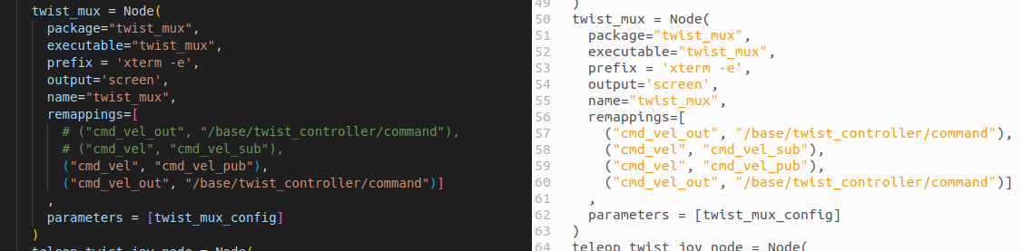

- Potential solution: skip ‘connection’ → in rossystem visualization, the connections between model blocks will be generated using different strategy
- time spend on bugs: 1,5 hour → considering bugs in RosTooling itself, should these errors be count?dfss

2024.05.22
1. Test yolobot
- path: yolo_ws/src/yolobot

- yolov8_ros2_pt.py: change /image topic subscription and model here

- launch only the yolo file with:
ros2 launch yolobot_recognition launch_yolov8.launch.py

2. Launch yolo with bridged /image_upright topic
- high latency: topic rate = 0.3 → each frame take 3 seconds!
TODO: resolve latency proble with bridge, perhaps queue_size?

- with yolo: Customize network for dection chair & sofa & box

2024.05.23
1. bridge image through image/compressed
- install pkg image_pipeline in image_ws
https://github.com/ros-perception/image_pipeline -b humble

- republish compressed → raw with command:
nhg-yc@IPA-UBN1452:~/image_ws$ ros2 run image_transport republish compressed raw --ros-args -r in/compressed:=/torso_cam3d_left_upright/rgb/image_raw/compressed -r out:=/cam_left/decompressed

- with image_pipeline, image could be viewed with command:
ros2 run image_view image_view -r image:=/image

- the decompressed raw image with name cam_left/decompressed will be published and could be further processed with yolo

avrage rate ros1 compressed topic: 16 – 25 hz
avrage rate ros2 compressed topic: 15 – 23 hz
avrage rate ros2 decompressed topic: 14 – 20 hz

- theora: perhaps? another compressed format for transport? Not necessary when decompressing is working

TODO: in yolo skript, publish logger/ info when class = bottle
check depth info from camera

2. importing gazebo-world model for simulation tests
https://automaticaddison.com/useful-world-files-for-gazebo-and-ros-2-simulations/#Office_World:~:text=%C2%A0%C2%A0return%20ld-,Worlds,-Cafe%20World

- Problem: robot fly away after launching → perhaps a collision happens when launching?

3. Problem with rostooling_ws

- after packages with ros1_bridge is build, could lead to problems with cob_slam_sim & cob_teleop_sim. Solution: delete build/ install/ log and rebuild simulation packages

- to launch cob_slam_sim & cob_teleop_sim:
source: ros2_ws/cob_ws & rostooling ws
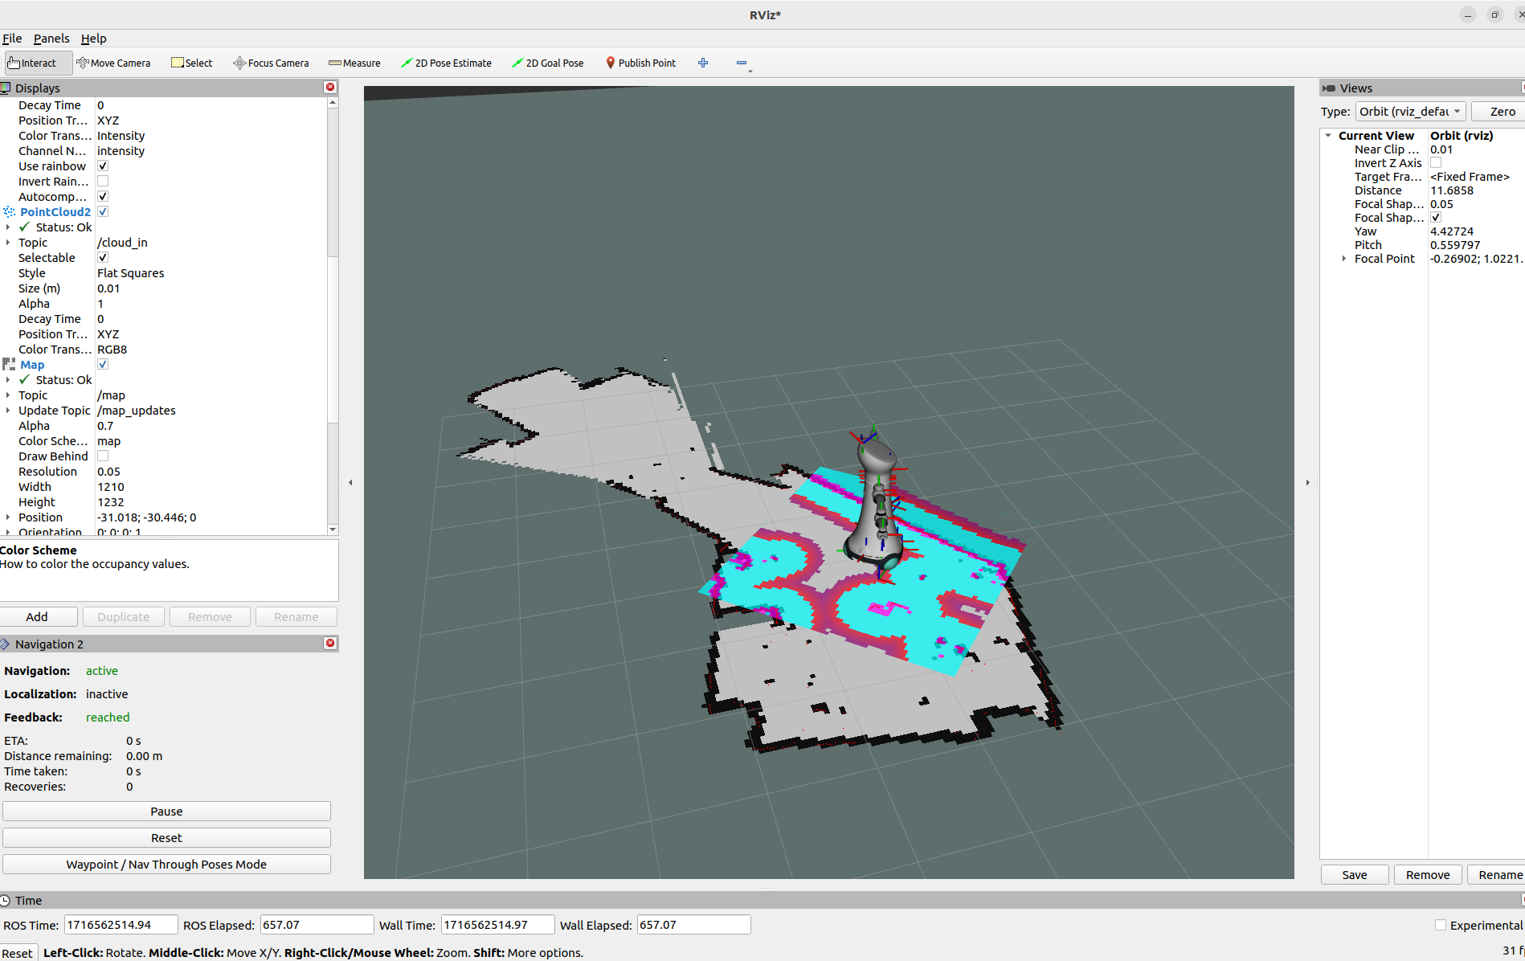
2024.05.24

1. Testing cob_slam with manual approach

- spend 1 hour on testing

first launch ros_bridge with:
nhg-yc@IPA-UBN1452:~/ros2_ws/cob_ws$ ros2 launch cob_slam ros1_bridges.launch.py

then start launch file with:
nhg-yc@IPA-UBN1452:~/ros2_ws/cob_ws$ ros2 launch cob_slam slam_ros2bringup.launch.py

2. Implement cob_slam_robot with RosTooling
- 1 hour on design ros system
- 2 hour on implementation

Problems with RosTooling for cob_slam_robot:
- bad remapping experience & performance! Have to reorganize RosTooling remapping mechanism

3. Manually test cob_navi_robot
- launch navigation toolbox with
nhg-yc@IPA-UBN1452:~$ ros2 launch nav2_bringup navigation_launch.py params_file:=/home/nhg-yc/ros2_ws/cob_ws/src/cob_hardware_test/cob_slam/config/navi_robot.yaml

robot works for Friday :)
PS: map saved under /rostolling_ws folder

