Connect ROS tooling models with SeRONet.

- Prerequisites.
Create a folder and clone the following Repositories.

git clone https://github.com/ipa320/ros-model
git clone https://github.com/ipa-nhg/ros-model-examples
git clone https://github.com/seronet-project/SeRoNet-examples
git clone https://github.com/Servicerobotics-Ulm/DomainModelsRepositories

- Install SeRoNet Toolchain.
Download SeRoNet Release Version

tar xzvf SeRoNet-Tooling-v1.0.tar.gz
SeRoNet-Tooling-v1.0/eclipse

The last command will open the toolchain, select a folder for your Workspace and switch to the Workbench view. We recommend to check the latest version of the software using the Help menu -> Check for updates.
Add the ROS Mixed Port plugins to the release. In Eclipse, go to Help > Install New Software.... To install the latest version of the ROS tooling, add the update site URL http://ros-model.seronet-project.de/updatesite/RosSeRoNetMixedPort/latest/ in the Work with section.

- Import or Create new project that contain node to connect with SeRoNet.
The previously installed toolchain contains the ROS tooling modules required to interpret the ROS models gramatic. You can change to the ROS perspective by:
Go to Menu Window -> Perspective -> Open Perspective -> Other... -> ROS developer. Your application toolbar will be automatically configured.
Before you bring your package you have to import the project located under the "ROSCommonObjects" folder of the ros-model repository (previously cloned) to the workspace of your application:
de.fraunhofer.ipa.ros.communication.objects
We can import the project for transformation, in this example cob_ligh ros model example repository.Below you will see how to import project in Eclipse IDE.
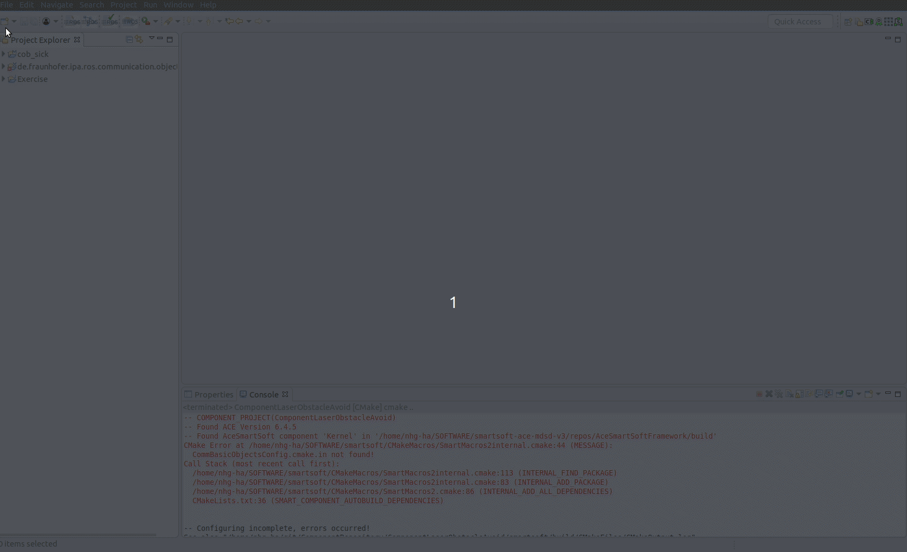
OR we can create
https://github.com/ipa320/ros-model/blob/master/docu/NewProject.md.
New project from above link. In case we have an existing ROS package that contain c++ code of component, it is recommended to use extractor instead starting from scratch.
https://github.com/ipa320/ros-model/blob/master/docu/NewRosModel.md.
NOTE: All messages, services and actions used by your node have to be described. We made available a most common ROS interface.
https://github.com/ipa320/ros-model/tree/master/ROSCommonObjects/de.fraunhofer.ipa.ros.communication.objects/basic_msgs
Incase package dependencies are not available we can create them from the following link.
https://github.com/ipa320/ros-model/blob/master/docu/NewCommunicationObjects.md

- Opening representation file for visualization.
One can view the visualization of of node by following the steps.

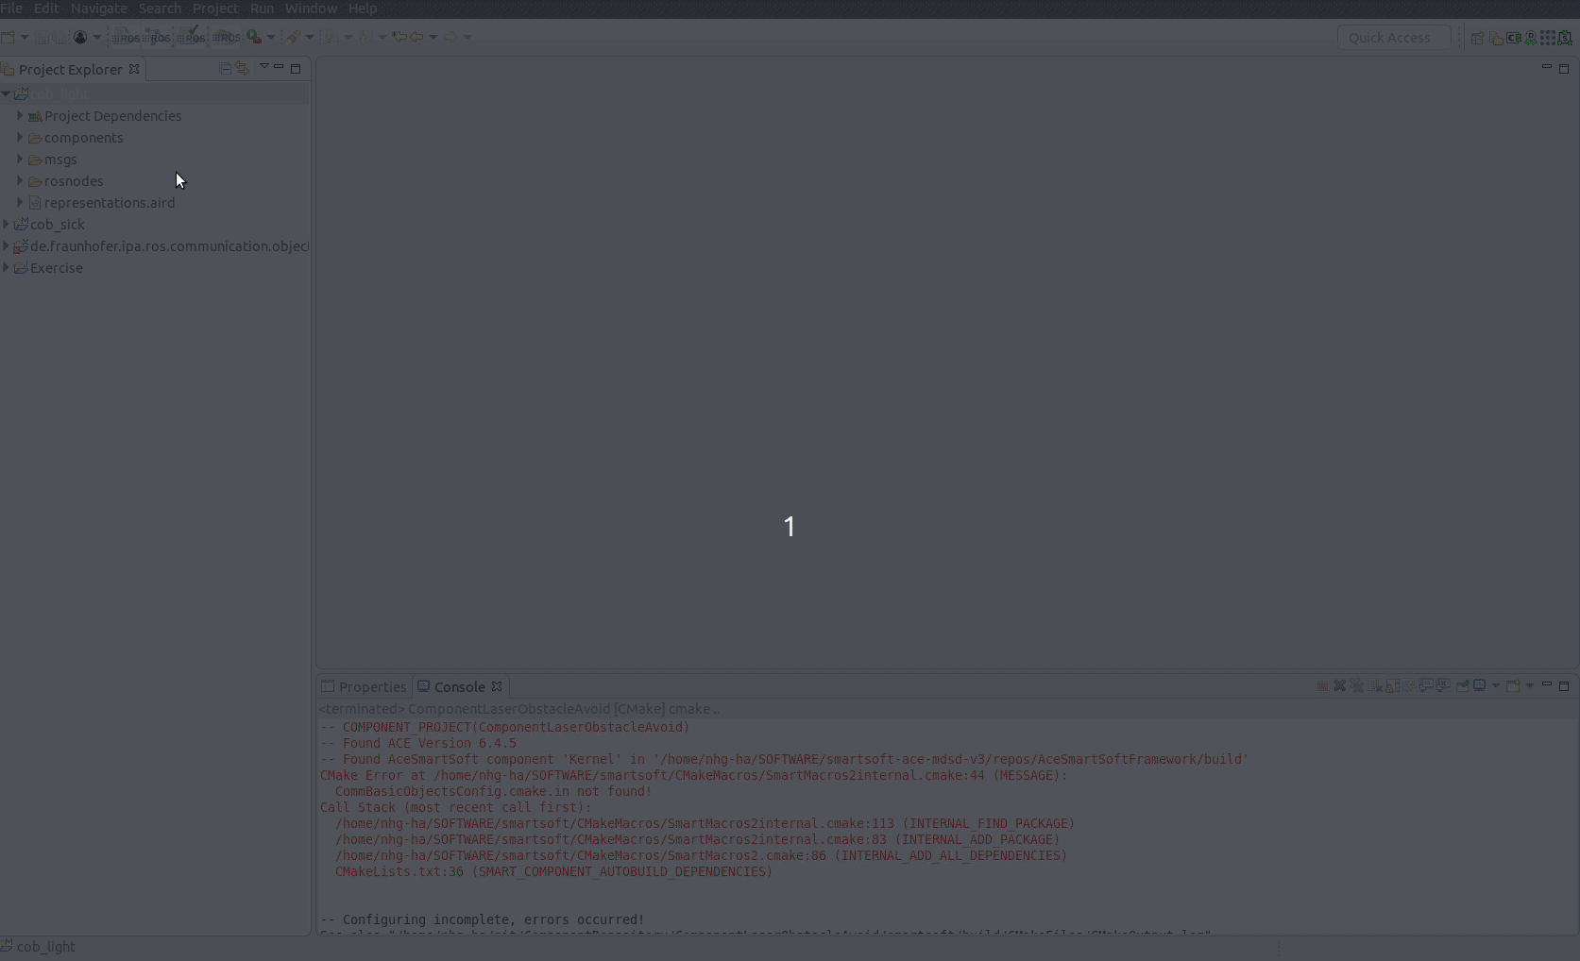

- Transform the ROS component model to SeRoNet component model.
By default opening the diagram will automatically create the component interface for the nodes on your ROS project. You can always find them under new folder called components/. This model is bridge from ROS to other frameworks. If SeRoNet tooling is included then a function will be activate by right clicking the file option Generate ROS-SeRoNet Mixed Port.

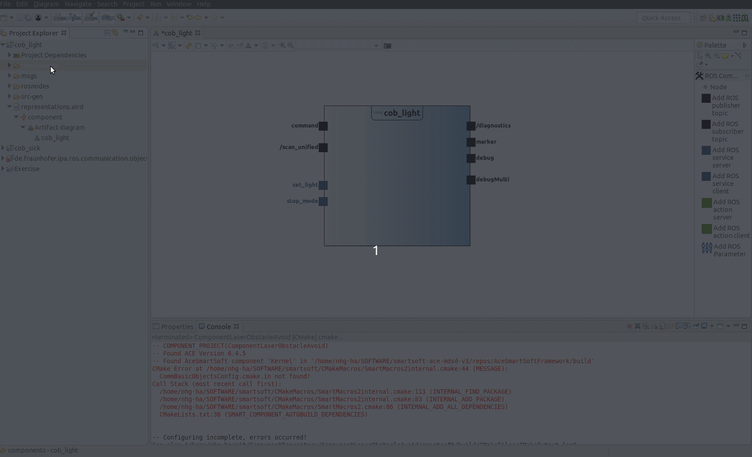
The result will call rospoolinterface. Start point of the following tutorial.
https://wiki.servicerobotik-ulm.de/tutorials:ros:mixed-port-component-ros.

To make it easier the interfaces we incorporated an extra help function that automaticaly relays one of the ROS interfaces. The previous function through its pop-up guides the user to generate not only rospoolinterface model but also a suggestion of a SeRoNet component with ROS mixed port. The resulted file will be under the folder src-gen/SeRoNetComponent
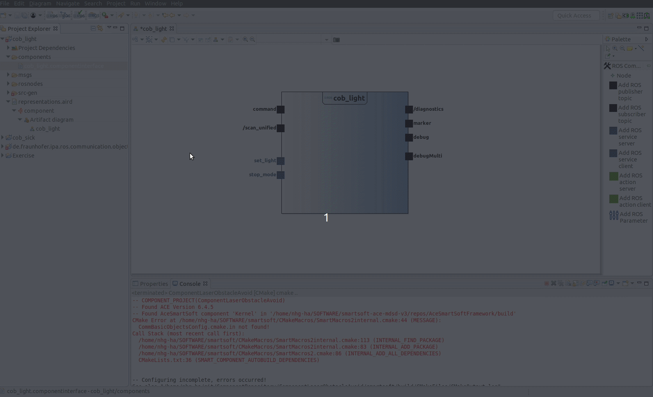

For this example SeRoNet component with ROS mixed Port by creating a component.
https://wiki.servicerobotik-ulm.de/tutorials:develop-your-first-component:start

- Modeling the Component.
Following tutorial will show how to create the component.
- Select the New Project → Component Project(tier 3)

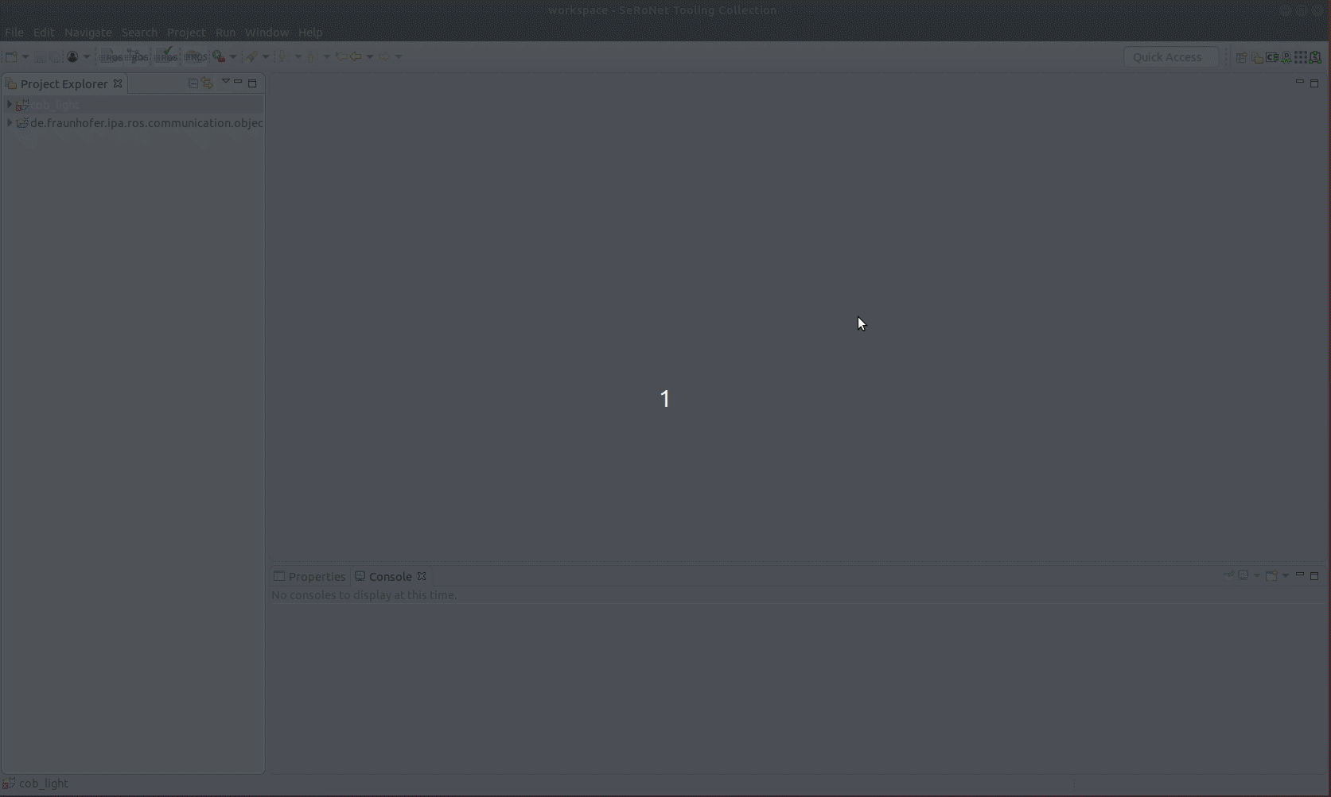

Give name and location to your project. After that you will see the project is created with empty component.

After creation of src-gen folder. There will be two files under that folder. Simply copy those file and paste it into the Model folder under you component project. After copying the file just follwing the tutorial will help you visualize the component.

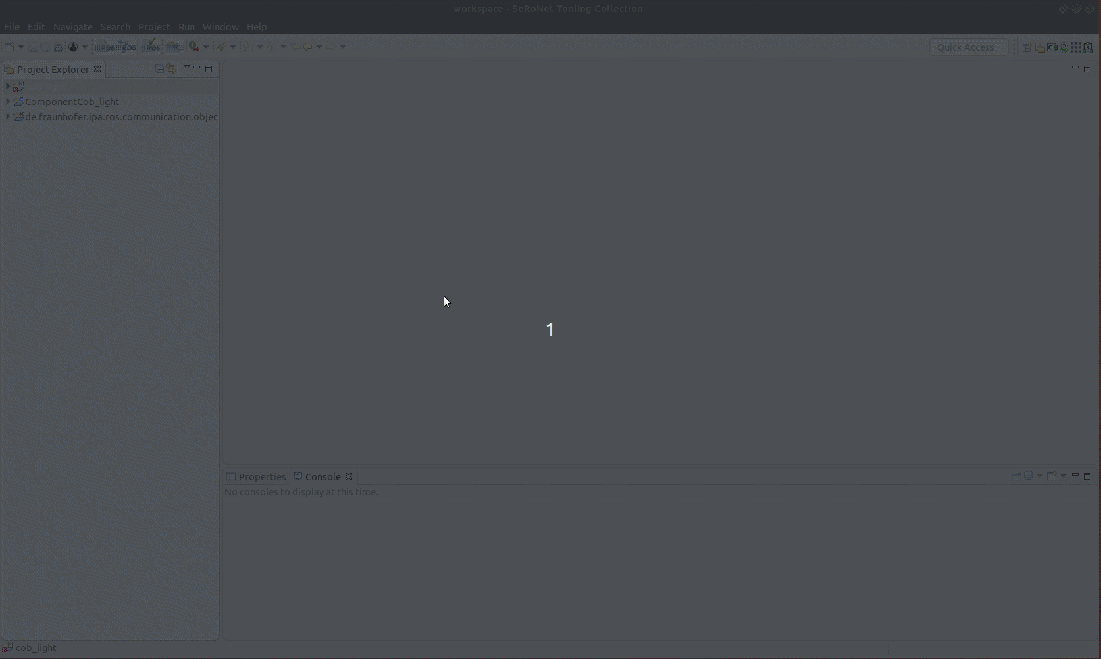

- Transform required communication objects.
For some cases like cob_light driver, ROS node definition requires some non-common ROS messages and services. For non-ROS frameworks we have to transform communication objects into SeRoNet standard format. There is tool that automate this process.
User can trigger it by right clicking on the ROS model file(cob_light/msgs/cob_light.ros)
and selecting the option “Generate SeRoNet communication objects”.
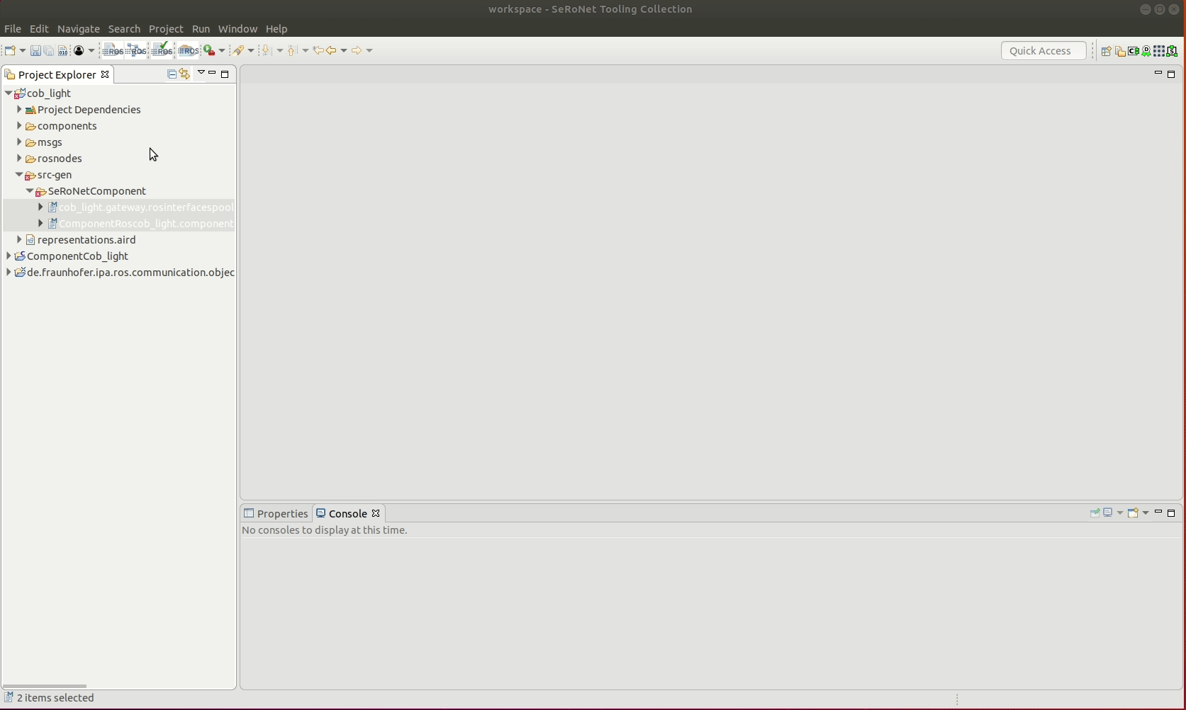
This will generate the file services and the files types under the folder src-gen

Further information can be found on.
https://github.com/ipa-nhg/SeRoNet-Tooling-ROS-Mixed-Port/tree/M2MCommunicationObjectsReadme/de.seronet_projekt.ros.componentGateway.generator#automatic-transformation-of-communication-objects

These files are the input for SeRoNet Domain Model. By creating new domain model

https://wiki.servicerobotik-ulm.de/tutorials:develop-your-first-domain-model:start

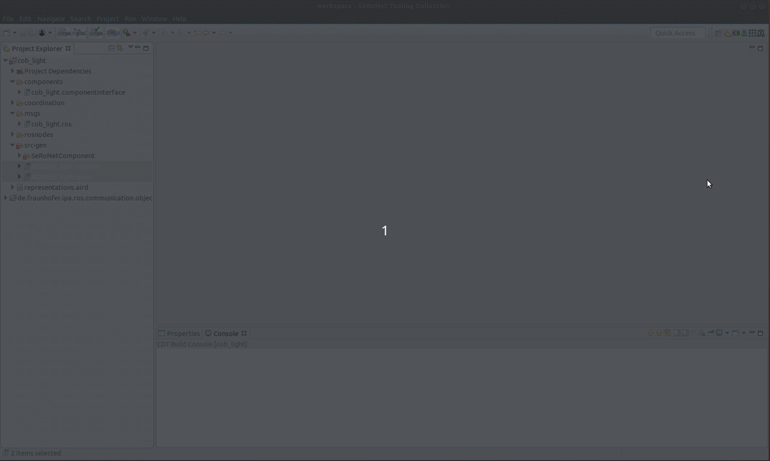

After creating the project just copy these two files and the model will automatically added the interpreter.Probably after create the new Domain Models project and add the types and services files you will get an error because some dependencies are missed.

For the most common ROS objects the project dependencies are already available. We suggest to import always by default the following projects from the GitHub repositories previously cloned:
- DomainModelsRepositories/CommBasicObjects
- SeRoNet_Release_test/git/SeRoNet-examples/SeRoNet-Tooling-ROS-Mixed-Port/DomainRosModelsRepositories/ROSRos_core
- SeRoNet_Release_test/git/SeRoNet-examples/SeRoNet-Tooling-ROS-Mixed-Port/DomainRosModelsRepositories/ROSCommon_msgs
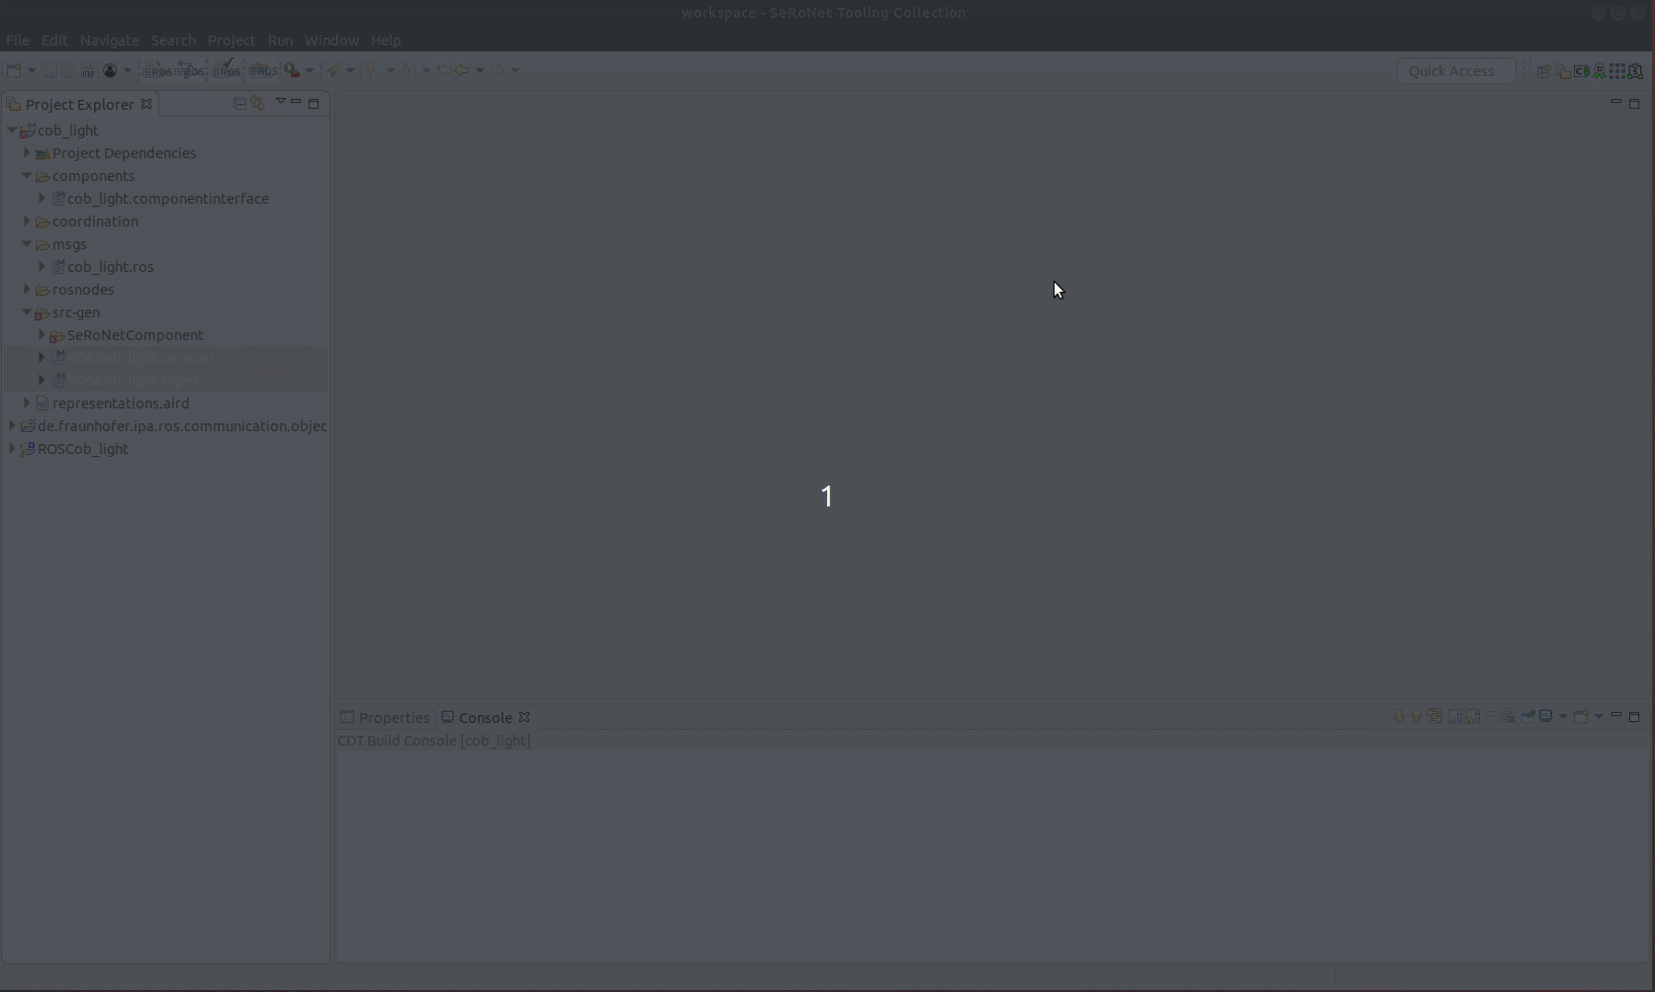

Then open the Domain Expert perspective (Go to Menu Window -> Perspective -> Open Perspective -> Other... -> Domain Expert) and for the created Domain Models expert that holds your communcaition object add the import dependencies (Right click on imports folder).



