


Air Compressor Risk Assessment

School Assessment No. | INFRA35
Title of Activity: | Use of lab compressor
Location(s) of Work: | Informatics Forum

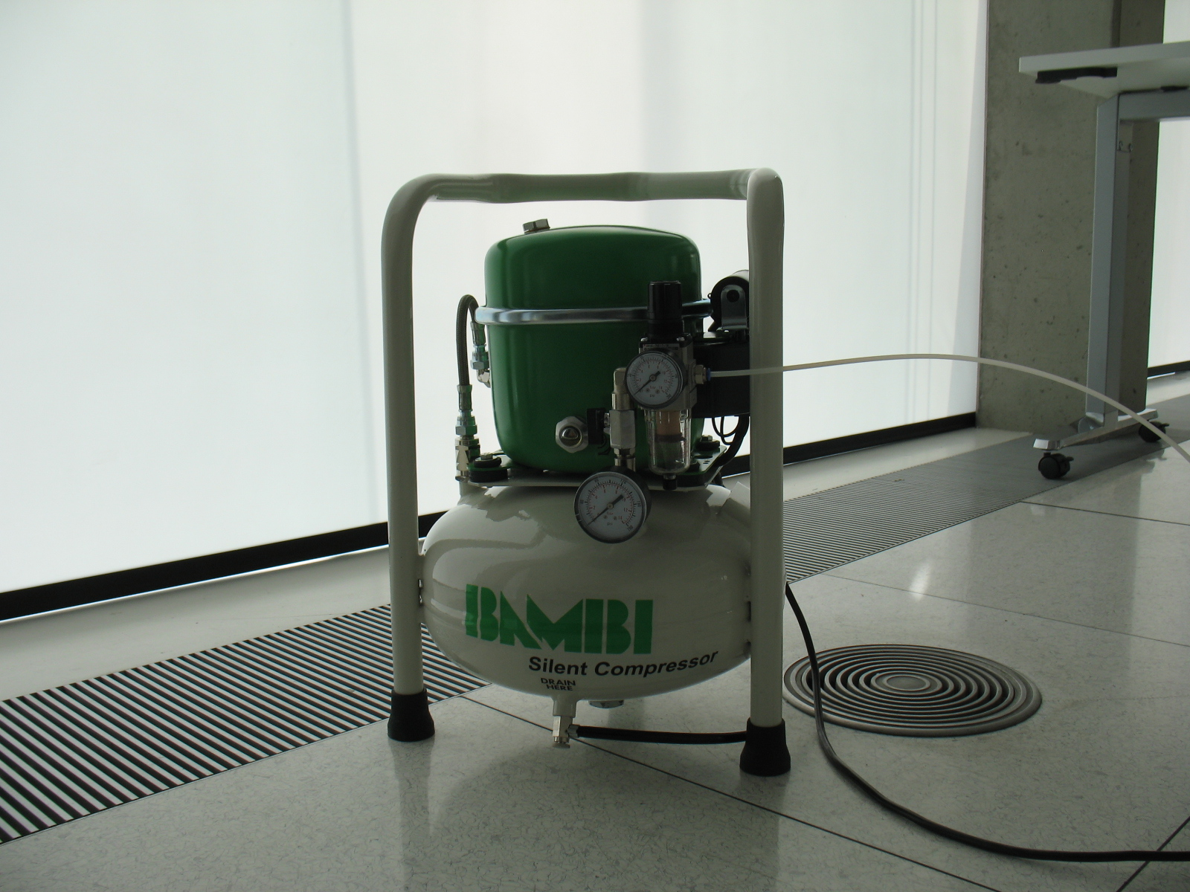
Hazard Identification: Identify all the hazards; evaluate the risks (low / medium / high); describe all existing control measures and identify any further measures required.

Hazard (s) | Risk  L / M / H | Control Measures (i.e., alternative work methods / mechanical aids / engineering controls, etc.) | Risk  L / M /H
Entry of compressed air into bloodstream  Skin or eye damage from contact with blown particles such as metal swarf.  Unsecured hoses whipping under pressure.  Electrical hazard  Slips/trips | M  M  L  M  L | Only those who have been instructed in its proper use may operate the compressor.  NEVER direct an air blast at yourself or at any other person. REMEMBER that a high pressure jet of air can cause injury.  NEVER attempt to blow dust or dirt off skin  or clothing.  The compressed air stream should not be used for cleaning purposes.  In free air flow situations eye protection must be worn to protect the eyes against flying swarf and dirt particles.  Visual inspection of hoses should be made before starting the operation.  Ensure that all hose fittings are securely connected prior to use.  The equipment must be regularly safety tested.  Visual inspection of the lead and plug should be made prior to use.  Avoid creating trip hazards caused by hoses running across the workspace.  Ensure that your workspace is free of slip/trip hazards. | L  L  L  L  L

Engineering Controls: Tick relevant boxes

Guarding |  | Extraction (LEV) |  | Interlocks |  | Enclosure
Other relevant information (incl. testing frequency if appropriate):

Personal Protective Equipment (PPE): Identify all necessary PPE.

Eye / Face | X | Hand /Arm |  | Feet / Legs |  | Respiratory
Body (clothing) |  | Hearing |  | Other (Specify)
Specify the grade(s) of PPE to be worn:

Safety glasses with side shields.

Specify when during the activity the item(s) of PPE must be worn:

Safety glasses with side shields should be used if air use is free flowing e.g. paint spraying.

Non-disposable items of PPE must be inspected regularly and records retained for inspection

Persons at Risk: Identify all those who may be at risk.

Academic staff | X | Technical staff | X | P’Grad students | X | U’Grad students | X
Maintenance staff | X | Office staff |  | Cleaning staff |  | Emergency personnel
Contractors |  | Visitors | X | Others

Additional Information: Identify any additional information relevant to the activity, including supervision, training requirements, special emergency procedures, requirement for health surveillance etc.

All air receivers are subject to a through examination at the statutorily required intervals.

Assessment carried out by:

Name: | David Hamilton | Date: | 22/6/2016
Signature: |  | Review Date: | June 2017

Checked by lab manager
Name: |  | Date:
Signature:

Safe system of work – Form SSW


School Assessment No. | INFRA35
Title of Activity: | Use of lab compressor
Location(s) of Work: | Informatics Forum

Compressor SSW

The compressor may only be used for those projects which are appropriate to it.
Risk assessment must be countersigned before using the equipment. No unauthorised use is allowed.

Before use check the hoses are properly connected. Check the maintenance records to ensure the regular maintenance has been done. If in doubt do the regular checks personally and sign the maintenance sheet to indicate this.

Never blast air directly at anyone, or use the stream to blow dust around.

If any injury occurs, the unit should be stopped, and medical assistance sought for the injured person.

Once finished. Shut down unit and depressurise the tank.

The emergency phone number is 2222
The nearest First Aid box is in the Inspace kitchen
Informatics First Aider list can be found on the web at;
http://www.inf.ed.ac.uk/safety/first-aiders.html

The person responsible for overall safety in the Inspace area is Subramanian Ramamoorthy

Verification by users

I may be involved in the task covered by this risk assessment. I have read the assessment and the prescribed safe system of work which I fully understand and hereby undertake to adhere to in the interest of my own health and safety and that of others who may be affected by my actions.

Operatives: | Signature: | Counter-signature (superviser): | Date:

School Assessment No. | INFRA35
Title of Activity: | Use of lab compressor
Location(s) of Work: | Informatics Forum

Verification by users (contd)

I may be involved in the task covered by this risk assessment. I have read the assessment and the prescribed safe system of work which I fully understand and hereby undertake to adhere to in the interest of my own health and safety and that of others who may be affected by my actions.

Operatives: | Signature: | Counter-signature (superviser): | Date:

