
Baxter Risk Assessment Form

School Assessment No: | INFRA 34
Title of Activity: | Working with Baxter robots
Location(s) of Work: | Assisted Living Lab; Bayes 1.25
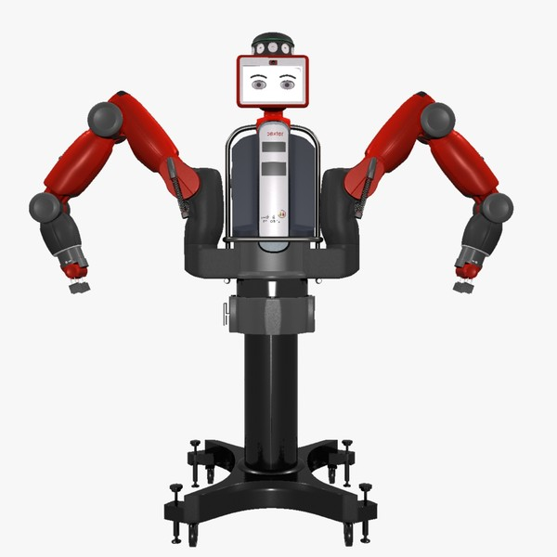
Brief Description of Work:
Working with the Baxter robot
for manipulation.

Hazard Identification:
Hazard(s) | Present Risk  Evaluation  L/M/H | Control Measures (i.e., alternative work methods / mechanical aids / engineering controls, etc.) | Risk  Evaluation after control  L/M/H
Impact between robotic arm and people or objects in its path (e.g. being struck by the robotic arm) | L | The Baxter robot is designed to allow human-robot close proximity, however only authorised and trained operators may work within the working envelope.  The emergency STOP button must be within easy reach of the operator at all times.  The operators should be familiar with safe code of working practice for working with the robot.  No unauthorised person should enter the robot’s working envelope when robot operation is underway, unless an authorised and trained operator is present attending control of the robot.  No unauthorised person should operate the robot. | L
Crushing and trapping (e.g. part of the body being trapped between the robotic arm joints) | L | Those working in close proximity to the robot should be aware of areas of possible injury, such as the small gaps in rotational joints.  The emergency STOP button must be within easy reach of the operator at all times. | L
Ejection of the workpiece from the grippers due to mechanical failure, malfunction or overloading. | L | The emergency STOP button must be within easy reach of the operator at all times. | L
Slipping/tripping | L | Working areas should be kept clear of obstructions.  Any spillages should be cleaned up immediately.  Any hazards such as trailing cables, defects to floors coverings, faulty lighting etc. should be reported immediately to the Admin Office / Local Safety Adviser or another senior member of staff. | L
Electrical equipment  (electrocution) | M | All portable electrical equipment must be safety tested at correct intervals and labelled with the date of test.  Electrical cables, plugs should be regularly visually inspected by the user for damage.  Any defective equipment should be reported immediately to the Admin Office / Local Safety Adviser or another member of senior staff, then suitably labelled and taken out of use until the repair has been effected.  Any computer hardware faults should be reported to members of computing staff. | L
Fire | L | Lab users must be acquainted with the Fire Routine Procedure for the area. | L
Compressed Air  (eye injury) | M | Baxter users should read and sign the compressed air risk assessment INFRA_35, to show awareness of this issue | L
Lifting of unit (back injuries) | H | A risk assessment must be completed for lifting the unit. Follow procedures for heavy and bulky loads that present a risk of injury. | L
Moving the unit (tripping/toppling) | M | Fully release stabilisers  Fully disconnect all external connections  Ensure route is clear and manageable  Move slowly and keep passers-by well clear | L

Engineering Controls:
Guarding |  | Extraction (LEV) |  | Interlocks |  | Enclosure
Other relevant information (incl. testing frequency if appropriate):

Personal Protective Equipment (PPE):
Eye / Face |  | Hand /Arm |  | Feet / Legs |  | Respiratory
Body (clothing) |  | Hearing |  | Other (Specify)
Specify the grade(s) of PPE to be worn:
Specify when during the activity the item(s) of PPE must be worn:
Non-disposable items of PPE must be inspected regularly and records retained for inspection

Persons at Risk:
Academic staff | X | Technical staff | X | P’Grad students | X | U’Grad students | X
Maintenance staff | X | Office staff |  | Cleaning staff |  | Emergency personnel
Contractors |  | Visitors | X | Others

Additional Information:
Everyone working in an office or general area should make themselves familiar with Part Two of the University Health and Safety Policy at: http://www.ed.ac.uk/schools-departments/health-safety/policy-cop

Staff/students should be familiar with the Safety Regulations for working in Office / General Areas. These can be found in the safety manuals for each building at: http://www.inf.ed.ac.uk/safety/

Assessment carried out by:
Name: | Subramanian Ramamoorthy | Date:
Signature: |  | Review Date:

Safe system of work – Form SSW
Working with the Baxter robot – INFRA 34
INFRA 12 + 35 must be read, understood and signed off along with this SSW, before use of the robot.
The Baxter is designed to allow close human-robot interaction, however it should only be used in this manner by authorised experienced users.
Inexperienced and unauthorised users should only enter the working envelope under the direction of an experienced authorised user who is present at the time.
No unauthorised use is allowed.
Before use the area should be checked and cleared of unnecessary items. Cables should be neatly routed and the emergency stop button available for use.
If any injury occurs, the unit should be stopped, disabled and medical assistance sought.
Once finished. Shut down unit and any associated equipment. Ensure computer is logged out, to prevent unauthorised use.
The emergency phone number is 2222
The nearest First Aid box is in the floor kitchen
Informatics First Aider list can be found on the web at;
http://www.inf.ed.ac.uk/safety/first-aiders.html
The person responsible for overall safety in the Assited Living Lab area is Subramanian Ramamoorthy.

Verification by users
Sign below to indicate you have read and understood the safe system of work.
Signature: | Date:

