
Kuka Youbot Risk Assessment Form

School Assessment No: | INFRA36
Title of Activity: | Working with Kuka Youbots
Location(s) of Work: | 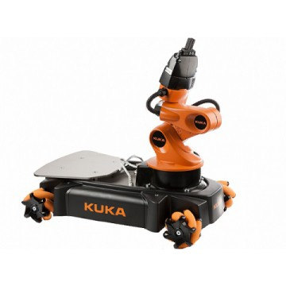  Assisted Living Lab; Bayes 1.25
Brief Description of Work:
Working with the Kuka Youbot robot
for navigation and manipulation.

Hazard Identification:
Hazard(s) | Present Risk  Evaluation  L/M/H | Control Measures (i.e., alternative work methods / mechanical aids / engineering controls, etc.) | Risk  Evaluation after control  L/M/H
Weight  (lifing injury) | M | With the manipulator arm the robot weighs around 27kg.  If lifting the robot,use two people, or a lifting aid, to avoid the risk of injury.  If transporting, use a trolley | L
Battery rupture (acid burn) | M | Due to incorrect usage, shorting, damage or ageing the batteries may rupture, leading to a spillage of acid.  If there is such a spill it should be immediately contained and mopped up and any affected floor tiles removed and washed down. Use rubber gloves to protect the hands and absorbent cloths/paper towels to soak up the spillage. Collect all used materials in a plastic bag for further disposal, do not place in normal waste stream. | L
Tripping | M | The robots are not particularly tall and may not be in the line of sight of inattentive passers by, causing a tripping incident.  Ensure that all those who may enter the working area of the robots are aware of their presence, by marking out the area in use or by verbal warning. | L

Engineering Controls:
Guarding |  | Extraction (LEV) |  | Interlocks |  | Enclosure
Other relevant information (incl. testing frequency if appropriate):

Personal Protective Equipment (PPE):
Eye / Face |  | Hand /Arm |  | Feet / Legs |  | Respiratory
Body (clothing) |  | Hearing |  | Other (Specify)
Specify the grade(s) of PPE to be worn: None
Specify when during the activity the item(s) of PPE must be worn: None
Non-disposable items of PPE must be inspected regularly and records retained for inspection

Persons at Risk:
Academic staff | X | Technical staff | X | P’Grad students | X | U’Grad students | X
Maintenance staff | X | Office staff |  | Cleaning staff |  | Emergency personnel
Contractors |  | Visitors | X | Others

Additional Information:
Supervision and training for this robot is at the discretion of the Lab. Manager.
Assessment carried out by:
Name: | Subramanian Ramamoorthy | Date:
Signature: |  | Review Date:

Safe system of work – Form SSW
Kuka Youbot
Before use check the battery connections are not damaged.
Never force cables into connection points
If lifting the unit, use two people.
If transporting, use a trolley. Ensure the unit can not move when transported (chock or disable the wheels)
When in operation ensure the work area is clearly marked or their is always an operator present to warn those not involved in the project about the robot’s movement.
Never place the robot where it may cause harm to others (i,e become a tripping hazard, or be in a position to fall on someone)
After use, ensure the unit is powered down and battery disconnected.
For acid leakage from the battery:
Ensure everything is powered down. Disconnect the battery if possible
Cordon off the area .
Obtain rubber gloves and cloths/paper towels from the Cleaner’s closet.
Put on the gloves and contain and mop up the spill.
Contact Technical support and arrange the removal of any affected floor tiles immediately for washing down.
In the event of injury due to acid spill, patient should place burn area under running water and irrigate until symptoms ease. If irritation is not reduced after 10-15 mins seek further medical advice.
The emergency phone number is 2222
The nearest First Aid box is in the floor kitchen
Informatics First Aider list can be found on the web at;
http://www.inf.ed.ac.uk/safety/first-aiders.html
The person responsible for overall safety in the Assited Living Lab area is Subramanian Ramamoorthy.

Verification by users
Sign below to indicate you have read and understood the safe system of work.
Signature: | Date:

